Exploratory Analysis of Claim Rates to support Mana Taurite | Equity of Access

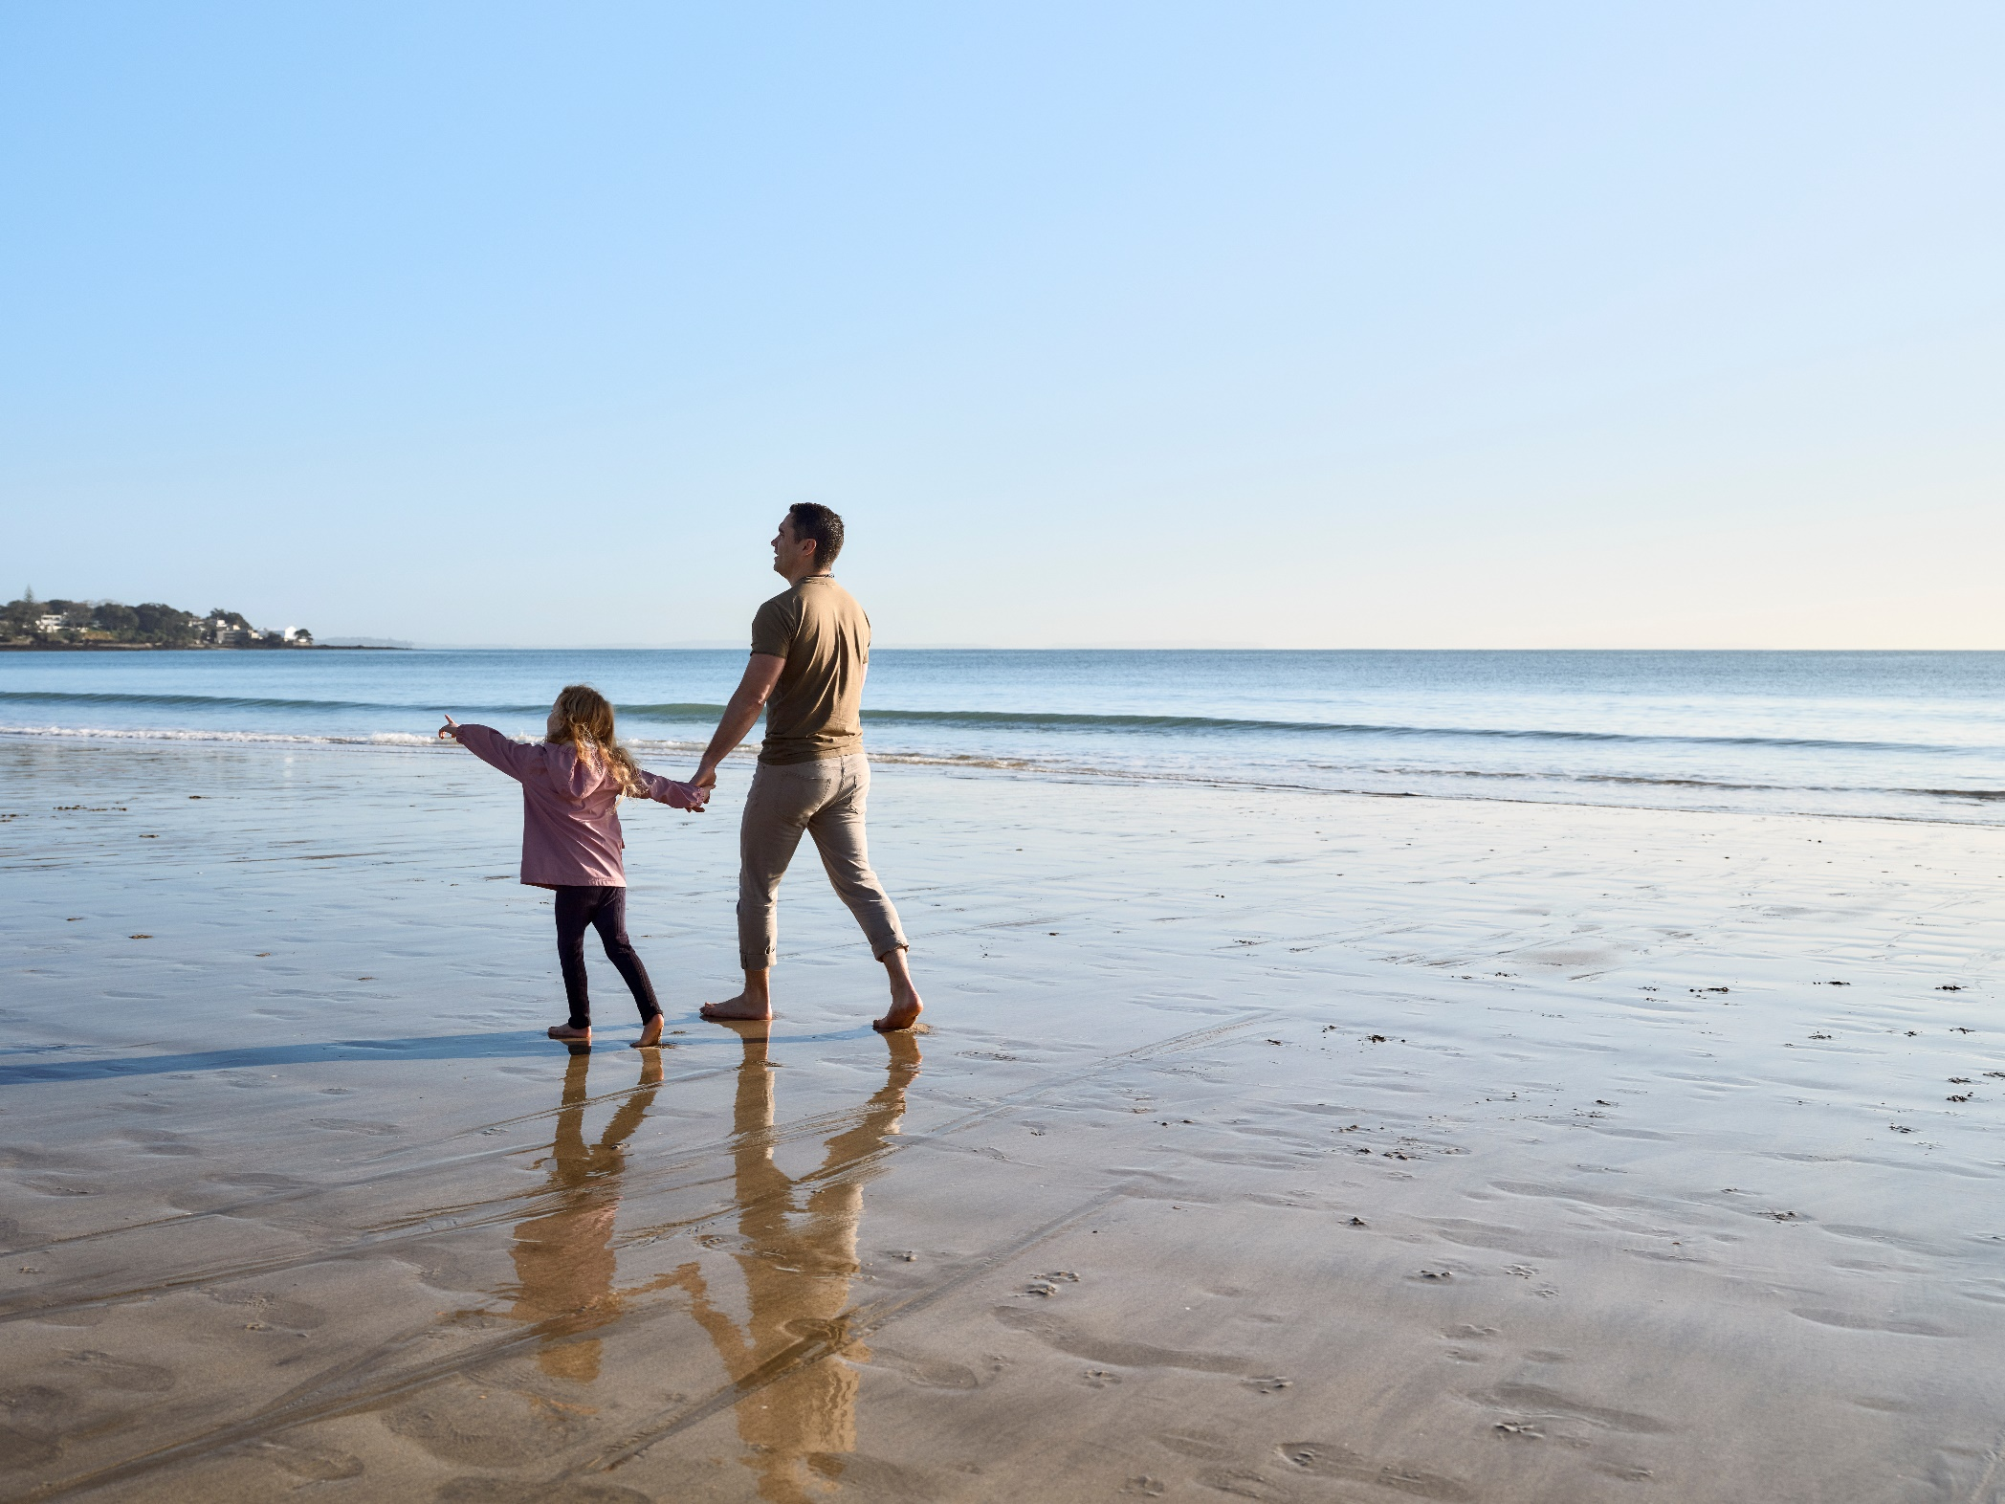

Analysis of IDI data for Māori, Pacific people, Asian people and disabled people

Authors: Dr Andrea Knox and Dr Michele Morris

Analysis conducted: July to December 2023

In December 2024, the analysis was updated to include 2023 ACC claims data in the IDI

**ACC Disclaimer:**

The information in the Exploratory Analysis of Claim Rates to support Mana Taurite | Equity of Access Report available on or through the ACC website is intended to provide general information to the public on measuring equity of access to ACC and all reasonable measures have been taken to ensure the quality and accuracy of the information published. However ACC makes no warranty, express or implied, nor assumes any legal liability or responsibility for the accuracy, suitability, correctness, completeness or use of any information in the Exploratory Analysis of Claim Rates to support Mana Taurite | Equity of Access Report. Nothing contained in the Exploratory Analysis of Claim Rates to support Mana Taurite | Equity of Access Report is, or shall be relied on as a promise or representation by ACC on any of the matters considered in the Exploratory Analysis of Claim Rates to support Mana Taurite | Equity of Access Report.

The content of the Exploratory Analysis of Claim Rates to support Mana Taurite | Equity of Access Report should not be construed as medical or professional advice. It is not intended to replace clinical judgement or be used as a clinical protocol.

Information contained in the Exploratory Analysis of Claim Rates to support Mana Taurite | Equity of Access Report is current as at the date of the Report, and may not reflect any event or circumstances which occur after the date of the Report.

The Exploratory Analysis of Claim Rates to support Mana Taurite | Equity of Access Report does not necessarily represent the official view of ACC or represent ACC policy.  
  
**Stats NZ Disclaimer:**

Access to the data used in this study was provided by Stats NZ under conditions designed to give effect to the security and confidentiality provisions of the Data and Statistics Act 2022. The results presented in this study are the work of the author, not Stats NZ or individual data suppliers.

These results are not official statistics. They have been created for research purposes from the Integrated Data Infrastructure (IDI) which is carefully managed by Stats NZ. For more information about the IDI please visit <https://www.stats.govt.nz/integrated-data/>.

**Copyright:**

Copyright © 2023 Unless otherwise stated, the information in this Exploratory Analysis of Claim Rates to support Mana Taurite | Equity of Access Report is protected by copyright and is subject to the copyright laws of New Zealand. The Exploratory Analysis of Claim Rates Among ACC’s Priority Groups Report was prepared by Dr Andrea Knox of Counterbalance Analytics. The Exploratory Analysis of Claim Rates to support Mana Taurite | Equity of Access Report may be reproduced without permission, subject to the material being reproduced accurately and not being used in a misleading context. In all cases, the Accident Compensation Corporation must be acknowledged as the source.  
  
**Acknowledgements:**

Many thanks to Dr Mairead Shanahan and Sarah Talboys for expert advice and review.

Contents

1 Summary 6

1.1 This report presents an exploratory analysis of population data in the IDI to help ACC meet its newly legislated reporting requirements 6

1.2 An analysis of claim rates from 2013 to 2022 found different claim rates and trajectories over time for the different groups 6

1.3 When other factors were controlled for, claim rates remained lower for Māori, Pacific people, and Asian people and disabled children, and higher for disabled adults 7

1.4 Potential barriers to access can be explored by analysing IDI data for the identified populations 8

1.5 This approach is repeatable and suggests areas for more nuanced research on barriers 13

2 Background 14

2.1 Despite being a compulsory scheme, there are disparities in access to the AC Scheme 14

2.2 ACC has undertaken to better understand and address disparities in access 14

2.3 Exploratory work on ways to measure equity of access recommended a survey of injured people and an analysis of ACC claim rates using integrated data 15

2.4 This report investigates differences in claim rates across ACC groups, changes over time, and factors that may affect claim rates for different ACC groups 15

3 Results 16

3.1 Claim rates over time for the ACC ethnic groups 16

3.1.1 Claim rates are lower for Māori, Pacific, and Asian people, and Māori and Pacific claim rates dropped more steeply than other groups’ rates in 2020-22 16

3.1.2 Age and ethnicity interact, with claim rates showing different trajectories over time for different age group and ethnicity combinations 19

3.1.3 Across all ethnicities, men had higher claim rates than women and the gender difference was more pronounced for Māori and Pacific ethnicities 23

3.2 Claim rates over time for people with disabilities 26

3.2.1 Disabled people had higher claim rates 27

3.2.2 Disabled people’s claim rates increase markedly with age and disabled children’s claim rates are lower than non-disabled children’s rates 28

3.2.3 Disabled people’s claim rates are less affected by gender than non-disabled people’s claim rates 29

3.3 The effect of claim lodgement delays on time series analysis of claim rates is negligible 30

3.4 Estimates of claim rates for the ACC groups when other factors are statistically controlled for 31

3.4.1 We used multiple regression to estimate more direct relationships between ACC group membership and ACC claim rates, when other factors are accounted for 31

3.4.2 When demographic and socio-economic factors were accounted for, claim rates remained lower for Māori, Pacific, and Asian adults, and higher for disabled adults 33

3.4.3 When demographic and socio-economic factors were accounted for, claim rates remained lower for Māori, Asian, and disabled children 39

3.5 Associations between claim rates and the demographic and socio-economic characteristics for each of the ACC groups 43

3.5.1 For most groups we found similar associations between claim rates and age, gender, region, employment, material hardship, and indicators of health and justice system interactions 43

3.5.2 Māori adults - factors associated with the likelihood of claiming 44

3.5.3 Māori children - factors associated with the likelihood of claiming 47

3.5.4 Pacific adults - factors associated with the likelihood of claiming 50

3.5.5 Pacific children - factors associated with the likelihood of claiming 53

3.5.6 Asian adults - factors associated with the likelihood of claiming 55

3.5.7 Asian children - factors associated with the likelihood of claiming 58

3.5.8 Disabled adults - factors associated with the likelihood of claiming 60

3.5.9 Disabled children - factors associated with the likelihood of claiming 63

4 Conclusions and next steps 66

4.1 An IDI-based exploration of claim rates can track changes over time and identify potential barriers to access 66

4.2 Extensions of this work could include investigating potential barriers to access further, analysing claim rates for more specific groups and injury types, and gathering qualitative insights 67

4.3 The analysis in this report can be repeated in future, with some improvements 68

5 References 70

6 Appendix 1. Data and methods 73

6.1 Data sources and variables 73

6.1.1 The Integrated Data Infrastructure (IDI) 73

6.1.2 Estimated resident population 73

6.1.3 Linked ACC claimants data 73

6.1.4 ACC group, demographic, and socio-economic variables 74

6.2 Time series analysis 78

6.3 Multiple regression analysis 79

6.3.1 Multiple regression purpose and populations 79

6.3.2 Model development 79

6.3.3 Random sampling for large populations 81

6.3.4 Estimation of standard errors and confidence intervals 82

7 Appendix 2. The effects of claim lodgement delays on time series analysis 83

7.1 Only two to three percent of claims are lodged more than 3 months after the injury 83

7.2 2022 claim rates may be underestimated by about half a percentage point 84

7.3 Claim lodgement delays have negligible effects on the comparisons between groups and do not change the conclusions in this report 85

8 Appendix 3. ACC group population distributions across demographic and socio-economic variables 92

9 Appendix 4. Regression results comparing the claim rates between ACC groups when other factors are accounted for 105

9.1 How to interpret the results 105

9.2 Adult models by ethnicity for all years 2013-2022 106

9.3 Adult models by ethnicity for 2018, including Census-derived variables on occupation and household characteristics 112

9.4 Child models by ethnicity for all years 2013-2022 120

9.5 Child models by ethnicity for 2018, including Census-derived variables for household characteristics 123

9.6 Adult models by disability 126

9.7 Child models by disability 133

10 Appendix 5. Regression results estimating associations between claim rates and socio-economic/demographic factors for each ACC group 136

10.1 Associations between demographic and socio-economic factors and claim rates for Māori adults 136

10.2 Associations between demographic and socio-economic factors and claim rates for Māori children 143

10.3 Associations between demographic and socio-economic factors and claim rates for Pacific adults 146

10.4 Associations between demographic and socio-economic factors and claim rates for Pacific children 152

10.5 Associations between demographic and socio-economic factors and claim rates for Asian adults 155

10.6 Associations between demographic and socio-economic factors and claim rates for Asian children 162

10.7 Associations between demographic and socio-economic factors and claim rates for disabled adults 165

10.8 Associations between demographic and socio-economic factors and claim rates for disabled children 171

# 1 Summary

## 1.1 This report presents an exploratory analysis of population data in the IDI to help ACC meet its newly legislated reporting requirements

The Accident Compensation (AC) Scheme provides comprehensive no-fault injury compensation support to people who are injured in an accident. However, even though it is a compulsory scheme, there are disparities in access to its support. Groups that experience barriers to healthcare in general are less likely to lodge an AC claim when injured, more likely to have their claim declined, and less likely to access the full range of diagnostic and treatment support (Tiatia et al. 2006, Wren and Jansen 2015, Ministry of Health 2019, ACC 2020, Ingham et al. 2022, The Treasury 2022, Xiang et al. 2023).

The Accident Compensation Corporation (ACC) has undertaken to better understand and address disparities in access and is now required, under the AC Amendment Act 2023, to provide annual reports to the Minister on the level of access to the Scheme, disparities in access, and barriers to access among Māori and other identified population groups (The Parliament of New Zealand 2023). ACC has identified Pacific people, Asian people, and disabled people as the population groups it will focus on, in addition to Māori.

Exploratory work on ways to measure equity of access recommended a survey of injured people and an analysis of ACC claim rates using population data in the Integrated Data Infrastructure (IDI) (Knox 2023). The survey can estimate how likely injured people are to claim, but will not have the sample size to support a detailed analysis of changes over time and barriers to access for identified groups. IDI data can support more detailed analysis but it has the disadvantage that it cannot identify people who were injured but did not lodge ACC claims.

This report presents the results of an exploratory analysis of claim rates (defined as the proportion of the population who made a claim) for Māori, Pacific, Asian and disabled people, using IDI data. We investigated how claim rates changed from 2013 to 2022, how claim rates differed for Māori, Pacific, Asian and disabled people, compared to others, when other factors were statistically controlled for, and what factors may be associated with barriers to access for the identified groups. The variables we used for this analysis are defined in Appendix 1.

## 1.2 An analysis of claim rates from 2013 to 2022 found different claim rates and trajectories over time for the different groups

An analysis of claim rates over time for Māori, Pacific, and Asian people found marked differences between ethnicities, genders and age groups.

* Claim rates were lower for Māori, Pacific and Asian people, compared to other ethnicities, and this was especially marked for Asian people, whose claim rates were 8 to 10 percentage points lower than those of non-Asian people.
* Claim rates for the whole New Zealand population dropped between 2020 and 2022, coinciding with the COVID-19 pandemic. The drop was steeper for Māori and Pacific people, and was especially steep for Pacific children.
* Age and ethnicity interact, with claim rates showing different trajectories over time for different age group and ethnicity combinations.
* Across all ethnicities, men had higher claim rates than women and gender differences were more pronounced for Māori and Pacific ethnicities.

The available data did not allow us to analyse disabled people’s claim rates over time, but we were able to look at 2019 to 2021 claim rates for people who reported a disability in Census 2018. We found that:

* disabled adults’ claim rates were higher than those of non-disabled adults (adults were defined as those aged 15 and over)
* disabled children’s claim rates were lower than those of non-disabled children (children were defined as those aged 0 to 14 years)
* disabled people’s claim rates were less affected by gender and disabled women had slightly higher claim rates than disabled men.

## 1.3 When other factors were controlled for, claim rates remained lower for Māori, Pacific people, and Asian people and disabled children, and higher for disabled adults

While the analysis of claim rates from 2013 to 2022 showed clear variation across groups, some of that may be due to other differences between the groups such as age, location, and employment characteristics. We used multiple regression to control statistically for other differences so that we could estimate more direct relationships between ethnicity or disability and claim rates. When other factors were statistically controlled for, we found that:

* claim rates remained lower for Māori and Pacific adults, much lower for Asian adults, and higher for disabled adults
* claim rates remained lower for Māori and disabled children, and much lower for Asian children.

## 1.4 Potential barriers to access can be explored by analysing IDI data for the identified populations

Among the adults and children of each group, we investigated how claim rates related to demographic and socio-economic characteristics, again using multiple regression. This indicates some areas where the groups may be facing barriers to access, but it is important to remember that the effects we estimate could relate either to the likelihood of injury, or to the likelihood of making a claim when injured (or to a combination of both). A survey-based approach is needed to estimate these likelihoods separately. In addition, factors associated with a lower rate of claiming when injured may indicate situations where people have less need for AC Scheme support, or situations where people could benefit from support but face barriers to access.

Table 1.1 summarises the main findings for adults and Table 1.2 does the same for children. In these charts, the symbols can be interpreted as follows.

       ↓ indicates that the factor was associated with lower claim rates, when other factors  
       were accounted for.

       ↓↓ indicates that the factor was associated with much lower claim rates when other  
       factors were accounted for. This is defined as claim rates that were 0.8 times (80% of)  
       the comparison group’s rates, or less.

       ↑ indicates that the factor was associated with higher claim rates, when other factors  
       were accounted for.

       ↑↑ indicates that the factor was associated with much higher claim rates when other  
       factors were accounted for. This is defined as claim rates that were at least 1.2 times  
       (20% higher than) the comparison group’s rates.

       - indicates that we did not see a statistically significant association between the  
       factor and claim rates.

*Table 1.1: Key relationships between ACC claim rates and demographic and socio-economic variables for all, Māori, Pacific, Asian, and disabled adults.*

| **Factor** | **All  adults** | **Māori  adults** | **Pacific  adults** | **Asian  adults** | **Disabled  adults** |
| --- | --- | --- | --- | --- | --- |
| Older age | ↓ | ↓ | ↓ | ↑ | ̶ |
| Male gender | ↑ | ↑↑ | ↑↑ | ↑ | ↓ |
| Overseas born | ↓↓ | ̶ | ↓ | ↓↓ | ↓ |
| Longer time  in NZ for  overseas born | ↑ | ↑ | ̶ | ↑ | ↑ |
| Material  hardship  indicators | ↓ | ↓ | ↓ | ↓ | ↓ |
| Employed | ↑ | ↑ | ↑ | ↑ | ↑ |
| Partnership | ↓ | ↓ | ↓ | ̶ | ̶ |
| Studying and  having  qualifications | ↑ | ↑ | ↑ | ↑ | ↑ |
| PHO  enrolment | ↑↑ | ↑↑ | ↑↑ | ↑↑ | ↑↑ |
| Serious offence | ↑ | ↑ | ↑ | ↑ | ↑↑ |
| Mental health  diagnosis | ↑↑ | ↑↑ | ↑↑ | ↑ | ↑↑ |
| **Region** |  |  |  |  |  |
| Northland, Bay  of Plenty,  Gisborne | ↑ | ↓ | ↑ | ↓↓ | ↓ |
| Auckland | ̶ | ↑ | ̶ | ↑ | ↑ |
| Wellington | ↓↓ | ↓↓ | ↓ | ↓↓ | ↓↓ |
| Canterbury | ↓ | ↓ | ↓ | ↓↓ | ↓ |
| Rest of  North Island | ↓ | ↓ | ̶ | ↓↓ | ↓ |
| Rest of  South Island | ↓ | ↓ | ̶ | ↓↓ | ↓↓ |

*Table 1.2: Key relationships between ACC claim rates and demographic and socio-economic variables for all, Māori, Pacific, Asian, and disabled children.*

| **Factor** | **All  children** | **Māori  children** | **Pacific  children** | **Asian  children** | **Disabled  children** |
| --- | --- | --- | --- | --- | --- |
| 10-14 years  old | ↑↑ | ↑ | ↑ | ↑ | ̶ |
| Male gender | ↑ | ↑↑ | ↑↑ | ↑ | ̶ |
| Overseas born | ↓ | ↑ | ↓ | ↓ | ̶ |
| Rural address | ↓ | ↓ | ̶ | ↓ | ̶ |
| Material  hardship  indicators | ↓ | ↓ | ↓ | ↓ | results  unclear |
| PHO  enrolment | ↑↑ | ↑↑ | ↑↑ | ↑↑ | ̶ |
| Mental health  diagnosis | ↑ | ↑ | ↑ | ↑↑ | ↑ |
| **Region** |  |  |  |  |  |
| Northland, Bay  of Plenty,  Gisborne | ↓ | ↓ | ↓↓ | ↓ | ↓ |
| Auckland | ↑ | ↑ | ↑ | ↑ | ↑ |
| Wellington | ↓↓ | ↓↓ | ↓↓ | ↓↓ | ↓↓ |
| Canterbury | ↓ | ↓↓ | ↓↓ | ↓↓ | ↓↓ |
| Rest of  North Island | ↓ | ↓ | ↓↓ | ↓ | ↓ |
| Rest of  South Island | ↓ | ↓ | ↓↓ | ↓↓ | ↓↓ |

In common across most groups, we found the following relationships for adults.

* Older people were less likely to claim than 15-39 year olds.
* Men were more likely to claim than women.
* Living in Auckland was associated with higher claim rates while living in Wellington was associated with especially low claim rates.
* Overseas-born adults were less likely to claim, but claim rates increased the longer they had been in New Zealand.
* Employed adults were more likely to claim than those who were not employed and claim rates tended to be higher for those in the Agriculture, Forestry and Fishing, Arts and Recreation Services, and Construction industries.
* Clerical and Administrative Services and Sales occupations were associated with lower claim rates than other occupations.
* Lower claim rates were associated with indicators of material hardship (such as neighbourhood deprivation, low income, benefit receipt, and household crowding) and with having a partner.
* Higher claim rates were associated with living in an owner-occupied home with a mortgage, participating in study or training, having qualifications, being enrolled at a Primary Healthcare Organisation (PHO), having a history of serious offending, and mental health diagnosis indicators.

For children we find the following common relationships.

* 10 to 14 year-olds were more likely to claim than younger children.
* Boys were more likely to claim than girls.
* Children in Auckland had higher claim rates, and especially low claim rates were seen in the Wellington and Canterbury regions.
* Lower claim rates were associated with indicators of material hardship, being born overseas, and living in a rural area.
* Higher claim rates were associated with living in an owner-occupied home with a mortgage, being enrolled at a PHO, and mental health diagnosis indicators.

For Māori, most of the common relationships were seen, but with two differences.

* Associations with being born overseas differed, with higher claim rates among overseas-born Māori children, and among overseas-born Māori adults once they had been in New Zealand for more than 9 years.
* Māori adults and children living in rented housing had significantly lower claim rates than those living in owner-occupied houses).

For Pacific people, we also saw most of the common relationships, with the following exceptions.

* Pacific adults living in Northland, the Bay of Plenty, and Gisborne had higher claim rates than those in Auckland.
* Claim rates for overseas-born Pacific adults did not appear to increase as they remained in New Zealand for longer.
* There was no statistically significant effect associated with living rurally for Pacific children.

For Asian people, we saw the following key divergences from the common relationships.

* Claim rates among Asian adults were the highest for older people (over 65 years) and the lowest for 15-39 year olds.
* Asian adults living in Auckland had much higher claim rates than those in any other region.
* While most indicators of material hardship were associated with lower Asian claim rates, adults receiving Jobseeker benefit payments were more likely to claim than others.
* Having a partner did not show a significant association with claim rates.
* Asian adults in Kainga Ora housing and private sector rentals had higher claim rates, alongside those in mortgaged owner-occupied homes. There were no statistically significant relationships between housing tenure and claim rates for Asian children.

Among disabled adults, we saw many of the common relationships, in addition to the following key differences.

* After controlling for other factors we found no significant relationships between claim rates and age, having a partner, or housing tenure.
* Claim rates were lower for disabled men than disabled women.
* Similar to the total adult population, we found that Māori, Pacific and Asian ethnicities were associated with significantly lower claim rates among disabled adults. The ethnic differences tended to be more pronounced among disabled adults, with especially low claim rates for Pacific disabled adults, compared to non-Pacific disabled adults.

For disabled children, our analysis was somewhat limited by the smaller size of the population. We saw some of the common relationships, but they were often not statistically significant, so we cannot know if they represent real differences or random fluctuations in the data. However, as for disabled adults, we saw significantly lower claim rates for disabled Māori, Pacific, and Asian children.

## 1.5 This approach is repeatable and suggests areas for more nuanced research on barriers

The analysis presented in this report is repeatable and can be extended to 2023 and beyond when data becomes available in the IDI. There is considerable scope to expand the analysis of barriers by using more tightly defined population groups and disaggregating claim rates by the type of accident (for example, work, traffic, sport and recreation). In combination with qualitative research on barriers and a survey-based approach to estimating claim rates among injured people, this will help ACC to meet its reporting requirements and better understand where to target disparity reduction efforts.

# 2 Background

## 2.1 Despite being a compulsory scheme, there are disparities in access to the AC Scheme

The Accident Compensation (AC) Scheme provides comprehensive no-fault injury compensation support to people who are injured in an accident. Support includes payments towards treatment, help at home and at work, and compensation for lost income. All people in New Zealand are covered by the Scheme including adults and children, citizens, residents, and temporary visitors who are injured in New Zealand (ACC 2023b).

However, despite it being compulsory there is evidence for longstanding disparities in access to AC Scheme support. Groups that experience barriers to healthcare, in general, are less likely to lodge an AC claim when injured, more likely to have their claim declined, and less likely to access the range of diagnostic and treatment services supported by the Accident Compensation Corporation (ACC) (Tiatia et al. 2006, Wren and Jansen 2015, Ministry of Health 2019, ACC 2020, Ingham et al. 2022, The Treasury 2022, Xiang et al. 2023).

## 2.2 ACC has undertaken to better understand and address disparities in access

Aligning with its 2023-2032 strategy: Huakina Te Rā, and responding to requirements in the Accident Compensation (Access Reporting and Other Matters) Amendment Act 2023, ACC has undertaken to deepen its understanding of equity and to reduce disparities in access, experience and outcomes (ACC 2023a, The Parliament of New Zealand 2023).

The AC Amendment Act 2023 requires ACC to provide annual Scheme access reports to the Minister covering the level of access to the Scheme, disparities in access, and barriers to access among Māori and other identified population groups. The legislation states that ACC must:

*13 (1) Consult with such organisations and people as the Corporation considers appropriate about the methods that it proposes to use in preparing that report, including the methods that the Corporation proposes to use to identify –  
(a) The levels of access to the accident compensation scheme by Māori and identified population groups the Corporation proposes to report on in the first annual scheme access report; and  
(b) Disparities in access to the accident compensation scheme that affect Māori or any identified population group*

The first access report is due soon after June 2024 and the population groups that have been identified for investigating disparities are Māori, Pacific people, Asian people, and disabled people. These are referred to as the ‘ACC groups’ in this report.

## 2.3 Exploratory work on ways to measure equity of access recommended a survey of injured people and an analysis of ACC claim rates using integrated data

Equity of access is interpreted by the ACC Board as ‘The absence of unfair, avoidable, or remedial difference in injury risk, Scheme access, service experience and wellbeing outcomes for the people we serve in Aotearoa’. The ACC 2021-2025 Statement of Intent states that ‘Equity is helping people to get the support they need, when they need it, to recover from injuries’ (ACC 2021).

Phase one of ACC’s work on equity of access focuses on entry to the ACC Scheme at the point of claim lodgement, with equity of access defined as the absence of disparities in claim lodgement rates among injured people. ACC is taking an intersectional approach, in which the associations between claim rates and variables such as gender, age, and socio-economic factors will be explored within each ACC group, to better inform ACC’s targeting of disparity reduction efforts.

ACC-commissioned research on ways to measure claim lodgement rates among injured people found that measurement is challenging due to the dearth of New Zealand injury data that is independent of ACC claims (Knox 2023), and recommended a two-pronged approach:

* use a survey that asks whether people have been injured and linked ACC claims data to estimate claim rates among injured people for each ACC group.
* accompany this with a more detailed analysis of claim rates over time and an intersectional analysis of how claim rates relate to socio-economic and demographic characteristics within the ACC groups, using population data in the Integrated Data Infrastructure (IDI).

The survey approach can estimate how likely injured people are to claim, but it will struggle to achieve the sample sizes needed for an intersectional analysis and analysis of changes over time. Population data in the IDI provides a large dataset that will support the more detailed time series and intersectional analysis, but it has the disadvantage that it cannot identify people who were injured but did not lodge ACC claims.

## 2.4 This report investigates differences in claim rates across ACC groups, changes over time, and factors that may affect claim rates for different ACC groups

This report presents the results of an exploratory analysis of claim rates for the ACC groups, using population data in the IDI. We investigate:

* the changes in claim rates of the ACC groups over the 10-year period: 2013 to 2022
* the differences between the claim rates of people who are, and are not, in the ACC groups, with statistical controls for other demographic and socio-economic factors
* how demographic and socio-economic factors are associated with claim rates within each ACC group.

# 3 Results

Linked data in the Stats NZ Integrated Data Infrastructure (IDI) was used to explore claim rates for the ACC groups. In this report, we define the claim rate as the proportion of the people in the population who had at least one accepted ACC claim in the specified year. Methods, datasets, and the variables we used are described in Appendix 1.

When interpreting the findings, it is important to remember that differences in ACC claim rates across groups may be due to different injury rates or to different rates of making a claim when injured. Where one group has a higher claim rate than another, it may be because they were more likely to get injured or because they were more likely to have an accepted ACC claim when they were injured. It may also be due to a combination of both issues. The survey-based approach, recommended in Knox (2023), will be able to separate these two contributions to the claim rate by measuring claim rates among people who report an injury.

In addition, groups that have a lower rate of claiming when injured may simply not need AC Scheme support, or they may be experiencing barriers to making claims. Factors that influence whether an injured person makes a claim are likely to be complex and a better understanding of them may be gained using qualitative research approaches.

## 3.1 Claim rates over time for the ACC ethnic groups

The proportion of the population who had at least one accepted ACC claim in each of the calendar years: 2013-2023 was calculated and compared across ethnic groups, with additional breakdowns by gender and age. People can identify as more than one ethnicity and for this analysis we used a ‘total response’ approach where a person is classified into each of the ethnicities that they identify with. People who identified as more than one of the ACC group ethnicities (Māori, Pacific, and Asian), are counted in all of the groups that they identified with and may be counted more than once in the figures below. This approach is generally considered to be a better way of reporting ethnicity than other approaches (Reid et al. 2016, Boven et al. 2020, Ministry of Social Development 2022).

### 3.1.1 Claim rates are lower for Māori, Pacific, and Asian people, and Māori and Pacific claim rates dropped more steeply than other groups’ rates in 2020-22

Figure 3.1 shows the percentage of Māori, Pacific, and Asian people who had ACC claims, compared to people not of those ethnicities, per year, for the 10-year period 2013-2022. Across all ethnicities except for Asian people, claim rates dropped from 2020-2022, presumably due to the effects of the COVID-19 pandemic and associated restrictions on activity.

* Māori claim rates were around half a percent lower than non-Māori claim rates from 2013 to 2019, and then dropped to around 1% lower from 2020 to 2022.[1]
* Pacific people’s claim rates were 2 to 3% lower than non-Pacific claim rates from 2013 to 2019, and then 4-5% lower for 2020-2022.
* The most marked ethnic contrast is the difference between Asian and non-Asian claim rates with Asian people’s claim rates 8-10% lower than non-Asian claim rates from 2013-2021. While Asian people’s claim rates dropped in 2020, their rates increased again in 2021 and 2022, so that the gap between Asian and non-Asian people’s claim rates had reduced to 6.8% in 2022.

We do not know the extent to which these differences relate to variation in injury rates or variation in the rates of making a claim when injured.

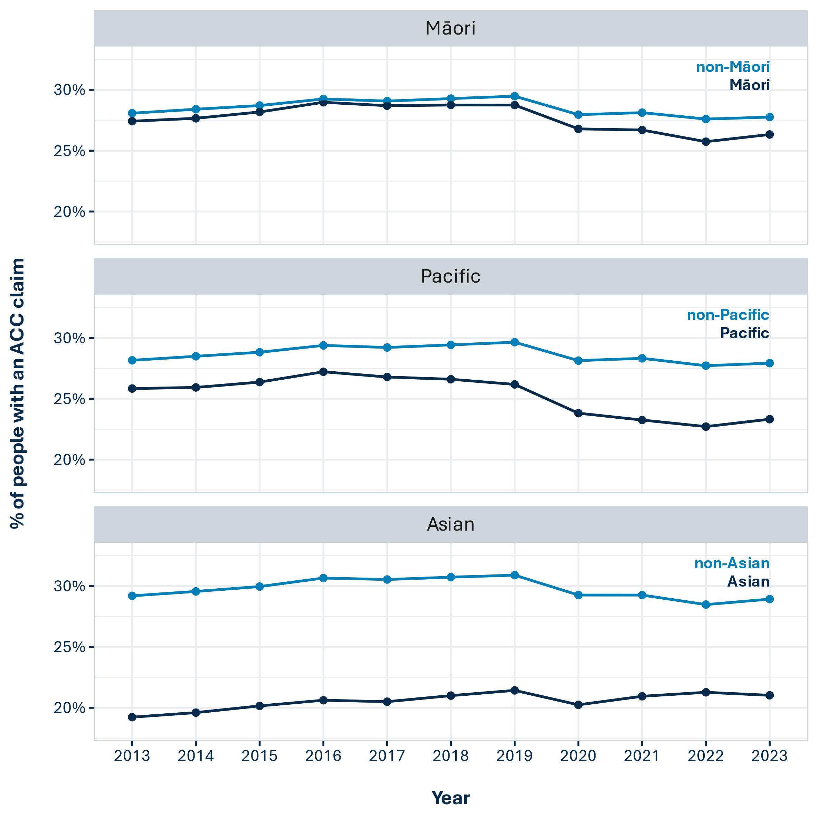

*Figure 3.1: The percentage of each ethnic group who had an ACC claim, per year, for the 10-year period 2013-2023. A person was counted as having a claim if they had at least one accepted ACC claim with an injury date during the calendar year. Confidence intervals are not shown as they are very small and do not alter the findings.*

Injury (and ACC claim) prevalence is related to age (next section), and the fact that Māori and Pacific people are, on average, younger than other ethnicities in New Zealand (Appendix 3 and Stats NZ 2018b, 2018c), may therefore influence their claim rates relative to other groups. Figure 3.2 shows age-standardised claim rates over time for the three ethnicities. Age-standardised rates show us what we would expect if each group’s age structure was identical to that of the total population. They were computed as described in Appendix 1. As we would expect, age standardisation decreases Māori and Pacific claim rates relative to non-Māori and non-Pacific people, but makes little difference to the relative claim rates of Asian and non-Asian people (because the age structure of the Asian population is more similar to the total population).

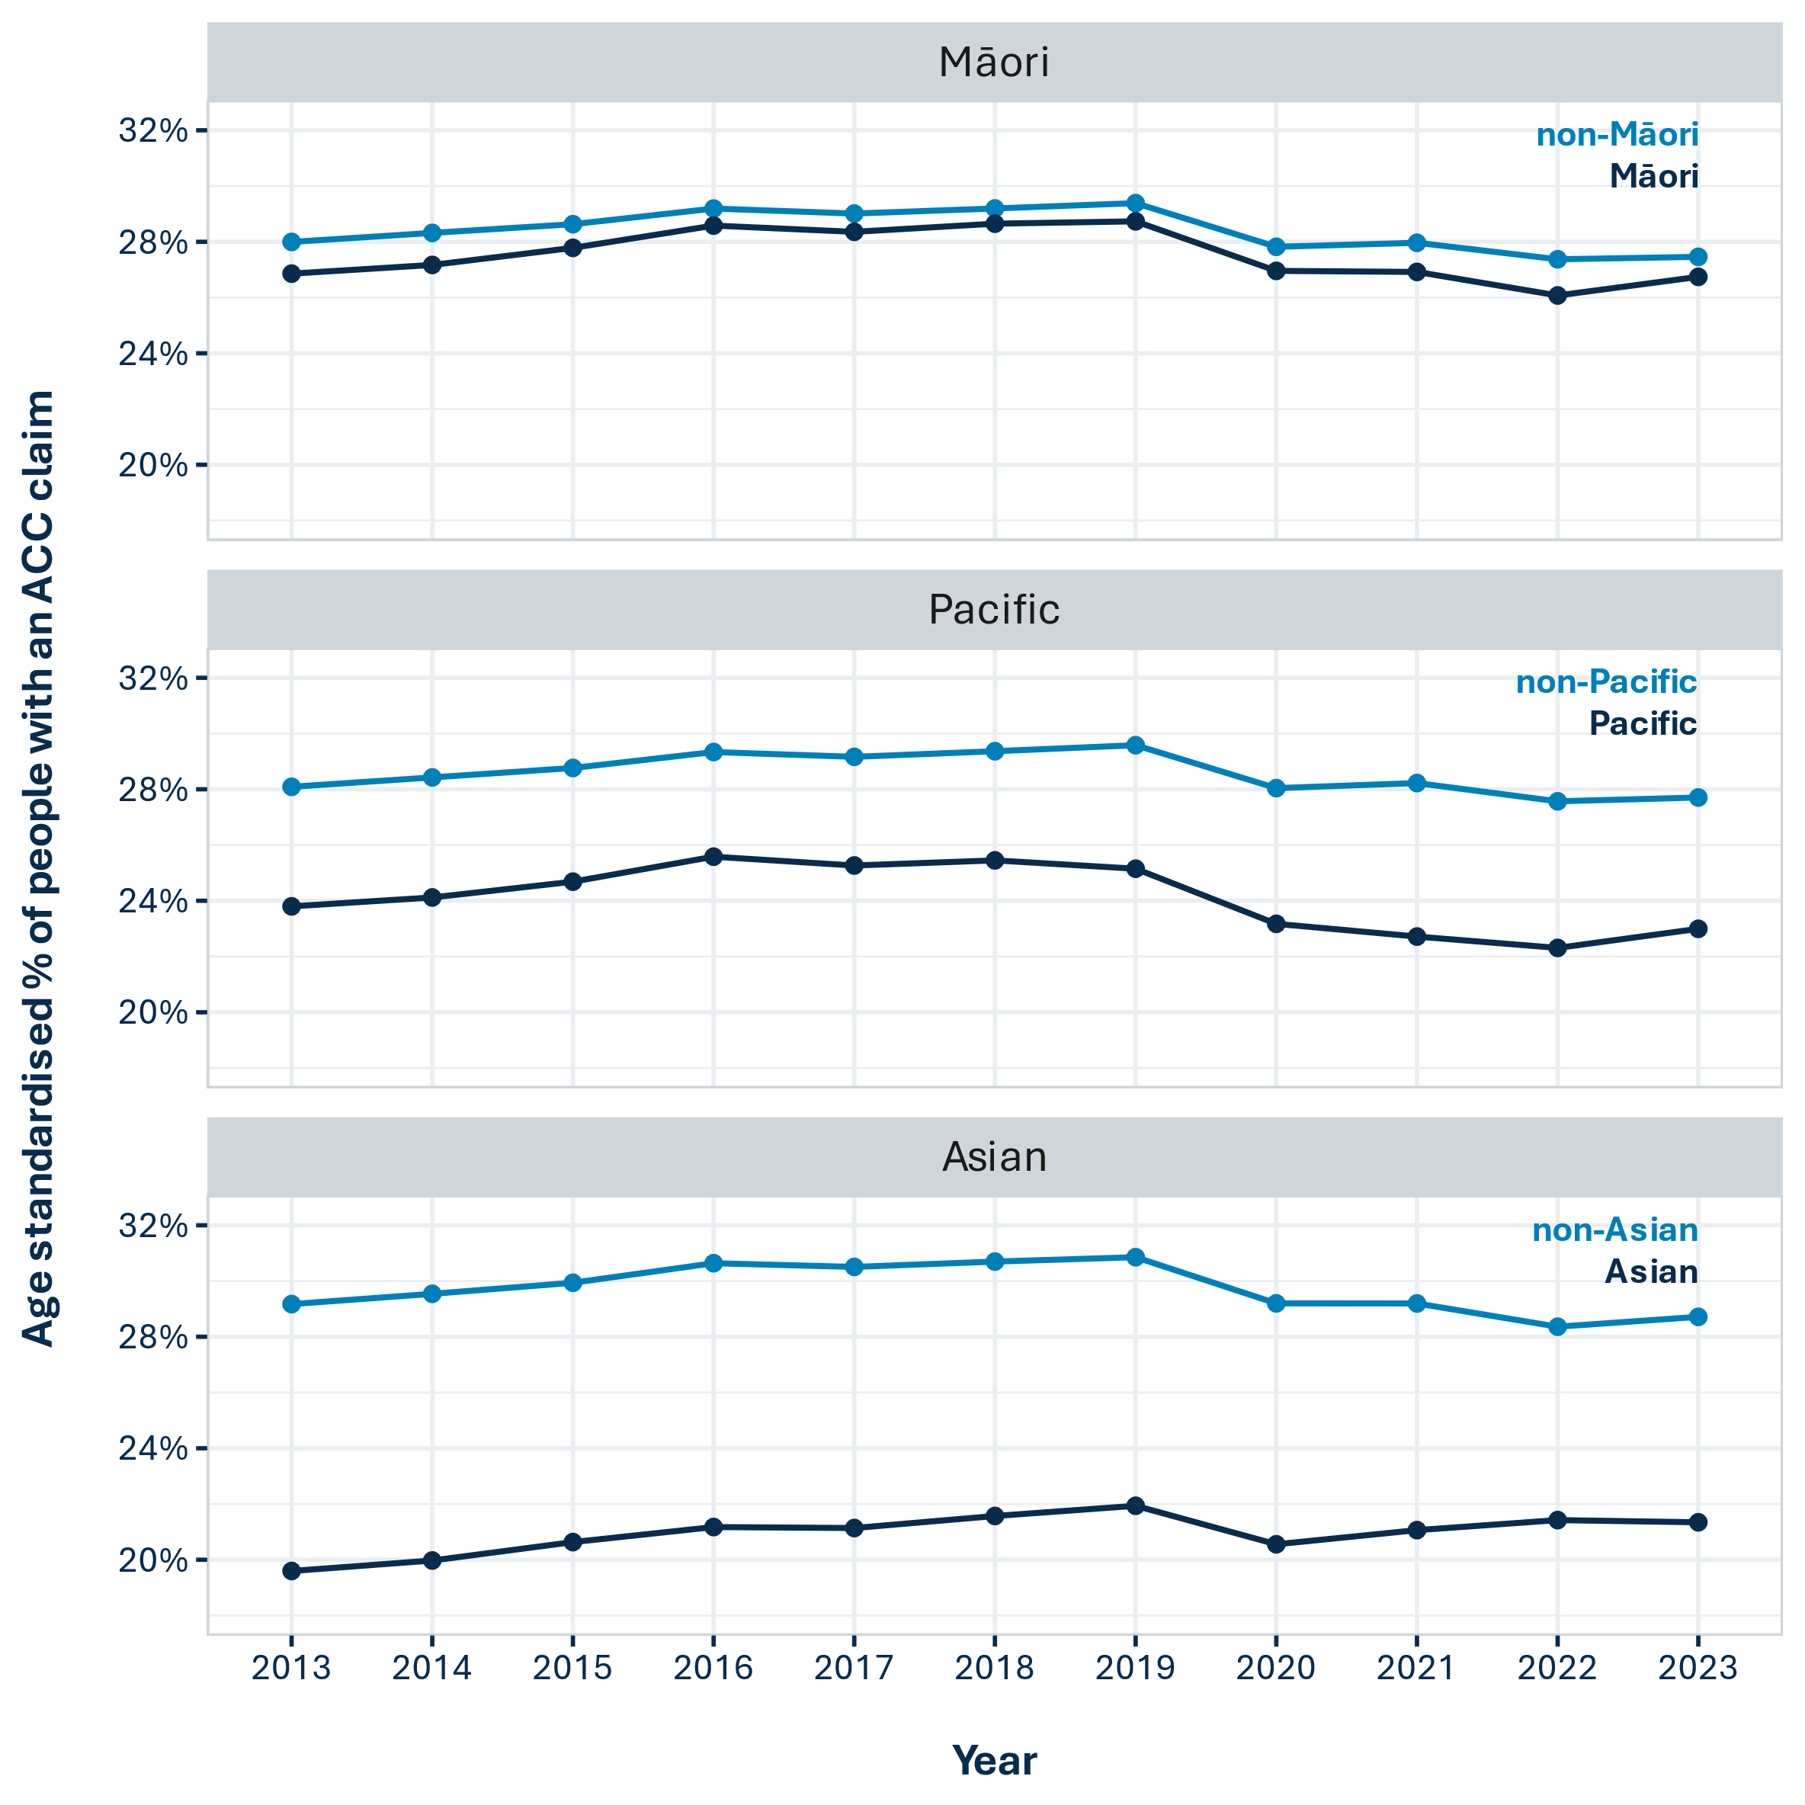

*Figure 3.2: Age-standardised claim rates by ethnicity, for the 10-year period 2013-2023. A person was counted as having a claim if they had at least one accepted ACC claim with an injury date during the calendar year. Age standardisation was carried out as described in* *Appendix 1**. Confidence intervals are not shown as they are very small and do not alter the findings.*

### 3.1.2 Age and ethnicity interact, with claim rates showing different trajectories over time for different age group and ethnicity combinations

Figure 3.3 shows claim rates over time for the three ethnicities, with additional breakdowns by age. We see some marked age-based differences in the patterns of claim rates across ethnicities.

**Māori:**

* Māori claim rates were lower than non-Māori for all age groups except 15-39 year olds, whose claim rates were 0.9 to 2.8% higher than non-Māori 15-39 year old rates. The steeper drop in Māori claim rates (compared to non-Māori) from 2020-2022 is entirely attributable to the drop within this age group.
* The biggest gap between Māori and non-Māori claim rates was for the 65+ age group, with 65-100 year-old Māori having 4-6% lower claim rates than 65-100 year-old non-Māori.

**Pacific:**

* Pacific children (0-14 year-olds) had similar claim rates to non-Pacific children from 2014-2016, but their relative claim rates dropped thereafter and, in 2021 and 2022, Pacific children’s claim rates were 4% lower than non-Pacific children’s rates.
* Similar to the pattern for 15-39 year-old Māori, there was a steeper drop in Pacific 15-39 year olds’ claim rates from 2020-2022, compared to non-Pacific people.
* Among adult Pacific people, claim rates decreased with increasing age. Pacific claim rates were 6-7% lower than non-Pacific claim rates for 40-64 year olds, and 9-10% lower for 65-100 year olds.

**Asian:**

* For Asian adults (aged 15 and over), claim rates increased from 2013 to 2022, apart from a one-year dip in 2020. However, even in 2022, Asian claim rates remained 6-8% below non-Asian claim rates.
* Unlike Māori and Pacific claim rates, the gap between Asian and non-Asian claim rates was the widest for the 15-39 year-old age group (8-13%). The gap narrowed to 6-8% for over-39 year olds.
* 0-14 year-old Asian children’s claim rates increased from 2013 to 2016, levelled off, and then dropped sharply from 2020 onwards. This is similar to the pattern of claim rates over time for non-Asian children, but the overall claim rates for Asian children were 5-7% lower.

**Age differences across all ethnicities**

* Across all ethnicities, we see a different trajectory of claim rates over time for children than for adults. While adult claim rates dropped in 2020 and then mostly levelled off, under-15 year-olds’ claim rates dropped sharply in 2020 and continued to drop further in 2021 and 2022. Disruptions due to the COVID-19 pandemic began in 2020 and continued during 2021 and 2022. Children’s injury and claim rates may have been more strongly affected by these disruptions, or there may have been other developments affecting children’s claim and/or injury rates during this period. It will be interesting find out whether this differential effect has continued into 2023.

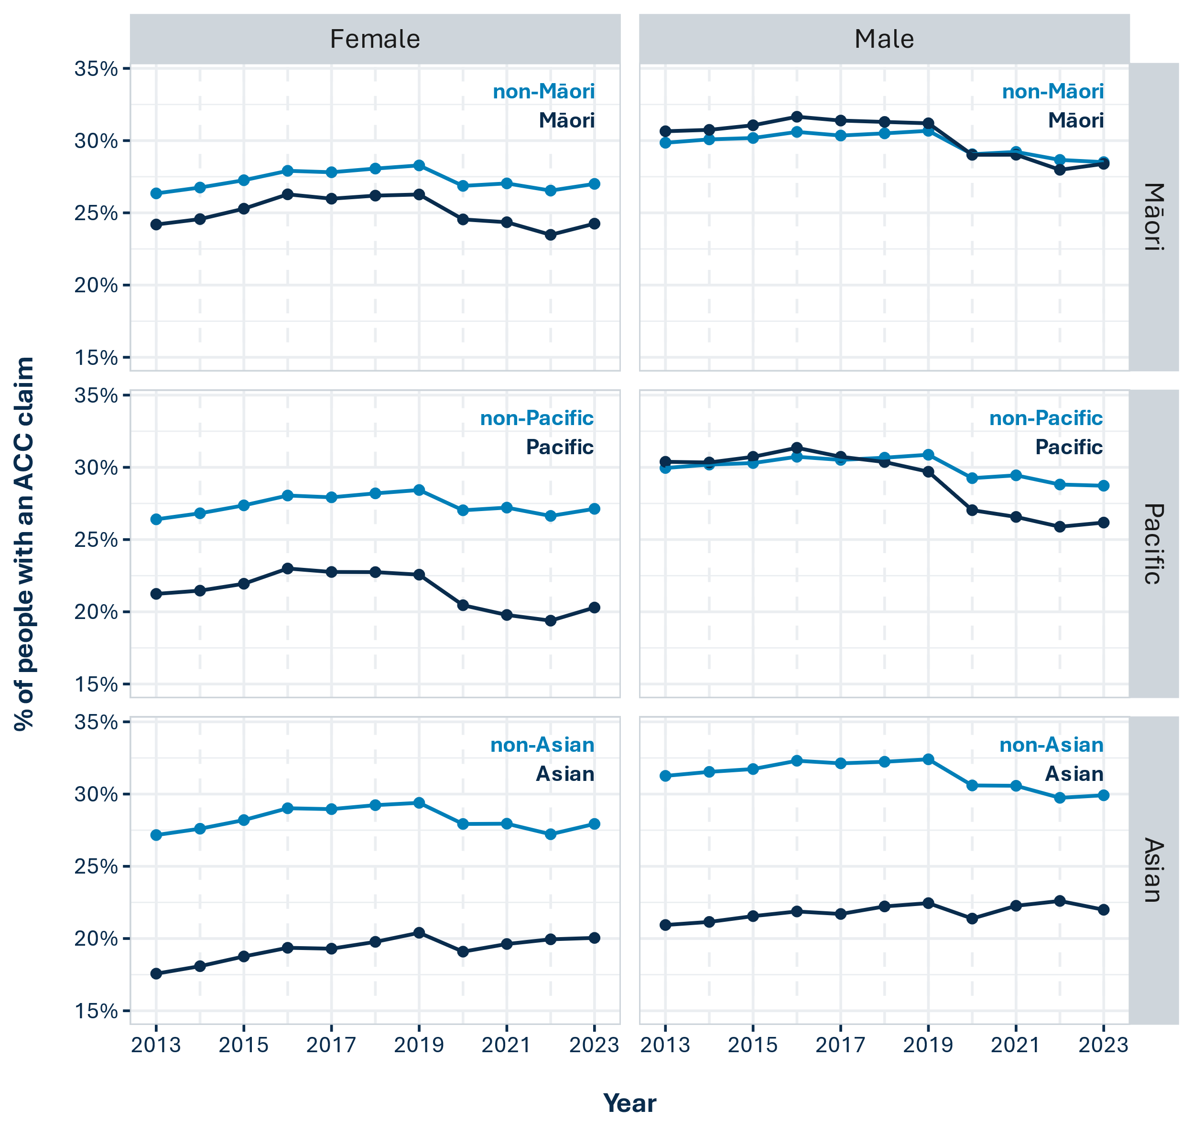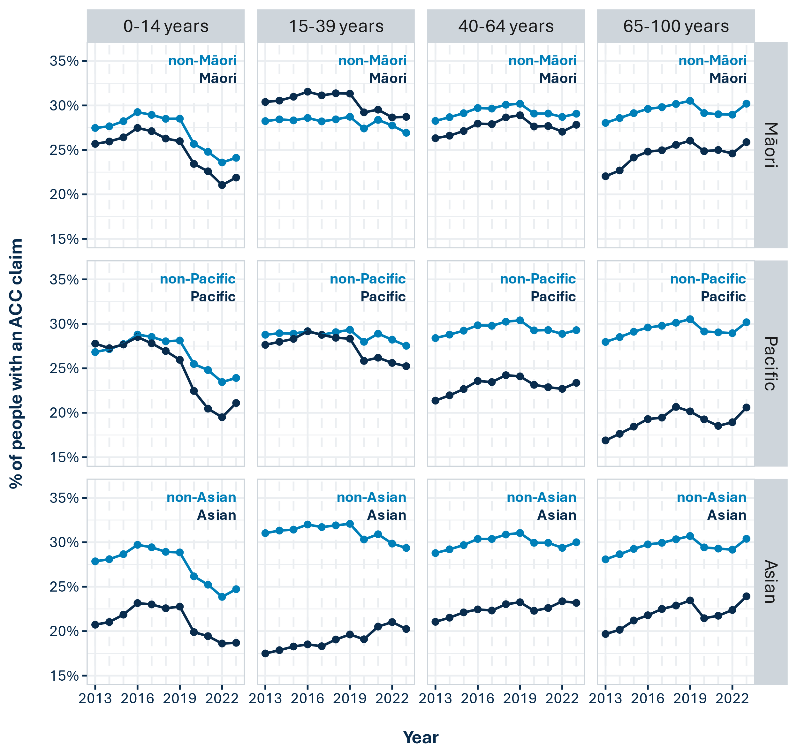

*Figure 3.3: The percentage of each ethnic group who had an ACC claim, by age group, per year for the 10-year period 2013-2023. A person was counted as having a claim if they had at least one accepted ACC claim with an injury date during the calendar year. Confidence intervals are not shown as they are very small and do not alter the findings.*

### 3.1.3 Across all ethnicities, men had higher claim rates than women and the gender difference was more pronounced for Māori and Pacific ethnicities

Figure 3.4 shows claim rates over time, by gender and ethnicity, while Figure 3.5 shows the same data but using age-standardised claim rates. Across all ethnicities, men had higher claim rates than women, but this gender difference was more marked for Māori and Pacific ethnicities.

**Māori:**

* Māori women’s claim rates were lower than non-Māori rates, while Māori men’s claim rates were higher than non-Māori rates up until 2020-2022, where they dipped slightly below non-Māori rates (Figure 3.4).
* Age standardisation brought Māori and non-Māori men’s claim rates closer together, and the trajectory over time for the two groups was very similar (Figure 3.5). This suggests that the slightly elevated claim rates for Māori men (as compared to non-Māori men) is influenced by the younger average age of Māori.

**Pacific:**

* Pacific women had 5-7% lower claim rates than non-Pacific women, and this gap widened over time (Figure 3.4).
* Pacific men had slightly higher claim rates than non-Pacific men from 2013-2018, but Pacific men’s claim rates dropped more over time than non-Pacific men’s rates, and by 2022 the gap was around 3% (Figure 3.4).
* Age standardised claim rates were lower than non-standardised rates for Pacific men, suggesting that the younger average age of the Pacific population drives claim rates upwards. With age standardisation, Pacific men’s claim rates were 2-4% lower than non-Pacific rates (Figure 3.5).

**Asian:**

* Claim rates for Asian men and women were markedly lower than non-Asian rates, with men’s claim rates 7-10% lower and women’s claim rates 7-9% lower (Figure 3.4).
* Age adjustment made little difference, as expected given that the age structures of the Asian and non-Asian populations are similar (Figure 3.5).



*Figure 3.4: The percentage of each ethnic group who had an ACC claim, by gender, per year for the 10-year period 2013-2023. A person was counted as having a claim if they had at least one accepted ACC claim with an injury date during the calendar year. Confidence intervals are not shown as they are very small and do not alter the findings.*

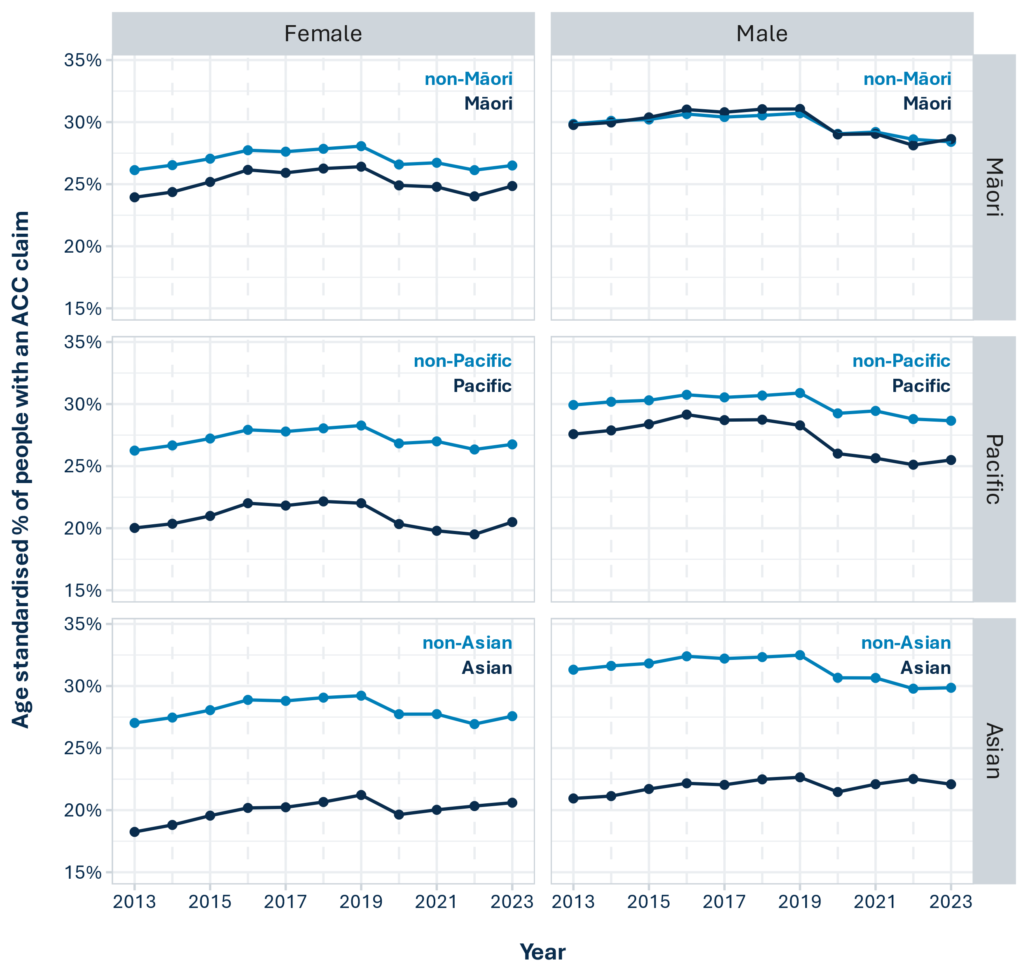

*Figure 3.5: Age-standardised claim rates by gender and ethnicity, for the 10-year period 2013-2023. A person was counted as having a claim if they had at least one accepted ACC claim with an injury date during the calendar year. Age standardisation was carried out as described in* *Appendix 1**. Confidence intervals are not shown as they are very small and do not alter the findings.*

## 3.2 Claim rates over time for people with disabilities

Claim rates among disabled people were estimated using Census 2018 data linked to demographic and ACC claims data in the IDI. The 2018 Census included the Washington Group Short Set of 6 questions on functioning (Washington Group on Disability Statistics 2023) that asked about difficulties with:

* seeing (even if wearing glasses)
* hearing (even if using a hearing aid)
* walking or climbing steps
* remembering or concentrating
* self-care (such as washing all over or dressing)
* communicating (for example understanding or being understood using your usual language).

People were classified as having a functional disability if they responded that they had a lot of difficulty with, or could not do at all, one or more of those activities. For some people the disability will be long term, while for others it may be temporary, for example if they had trouble walking at the time of the Census due to a sprained ankle or broken leg. Data in the IDI does not allow us to determine how long someone has had a functional disability for.

Complicating matters, we expect claim rates to be elevated for disabled people during and before 2018 because, for some, the disability they reported in the Census will have been caused by an accidental injury, for which they lodged an ACC claim.

For this report, we are interested in ACC claim rates among people who already had a disability. So we explore the 2019-2021 claim rates of people who reported a disability in 2018. Not all of those people will have continued to experience disability post-2018 and the proportion who did is likely to have decreased over time. Because of this, the 2019 findings below may be more reliable than the 2020 and 2021 findings. We do not present 2022 claim rates due to the time elapsed since the disability was reported. A more current indicator of disability will be available when 2023 Census data is loaded into the IDI.

### 3.2.1 Disabled people had higher claim rates

Figure 3.6 shows that disabled people’s claim rates were higher than non-disabled people’s claim rates, both before and after 2018. Similar to other groups, disabled people’s claim rates dropped in 2020 and 2021, presumably due to the COVID-19 pandemic.

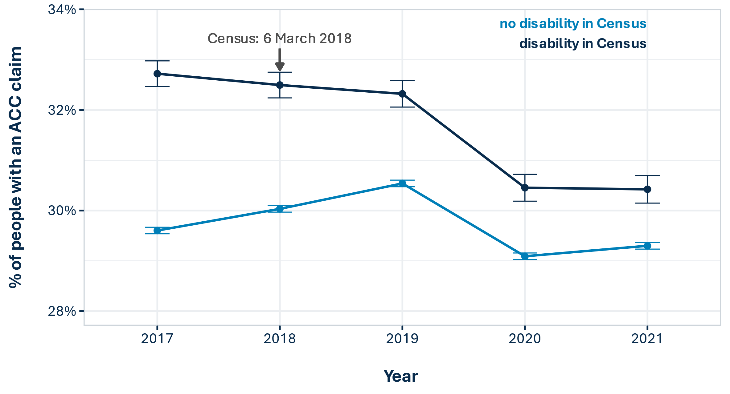

*Figure 3.6: The percentage of people who had an ACC claim, per year, for the 2017-2021 period, by whether or not they reported a functional disability in the 2018 Census. Non-respondents to the 2018 Census question on disability are excluded from the analysis. A person was counted as having a claim if they had at least one accepted ACC claim with an injury date during the calendar year. Error bars represent 99% confidence intervals.*

### 3.2.2 Disabled people’s claim rates increase markedly with age and disabled children’s claim rates are lower than non-disabled children’s rates

Disabled people’s claim rates were strongly related to age, increasing for older groups. Disabled children (0-14 years) had claim rates that were 4-5% lower than non-disabled rates, while 65+ year-olds had claim rates that were 2-3% above non-disabled rates (Figure 3.7). The relationship between disabled people’s claim rates and age is striking in comparison to non-disabled people’s claim rates, which showed much less variation across age groups.

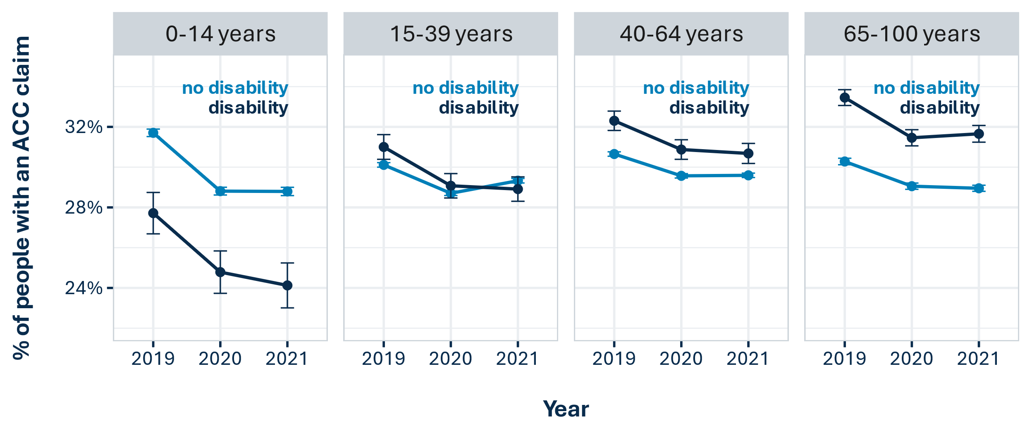

*Figure 3.7: The percentage of people who had an ACC claim in 2019, 2020, and 2021, by age group and by whether or not they reported a functional disability in the 2018 Census. Non-respondents to the 2018 Census question on disability are excluded from the analysis. A person was counted as having a claim if they had at least one accepted ACC claim with an injury date during the calendar year. Error bars represent 99% confidence intervals.*

### 3.2.3 Disabled people’s claim rates are less affected by gender than non-disabled people’s claim rates

While claim rates were significantly higher for men (than for women) among non-disabled people, the claim rates of disabled men and women were relatively similar, with slightly higher claim rates for disabled women (Figure 3.8). Disabled women’s claim rates were significantly higher than non-disabled women’s claim rates, while disabled men’s claim rates were slightly lower than non-disabled men’s claim rates.

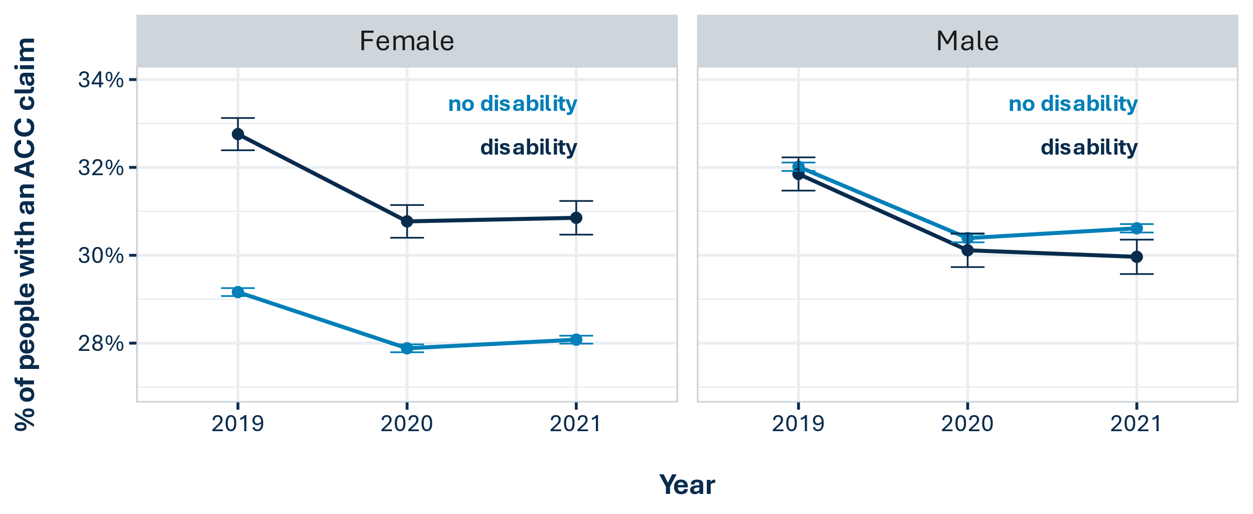

*Figure 3.8: The percentage of people who had an ACC claim in 2019, 2020, and 2021, by gender and by whether or not they reported a functional disability in the 2018 Census. Non-respondents to the 2018 Census question on disability are excluded from the analysis. A person was counted as having a claim if they had at least one accepted ACC claim with an injury date during the calendar year. Error bars represent 99% confidence intervals.*

## 3.3 The effect of claim lodgement delays on time series analysis of claim rates is negligible

The time series analysis described above is based on the injury dates of ACC claims. The IDI data that we used only included ACC claims that had been lodged up to 31 March 2023 because this was the most recent data available. This presents a potential problem, wherein more recent years’ claim rates may be underestimated because, for some claims, there is a delay between the injury and claim lodgement. Claims lodged after 31 March 2023 were not included in our dataset and so, for example, a claim for an injury on 31 December 2022, that was lodged more than 3 months later will not be included in our dataset.

We investigate the effect of lodgement delays on claim rates in Appendix 2 and find that it is negligible. Only two to three percent of claims were lodged more than three months after the injury date. While 2022 claim rates may be underestimated by about half a percent, the effects of claim lodgement delays on the comparisons between ACC groups are very minor and do not change our conclusions.

## 3.4 Estimates of claim rates for the ACC groups when other factors are statistically controlled for

The analysis in this section uses data on the total estimated resident population and looks for differences in the claim rates of people who identify with each ACC group, as compared to people who do not identify with that group. This is different to the analysis in the next section, which estimates demographic and socio-economic influences within each ACC group, using data for that group only.

### 3.4.1 We used multiple regression to estimate more direct relationships between ACC group membership and ACC claim rates, when other factors are accounted for

The time series analysis by ethnicity and disability showed that disabled children and Māori, Pacific, and Asian people had lower claim rates than others, and that disabled adults had higher claim rates. However, there are additional differences that may account for the variation in claim rates. For example, Māori and Pacific people are, on average younger than non-Māori and non-Pacific people (Stats NZ 2018b, 2018c) and disabled people are, on average, older (Stats NZ 2014). There are also differences in the distributions of where people live, their occupations, and many other factors (Stats NZ 2014, Appendix 3, Stats NZ 2018b, 2018c, 2018a). From the analysis presented up to this point, we cannot tell whether the differences in claim rates are directly related to ethnicity and disability, or whether they relate more closely to other factors that vary between the groups

One way to estimate more direct relationships between ACC group membership and claim rates is to use multiple regression to control for the effects of the other factors. Multiple regression uses data on many different variables and estimates how each variable relates, independently, to an outcome variable.

In our analysis, the outcome variable is the likelihood of a person having an accepted ACC claim. Multiple regression estimates the relationships between this likelihood and ACC group membership, plus demographic and socio-economic factors. Each relationship can be thought of as what we would see if the other factors were held constant. This gives us a way to more precisely estimate the differences in claim rates that are attributable to ACC group membership: the estimated differences are what remains when additional differences related to age, gender, location, employment, and other factors are accounted for.

Multiple regression improves our estimates of the relationships, but caveats remain:

* Estimated differences between groups may be caused by their different injury rates, their different likelihoods of making a claim when injured, or some combination of both. Population data available in the IDI does not provide a way to identify the cause.
* We cannot control for all of the differences between groups because some differences are unmeasurable.
* There is imprecision in how the demographic and socio-economic factors are measured, meaning that they are not perfectly controlled for. For example, income is only somewhat indicative of a person’s material wellbeing as it does not measure that person’s living costs or the other material support that they may have.
* Multiple regression measures correlation, not causation, and it does not tell us anything about the causal direction. For example, while a person’s type of work can influence their injury risk (and therefore their ACC claim rate), having an injury can also influence the type of work that a person does.

The estimates from multiple regression should therefore be thought of as broadly indicative rather than precise measurements of how each factor is associated with claim rates.

The method of multiple regression analysis is described in Appendix 1 and detailed tables of results are provided in Appendix 4.

In the next few sections, findings are summarised into tables, with arrows indicating the direction and size of the differences in claim rates associated with each factor:

       ↓ indicates that the variable was associated with lower claim rates, when other factors  
       were accounted for.

       ↓↓ indicates that the variable was associated with much lower claim rates when other  
       factors were accounted for. This is defined as claim rates that were 0.8 times (80% of)  
       the comparison group’s rates, or less.

       ↑ indicates that the variable was associated with higher claim rates, when other factors  
       were accounted for.

       ↑↑ indicates that the variable was associated with much higher claim rates when other  
       factors were accounted for. This is defined as claim rates that were at least 1.2 times  
       (20% higher than) the comparison group’s rates.

       - indicates that we did not see a statistically significant association between the  
       factor and claim rates.

Unless otherwise stated, all associations were significant at the 1% level, meaning that we estimate that there is a less than 1% chance that the association is purely due to random fluctuation.

### 3.4.2 When demographic and socio-economic factors were accounted for, claim rates remained lower for Māori, Pacific, and Asian adults, and higher for disabled adults

Table 3.1 summarises the findings from multiple regression analysis, estimating the relationships between claim rates, ACC groups, and other factors, for adults (aged 15 and over). When other factors were accounted for:

* Māori adults were less likely to have ACC claims than non-Māori adults, with an estimated claim rate 0.96 to 0.97 times that of non-Māori adults (Table 3.1; Appendix 4)
* Pacific adults were less likely to have ACC claims than non-Pacific adults, with an estimated claim rate 0.96 times that of non-Pacific adults, although this relationship may be weaker as it was only statistically significant in some regression models (Table 3.1; Appendix 4)
* Asian adults were much less likely to have ACC claims than non-Asian adults, with an estimated claim rate 0.7 to 0.71 times that of non-Asian adults (Table 3.1; Appendix 4)
* Disabled adults were more likely to have ACC claims than non-disabled adults in the two years following Census 2018, with estimated claim rates 1.13 to 1.16 times that of non-disabled adults (Table 3.1; Appendix 4).

*Table 3.1: Summary of the findings from multiple regression analysis of the effects on ACC claim rates associated with ACC group membership, demographic variables, and socio-economic variables for the total population of adults (aged 15 years and over). Arrows indicate the direction and magnitude of the estimated effects, as described above. Detailed results are provided in* *Appendix 4**. This summary collates results from several different regression models and where findings differed substantively between models, 2018 model results are presented in preference because they account for more factors using data from the 2018 Census. Where associations with other factors differed substantively between models, results from the 'Base model' are presented in preference.*

| **Variable** | **Association with  claim rates** | **Comment** | |
| --- | --- | --- | --- |
| **Associations with ACC groups** | | |
| Māori | ↓ | Māori adults were less likely to claim than non-Māori. | |
| Pacific | ↓ | Pacific adults were less likely to claim than non-Pacific. (statistically significant in some models but not others). | |
| Asian | ↓↓ | Asian adults were much less likely to claim than non-Asian. | |
| Disability | ↑ | Disabled adults were more likely to claim than non- disabled. | |
| **Associations with other factors** | | |
| Year | 2016-19 ↑ | Claim rates peaked in 2016-19 then dropped back down to 2013-15 levels in 2020-22. | |
| Age | older ↓ | 40-64 year olds had the lowest claim rates, 15-39 year olds had the highest claim rates. | |
| Gender | male ↑ | Men were more likely to claim than women. | |
| Overseas born | overseas born  ↓↓    time in NZ ↑ | Overseas born adults were much less likely to claim than NZ-born adults in their first 10 years in NZ, but claim rates increased the longer they remained. | |
| Region | Northland,  Bay of Plenty,  Gisborne ↑    Rest of  North Island,  South Island ↓    Wellington ↓↓ | Compared to the Auckland region, claim rates were higher in Northland, Bay of Plenty, and Gisborne, much lower in the Wellington region, and lower in the rest of the North Island and in the South Island. | |
| Neighbourhood  Deprivation | ↓ | Claim rates decreased as deprivation increased. | |
| Industry of  employment | Agriculture,   Forestry, Fishing,  Construction,  Public  Administration  ↑↑    Arts and  Recreation,  Education and  Training, Finance  and Insurance,  Healthcare and  Social Assistance  Manufacturing,  Professional,  Scientific and  Administrative,  Rental Hiring and  Real Estate,  Wholesale Trade ↑    Information and  Communications,  Media, Mining,  Retail,  Accommodation,  not employed ↓ | Claim rates by industry varied depending on whether occupation was included in the model.    Compared to people who were not employed, those in the Construction, Agriculture, Forestry and Fishing, and Public Administration and Safety  industries had much higher claim rates.    Other industries with higher claim rates included  Arts and Recreation, Education and Training, Finance and Insurance, Healthcare and Social Assistance, Manufacturing, Professional, Scientific and Administrative Support, Rental, Hiring and Real Estate, Wholesale Trade.    The Electricity, Gas, Water and Waste and Transport, Postal and Warehousing industries also had higher claim rates but statistical significance was lower.    Higher claim rates also seen among people whose  industry data was missing. | |
| Occupation | Community and  Personal Services,  Technicians and  Trades ↑↑     Labourers,   Managers,  Professionals,  Machinery  Operators ↑ | Compared to clerical and administrative workers,  Community and Personal Services and Technicians and Trades workers had much higher claim rates. Labourers, Managers, Professionals and Machinery Operators had higher claim rates.     Higher claim rates also seen among people who  not employed or whose occupation data was  missing. | |
| Income | ↑ | Claim rates increased as income increased. | |
| Benefit  receipt | Supported  Living ↓↓    Sole Parent,  Jobseeker ↓ | Claim rates were much lower for people receiving  supported living payments.  Claim rates were lower for people receiving sole parent or jobseeker support. | |
| Partnership | ↓ | People with partners were less likely to claim than  people without. | |
| Housing  tenure | Owned house  with  mortgage ↑ | Little effect of housing tenure but adults in owner-  occupied houses with a mortgage had higher claim rates than adults in owner-occupied freehold houses. | |
| Household  crowding | ↓ | Adults in overcrowded houses had lower claim rates. | |
| Phone/internet  at home | No internet ↓ | Adults in houses with no internet access had lower  claim rates. | |
| Studying | ↑↑ | Adults who were studying had much higher claim rates. | |
| Highest  qualification | ↑ | Adults with NQF level 4 to 6 qualifications were more likely to claim than others. | |
| PHO enrolment | ↑↑ | Adults enrolled at Primary Healthcare Organisations (PHOs) had much higher claim rates. | |
| Serious offence | ↑ | Adults convicted of serious offences in the last 10 years had higher claim rates | |
| Mental health  diagnosis | ↑↑ | Adults with a mental health diagnosis in the last 5 years  had much higher claim rates. | |

Table 3.1 (above) also summarises the findings for the associations between adult ACC claim rates and demographic and socio-economic characteristics. We see the following relationships between adults’ claim rates and these variables, when other factors are accounted for.

**Claim rates by year and gender are consistent with the time series analysis**

* Claim rates by year remain consistent with the results in the time series analysis for ethnicities and [disabled people](https://accnz-my.sharepoint.com/personal/andrea_knox_acc_co_nz/Documents/2013-22_claim_rates_analysis_report/disabtimeresults). Controlling for other factors had no substantive effect on the trajectories of claim rates over time.
* Men had higher claim rates, estimated to be 1.12 to 1.15 times those of women (Table 3.1; Appendix 4).

**Claim rates decreased with age, but there was a slight increase for the oldest age group**

* Claim rates were highest among 15 to 39 year olds, followed by 65+ year olds and then 40-64 year olds. This dip for the middle age group, followed by an uptick for older ages, is different to what we saw in the time series analysis and shows that controlling for other factors does shift the estimated relationship between age and claim rates.

**Region and neighbourhood deprivation influenced claim rates**

* Some aspects of geography were significantly associated with differences in claim rates, with adults in Auckland, Northland, the Bay of Plenty and Gisborne having the highest claim rates and adults in Wellington having the lowest.
* Neighbourhood deprivation was also a significant factor, with lower claim rates among people living in more deprived areas.
* For adults, there was no significant relationship between claim rates and whether they lived in urban or rural locations, once region and neighbourhood deprivation were accounted for (data not shown).

**Different employment situations are associated with different claim rates**

* Aspects of employment were significantly associated with claim rates. People who were not in employment had lower claim rates than people employed in most industries and people employed in the Construction industry had the highest claim rates. The occupations with the highest claim rates (once industry of work and other factors were accounted for) were Community and Personal Service workers, and Technicians and Trades workers. Note that the analysis included all claims: work as well as non-work. We might see clearer associations between claim rates, industry and occupation if we were to restrict the analysis to work claims but this was beyond the scope of this project.

**Moving to New Zealand from overseas, having a partner, and various indicators of material hardship are associated with lower claim rates**

* Whether someone was born in New Zealand and how long they had been here was significantly associated with claim rates. There were much lower claim rates for people who had been born overseas compared to people who were born in New Zealand, but claim rates increased for overseas-born adults who had been in New Zealand longer.
* Adults with partners were less likely to claim than non-partnered people, possibly because support from a partner may make ACC support less necessary.
* Consistent with the results for neighbourhood deprivation, other indicators of material wellbeing: income and receipt of a benefit, showed that lower claim rates were associated with lower incomes and receipt of a benefit.
* Adults living in overcrowded housing also had lower claim rates, possibly reflecting the relationship between household crowding and material hardship.
* Likewise, lower claim rates were seen among adults who did not have access to the internet in their homes. This may relate to hardship, or to the association between internet access and age (with older people less likely to access the internet (Grimes and White 2019)), or to a direct relationship between internet access and a person’s ability to access healthcare for an injury.
* Housing tenure (whether the household was renting from the public or private sector, or owned the house freehold or with a mortgage) can also indicate material wellbeing to some degree, with renters generally less well off (Stats NZ 2020a). As we might expect, people who were renting from Kainga Ora or another public sector agency had lower claim rates than people in owner-occupied houses, but the difference was not significant. Adults in owner-occupied houses with a mortgage were more likely to claim than adults in a freehold owner-occupied house.

**There may be lower claim rates among people who interact less with official systems**

* We see significantly lower claim rates among adults whose industry, occupation, income or housing tenure data was missing. This suggests that people who did not respond to the Census questions about occupation and housing tenure, and people whose industry or income data is not recorded because they had fewer interactions with official systems may also be less likely to lodge ACC claims. However, it is also possible that IDI data linkage for these groups may have failed more often (due to their missing data), lowering their apparent claim rates.

**Education, PHO enrolment, a mental health diagnosis and a history of offending were associated with higher claim rates**

* Adults who were studying were more likely to claim than adults who were not, and adults with qualifications at NQF levels 4 to 6 were more likely to claim than adults with no qualifications. This relationship did not continue for adults with NQF level 7+ (Bachelor Degree and higher) qualifications, whose claim rates were not significantly different to those of adults with no qualifications. Surprisingly, we also see higher claim rates among adults with missing qualifications data.
* Adults who were enrolled at a PHO were much more likely to claim. This may reflect their greater access to healthcare services, but there could also be reverse causation where adults who were injured were more likely to be enrolled after visiting a clinic for their injury. Interestingly, PHO enrolment rates across ethnicities show some similarities with claim rates, with a much lower percentage of Asian people enrolled (Appendix 3).
* People who had a history of serious offending in the previous 10 years were more likely to have ACC claims than others. This may be unexpected, given the apparent relationship between material hardship and lower claim rates. It may indicate that this group had a higher rate of injuries.
* Adults who had a diagnosis for a mental health condition in the previous 5 years were much more likely to claim than others. This could relate to injury prevalence or to a greater likelihood of accessing healthcare and making a claim when injured.

### 3.4.3 When demographic and socio-economic factors were accounted for, claim rates remained lower for Māori, Asian, and disabled children

Table 3.2 summarises the findings from multiple regression analysis of the relationships between claim rates, ACC groups, and other factors, for children (aged 0 to 14 years). When other factors were accounted for:

* Māori children were less likely to have ACC claims than non-Māori children with an estimated claim rate 0.93 to 0.95 times that of non-Māori children (Table 3.2; Appendix 4)
* Pacific children did not have consistently different claim rates to non-Pacific children, with different models showing higher or lower claim rates and only weak, or no, statistical significance (Table 3.2; Appendix 4)
* Asian children were much less likely to have ACC claims than non-Asian children with an estimated claim rate 0.71 to 0.72 times that of non-Asian children (Table 3.2; Appendix 4)
* Disabled children were less likely to have ACC claims than non-disabled children in the two years following Census 2018, with estimated claim rates 0.84 times that of non-disabled children (Table 3.2; Appendix 4).

*Table 3.2: Summary of the findings from multiple regression analysis of the effects on ACC claim rates associated with ACC group membership, demographic, and socio-economic variables for the total population of children (under 15 year olds). Arrows indicate the direction and magnitude of the estimated effects, as described above. Detailed results are provided in* *Appendix 4**. This summary collates results from several different regression models and where findings differed substantively between models, 2018 model results are presented in preference because they account for more factors using data from the 2018 Census. Where associations with other factors differed substantively between models, results from the 'Base model' are presented in preference.*

| **Variable** | **Association with  claim rates** | **Comment** | |
| --- | --- | --- | --- |
| **Associations with ACC groups** | | |
| Māori | ↓ | Māori children were less likely to claim than non-Māori. | |
| Pacific | ̶ | Pacific children's claim rates were not consistently  different to non-Pacific claim rates. | |
| Asian | ↓↓ | Asian children were much less likely to claim than non-Asian. | |
| Disability | ↓ | Disabled children were less likely to claim than non-disabled. | |
| **Associations with other factors** | | |
| Year | 2016-17 ↑  2020-21 ↓  2022 ↓↓ | Claim rates peaked in 2016-17. Claim rates dropped from 2020 on and by 2022 were much lower than 2013 claim rates. | |
| Age | 10-14 years ↑↑ | 10-14 year olds were much more likely to claim than younger children. | |
| Gender | male ↑ | Boys were more likely to claim than girls. | |
| Overseas born | ↓ | Children who had been born overseas were less likely to claim than NZ-born. | |
| Region | Northland,  Bay of Plenty,  Gisborne,  Rest of North  Island, South  Island ↓    Wellington ↓↓ | Highest claim rates in the Auckland region. Much lower rates in the Wellington region, and lower rates in Northland, Bay of Plenty, Gisborne, the rest of the North Island and the South Island. | |
| Rural | ↓ | Children in rural areas were slightly less likely to claim  than children in urban areas (statistically significant in  some models, not others). | |
| Neighbourhood  Deprivation | ↓↓ | Claim rates decreased as deprivation increased and were much lower in the most deprived areas. | |
| Housing  tenure | Owned house  with  mortgage ↑ | Little effect of housing tenure but children in owner-  occupied houses with a mortgage had higher claim rates. | |
| Household  crowding | ↓ | Children in overcrowded houses had lower claim rates. | |
| Phone/internet  at home | No phone ↓ | Children in houses with no phone or cellphone had lower claim rates. | |
| PHO enrolment | ↑↑ | Children enrolled at Primary Healthcare Organisations (PHOs) had much higher claim rates. | |
| Mental health  diagnosis | ↑ | Children with a mental health diagnosis in the last 5 years had higher claim rates. | |

Table 3.2 (above) also summarises the findings for the associations between children’s ACC claim rates and their demographic and socio-economic characteristics. We see the following relationships between children’s claim rates and these variables.

**Claim rates by year and gender are consistent with the time series analysis**

* Claim rates by year remain consistent with the time series analysis for ethnicities and [disabled people](https://accnz-my.sharepoint.com/personal/andrea_knox_acc_co_nz/Documents/2013-22_claim_rates_analysis_report/disabtimeresults). Controlling for other factors had no substantive effect on the trajectories of claim rates over time.
* Boys had higher claim rates, when other factors were accounted for, estimated to be 1.20 to 1.21 times those of girls (Appendix 4).

**Claim rates increased for older children**

* Claim rates were consistently much higher for the 10-14 year old age group, compared to 0-4 year olds.
* The claim rates of the 5-9 year-old group compared to 0-4 year-olds varied: sometimes higher, sometimes lower, and sometimes not significantly different, depending on which other variables were included in the models (Appendix 4).

**Region, neighbourhood deprivation, and urban/rural location influenced claim rates**

* Aspects of geography were significantly associated with differences in claim rates, with children in Auckland having the highest claim rates and children in Wellington having the lowest.
* Similar to what we found for adults, neighbourhood deprivation was a significant factor, with lower claim rates among children living in more deprived areas.
* Children living in rural locations had slightly lower claim rates than children in urban areas. This difference was statistically significant in some models but not others.

**Moving to New Zealand from overseas, and various indicators of material hardship are associated with lower claim rates**

* Similar to the adult findings, children who had been born overseas had lower claim rates than children who had been born in New Zealand.
* Children living in overcrowded housing also had lower claim rates, possibly reflecting the relationship between household crowding and poverty.
* While children’s claim rates showed no significant association with internet access in the home, there was a significant relationship with telephone access, where the lack of a landline phone or cell phone in the house was associated with lower claim rates. This may relate to poverty, or to a direct relationship between telephone access and a caregiver’s ability to access healthcare for an injured child.
* Similar to adults, children in owner-occupied houses with a mortgage were more likely to claim than children in freehold owner-occupied houses. Living in a rented house was associated with lower claim rates, but this was significantly different to owner-occupied freehold claim rates in only some models. Children for whom data on housing tenure was missing were significantly less likely to claim, suggesting that there may be lower claim rates among children in households that did not respond to this question in Census 2018.

**PHO enrolment and mental health diagnoses were associated with higher claim rates**

* Children who were enrolled at a PHO were much more likely to claim. This may reflect their greater access to healthcare services, but there could also be reverse causation where children who were injured were more likely to be enrolled after visiting a clinic for their injury.
* Over 5-year-olds who had a diagnosis for a mental health condition in the previous 5 years were more likely to claim than others. This could relate to injury prevalence or to a greater likelihood of accessing healthcare and making a claim when injured.

## 3.5 Associations between claim rates and the demographic and socio-economic characteristics for each of the ACC groups

We used multiple regression to estimate how demographic and socio-economic characteristics associated with claim rates for each ACC group. In this analysis, the population was first filtered for adults (15 years and older) or children (0-14 years) of the ACC group and then multiple regression was used to estimate how socio-economic and demographic variables related to the likelihood of a person in that group having an ACC claim. This identifies factors that may affect claim rates within the ACC groups and forms the beginnings of an intersectional analysis of claim rates for each group.

This is different to the analysis in the previous section, which used data for the whole New Zealand resident population.

Caveats with the use of multiple regression and instructions on how to interpret the tables below are as previously described. The multiple regression method is described in Appendix 1 and detailed tables of results are in Appendix 5.

### 3.5.1 For most groups we found similar associations between claim rates and age, gender, region, employment, material hardship, and indicators of health and justice system interactions

There were a number of associations between claim rates and other factors that were consistent across the total population and several of the ACC groups. For adults we saw the following common relationships.

* Older adults were less likely to claim than 15-39 year olds.
* Men were more likely to claim than women.
* Adults in Auckland tended to have higher claim rates than those in other regions, and especially low claim rates were commonly seen in the Wellington region.
* Adults who had been born overseas were less likely to claim, but their claim rates increased the longer they had been in New Zealand.
* Employed adults were more likely to claim than those who were not and claim rates tended to be higher for those in the Agriculture, Forestry and Fishing, Arts and Recreation Services, and Construction Industries.
* Adults working in Clerical and Administrative Services and Sales occupations tended to have lower claim rates than those in other occupations.
* Factors related to material hardship, including neighbourhood deprivation, lower income, household crowding, and no internet in the home, were associated with lower claim rates.
* Adults in owner-occupied houses with a mortgage had higher claim rates than those in owner-occupied freehold houses.
* People with partners tended to have lower claim rates.
* People who were participating in study or training and those with qualifications had higher claim rates.
* Indicators for PHO enrolment, a mental health diagnosis, and a history of serious offending were associated with higher claim rates.

For children we saw the following common relationships.

* 10 to 14 year-olds were more likely to claim than younger children.
* Boys were more likely to claim than girls.
* Children in Auckland tended to have higher claim rates than those in other regions, and especially low claim rates were commonly seen in the Wellington and Canterbury regions.
* Children living rurally were less likely to claim than those in urban locations.
* Children who had been born overseas were less likely to claim.
* Factors related to material hardship, including neighbourhood deprivation, lower income, household crowding, and no telephone in the home, were associated with lower claim rates.
* Children living in owner-occupied houses with a mortgage had higher claim rates than those living in owner-occupied freehold houses.
* Indicators for PHO enrolment and a mental health diagnosis, were associated with higher claim rates.

Below we describe each group’s main divergences from these common relationships.

### 3.5.2 Māori adults - factors associated with the likelihood of claiming

Table 3.3 summarises the findings for the estimated associations between ACC claim rates and demographic and socio-economic characteristics for Māori adults. We see the following divergences from the common relationships.

* Māori adults who were renting from the public or private sectors had significantly lower claim rates than those who were in owner-occupied houses, consistent with what we might expect, given that renters are generally less well off (Stats NZ 2020a).
* There was no significant difference in the claim rates of New Zealand-born Māori and Māori who had been born overseas and arrived in New Zealand 0 to 9 years ago. Overseas-born Māori who had arrived in New Zealand more than 9 years ago had significantly higher claim rates than New Zealand-born Māori.

*Table 3.3: Summary of the findings from multiple regression analysis of the associations between ACC claim rates and demographic and socio-economic characteristics for Māori adults (15+ year olds). This summary collates results from two different regression models: one that estimated 2013-2022 claim rates and one that was restricted to 2018. Where findings differed substantively between models, 2018 model results are presented in preference because they account for more factors using data from the 2018 Census. Detailed results are provided in* *Appendix 5**.*

| **Variable** | **Association with  claim rates** | **Comment** |
| --- | --- | --- |
| Year | 2016 ↑  2021-22 ↓ | Claim rates peaked in 2016, levelled off, then dropped  below 2013 levels after 2020. |
| Age | older ↓ | 15-39 year olds had higher claim rates than 40-64 year-olds and 65+ year olds |
| Gender | male ↑↑ | Māori men were much more likely to claim than Māori women. |
| Overseas born  and time in NZ | overseas born  & in NZ > 9  years ↑ | No significant difference between overseas and NZ-born Māori, within 9 years of arrival. Māori born overseas who had been in NZ >9 years had higher claim rates than NZ-born Māori. |
| Region | Auckland ↑    Wellington ↓↓    Rest of North Island,  South Island ↓ | Compared to the Auckland region, claim rates for Māori adults were much lower in the Wellington region and lower everywhere else. |
| Neighbourhood  Deprivation | ↓ | Claim rates decreased as deprivation increased. |
| Industry of  employment | Agriculture,  Forestry, Fishing,  Arts and  Recreation,  Construction, Electricity, Gas,  Water, Waste,  Financial and  Insurance Services,  Healthcare and  Social Assistance,  Manufacturing,  Mining, Professional Scientific and  admin support,  Public Administration,  Rental Hiring and  Real Estate,  Transport, Postal, Warehousing,  Wholesale Trade   ↑↑  Education and  Training, Retail and  Accommodation  ↑ | Compared to Māori who were not employed, claim rates were significantly higher for Māori in all industries except for Information, Media and Telecommunications.    Rates were much higher for Māori working in Agriculture, Forestry, Fishing, Arts and Recreation, Construction, Electricity, Gas, Water, Waste, Financial and Insurance Services, Healthcare and Social Assistance, Manufacturing, Mining, Professional Scientific  and Administrative support, Public Administration, Rental Hiring and Real Estate, Transport, Postal, Warehousing, and Wholesale Trade. |
| Occupation | Community and  Personal Services,  Technicians and  Trades ↑↑    Labourers,   Managers,  Professionals,  Machinery  Operators ↑ | Compared to clerical and administrative workers, Community and Personal Services and Technicians and Trades workers had much higher claim rates. Labourers, Managers, Professionals and Machinery Operators had higher claim rates. |
| Income | ↑ | Claim rates increased as income increased. |
| Benefit  receipt | Supported  Living,  Sole Parent,  Jobseeker ↓ | Claim rates were lower for Māori receiving supported living payments or sole parent or jobseeker support. |
| Partnership | ↓ | Māori with partners were less likely to claim than those without. |
| Housing  tenure | Owned house  with  mortgage ↑    Rented house ↓ | Māori adults in owner-occupied homes with a mortgage had higher claim rates than adults in owner-occupied freehold houses while Māori adults in rented homes had lower claim rates. |
| Household  crowding | ↓ | Māori adults in overcrowded houses had lower claim rates. |
| Phone/internet  at home | No internet ↓ | Māori adults in houses with no internet access had lower claim rates. |
| Studying | ↑↑ | Māori adults who were studying had much higher claim rates. |
| Highest  qualification | ↑ | Māori adults with qualifications had higher claim rates than Māori adults with no qualifications. |
| PHO enrolment | ↑↑ | Māori adults enrolled at Primary Healthcare Organisations (PHOs) had much higher claim rates. |
| Serious offence | ↑ | Māori adults convicted of a serious offence in the last 10 years had higher claim rates. |
| Mental health  diagnosis | ↑↑ | Māori adults with a mental health diagnosis in the last 5 years had much higher claim rates. |

### 3.5.3 Māori children - factors associated with the likelihood of claiming

Table 3.4 summarises the findings on the associations between Māori children’s ACC claim rates and their demographic and socio-economic characteristics. We see the following divergences from the common relationships.

* Māori children in houses that were rented from the public or private sectors had significantly lower claim rates than those who were in owner-occupied houses
* While lower claim rates were seen among children in homes where no phone was present, this difference was not statistically significant.
* Claim rates among Māori children who had been born overseas were slightly higher than among New Zealand-born Māori children, but this result was only significant at the 5% level (meaning that we estimate that there is a 1 to 5% chance that this difference is due to random fluctuation).

*Table 3.4: Summary of the findings from multiple regression analysis of the associations between ACC claim rates and demographic and socio-economic characteristics for Māori children (0-14 year olds). This summary collates results from two different regression models: one that estimated 2013-2022 claim rates and one that was restricted to 2018. Where findings differed substantively between models, 2018 model results are presented in preference because they account for more factors using data from the 2018 Census. Detailed results are provided in* *Appendix 5**.*

| **Variable** | **Association with  claim rates** | **Comment** |
| --- | --- | --- |
| Year | 2015-17 ↑  2020-21 ↓  2022 ↓↓ | Māori children's claim rates peaked in 2015-17. Rates dropped from 2020 on and by 2022 were much lower than 2013 claim rates. |
| Age | 5-9 years ↓  10-14 years ↑↑ | 5-9 year olds were less likely to claim than older and younger children. 10-14 year olds were much more likely to claim than younger children. |
| Gender | male ↑↑ | Māori boys were much more likely to claim than girls. |
| Overseas born | ↑ | Māori children who had been born overseas were slightly more likely to claim than NZ-born Māori children but statistical significance was marginal. |
| Region | Northland,  Bay of Plenty,  Gisborne,  Rest of North  Island, South  Island ↓    Wellington,  Canterbury ↓↓ | Highest claim rates in the Auckland region. Much lower rates in Wellington and Canterbury, and lower rates everywhere else. |
| Rural | ↓ | Māori children in rural areas were less likely to claim than those in urban areas. |
| Neighbourhood  Deprivation | ↓↓ | Claim rates decreased as deprivation increased and were much lower in the most deprived areas. |
| Housing  tenure | Rented house ↓ | Māori children in rented homes had lower claim rates than Māori children in owner-occupied homes. |
| Household  crowding | ↓ | Māori children in overcrowded houses had lower claim rates. |
| Phone/internet  at home | ̶ | No significant association between claim rates and presence of a phone or internet in the home. |
| PHO enrolment | ↑↑ | Māori children enrolled at Primary Healthcare Organisations (PHOs) had much higher claim rates. |
| Mental health  diagnosis | ↑ | Māori children with a mental health diagnosis in the last 5 years had higher claim rates. |

### 3.5.4 Pacific adults - factors associated with the likelihood of claiming

Table 3.5 summarises the findings for the associations between Pacific adults’ ACC claim rates and their demographic and socio-economic characteristics. We see the following divergences from the common relationships.

* Pacific adults living in Northland, the Bay of Plenty, and Gisborne had higher claim rates than those in the Auckland region.
* Consistent with the results for other groups, Pacific adults who had been born overseas were less likely to claim than those who had been born in New Zealand. However, claim rates did not appear to increase among overseas-born Pacific people who had been in New Zealand for longer.
* The relationship between housing tenure and claim rates was unclear. While the regression model for 2013-2022 estimated that Pacific adults in Kainga Ora housing were more likely to claim, the model for 2018 (which controlled for extra variables derived from the Census) suggested no significant difference in the claim rates of Pacific adults in public housing compared to those in freehold owner-occupied homes. This disagreement between models could relate to the different year range that they cover or to the inclusion of extra variables in the 2018 model.

*Table 3.5: Summary of the findings from multiple regression analysis of the associations between ACC claim rates and demographic and socio-economic characteristics for Pacific adults (15+ year olds). This summary collates results from two different regression models: one that estimated 2013-2022 claim rates and one that was restricted to 2018. Where findings differed substantively between models, 2018 model results are presented in preference because they account for more factors using data from the 2018 Census. Detailed results are provided in* *Appendix 5**.*

| **Variable** | **Association with  claim rates** | **Comment** |
| --- | --- | --- |
| Year | 2014-19 ↑  2021-22 ↓ | Claim rates rose each year from 2014-15, remained elevated through to 2019, then dropped and were significantly below 2013 levels in 2021-22. |
| Age | older ↓ | 15-39 year olds had higher claim rates than 40-64 year-olds and 65+ year olds |
| Gender | male ↑↑ | Pacific men were much more likely to claim than Pacific women. |
| Overseas born  and time in NZ | overseas born ↓    time in NZ ̶ | Overseas-born Pacific people were less likely to claim than NZ-born. Claim rates did not change with length of time in NZ. |
| Region | Northland, Bay  of Plenty,  Gisborne ↑    Wellington ↓ | Compared to the Auckland region, claim rates were higher for Pacific adults in Northland, Bay of Plenty and Gisborne. Claim rates were lower in the Wellington region. Elsewhere, claim rates  were not significantly different to Auckland. |
| Neighbourhood  Deprivation | ↓ | Claim rates decreased as deprivation increased. |
| Industry of  employment | Agriculture,  Forestry, Fishing,  Arts and  Recreation,  Construction,  Education and  Training,  Electricity, Gas,  Water, Waste,  Healthcare and  Social Assistance,  Manufacturing,  Professional  Scientific and  admin support,  Public  Administration,  Rental Hiring and  Real Estate,  Transport, Postal,  Warehousing,  Wholesale Trade   ↑↑    Financial and  Insurance,  Retail and  Accommodation ↑ | Compared to those who were not employed, claim rates were significantly higher for Pacific people in all industries except for Information, Media and Telecommunications.    Rates were much higher for those working in Agriculture, Forestry, Fishing, Arts and Recreation, Construction, Education and  Training, Electricity, Gas, Water, Waste, Healthcare and Social Assistance, Manufacturing, Professional Scientific and  Administrative support, Public Administration, Rental Hiring and Real Estate, Transport, Postal, Warehousing, and Wholesale Trade. |
| Occupation | Community and  Personal Services,  Labourers,  Machinery  Operators,  Managers,  Professionals,  Technicians and  Trades ↑ | Compared to clerical and administrative workers, Pacific people in all occupations except Sales had higher claim rates. |
| Income | ↑ | Claim rates increased as income increased. |
| Benefit  receipt | Supported  Living ↓↓    Sole Parent,  Jobseeker ↓ | Claim rates were much lower for Pacific people receiving supported living payments.    Claim rates were lower for Pacific people receiving sole parent or jobseeker support. |
| Partnership | ↓ | Pacific people with partners were less likely to claim than those without partners. |
| Housing  tenure | ̶ | Pacific renters less likely to claim but difference is only marginally statistically significant in 2018.  Kainga Ora tenants more likely to claim in 2013-22 model but 2018 public housing tenants are not more likely to claim than others. |
| Household  crowding | ↓ | Pacific adults in overcrowded houses had lower claim rates. |
| Phone/internet  at home | ̶ | Lower claim rates for Pacific adults with no internet or no phone, but not statistically significant. |
| Studying | ↑↑ | Pacific adults who were studying had much higher claim rates. |
| Highest  qualification | ↑ | Pacific adults with NQF level 1 to 6 qualifications were more likely to claim than those with no Qualifications. No significant difference between the claim rates of Pacific adults with no  qualifications and those with level 7+ qualifications. |
| PHO enrolment | ↑↑ | Pacific adults enrolled at Primary Healthcare Organisations (PHOs) had much higher claim rates. |
| Serious offence | ↑ | Pacific adults convicted of a serious offence in the last 10 years had higher claim rates. |
| Mental health  diagnosis | ↑↑ | Pacific adults with a mental health diagnosis in the last 5 years had much higher claim rates. |

### 3.5.5 Pacific children - factors associated with the likelihood of claiming

Table 3.6 summarises the findings for the associations between Pacific children’s ACC claim rates and their demographic and socio-economic characteristics. We see the following divergences from the common relationships.

* Dissimilar to the results for all, Māori, and Asian children, there was no significant effect associated with living rurally for Pacific children.
* As for Pacific adults, the relationship between claim rates and housing tenure was unclear, with conflicting results from the 2018 and 2013-2022 models.

*Table 3.6: Summary of the findings from multiple regression analysis of the associations between ACC claim rates and demographic and socio-economic characteristics for Pacific children (0-14 year olds). This summary collates results from two different regression models: one that estimated 2013-2022 claim rates and one that was restricted to 2018. Where findings differed substantively between models, 2018 model results are presented in preference because they account for more factors using data from the 2018 Census. Detailed results are provided in* *Appendix 5**.*

| **Variable** | **Association with  claim rates** | **Comment** |
| --- | --- | --- |
| Year | 2016 ↑  2014, 2018-19 ↓  2020-22 ↓↓ | Pacific children's claim rates peaked in 2016 and dropped thereafter. Compared to 2013, claim rates were lower in 2014 and 2018-19 and much lower in 2020-22. |
| Age | 5-9 years ↓  10-14 years ↑ | 10-14 year olds were the most likely to claim, followed by 0-4 year olds. 5-9 year olds were the least likely to claim. |
| Gender | male ↑↑ | Pacific boys were much more likely to claim than girls. |
| Overseas born | ↓ | Pacific children who had been born overseas were less likely to claim than NZ-born Pacific children. |
| Region | Northland,  Bay of Plenty,  Gisborne ↓    Wellington,  Canterbury,  Rest of North  Island, Rest of  South Island  ↓↓ | Highest claim rates in the Auckland region. Lower rates in Northland, Bay of Plenty, Gisborne and much lower rates everywhere else. |
| Rural | ̶ | Lower rates in rural areas but not statistically significant. |
| Neighbourhood  Deprivation | ↓ | Claim rates decreased as deprivation increased. |
| Housing  tenure | Rented house ↓ | Pacific children in rented homes had lower claim rates than Pacific children in owner-occupied homes. |
| Household  crowding | ↓ | Pacific children in overcrowded houses had lower claim rates. |
| Phone/internet  at home | No phone ↓ | Pacific children in houses with no phone or cellphone had lower claim rates. |
| PHO enrolment | ↑↑ | Pacific children enrolled at Primary Healthcare Organisations (PHOs) had much higher claim rates. |
| Mental health  diagnosis | ↑ | Pacific children with a mental health diagnosis in the last 5 years had higher claim rates. |

### 3.5.6 Asian adults - factors associated with the likelihood of claiming

Table 3.7 summarises the findings for the associations between Asian adults’ ACC claim rates and demographic and their socio-economic characteristics. We see the following divergences from the common relationships.

* Differing from the other groups, claim rates among Asian adults were the highest for older people (over 65 years) and the lowest for 15-39 year olds, when other factors were accounted for.
* Asian adults living in Auckland had much higher claim rates than Asian adults living in any other region. Claim rates in Auckland were around 40% higher than in the Wellington region, 30% higher than in Canterbury, and more than 20% higher than other regions.
* Asian adults with lower incomes and those receiving Supported Living payments were less likely to claim (consistent with the results for other groups). However, unlike other groups, Asian adults receiving Jobseeker payments were significantly more likely to claim than others. Receipt of Sole Parent Support showed no significant relationship with Asian adult claim rates.
* There was no significant relationship between Asian adults claim rates and having internet in the home.
* Unlike the results for other groups, having a partner did not show a significant association with claim rates among Asian adults.
* Housing tenure did show some significant relationships, with Asian adults in Kainga Ora housing having higher claim rates than others, and those in private sector rentals and mortgaged owner-occupied homes having higher claim rates than those in freehold owner-occupied homes.

*Table 3.7: Summary of the findings from multiple regression analysis of the associations between ACC claim rates and demographic and socio-economic characteristics for Asian adults (15+ year olds). This summary collates results from two different regression models: one that estimated 2013-2022 claim rates and one that was restricted to 2018. Where findings differed substantively between models, 2018 model results are presented in preference because they account for more factors using data from the 2018 Census. Detailed results are provided in* *Appendix 5**.*

| **Variable** | **Association with  claim rates** | **Comment** |
| --- | --- | --- |
| Year | 2018-19,  2022 ↑ | Claim rates rose from 2016 onwards and were significantly higher than 2013 claim rates in 2018, 2019 and 2022. |
| Age | older ↑ | Claim rates increased with age and were highest for the 65+ age group. |
| Gender | male ↑ | Asian men were more likely to claim than Asian women. |
| Overseas born  and time in NZ | overseas born  ↓↓    time in NZ ↑ | Overseas born Asian adults were much less likely to claim than NZ-born in their first 10 years in NZ, but claim rates increased the longer they remained. |
| Region | Auckland ↑↑ | Asian adults in the Auckland region had much higher claim rates than those in other regions. |
| Neighbourhood  Deprivation | ↓ | Claim rates decreased as deprivation increased. |
| Industry of  employment | Arts and  Recreation,  Construction,  Education and  Training, Mining,  Public  Administration,  Rental Hiring and  Real Estate,  Wholesale Trade   ↑↑    Other industries  ↑ | Compared to those who were not employed, claim rates were significantly higher for Asian people in all industries.    Claim rates were much higher for those working in Arts and Recreation, Construction, Education and Training, Mining, Public  Administration and Safety, Rental Hiring and Real Estate, and Wholesale Trade. |
| Occupation | Community and  Personal Services,  Labourers,  Machinery  Operators,  Managers,  Professionals,  Technicians and  Trades ↑ | Compared to clerical and administrative workers, Asian people in all occupations except Sales had higher claim rates. |
| Income | ↑ | Claim rates increased as income increased. |
| Benefit  receipt | Supported  Living ↓    Sole Parent   ̶    Jobseeker ↑ | Claim rates were lower for Asian people receiving  supported living payments, higher for those  receiving jobseeker support and not significantly  different for those receiving sole parent support. |
| Partnership | ̶ | No significant difference in claim rates associated with partnership status. |
| Housing  tenure | Owned house  with mortgage,  Rented house ↑ | Asian adults in rented homes and owner-occupied homes with a mortgage had higher claim rates than adults in owner-occupied freehold homes.  Kainga Ora tenants also more likely to claim. |
| Household  crowding | ↓ | Asian adults in overcrowded houses had lower claim rates. |
| Phone/internet  at home | ̶ | No significant difference in claim rates associated with having phone or internet at home. |
| Studying | ↑ | Asian adults who were studying had higher claim rates. |
| Highest  qualification | ↑ | Asian adults with qualifications were more likely  to claim than those with no qualifications. |
| PHO enrolment | ↑↑ | Asian adults enrolled at Primary Healthcare  Organisations (PHOs) had much higher claim rates. |
| Serious offence | ↑ | Asian adults convicted of a serious offence in the  last 10 years had higher claim rates. |
| Mental health  diagnosis | ↑↑ | Asian adults with a mental health diagnosis in the  last 5 years had much higher claim rates. |

### 3.5.7 Asian children - factors associated with the likelihood of claiming

Table 3.8 summarises the findings for the associations between Asian children’s ACC claim rates and their demographic and socio-economic characteristics. We see the following divergences from the common relationships.

* While we see lower claim rates among Asian children in homes without a phone, the result was not statistically significant.
* There were no statistically significant relationships between housing tenure and claim rates for Asian children.

*Table 3.8: Summary of the findings from multiple regression analysis of the associations between ACC claim rates and demographic and socio-economic characteristics for Asian children (0-14 year olds). This summary collates results from two different regression models: one that estimated 2013-2022 claim rates and one that was restricted to 2018. Where findings differed substantively between models, 2018 model results are presented in preference because they account for more factors using data from the 2018 Census. Detailed results are provided in* *Appendix 5**.*

| **Variable** | **Association with  claim rates** | **Comment** |
| --- | --- | --- |
| Year | 2015-19 ↑  2020-22 ↓ | Asian children's claim rates peaked in 2015-19 and  dropped thereafter, reaching their lowest rates in 2022. |
| Age | 5-9 years ↓  10-14 years ↑ | 10-14 year olds were the most likely to claim, followed by 0-4 year olds. 5-9 year olds were the least likely to claim. |
| Gender | male ↑↑ | Asian boys were much more likely to claim than girls. |
| Overseas born | ↓ | Asian children who had been born overseas were less likely to claim than NZ-born Asian children. |
| Region | Northland,  Bay of Plenty,  Gisborne,  Rest of North  Island ↓    Wellington,  South Island  ↓↓ | Highest claim rates in the Auckland region. Much lower claim rates in the Wellington region and the South Island. Lower rates in Northland, Bay of Plenty, Gisborne and the rest of the North Island. |
| Rural | ↓ | Lower claim rates for Asian children in rural areas. |
| Neighbourhood  Deprivation | ↓ | Claim rates decreased as deprivation increased. |
| Housing  tenure | ̶ | No significant associations between housing tenure and Asian children's claim rates. |
| Household  crowding | ↓ | Asian children in overcrowded houses had lower claim rates. |
| Phone/internet  at home | ̶ | Lower claim rates for Asian children without a phone at home but not statistically significant. |
| PHO enrolment | ↑↑ | Asian children enrolled at Primary Healthcare Organisations (PHOs) had much higher claim rates. |
| Mental health  diagnosis | ↑↑ | Asian children with a mental health diagnosis in the last 5 years had much higher claim rates. |

### 3.5.8 Disabled adults - factors associated with the likelihood of claiming

Table 3.9 summarises the findings for the associations between disabled adults’ ACC claim rates and their demographic and socio-economic characteristics. We see the following divergences from the common relationships.

* After controlling for other factors using multiple regression, we find no significant relationship between age and claim rates among disabled adults. The regression actually estimated higher claim rates for younger people, but the difference was not statistically significant.
* After accounting for other factors, claim rates continued to be higher for disabled women. Disabled men’s claim rates were 0.93 to 0.95 times those of disabled women.
* The ACC group ethnicities were associated with significantly lower claim rates among disabled adults. The relationships are similar to what we saw for all adults, but some are more pronounced.
* Disabled Māori had estimated claim rates that were 0.82 to 0.83 times that of disabled non-Māori
* Disabled Pacific adults had estimated claim rates that were 0.71 to 0.72 times that of disabled non-Pacific adults. This is a much bigger difference than what we found for all adults.
* Disabled Asian adults had estimated claim rates that were 0.71 to 0.73 times that of disabled non-Asian adults.
* We do not see significant relationships between disabled adults’ claim rates and household tenure or having a partner.

*Table 3.9: Summary of the findings from multiple regression analysis of the associations between ACC claim rates and demographic and socio-economic characteristics for disabled adults (15+ year olds). This summary collates results from two different regression models: one analysing claim rates in 2019 for people who indicated a functional disability in Census 2018, and the other analysing 2020 claim rates for those people. Where findings differed substantively, results from the 2019 claim rates model are used because a person’s functional disability is more likely to remain present in 2019 than in 2020. Detailed results are provided in* *Appendix 5**.*

| **Variable** | **Association with  claim rates** | **Comment** |
| --- | --- | --- |
| Age | ̶ | No significant relationship between age and claim rates. |
| Gender | male ↓ | Disabled men were less likely to claim than disabled women. |
| Ethnicity | Māori ↓  Pacific, Asian ↓↓ | Disabled Māori adults were less likely to claim than disabled non-Māori adults. Disabled Asian and Pacific adults were much less likely to claim than disabled adults not of those ethnicities |
| Overseas born  and time in NZ | overseas born ↓ | Overseas born disabled adults were less likely to claim than NZ-born. Claim rates were slightly higher for those who had been in NZ >9 years. |
| Region | Auckland ↑    Wellington ↓↓ | Disabled adults in the Auckland region had higher claim rates than those in other regions and much higher rates than those in the Wellington region. |
| Neighbourhood  Deprivation | ↓ | Claim rates decreased as deprivation increased, but the only significant difference was between the most and least deprived areas. |
| Industry of  employment | Agriculture,  Forestry, Fishing,  Construction ↑↑    Arts and  Recreation,  Manufacturing,  Transport, Postal,  Warehousing ↑ | Compared to those who were not employed, claim rates were much higher for disabled people in the Agriculture, and Construction industries and higher for those in the Arts and Recreation, Manufacturing, and Transport, Postal and Warehousing industries. |
| Occupation | Community  and Personal  Services ↑↑    Labourers,  Machinery  Operators,  Managers,  Professionals,  Technicians and  Trades ↑ | Compared to clerical and administrative workers, disabled people in all occupations except Sales had higher claim rates. Disabled Community and Personal Service workers had much higher claim rates. |
| Income | ↑ | Claim rates increased as income increased. |
| Benefit  receipt | Supported  Living ↓↓    Sole Parent,  Jobseeker ↓ | Claim rates were lower for disabled people receiving sole parent or jobseeker support and much lower for those receiving supported living payments. |
| Partnership | ̶ | No significant difference in claim rates associated with partnership status. |
| Housing  tenure | Other ↑ | No significant difference in claim rates by housing tenure,  except for higher rates among those in 'Other' tenure types. |
| Household  crowding | ↓ | Disabled adults in overcrowded houses had lower claim rates. |
| Phone/internet  at home | No phone ↓ | Disabled adults in homes with no phone had lower claim rates.  No significant association with presence of home internet. |
| Studying | ↑ | Disabled adults who were studying had higher claim rates. |
| Highest  qualification | ↑ | Disabled adults with qualifications were more likely to claim than those with no qualifications. |
| PHO enrolment | ↑↑ | Disabled adults enrolled at Primary Healthcare Organisations (PHOs) had much higher claim rates. |
| Serious offence | ↑↑ | Disabled adults convicted of a serious offence in the last 10 years had much higher claim rates. |
| Mental health  diagnosis | ↑↑ | Disabled adults with a mental health diagnosis in the last 5 years had much higher claim rates. |

### 3.5.9 Disabled children - factors associated with the likelihood of claiming

Table 3.10 summarises the findings for the associations between disabled children’s ACC claim rates and their demographic and socio-economic characteristics. Relative to the other ACC groups covered by this report, the disabled child population was small: comprised of only 13,974 people. Thus the regression analysis has less statistical power for this group and we sometimes see some fairly large differences that are not statistically significant because we would need more data to be certain that the result is not due to random fluctuation. As above, unless otherwise stated, associations were significant at the 1% level.

* We see the following divergences from the common relationships for disabled children.
* While the regression estimated higher claim rates for older disabled children, the result was not statistically significant and so it may be due to random chance.
* Likewise we see no significant relationship between gender and claim rates for disabled children.
* Similar to what we see for all children, the ACC group ethnicities are associated with significantly lower claim rates among disabled children.
* Disabled Māori children had 2019 claim rates that were estimated to be 0.91 times those of disabled non-Māori. This difference was significant at the 5% level only, meaning there is a 1 to 5% chance that the difference is due to random chance. 2020 claim rates were not significantly different between Māori and non-Māori disabled children.
* Disabled Pacific children had estimated claim rates that were 0.84 times those of disabled non-Pacific children. 2020 claim rates were not significantly different between Pacific and non-Pacific disabled children.
* Disabled Asian children had estimated claim rates that were 0.62 to 0.67 times those of disabled non-Asian children, in 2019 and 2020.
* Unlike the results for children in the other ACC groups, we do not see significant associations between disabled children’s claim rates and neighbourhood deprivation or urban/rural location.
* While we see much lower claim rates for disabled children living in overcrowded housing, it is unclear whether this represents an association with material wellbeing, given that we do not see significant relationships with things such as neighbourhood deprivation and the presence of a phone or internet in the home.
* While the regression estimated lower claim rates for disabled children who had been born overseas, compared to New Zealand-born, the relationship was not statistically significant.
* Unlike all other ACC groups, we do not see a significant association between PHO enrolment and claim rates for disabled children. This is perhaps surprising, given the strength and consistency of this association in other groups. However, the smaller size of the disabled child population combined with their higher PHO enrolment rates (Appendix 3) may reduce the ability of the regression to detect a significant effect.

*Table 3.10: Summary of the findings from multiple regression analysis of the associations between ACC claim rates and demographic and socio-economic characteristics for disabled children (0-14 year olds). This summary collates results from two different regression models: one analysing claim rates in 2019 for children who indicated a functional disability in Census 2018, and the other analysing 2020 claim rates for those children. Where findings differed substantively, results from the 2019 claim rates model are used because a person’s functional disability is more likely to remain present in 2019 than in 2020. Detailed results are provided in* *Appendix 5**.*

| **Variable** | **Association with  claim rates** | **Comment** |
| --- | --- | --- |
| Age | ̶ | Much higher claim rates for older disabled children but  the result was not statistically significant. |
| Gender | ̶ | No statistically significant association. |
| Ethnicity | Māori, Pacific ↓  Asian ↓↓ | Disabled Māori and Pacific children were less likely to claim than disabled non-Māori and non-Pacific children.  Disabled Asian children were much less likely to claim than  disabled non-Asian children. |
| Overseas born | ̶ | Disabled children who had been born overseas were less likely to claim than NZ-born but the result was not statistically significant. |
| Region | Northland,  Bay of Plenty,  Gisborne,  Rest of North  Island ↓    Wellington,  South Island  ↓↓ | Highest claim rates in the Auckland region. Much lower claim rates in the Wellington region and the South Island.  Lower claim rates in Northland, Bay of Plenty, Gisborne and the rest of the North Island. |
| Rural | ̶ | No statistically significant association. |
| Neighbourhood  Deprivation | ̶ | Possible lower claim rates for disabled children in the most  deprived areas but not consistently statistically significant. |
| Housing  tenure | ̶ | No statistically significant association. |
| Household  crowding | ↓↓ | Disabled children in overcrowded houses had much lower  claim rates. |
| Phone/internet  at home | ̶ | No statistically significant association. |
| PHO enrolment | ̶ | Possible higher claim rates for children enrolled at Primary  Healthcare Organisations (PHOs) but not statistically significant. |
| Mental health  diagnosis | ↑ | Disabled children with a mental health diagnosis in the last 5 years had higher claim rates. |

# 4 Conclusions and next steps

## 4.1 An IDI-based exploration of claim rates can track changes over time and identify potential barriers to access

This analysis has investigated ACC claim rates among Māori, Pacific people, Asian people, and disabled people, analysing changes over time, differences between the groups’ claim rates when other differences are accounted for, and associations between claim rates and demographic and socio-economic factors. A number of key findings have emerged.

* Māori and Pacific adults were less likely to claim than non-Māori and non-Pacific adults. These differences persisted when other (demographic and socio-economic) factors were accounted for.
* Māori and Pacific children were also less likely to claim than non-Māori and non-Pacific children, and the differences persisted for Māori children when other factors were accounted for.
* Asian adults and children were much less likely to claim, with rates almost 30% lower than the claim rates of non-Asian adults and children when other factors were accounted for.
* Disabled adults were more likely to claim than non-disabled adults. Conversely, disabled children were less likely to claim than non-disabled children. These differences persisted when other factors were accounted for.
* For the total New Zealand population, claim rates dropped from 2020 to 2022, possibly due to the COVID-19 pandemic. This drop was steeper for Māori and Pacific people, and especially so for Pacific children.
* Across most groups, claim rates were higher for teenagers and younger adults, male adults and children, people in Auckland, employed adults, adults who were participating in study or training, adults with higher qualifications, and people who had interacted with the health or justice systems.
* Claim rates tended to be lower for people who had been born overseas, people living in more deprived areas, people in overcrowded houses, adults with partners, adults with lower incomes, and adults receiving benefit support.
* Among Māori, the above associations between socio-economic and demographic factors were evident, with one key difference: Māori who had been born overseas were somewhat more likely to claim than New Zealand-born Māori.
* Among Pacific people, we saw the same key relationships, plus elevated claim rates in the Northland, the Bay of Plenty, and Gisborne regions. Overseas-born Pacific people were less likely to claim than New Zealand-born, and their claim rates did not appear to increase as the length of time they had been in New Zealand increased.
* Among Asian people, the relationship between age and claim rates differed, with older adults more likely to claim than younger adults. Among Asian adults, there were especially high claim rates in Auckland (compared to other regions), and there was no apparent relationship between claim rates and having a partner. Asian people who had been born overseas were less likely to claim than those who were born in New Zealand, but claim rates increased as the length of time they had been in New Zealand increased.
* Among disabled adults, gender and age interacted differently with claim rates: we did not find significantly higher claim rates among younger disabled adults, once other factors were accounted for, and women had higher claim rates than men.
* Among disabled adults and children, we continued to see significant associations between ethnicity and claim rates, with lower claim rates among Māori and Pacific people and much lower rates among Asian people. There were especially low claim rates among Pacific disabled adults, as compared to non-Pacific disabled adults.

These findings come with the caveat that we cannot distinguish whether the differing claim rates were due to different injury rates or different rates of making a claim when injured (or a combination of both). In addition, factors associated with a lower rate of claiming when injured may indicate situations where people have less need for AC Scheme support, or situations where they could benefit from support but face barriers to access.

Nevertheless, alongside a survey to measure claim rates among people who report an injury (Knox 2023) and qualitative approaches to investigating the reasons why people do or don’t claim when injured, the type of analysis in this report should help ACC to achieve its goals under Huakina Te Rā, and its obligations under the Accident Compensation (Access Reporting and Other Matters) Amendment Act 2023. This is because IDI-based analysis provides detailed information on the characteristics of people who are more and less likely to claim, identifying potential barriers to access that may be investigated further.

## 4.2 Extensions of this work could include investigating potential barriers to access further, analysing claim rates for more specific groups and injury types, and gathering qualitative insights

Based on the findings of this report, some questions that ACC could consider investigating further are as follows.

* To what extent do the lower claim rates among Māori, Pacific and Asian people, and disabled children, reflect lower injury rates or lower rates of making a claim when injured?
* Why do we see especially low claim rates among Asian people?
* What factors contributed to the particularly steep drop in claim rates for Pacific children from 2020-2022?
* How does being born overseas relate to claim and injury rates and why do claim rates increase among some ethnic groups but not others, as their length of time in New Zealand increases?
* What factors influence the associations between claim rates, age and gender for disabled people and why do we see different patterns for disabled and non-disabled people?

These questions can be investigated using a combination of approaches including a survey to estimate claim rates among injured people, further analysis of IDI data for specific groups, and qualitative research with the communities that comprise the ACC groups.

While this work has provided some indications of where potential barriers to access may exist, the regression modelling approach that we used has the drawback that it covered a very wide range of situations, comprising all types of claims (for many different injury types), and the broad populations defined by the ACC groups (which are large and heterogeneous). Relationships between claim rates, socio-economic, and demographic factors may be less clear because of the wide variation inherent in these large groups. Further work could address this by investigating factors associated with claim rates for specific injury types and more tightly defined populations within the ACC groups. For example, ACC could:

* investigate how claim rates for serious and non-serious injuries differ between the ACC groups
* split the analysis by injury location, estimating separate associations for claims related to work, road accidents, sport and recreation, and other situations
* investigate claim rates for a longer term disabled population, once Census 2023 data is available, defining the longer term disabled group as people who reported a functional disability in both 2018 and 2023.

## 4.3 The analysis in this report can be repeated in future, with some improvements

As more data is added to the IDI, the analysis in this report can be updated and claim rates for 2023 and beyond can be explored. In addition to the areas for further investigation described above, there are some small improvements to the analysis that could be implemented fairly easily, as follows.

* The PHO enrolment variable could be adapted so that it measures whether someone was enrolled in the year before the year of injury. In this report, PHO enrolment was measured in the same year as the year of injury, limiting its usefulness as an indicator of access to healthcare because people may have become enrolled as a result of their injury.
* The associations that we found between industry, occupation, and claim rates are not especially clear and it may be better to implement separate regression models for work-related claims only.
* The analysis could be restricted to claims that were lodged within three months of an injury so that lodgement delays do not affect the time series analysis. This may not be necessary given that our investigation in Appendix 2 suggests that the effects of lodgement lags are negligible, but it could be worthwhile simply to avoid confusion.
* When data on declined claims becomes available in the IDI, they could be included in the count of lodged claims, so that the claim rates are a more accurate measure of claim lodgement rates. This could be accompanied by an analysis of the rates of accepted and declined claims for the ACC groups.

# 5 References

ACC (2020) Te Wero: Te Ara Kōmihana i ngā rātonga kaupapa Māori ki Te Ara Te Kaporeihana Āwhina Hunga Whara, The Challenge. ACC.

ACC (2021) Tauākī Whakamaunga atu Statement of Intent 2021–2025. ACC. Available from: <https://www.acc.co.nz/assets/corporate-documents/ACC7849-Statement-of-Intent-2021-2025.pdf>.

ACC (2023a) Our strategy | Huakina Te Rā. Available from: <https://www.acc.co.nz/about-us/corporate-documents/our-strategy-huakina-te-ra/>.

ACC (2023b) What we do. Available from: <https://www.acc.co.nz/about-us/who-we-are/what-we-do> (October 31, 2023).

Atkinson J, Salmond C, Crampton P (2019) NZDep2018 Index of Deprivation, Interim Research Report. University of Otago. Available from: <https://www.otago.ac.nz/__data/assets/pdf_file/0025/327481/nzdep2018-index-of-deprivation-research-report-interim-dec-2019-730394.pdf>.

Australian Bureau of Statistics (2013a) 1220.0 - ANZSCO – Australian and New Zealand Standard Classification of Occupations, 2013, Version 1.2. Available from: <https://www.abs.gov.au/AUSSTATS/abs@.nsf/allprimarymainfeatures/4AF138F6DB4FFD4BCA2571E200096BAD?opendocument>.

Australian Bureau of Statistics (2013b) Australian and New Zealand Standard Industrial Classification (ANZSIC). Available from: <https://www.abs.gov.au/statistics/classifications/australian-and-new-zealand-standard-industrial-classification-anzsic/latest-release>.

Borman B (n.d) Standardising Rates of Disease. Public Health Commission; the Ministry of Health. Available from: <https://www.health.govt.nz/system/files/documents/publications/standardising-rates-disease_0.pdf>.

Boven N, Exeter D, Sporle A, Shackleton N (2020) The implications of different ethnicity categorisation methods for understanding outcomes and developing policy in New Zealand. Kōtuitui: New Zealand Journal of Social Sciences Online 15: 123–139. <https://doi.org/10.1080/1177083X.2019.1657912>

Bowden N, Gibb S, Thabrew H, Kokaua J, Audas R, Merry S, Taylor B, Hetrick SE (2020) Case Identification of mental health and related problems in children and young people using the New Zealand Integrated Data Infrastructure. Medical Informatics and Decision Making 20: 42. <https://doi.org/0.1186/s12911-020-1057-8>

Canada Mortgage and Housing Corporation (2022) National Occupancy Standard. Available from: <https://www.cmhc-schl.gc.ca/professionals/industry-innovation-and-leadership/industry-expertise/affordable-housing/provincial-territorial-agreements/investment-in-affordable-housing/national-occupancy-standard#:~:text=Under%20the%20Standard%2C%20suitable%20housing,separate%20bedroom%20from%20their%20children>.

Grimes A, White D (2019) Digital inclusion and wellbeing in New Zealand. Motu. Available from: <https://motu-www.motu.org.nz/wpapers/19_17.pdf>.

Ingham TR, Jones B, Perry M, King PT, Baker G, Hickey H, Pouwhare R, Nikora LW (2022) The Multidimensional Impacts of Inequities for Tangata Whaikaha Māori (Indigenous Māori with Lived Experience of Disability) in Aotearoa, New Zealand. International Journal of Environmental Research and Public Health 19: 13558. <https://doi.org/10.3390/ijerph192013558>

Knox A (2023) Measuring Equity of Access to ACC. ACC. Available from: [ACC - Home](https://www.acc.co.nz/).

Ministry of Health (2019) Achieving Equity in Health Outcomes: Summary of a discovery process. Ministry of Health. Available from: <https://www.health.govt.nz/publication/achieving-equity-health-outcomes-summary-discovery-process> (November 21, 2023).

Ministry of Social Development (2022) Improving how we report ethnicity. Available from: <https://www.msd.govt.nz/about-msd-and-our-work/tools/how-we-report-ethnicity.html> (December 19, 2023).

New Zealand Qualifications Authority (2016) The New Zealand Qualifications Framework. New Zealand Qualifications Authority. Available from: <https://www.nzqa.govt.nz/assets/Studying-in-NZ/New-Zealand-Qualification-Framework/requirements-nzqf.pdf>.

Reid G, Bycroft C, Gleisner F (2016) Comparison of ethnicity information in administrative data and the census. Stats NZ. Available from: <https://www.stats.govt.nz/assets/Research/Comparison-of-ethnicity-information-in-administrative-data-and-the-census/comparison-of-ethnicity-information-in-administrative-data-and-the-census.pdf> (December 19, 2023).

Stats NZ (2014) Disability survey: 2013. Available from: <https://www.stats.govt.nz/information-releases/disability-survey-2013>.

Stats NZ (2018a) Asian ethnic group. Available from: <https://www.stats.govt.nz/tools/2018-census-ethnic-group-summaries/asian>.

Stats NZ (2018b) Māori ethnic group. Available from: <https://www.stats.govt.nz/tools/2018-census-ethnic-group-summaries/māori>.

Stats NZ (2018c) Pacific Peoples ethnic group. Available from: <https://www.stats.govt.nz/tools/2018-census-ethnic-group-summaries/pacific-peoples>.

Stats NZ (2020a) Housing in Aotearoa: 2020. Stats NZ. Available from: <https://www.stats.govt.nz/reports/housing-in-aotearoa-2020>.

Stats NZ (2020b) Microdata output guide (fifth edition). Stats NZ. Available from: <https://www.stats.govt.nz/assets/Methods/Microdata-Output-Guide-2020-v5-Sept22update.pdf> (November 13, 2023).

Stats NZ (2021) Experimental administrative population census: Data sources and methods. Stats NZ. Available from: <https://www.stats.govt.nz/research/experimental-administrative-population-census-data-sources-and-methods/>.

Stats NZ (2022) Integrated Data Infrastructure. Available from: <https://www.stats.govt.nz/integrated-data/integrated-data-infrastructure/> (November 13, 2023).

Stats NZ (2023) Integrated Data Infrastructure (IDI) refresh: linking report. Stats NZ. Available from: <https://statsnz.contentdm.oclc.org/digital/collection/p20045coll4/id/558/rec/7> (December 19, 2023).

The Parliament of New Zealand (2023) Accident Compensation (Access Reporting and Other Matters) Amendment Act 2023. [Accident Compensation (Access Reporting and Other Matters) Amendment Act 2023 No 26, Public Act – New Zealand Legislation](https://www.legislation.govt.nz/act/public/2023/0026/latest/whole.html).

The Treasury (2022) Pacific peoples’ wellbeing: Background Paper to Te Tai Waiora: Wellbeing in Aotearoa New Zealand. The Treasury. Available from: <https://www.treasury.govt.nz/sites/default/files/2023-04/ap23-01.pdf> (November 21, 2023).

Tiatia J, Kingi P, Clarke FP (2006) “ACCess” Pacific Peoples’ Access and ACC. NIU Development Inc.

Washington Group on Disability Statistics (2023) WG Short Set on Functioning (WG-SS). Available from: <https://www.washingtongroup-disability.com/question-sets/wg-short-set-on-functioning-wg-ss/>.

Wren J, Jansen P (2015) Brief of Expert Evidence: History of Māori underutilisaton ACC injury treatment and rehabilitation support services, the barriers to their utilisation, and what works to improve service delivery to Māori. ACC Research, Wellington, New Zealand.

Xiang V, Parackal S, Gurung G, Subramaniam RM (2023) Asian migrants navigating New Zealand primary care: A qualitative study. Journal of Primary Health Care 15: 30–37. <https://doi.org/10.1071/HC22132>

# 6 Appendix 1. Data and methods

## 6.1 Data sources and variables

This report presents analysis of data that was outputted from the IDI. While this report focuses on the findings for the ACC groups, additional data was outputted for some other groups (including New Zealand European) and is available for ACC to use in further analysis. In addition, analysis for the total population can be carried out simply by adding together the results for people who were, and were not, identified with a particular ethnic group (for example, Māori plus non-Māori). This report does not present all possible permutations of the data, instead focusing on what was within scope for the exploration of the claim rates among the ACC groups.

### 6.1.1 The Integrated Data Infrastructure (IDI)

Data was accessed through the Integrated Data Infrastructure (IDI), a large research database developed by Statistics New Zealand (Stats NZ 2022). The IDI links data across various administrative data sources, including health, welfare and economic data, as well as Census and survey data collected by Statistics New Zealand. The IDI operates under strict security protocols to maintain the security, privacy and confidentiality of individuals and their information.

As required by the microdata output rules of the IDI, all results were rounded to maintain confidentiality and suppressed if based on small samples (Stats NZ 2020b).

### 6.1.2 Estimated resident population

The population that this analysis is based on is the Administrative Population Census (APC) resident population of New Zealand, for the 10 year period: 2013-2022, as defined by the APC tables in the IDI. The APC tables have been constructed from administrative data and include people who, in each year, were in New Zealand, showed activity in selected administrative data sources, and did not die before 30 June. These people are on the IDI ‘spine’, which means that their data from the various sources in the IDI can be linked. Further information on how the APC is derived can be found in Stats NZ (2021).

### 6.1.3 Linked ACC claimants data

Linked ACC data in the IDI was used to create a flag for whether each person in the APC resident population had lodged at least one accepted ACC claim with an injury date in the calendar year. We did not include flags for ACC claims that had been lodged and then declined because data on declined claims was not available in the IDI at the time of this work.

Thus, the ‘claim rates’ presented in this report equate to the proportion of people in the APC resident population who had one or more accepted claims with an injury date during the specified calendar year. For later years, claim rates may be slightly underestimated because IDI data on claims lodged after 31 March, 2023 were not available at the time of this work. However, we find that the effect of this is likely to be negligible (Appendix 2).

The linkage rate for ACC data in the June 2023 IDI refresh (the source data for this report) was 86.6% (Stats NZ 2023), meaning that 86.6% of the individuals in the ACC data were also found on the IDI spine. The AC scheme includes coverage for visitors to New Zealand, so it is likely that a proportion of the unlinked individuals were people who did not meet the requirements to be included in the IDI spine (they were not registered as born in NZ, they never worked in New Zealand and they never applied for a visa to be in New Zealand). In this report, we assume that linkage rates are similar across the ACC groups.

### 6.1.4 ACC group, demographic, and socio-economic variables

Additional variables on the demographic characteristics and socio-economic circumstances of people in the APC resident population were derived from various IDI datasets and linked using the unique identifier for each person provided by Stats NZ. These variables are described in the table below.

| **Variable** | **IDI Source** | **Description** |
| --- | --- | --- |
| Gender | Personal Details table | Two categories: Male, Female. Data on other genders was not available in the IDI for the time period covered by this report. |
|  |  |  |
| Age group | APC Constants | Computed using date of birth. The age of the person, in years, as at 30 June in the specified year. Grouped into age bands. |
|  |  |  |
| Māori | Personal Details | Whether the person identified as having Māori ethnicity. This includes people who identified as only Māori and those with Māori and other ethnic identities |
|  |  |  |
| Pacific | Personal Details | Whether the person identified as having a Pacific ethnicity. This includes people who identified as only Pacific and those with Pacific and other ethnic identities. |
|  |  |  |
| Asian | Personal Details | Whether the person identified as having an Asian ethnicity. This includes people who identified as only Asian and those with Asian and other ethnic identities |
|  |  |  |
| Disabled | Census 2018 | People were classified as disabled if they reported ‘a lot of difficulty’ or ‘cannot do at all’ in response to one or more of the six activities in the Washington Group Short Set of 6 questions on functioning (Washington Group on Disability Statistics 2023). |
|  |  |  |
| Region | APC Time Series | Regional Council area of home address. Grouped into six categories: Auckland, Wellington, Northland Bay of Plenty and Gisborne, Rest of North Island, Canterbury, Rest of South Island. Note that address-based data in the IDI is reliant on people reporting up-to-date and accurate address information to government agencies and so is not 100% accurate. |
|  |  |  |
| Urban/Rural | APC Time Series | Urban/rural indicator based on the meshblock of a person’s home address and whether the meshblock is in a rural area. |
|  |  |  |
| NZ Deprivation index | APC Time Series | New Zealand Deprivation Index 2018 (Atkinson et al. 2019) value for the meshblock of a person’s home address. Values of 1 indicate the least deprived areas and 10 indicate the most deprived. Grouped into quintiles. |
|  |  |  |
| Overseas born and years in NZ | APC Constants | Whether the person was born overseas and, for adults, the number of years since their arrival in New Zealand. |
|  |  |  |
| Income band | APC Time Series | The person’s total taxable personal income for the year, including income from wages, benefits, investments and other sources. Grouped into bands as presented in Results |
|  |  |  |
| Industry | APC Time Series | The industry in which the person was employed as at 30 June of the specified year. ANZSIC06 Level 1 industry categories were used (Australian Bureau of Statistics 2013b), with three extra groupings as follows. The ‘Retail Trade’ and ‘Accommodation and Food Services’ industries were grouped together into ‘Retail Trade and Accommodation’. ‘Professional, Scientific and Technical Services’ and ‘Administrative Support Services’ were grouped together into ‘Professional, Scientific, Technical and Administrative Support Services’. ‘Arts and Recreation Services’ and ‘Other Services’ were grouped together into ‘Arts, Recreation, and Other Services’. |
|  |  |  |
| Occupation | Census 2018 | The occupation given by people who were in employment, in Census 2018. ANZSCO V1.2 Level 1 occupation categories were used (Australian Bureau of Statistics 2013a). |
|  |  |  |
| Sole parent support | APC Time Series | Whether the person received $100 or more in payments from Sole Parent support in the year ending 31 March. |
|  |  |  |
| Supported Living Payments | APC Time Series | Whether the person received $100 or more from Supported Living Payments in the year ending 31 March. |
|  |  |  |
| Jobseeker support | APC Time Series | Whether the person received $100 or more in payments from Jobseeker support in the year ending 31 March. |
|  |  |  |
| Kainga Ora tenant | HNZ Tenancy Household Snapshot | Whether the person was a tenant in a Kainga Ora house as at 30 June of the specified year. |
|  |  |  |
| Was studying | APC Time Series | Whether the person was participating in study at secondary or tertiary level (including full- or part-time study) in the specified year. |
|  |  |  |
| Highest qualification | APC Time Series, Census 2018, MSD Education History | Level of highest qualification, based on the New Zealand Qualifications Framework (NQF) classification (New Zealand Qualifications Authority 2016), or equivalent for overseas and older qualification types. |
|  |  |  |
| PHO enrolled | MOH NES and PHO Enrolment | Whether the person was enrolled at a Primary Healthcare Organisation (PHO) during the second quarter of the specified year. |
|  |  |  |
| Serious Offence 10 years | Corrections Major Management Periods | Whether the person had been in prison or on remand or subject to post-release conditions in the prior 10 years. Limited to custodial sentences and offenders 14 years and older only. |
|  |  |  |
| Mental health diagnosis 5 years | Hospital Discharges, SOCRATES, PRIMHD, PHARMA | Whether the person showed evidence of a mental health diagnosis associated with a hospitalisation, a referral to disability support or mental health and addiction services, or a pharmaceutical dispensing in the prior 5 years. Uses the method described by Bowden et al. (2020). |
|  |  |  |
| Has partner | Census 2018 | Whether the person reported that they had a partner in the 2018 Census. |
|  |  |  |
| Housing tenure | Census 2018 | The tenure type of the house that the person was living in as of the 2018 Census, including owner-occupied freehold, owner-occupied with a mortgage, rented from a private sector landlord, rented from a public sector landlord, and other. |
|  |  |  |
| Household crowding | Census 2018 | Whether the person was living in an overcrowded household as of Census 2018. Overcrowded defined as the household needing at least one extra bedroom as per the Canadian National Occupancy Standard (Canada Mortgage and Housing Corporation 2022). |
|  |  |  |
| Household internet | Census 2018 | Flag for whether the person was living in a house with no internet access, as of Census 2018. |
|  |  |  |
| Household phone/cellphone | Census 2018 | Flag for whether the person was living in a house with no landline phone and or cellphone present, as of Census 2018. |

## 6.2 Time series analysis

For the analysis of claim rates over time, the proportion of each group that had at least one ACC claim with an injury date in the specified year was calculated. 99% confidence intervals were computed from standard errors using the normal approximation, but are only plotted where they were large enough to influence the interpretation of results.

Age-standardised claim rates were calculated as described by Borman (n.d). Direct standardisation was used, with the standard population set as the APC resident population in 2018. In this approach:

* the age-specific claim rate for each group, in each 5-year age bracket and year, was computed as the number of people who had a claim, divided by the total number of people
* the population-weighted claim rate for each age bracket was calculated by multiplying the age specific rate by the number of people in that 5-year age bracket in 2018
* age-standardised claim rates by ethnicity and gender were then computed by summing together the population-weighted claim rates for each ethnicity and gender and dividing them by the number of people in the 2018 standard population of that ethnicity and gender.

## 6.3 Multiple regression analysis

### 6.3.1 Multiple regression purpose and populations

Multiple logistic regression modelling was used to estimate associations between the likelihood of a person having an accepted ACC claim and their demographic and socio-economic characteristics. Models were developed for the following populations:

* All resident adults (aged 15 and over) for the years 2013-2022
* All resident adult (aged 15 and over) Census 2018 respondents, for 2018
* All resident children (aged 0-14 years) for the years 2013-2022
* All resident children (aged 0-14 years) Census 2018 respondents, for 2018
* All resident Māori adults (aged 15 and over) for the years 2013-2022
* All resident Māori adult (aged 15 and over) Census 2018 respondents, for 2018
* All resident Māori children (aged 0-14 years) for the years 2013-2022
* All resident Māori child (aged 0-14 years) Census 2018 respondents, for 2018
* All resident Pacific adults (aged 15 and over) for the years 2013-2022
* All resident Pacific adult (aged 15 and over) Census 2018 respondents, for 2018
* All resident Pacific children (aged 0-14 years) for the years 2013-2022
* All resident Pacific child (aged 0-14 years) Census 2018 respondents, for 2018
* All resident Asian adults (aged 15 and over) for the years 2013-2022
* All resident Asian adult (aged 15 and over) Census 2018 respondents, for 2018
* All resident Asian children (aged 0-14 years) for the years 2013-2022
* All resident Asian child (aged 0-14 years) Census 2018 respondents, for 2018
* All resident adult (15 and over) Census 2018 respondents who reported a functional disability in the Census, for 2018
* All resident child (0-14 years) Census 2018 respondents who reported a functional disability in the Census, for 2018

The 2018 models only used one year of data, but have the advantage that they include extra variables from Census 2018 related to occupation and household characteristics.

### 6.3.2 Model development

Four initial ‘base’ models were developed for:

* the total adult 2013-2022 population
* the total adult 2018 population
* the total child 2013-2022 population
* the total child 2018 population.

Independent variables were progressively introduced into each model and, at each step, the model was assessed using the Akaike Information Criterion (AIC) to measure goodness of fit relative to other models, and Variance Inflation Factors (VIFs) to check for collinearity between independent variables. If an independent variable increased the AIC (suggesting it made the model’s fit worse), if it resulted in serious collinearity, or if it was not a significant predictor of the likelihood of claiming, it was removed from the model. The variables that were retained in the models consistently showed significant associations with claim rates across a variety of model specifications. Variables were introduced and tested in the following order for the 2013-2022 adult models.

* Year (2013-2022 models only).
* Gender.
* Age.
* Location, including Urban/Rural location, region, and NZ Deprivation index.
* Income amount and type, including personal income bands and flags for whether a person received NZ Superannuation or various benefit types.
* Employment, including industry of work and flags for self-employment.
* Education, including highest qualification and a flag for whether a person was participating in study.
* Migration and transience, including whether someone was overseas born, years since arrival in New Zealand, and variables address changes in the last one to five years.
* Housing, including current and historical Kainga Ora tenancies and applications.
* A flag for whether the person had been sentenced for a serious Offence in the last 10 years.
* A flag for whether hospitalisation, referral, or pharmaceutical dispensing data indicated a mental health diagnosis in the last 5 years.
* A flag for PHO enrolment.

At the end of the initial round of addition and selection of variables, any variables that had been omitted earlier because they were not significant were re-added and retained in the model if they had become significant after addition of the other variables. This became the base 2013-2022 adult model.

The base 2018 model was developed from the base 2013-2022 model, without the year variable. Extra variables from Census 2018 were added and tested in the following order.

* Occupation.
* Household and dwelling characteristics, including whether a person had a partner, household composition, housing tenure, crowding, the presence of a home phone, home internet, and the number of amenities in the home. The Kainga Ora tenancy variable was removed because of collinearity with housing tenure.

The base child models were developed in a similar way, but without variables relating to employment, education, and offending as they are not applicable to children.

Variables for the ACC group ethnicities and for disability were only added and tested for significance after the base models had been developed.

For testing associations between claim rates and disability, the base 2018 adult and child models were used, but the outcome variable was changed to be a flag for whether the person had made at least one ACC claim in 2017, 2018, 2019, 2020 or 2021.

For the analysis of factors associated with claim rates within the ACC groups, the base models that had been developed for the total adult and child populations were applied to the sub-populations (Māori, Pacific, Asian and disabled), without further revision.

The statistical software R and packages ‘broom’, ‘car’, ‘sandwich’, and ‘lmtest’, were used for the regression modelling.

### 6.3.3 Random sampling for large populations

Some of the populations that this analysis uses are very large. For example, the 2013-2022 adult population consisted of over 38 million records: 10 years of observations for more than 3.8 million adults. Multiple logistic regression using R, on the Stats NZ datalab architecture, is not possible for a dataset this large due to memory constraints. We addressed this by generating random samples from each population that were small enough to be used. The results in this report are based on three sampling approaches:

* regressions using 100 replicate random samples, with bootstrapped standard errors and confidence intervals (the bootstrap method)
* regression using a single randomly drawn sample of around 350,000 observations
* regression using the entire population, where it was small enough to be used.

Where a single random sample was used, the regression was carried out several times on independently drawn random samples of different sizes, to check that the results were stable across samples, but the results from only one random sample are presented in this report. Where the bootstrap method was used, it was checked for consistency with results from single randomly drawn samples. In all cases, results were found to be stable across different samples and sampling methods (data not shown).

### 6.3.4 Estimation of standard errors and confidence intervals

Three methods of estimating standard errors and confidence intervals were used, as follows.

* For the bootstrap method, standard errors were estimated from the standard deviation of the replicate estimates divided by the square root of the number of replicates. Confidence intervals were estimated from the quantiles of the replicate coefficient estimates.
* For the 2013-2022 models, cluster-robust standard errors were used (with each person defined as a cluster) to account for the serial correlation introduced when a person was present in the dataset for more than one year. The ‘sandwich’ package in R was used to generate a cluster-robust covariance matrix and standard errors and confidence intervals were calculated from this matrix.
* For the 2018 models, the usual standard error and confidence interval computations were used, as implemented in the ‘stats’ package of R.

# 7 Appendix 2. The effects of claim lodgement delays on time series analysis

The dataset used for this report included ACC claims with injury dates between 1 January 2013 and 31 December 2022, that had been lodged up to 31 March, 2023 (the most recent data that was available in the IDI). In theory this may under-count claims for 2022 (and to a lesser extent for 2021, 2020, and earlier years) because of delays in claim lodgement. Some claims for injuries in 2022 would not have been present in the data because they were not lodged until after 31 March 2023. This appendix investigates the likely effects of this on the time series analysis in this report.

In December 2024, we updated the analysis include all the 2023 ACC claims data available in the IDI This updated data is presented in figures 3.1 to 3.5.

## 7.1 Only two to three percent of claims are lodged more than 3 months after the injury

Figure 7.1 shows that nearly 50% of claims were lodged within 4 days of the injury date and 90% were lodged within 30 days. Only 2.6% were lodged 90 or more days after the injury (Figure 7.1(a)). This pattern has varied a little over the years, with a slightly higher proportion of claims (3.5%) lodged 90 days or later in 2020 (Figure 7.1(b))

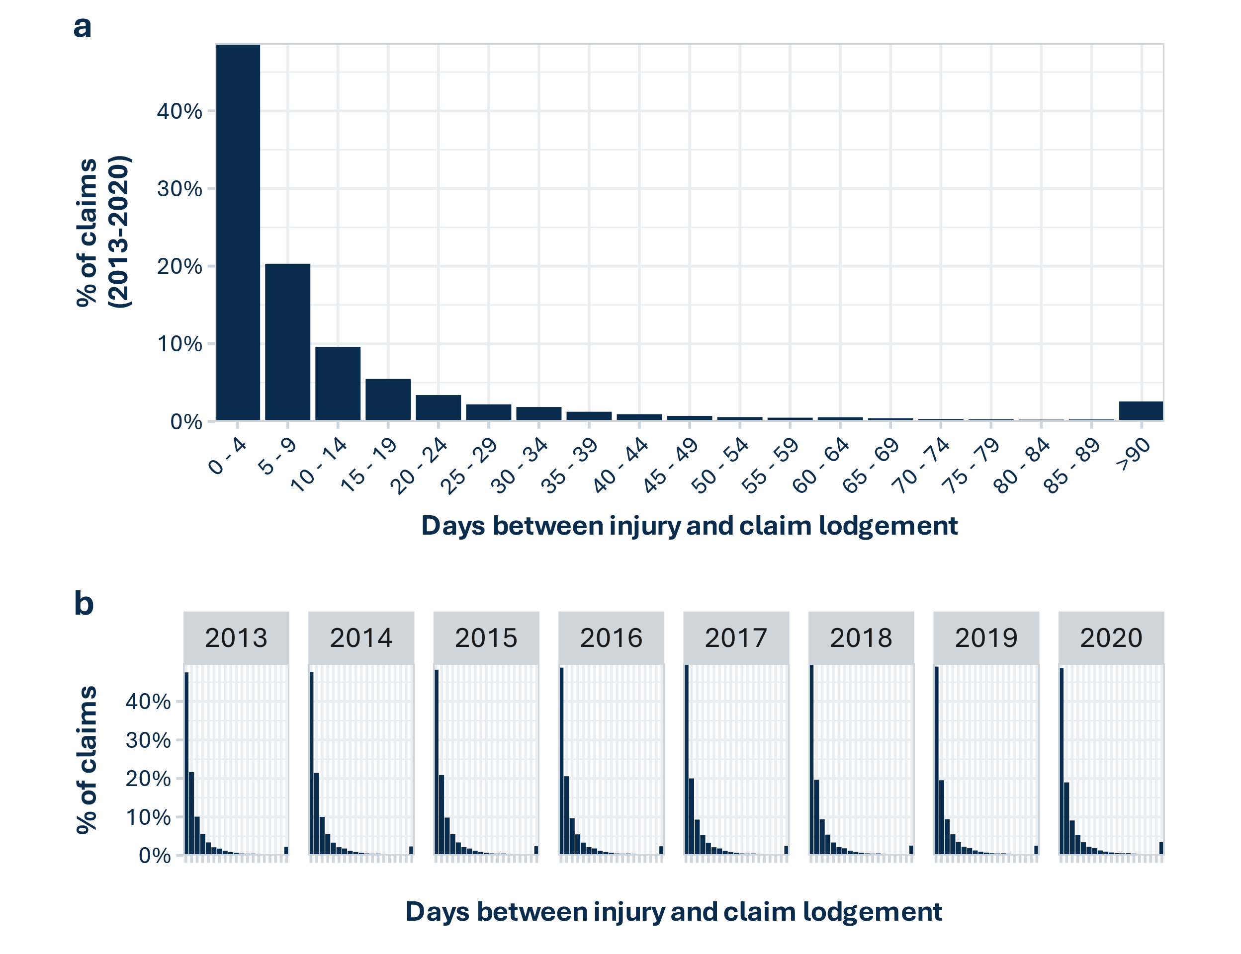

*Figure 7.1: Histograms of the percentage of claims lodged (y-axis) by the number of days elapsed between the injury date and the date of claim lodgement (x-axis). (a) results collated for claims with injury dates during the 8-year period 1 January 2013 to 31 December 2020, (b) results for each calendar year.*

## 7.2 2022 claim rates may be underestimated by about half a percentage point

To estimate the effects of lodgement delays on claim rates, we extracted IDI data for 2013 to 2020 on the number of claims that were lodged within 3 months, 1 year and 3 months, and 2 years and 3 months of the end of the calendar year (Table 7.1). The number of claims lodged within 3 months of the end of each year is equivalent to the available data for 2022, which includes claims lodged up to 31 March 2023. The number of claims lodged within 1 year and 3 months of the end of the year is equivalent to the available data for 2021 and the number of claims lodged within 2 years and 3 months of the end of the year is equivalent to the available data for 2020. We find that claimant numbers rise by only 0.37 to 0.51% when a 1-year 3 month lag is allowed for, and 0.39 to 0.55% when a 2 year 3 month lag is allowed (Table 7.1). So, 2022 claim rates may be expected to increase by around half a percent when data on claims lodged after 31 March 2023 becomes available.

*Table 7.1: Number and percentage of claimants who lodged their claims within three months, one year and three months, and two years and three months of the end of the year in which they were injured.*

| **Year** | **claimants within 3 months of year end** | **claimants within 1 year  3 months of year end** | **claimants within  2 years  3 months of year end** | **claimants  up to 31 March 2023** | **%  claimants added allowing 1 extra year's lag** | **%  claimants added allowing 2 extra years' lag** | **%  claimants added allowing lag to March 2023** |
| --- | --- | --- | --- | --- | --- | --- | --- |
| 2013 | 1,213,578 | 1,218,045 | 1,218,324 | 1,218,966 | 0.37% | 0.39% | 0.44% |
| 2014 | 1,246,005 | 1,250,805 | 1,251,141 | 1,251,723 | 0.39% | 0.41% | 0.46% |
| 2015 | 1,284,336 | 1,289,571 | 1,289,922 | 1,290,489 | 0.41% | 0.43% | 0.48% |
| 2016 | 1,337,103 | 1,342,287 | 1,342,644 | 1,343,151 | 0.39% | 0.41% | 0.45% |
| 2017 | 1,350,579 | 1,356,150 | 1,356,576 | 1,357,029 | 0.41% | 0.44% | 0.48% |
| 2018 | 1,378,896 | 1,384,995 | 1,385,385 | 1,385,790 | 0.44% | 0.47% | 0.50% |
| 2019 | 1,409,139 | 1,414,554 | 1,414,980 | 1,415,262 | 0.38% | 0.41% | 0.43% |
| 2020 | 1,358,154 | 1,365,018 | 1,365,606 |  | 0.51% | 0.55% |  |
| 2021 | 1,371,048 | 1,378,071 |  |  | 0.51% |  |  |
| 2022 | 1,342,746 |  |  |  |  |  |  |

## 7.3 Claim lodgement delays have negligible effects on the comparisons between groups and do not change the conclusions in this report

Time series comparisons between ACC groups may be affected by claim lodgement delays if some groups are more likely to delay claim lodgement than others. To estimate how different groups may be affected by delays, we used 2019 claim rates to estimate the proportional increase in claimants for each group, when delays were allowed for. We then adjusted the 2020, 2021 and 2022 claimant counts upwards by these proportions, as follows.

* 2020 percentages were adjusted upwards by the percentage of 2019 claimants of that ACC group (and gender or age) who lodged their claims between 1 April 2022 and 31 March 2023 (estimating the effect of allowing an extra 27 to 39 months for claim lodgement).
* 2021 percentages were adjusted upwards by the percentage of 2019 claimants of that ACC group (and gender or age) who lodged their claims between 1 April 2021 and 31 March 2023 (estimating the effect of allowing an extra 15 to 39 months for claim lodgement).
* 2022 percentages were adjusted upwards by the percentage of 2019 claimants of that ACC group (and gender or age) who lodged their claims between 1 April 2020 and 31 March 2023 (estimating the effect of allowing an extra 3 to 39 months for claim lodgement).

We find that the estimated effects are negligible and do not change the conclusions that we draw in this report. The adjustments, shown as dashed lines and open circles in the charts below (Figure 7.2, Figure 7.3, Figure 7.4, Figure 7.5, Figure 7.6, Figure 7.7).

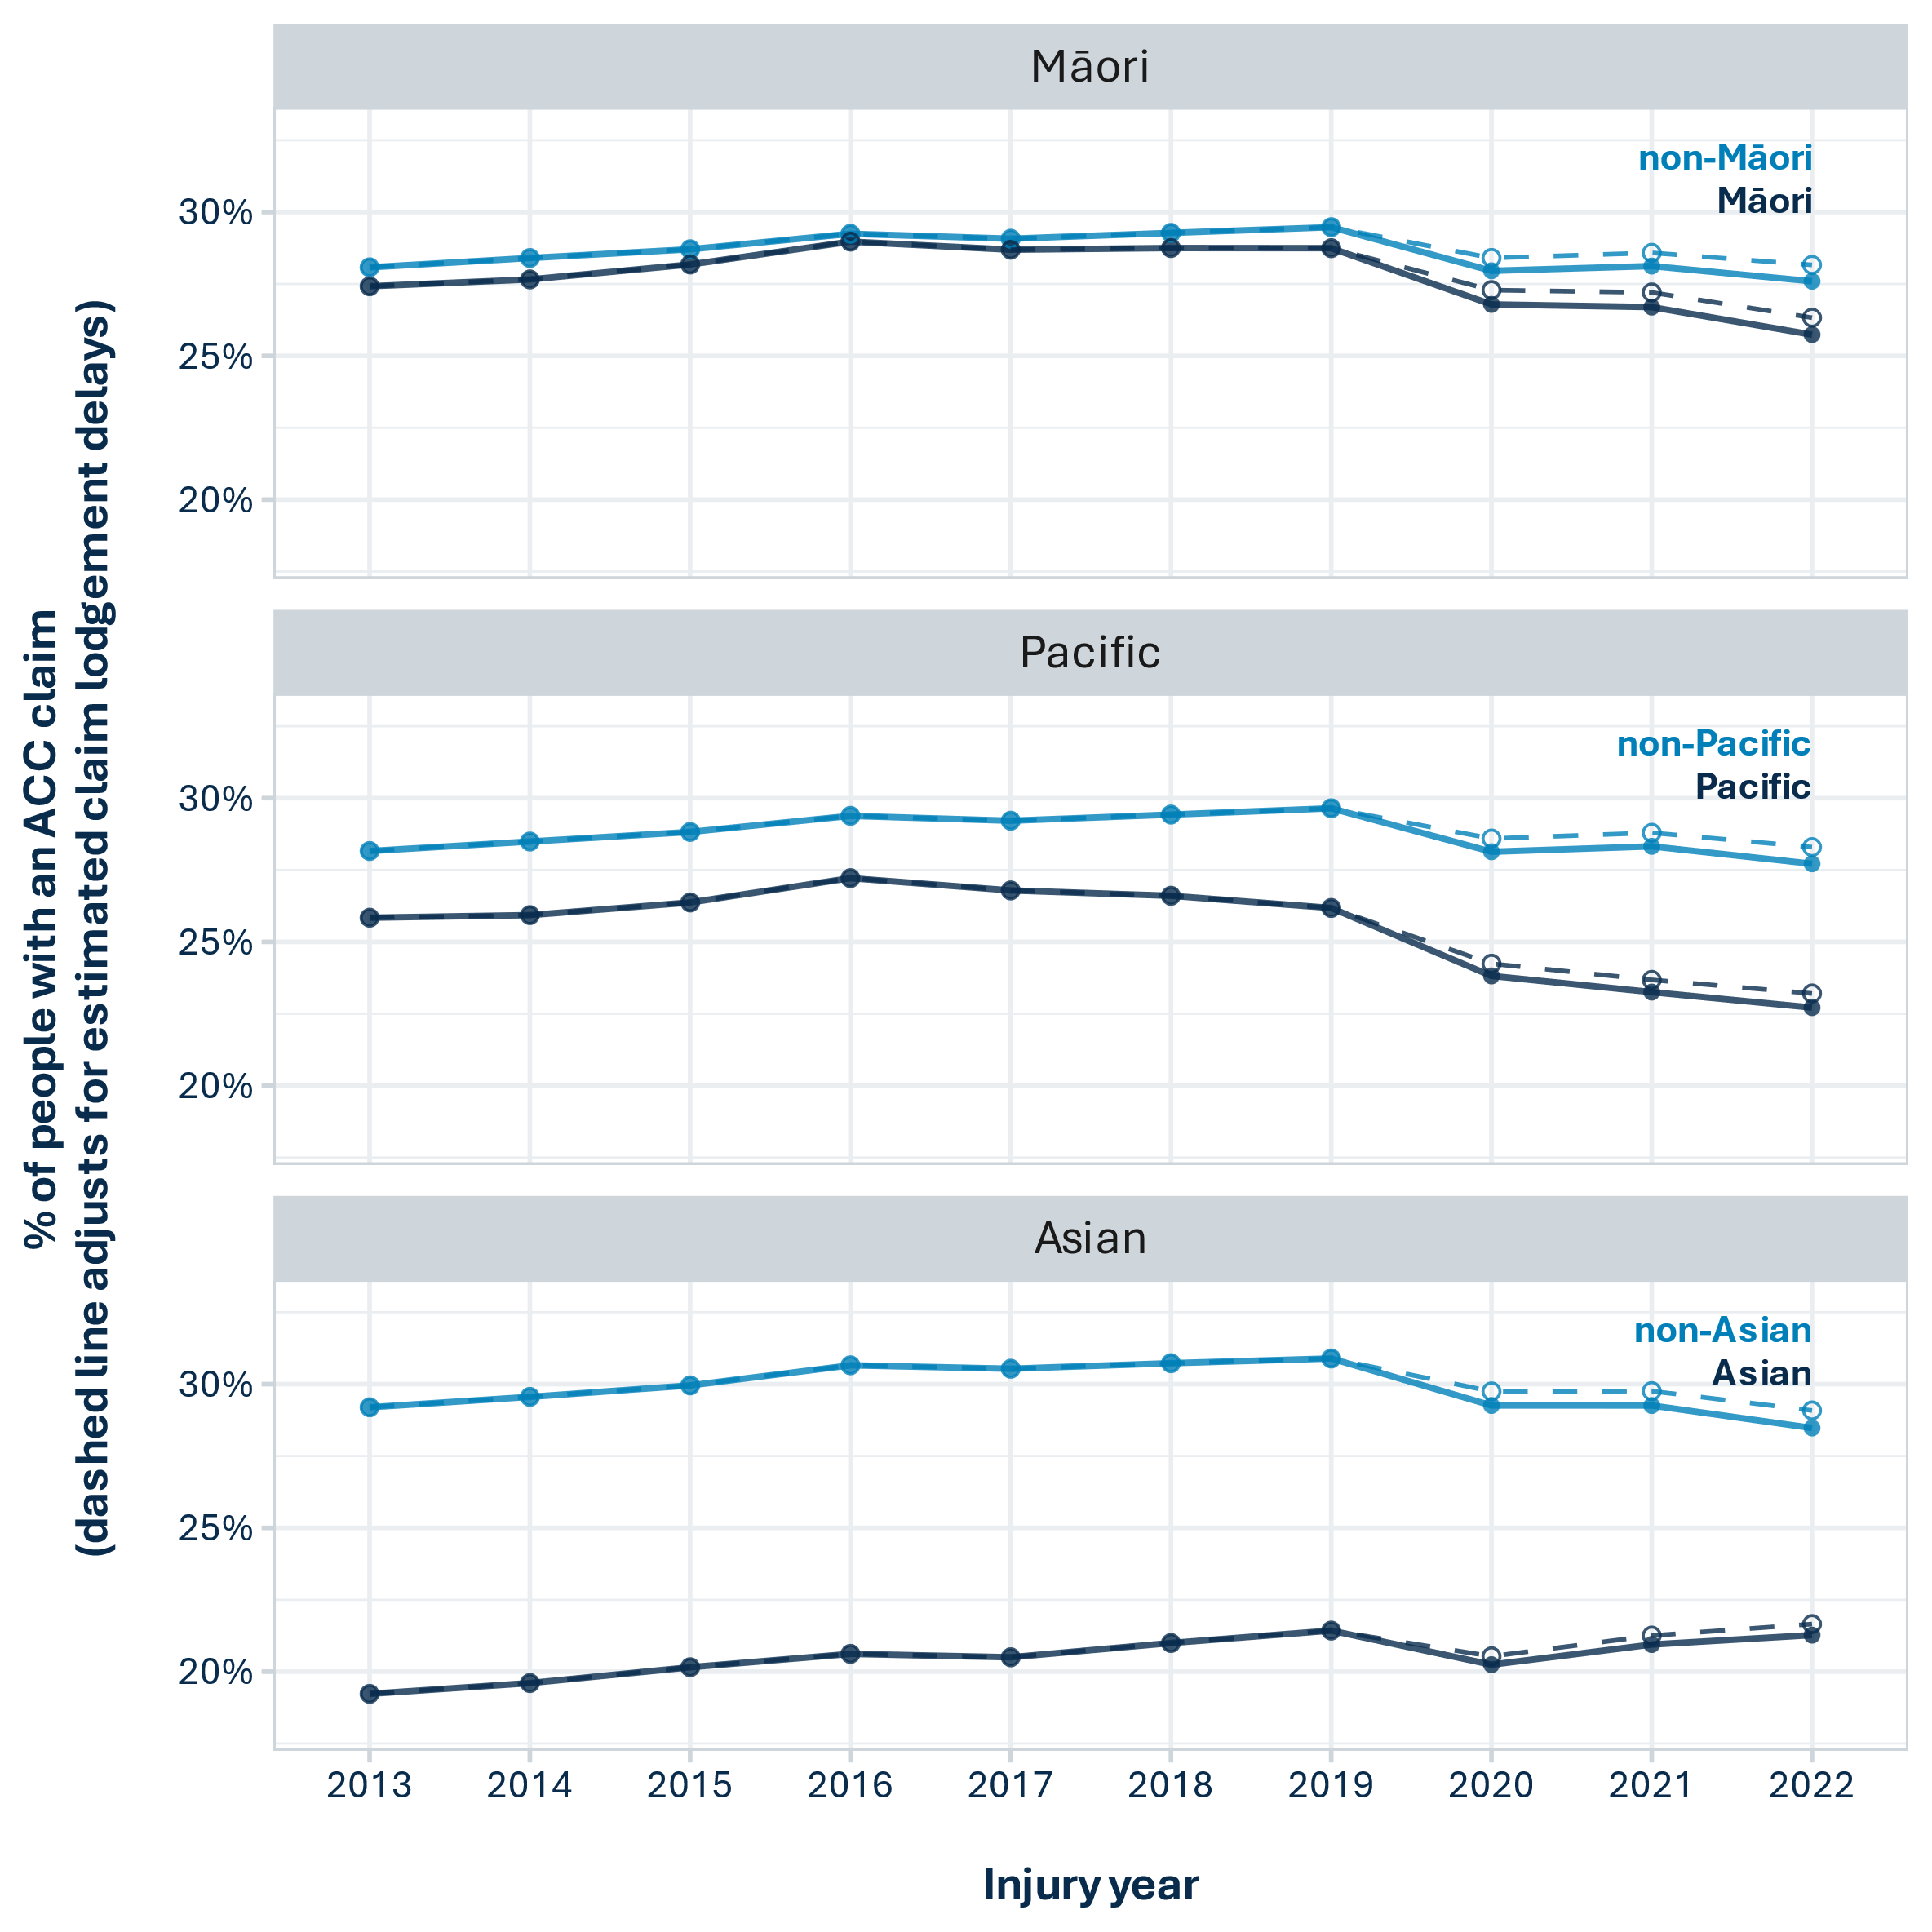

*Figure 7.2: Claim rates for each priority ethnicity, by year. Actual claim rates are indicated by solid lines and closed circles while dashed lines and open circles indicate the estimated effects of allowing for claim lodgement delays of up to 39 months (three years and three months).*

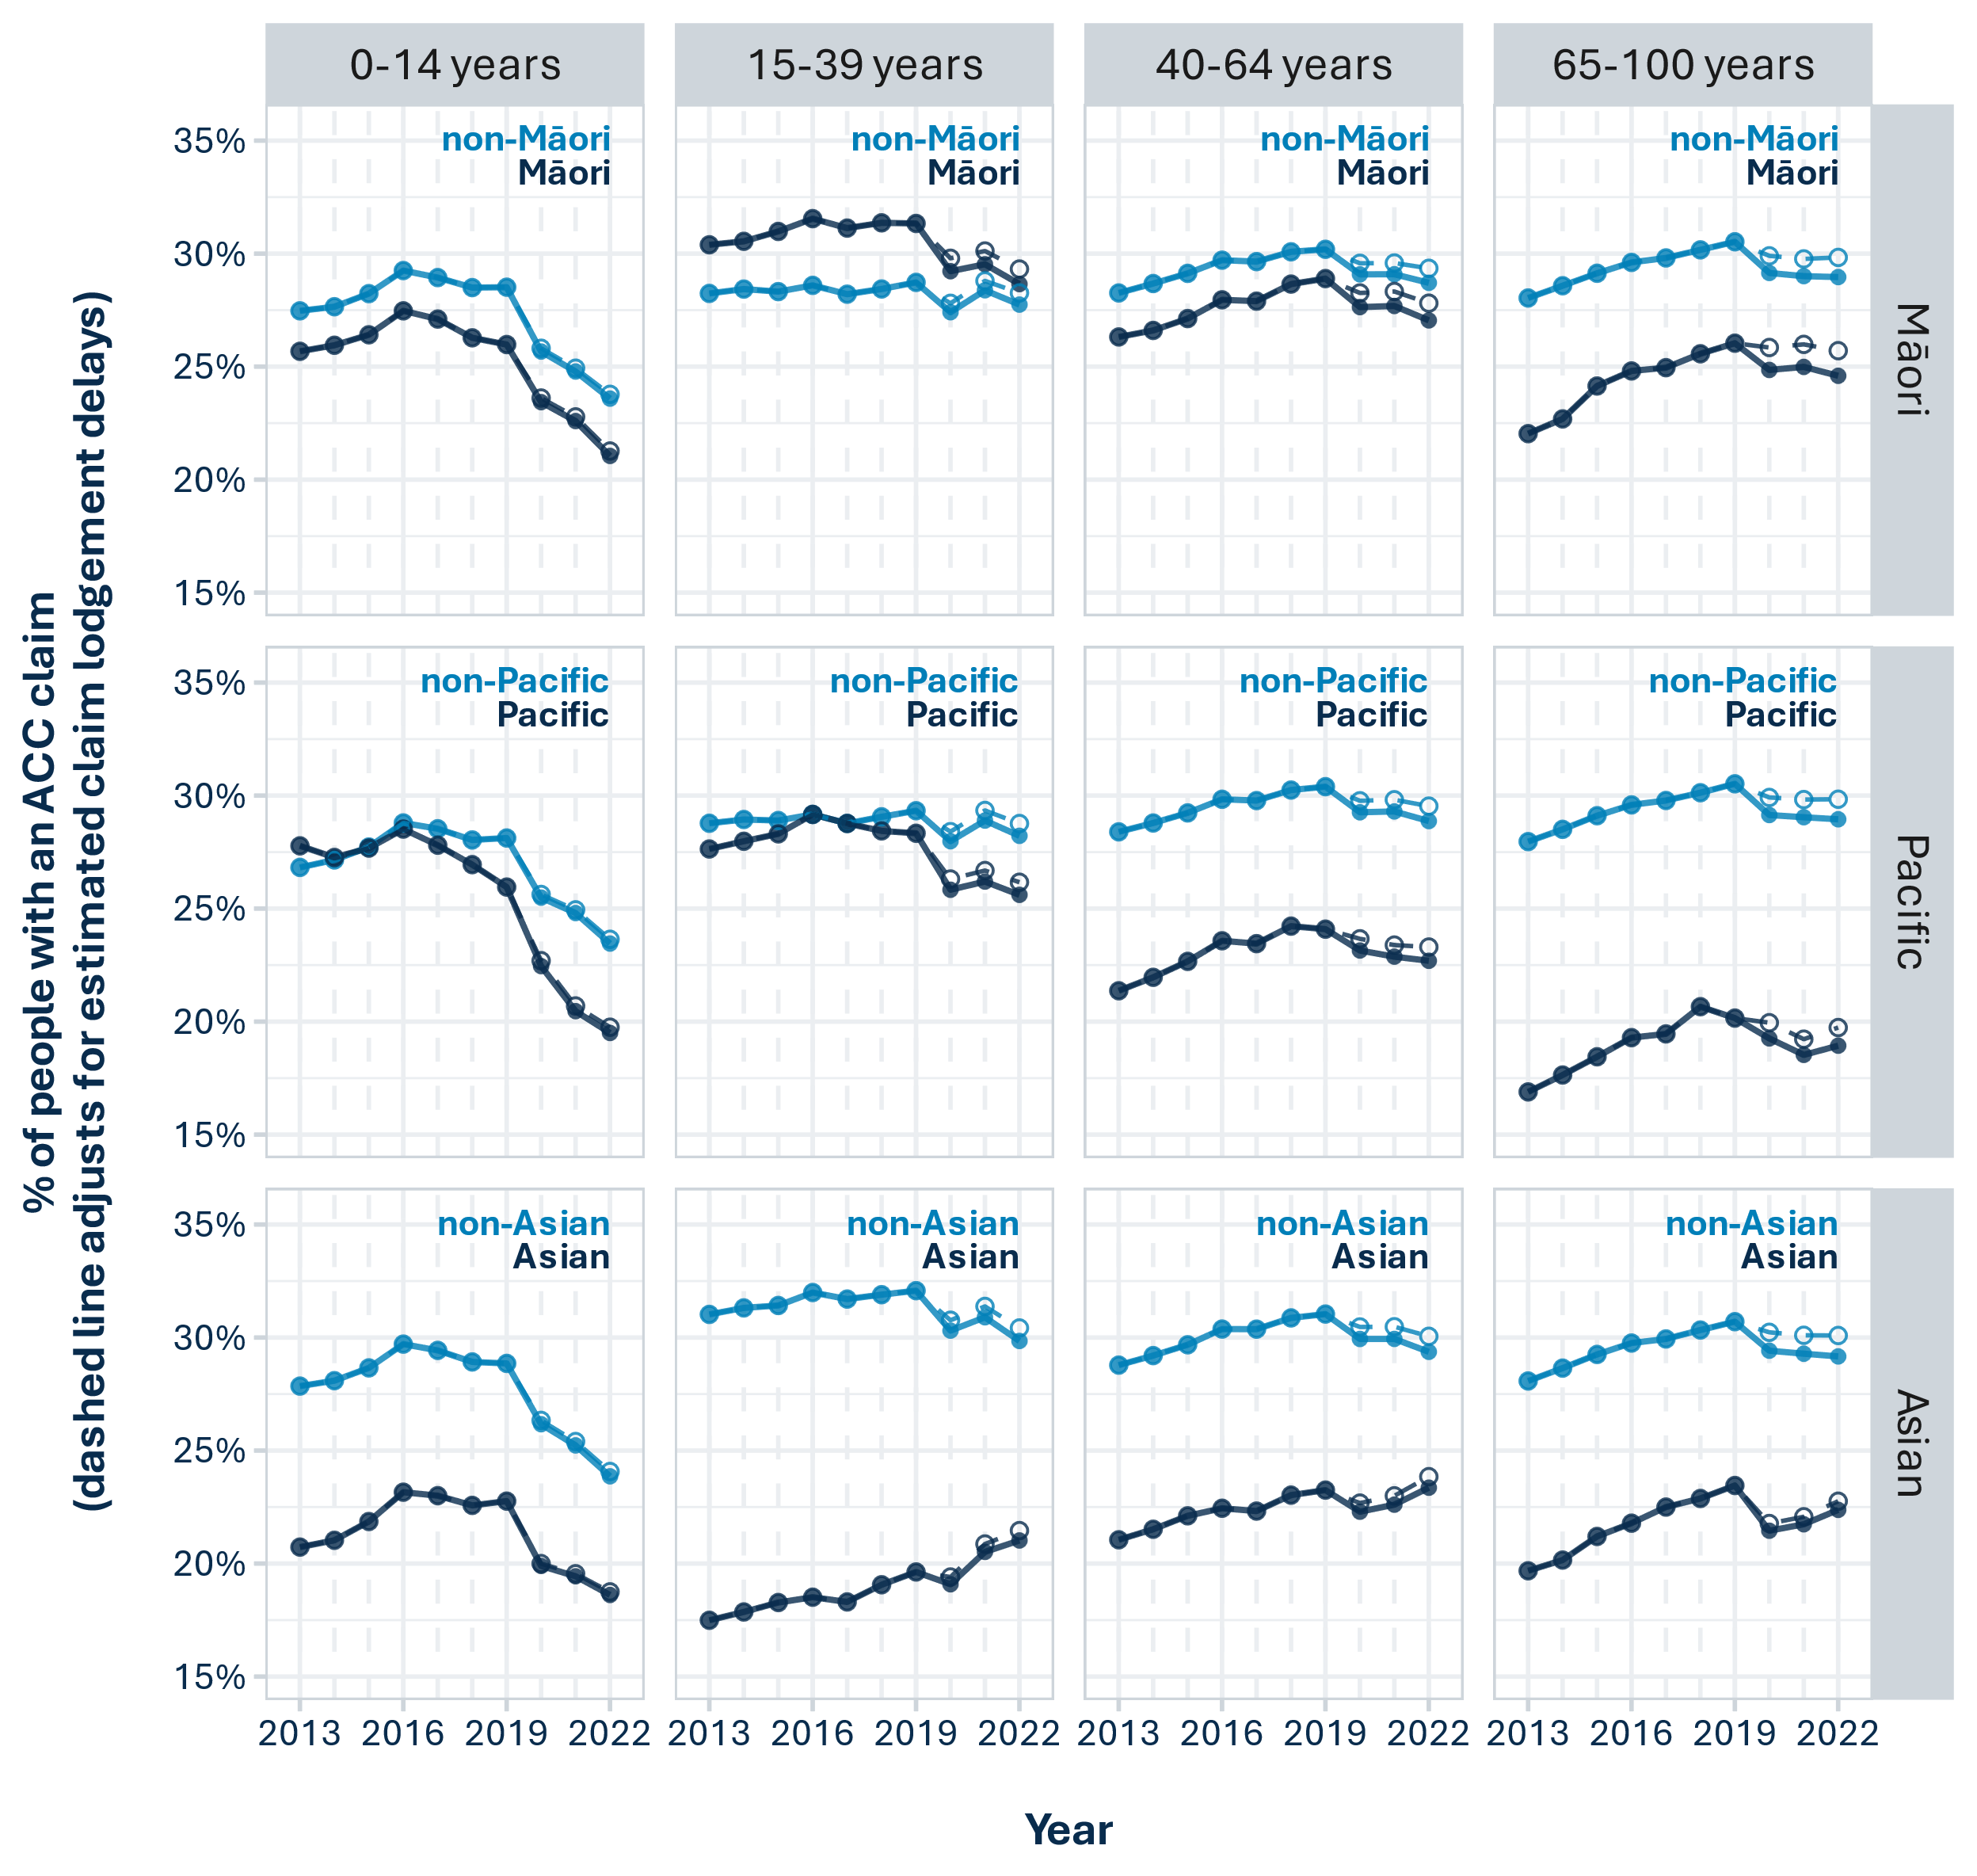

*Figure 7.3: Claim rates for each priority ethnicity, by year and age group. Actual claim rates are indicated by solid lines and closed circles while dashed lines and open circles indicate the estimated effects of allowing for claim lodgement delays of up to 39 months (three years and three months).*

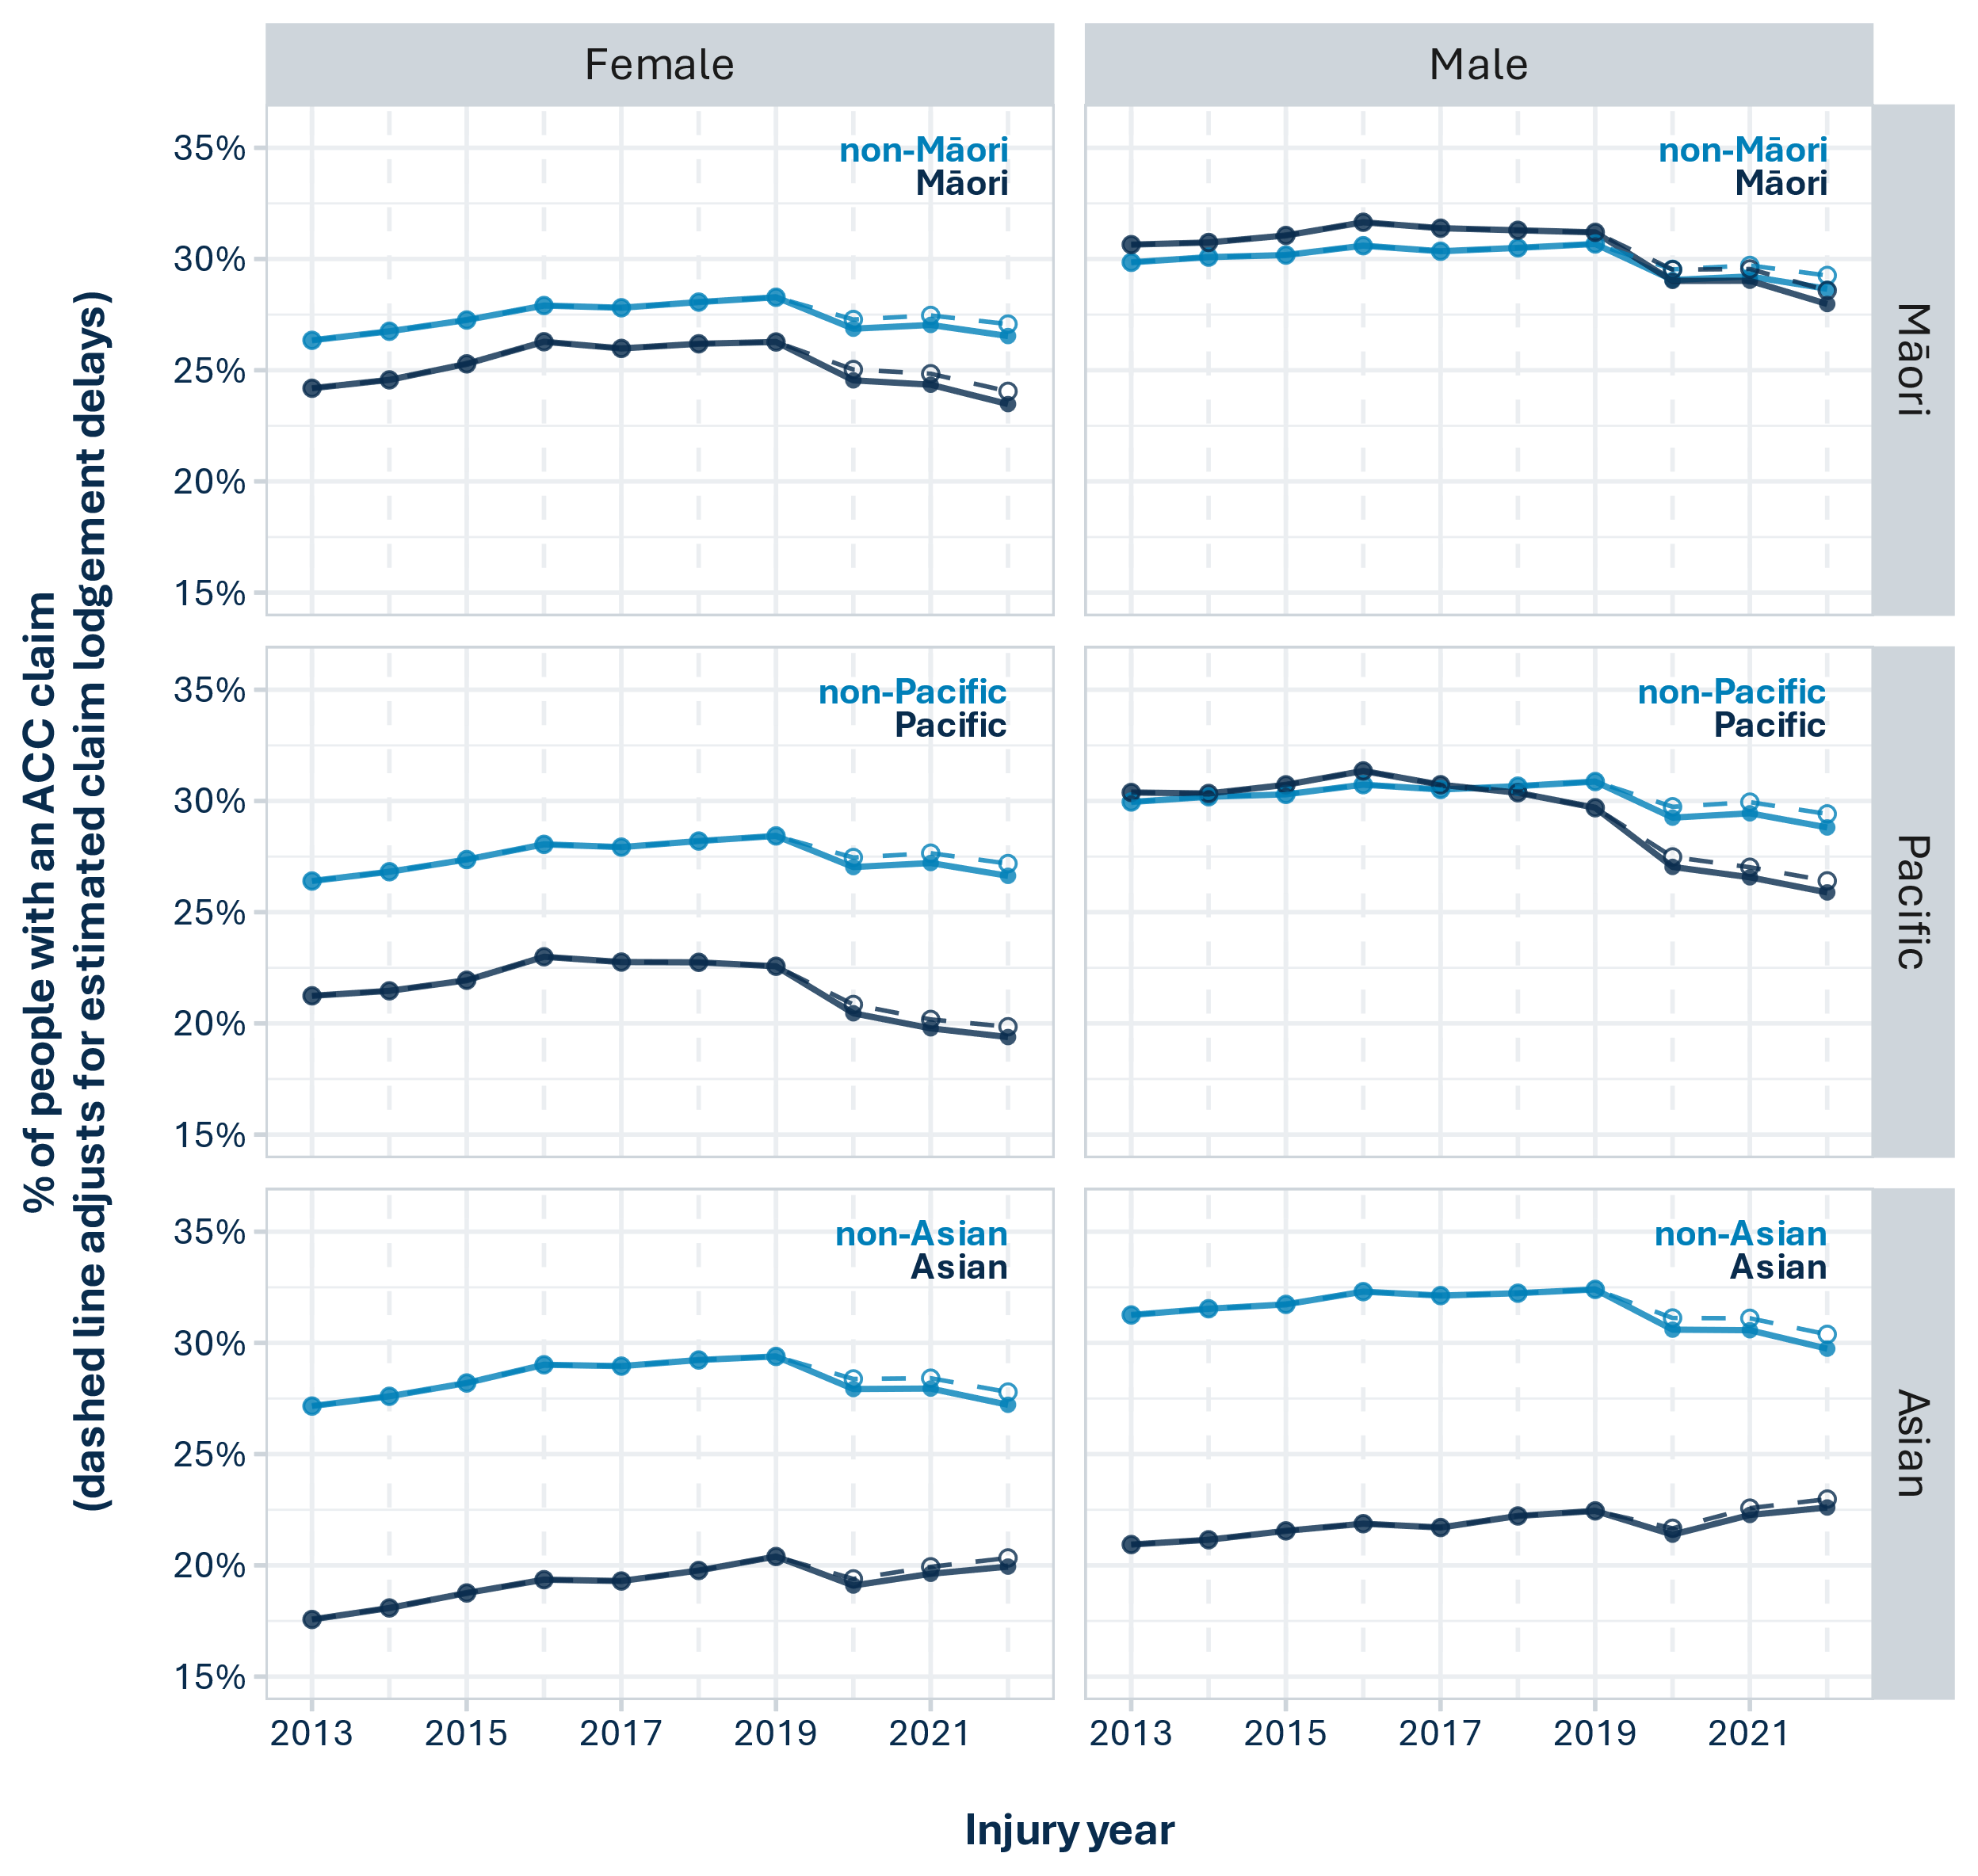

*Figure 7.4: Claim rates for each priority ethnicity, by year and gender. Actual claim rates are indicated by solid lines and closed circles while dashed lines and open circles indicate the estimated effects of allowing for claim lodgement delays of up to 39 months (three years and three months).*

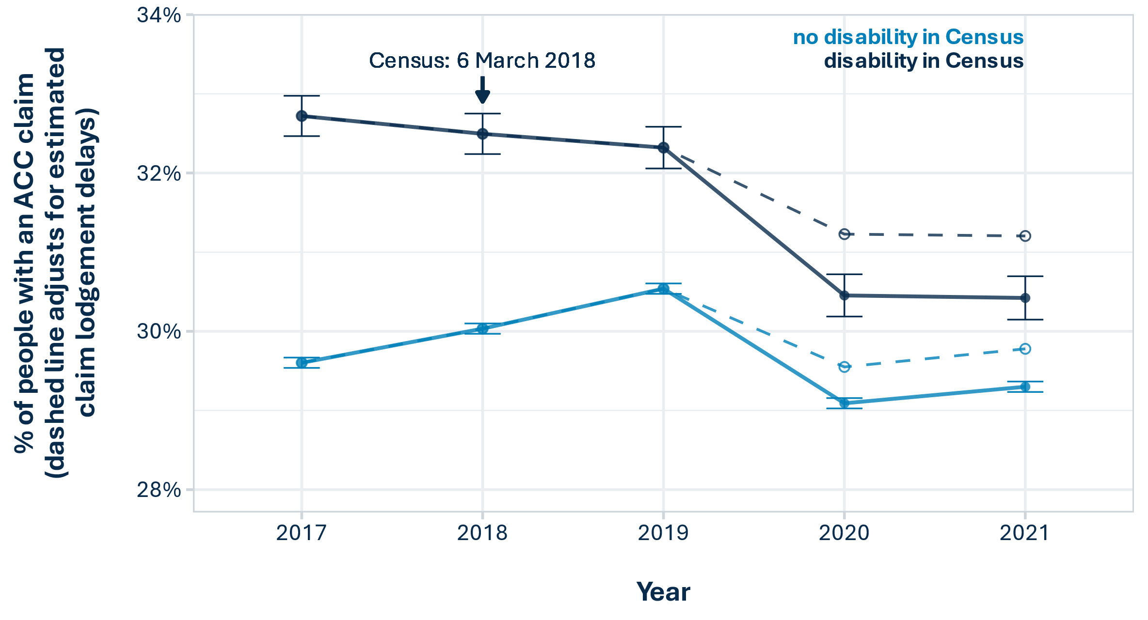

*Figure 7.5: Claim rates over time for people who reported a functional disability in Census 2018. Actual claim rates are indicated by solid lines and closed circles while dashed lines and open circles indicate the estimated effects of allowing for claim lodgement delays of up to 39 months (three years and three months). Error bars represent 99% confidence intervals.*

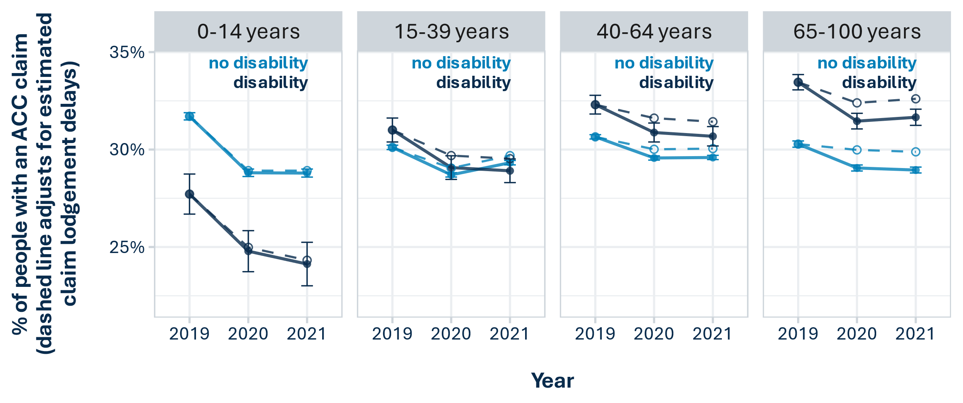

*Figure 7.6: 2019-2021 claim rates for people who reported a functional disability in Census 2018, by age group. Actual claim rates are indicated by solid lines and closed circles while dashed lines and open circles indicate the estimated effects of allowing for claim lodgement delays of up to 39 months (three years and three months). Error bars represent 99% confidence intervals.*

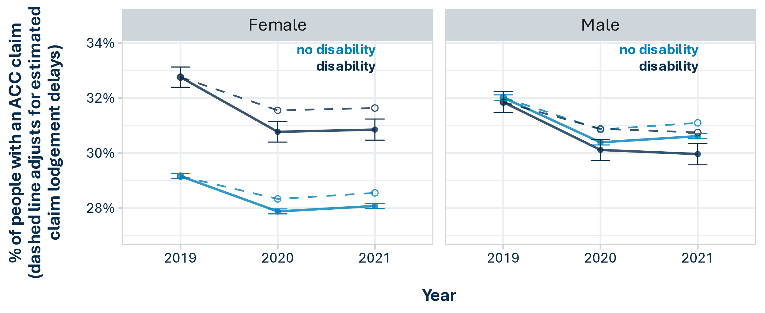

*Figure 7.7: 2019 and 2020 claim rates for people who reported a functional disability in Census 2018, by gender. Actual claim rates are indicated by solid lines and closed circles while dashed lines and open circles indicate the estimated effects of allowing for claim lodgement delays of up to 39 months (three years and three months). Error bars represent 99% confidence intervals.*

# 8 Appendix 3. ACC group population distributions across demographic and socio-economic variables

The tables in this appendix present the distribution of each ACC group’s population across the demographic and socio-economic variables used in the multiple regression modelling. This is presented for the whole ACC group (claimants and non-claimants) (Table 8.1) and for just the claimants in each ACC group (Table 8.2).

*Table 8.1: Demographic and socio-economic characteristics of the total APC resident population (claimants and non-claimants).*

| **Variable** | **Level** | **Māori** | **non- Māori** | **Pacific** | **non- Pacific** | **Asian** | **non- Asian** | **Disabled** | **not  disabled** |
| --- | --- | --- | --- | --- | --- | --- | --- | --- | --- |
| Gender | Male | 50.1% | 49.7% | 50.7% | 49.7% | 49.9% | 49.7% | 48.3% | 48.3% |
| Age | 0-14 years | 31% | 17% | 32.5% | 18.2% | 20.3% | 19.3% | 6.1% | 12.9% |
| 15-39 years | 37.8% | 33.1% | 40.1% | 33.4% | 47.2% | 31.6% | 18.1% | 34.6% |
| 40-64 years | 25.2% | 33% | 22.1% | 32.5% | 25.9% | 32.6% | 30.3% | 36% |
| 65-100 years | 6.1% | 16.9% | 5.3% | 15.9% | 6.5% | 16.5% | 45.5% | 16.6% |
| Region | Auckland | 23.9% | 35.8% | 63.8% | 30.8% | 62.4% | 28.6% | 27.2% | 32.5% |
| Northland,  Bay  of Plenty,  Gisborne | 22.8% | 9% | 5.6% | 12% | 4.6% | 12.6% | 13.1% | 10.7% |
| Wellington  region | 9.2% | 11% | 11.1% | 10.7% | 9.3% | 10.9% | 10.4% | 11.4% |
| Rest of North  Island | 29.7% | 19% | 11.2% | 21.8% | 10.5% | 22.7% | 24.2% | 20.6% |
| Canterbury | 7.4% | 13.9% | 5% | 13.4% | 9.1% | 13.3% | 13% | 13.6% |
| Rest of South  Island | 7% | 11.4% | 3.4% | 11.3% | 4.1% | 11.8% | 12.2% | 11.2% |
| Deprivation  index | NZDep 1-2 | 8.5% | 21.1% | 5.2% | 20.2% | 15.9% | 19.4% | 12.4% | 21.8% |
| NZDep 3-4 | 11.2% | 21.1% | 8.1% | 20.4% | 19.8% | 19.3% | 16.5% | 21% |
| NZDep 5-6 | 15.1% | 20.8% | 12.2% | 20.6% | 22.6% | 19.4% | 19.6% | 20.4% |
| NZDep 7-8 | 22.6% | 20% | 20.5% | 20.4% | 23.1% | 20% | 24% | 19.6% |
| NZDep 9-10 | 42.6% | 16.9% | 54% | 18.4% | 18.6% | 22% | 27.4% | 17.2% |
| Urban/rural  location | Rural | 17% | 15.2% | 4.3% | 16.6% | 3.7% | 17.6% | 13.5% | 16.1% |
| Industry of  employment | Agriculture,  Forestry  and Fishing | 3.9% | 3.2% | 2.1% | 3.4% | 2.2% | 3.5% | 2.3% | 3.1% |
| Arts, Recreation  and Other  Services | 0.9% | 1% | 0.8% | 1% | 0.6% | 1% | 0.5% | 1% |
| Arts, Recreation  and Other  Services | 1.7% | 2.1% | 1.6% | 2.1% | 1.7% | 2.2% | 1.4% | 2.2% |
| Construction | 5.8% | 5.4% | 4.7% | 5.5% | 3.5% | 5.8% | 3.3% | 5.5% |
| Education  and Training | 2.4% | 2.7% | 2% | 2.7% | 2.4% | 2.7% | 1.4% | 3.1% |
| Electricity, Gas,  Water and  Waste Services | 0.5% | 0.5% | 0.5% | 0.5% | 0.4% | 0.5% | 0.2% | 0.6% |
| Financial and  Insurance  Services | 1% | 1.9% | 1.4% | 1.8% | 2.3% | 1.7% | 0.7% | 2% |
| Health Care  and Social  Assistance | 5.1% | 6.4% | 5.2% | 6.3% | 7.1% | 6.1% | 4% | 7% |
| Information,  Media and  Telecommun- ications | 0.6% | 1% | 0.7% | 1% | 1.2% | 0.9% | 0.5% | 1.1% |
| Manufacturing | 6.3% | 6.2% | 9.3% | 6% | 6.2% | 6.2% | 4.2% | 6.4% |
| Mining | 0.2% | 0.2% | 0% | 0.2% | 0% | 0.2% | 0.1% | 0.2% |
| Professional,  Scientific,  Technical,  Administrative  and Support  Services | 2.5% | 5.8% | 1.7% | 5.6% | 5% | 5.3% | 2.2% | 6.2% |
| Professional,  Scientific,  Technical,  Administrative  and Support  Services | 3.5% | 2.8% | 5.7% | 2.7% | 3.4% | 2.8% | 2% | 2.7% |
| Public  Administration  and Safety | 3.5% | 3.4% | 3.7% | 3.4% | 2.1% | 3.7% | 1.9% | 3.9% |
| Rental, Hiring  and Real  Estate Services | 0.9% | 1.6% | 0.8% | 1.6% | 1.3% | 1.6% | 1% | 1.7% |
| Retail Trade and  Accommodation | 4.6% | 6% | 4.5% | 5.9% | 7.7% | 5.5% | 3.6% | 6.1% |
| Retail Trade and  Accommodation | 3.5% | 3.9% | 3.2% | 3.9% | 7.9% | 3.1% | 2.1% | 3.7% |
| Transport,  Postal and  Warehousing | 3% | 2.7% | 4.1% | 2.6% | 2.7% | 2.7% | 1.8% | 2.8% |
| Wholesale Trade | 2% | 3.2% | 3.1% | 3% | 2.9% | 3% | 1.6% | 3.3% |
| Not employed | 40% | 25.2% | 39.3% | 26.6% | 28.6% | 27.4% | 53.3% | 22.3% |
| No data | 8.1% | 14.6% | 5.6% | 14.2% | 10.6% | 14.1% | 11.8% | 15.2% |
| Occupation | Clerical and  Administrative | 4.1% | 6.2% | 4% | 6% | 4.4% | 6.2% | 3.9% | 7.8% |
| Community  and Personal  Services | 4.6% | 4.7% | 4.3% | 4.7% | 4.2% | 4.8% | 3.8% | 6.2% |
| Labourers | 6.6% | 4.8% | 6.1% | 5% | 4.5% | 5.2% | 5.6% | 6.5% |
| Machinery  Operators  and Drivers | 3.3% | 2.7% | 4% | 2.7% | 2.1% | 2.9% | 2.9% | 3.6% |
| Managers | 5.7% | 10.7% | 3.4% | 10.5% | 7.1% | 10.5% | 5.9% | 13.1% |
| Professionals | 7.2% | 14% | 5.3% | 13.5% | 12% | 13.1% | 6.3% | 17.2% |
| Sales | 3.3% | 4.8% | 3.3% | 4.7% | 5% | 4.5% | 3.3% | 6% |
| Technicians  and Trades | 4.4% | 6.5% | 3.6% | 6.3% | 5.6% | 6.2% | 4.8% | 8% |
| No data | 60.9% | 45.5% | 66.1% | 46.5% | 55% | 46.5% | 63.5% | 31.6% |
| Personal  income | $10001 or less | 9.6% | 9.4% | 10.6% | 9.3% | 13.5% | 8.7% | 4.5% | 8.9% |
| $10001-$20000 | 9.5% | 11.1% | 10.1% | 10.9% | 11.4% | 10.8% | 18.2% | 11.5% |
| $20001-$30000 | 14.7% | 14.7% | 12.8% | 14.8% | 11% | 15.3% | 30.9% | 12.5% |
| $30001-$40000 | 14.3% | 10.9% | 12.6% | 11.3% | 10% | 11.6% | 16% | 10.2% |
| $40001-$50000 | 12.9% | 10.2% | 12.8% | 10.5% | 10.1% | 10.7% | 7.5% | 10.5% |
| $50001-$70000 | 17.2% | 15.7% | 17.8% | 15.7% | 15.1% | 16% | 9.2% | 16.8% |
| $70001+ | 12.8% | 20.3% | 10.7% | 19.8% | 15% | 19.9% | 7.6% | 21.8% |
| No data | 9% | 7.8% | 12.6% | 7.6% | 14% | 6.9% | 6% | 7.7% |
| Benefit | Received  Sole parent  support | 7.9% | 1.7% | 5.9% | 2.4% | 0.8% | 3% | 3.2% | 1.8% |
| Received  Supported  living | 5.6% | 2.6% | 3.9% | 3% | 1.2% | 3.4% | 18% | 1.9% |
| Received Jobseeker | 18% | 6.1% | 13.3% | 7.6% | 4.8% | 8.6% | 12.1% | 4.8% |
| Was studying  (school or  tertiary) | Studying | 16.7% | 10.8% | 15.6% | 11.4% | 14.3% | 11.3% | 5.2% | 12.3% |
| Highest  qualification | None | 12.9% | 10.7% | 13.7% | 10.8% | 5.8% | 11.9% | 29% | 10.4% |
| NQF 1-3 | 44.7% | 31.5% | 44% | 32.7% | 21.9% | 35.6% | 34.9% | 34.9% |
| NQF 4-6 | 23.2% | 20.9% | 18.2% | 21.4% | 15.4% | 22.2% | 21.6% | 24.2% |
| NQF 7+ | 11.7% | 23.3% | 9.6% | 22.5% | 34% | 19.3% | 11.8% | 29.3% |
| No data | 7.5% | 13.7% | 14.4% | 12.6% | 22.9% | 11% | 2.7% | 1.2% |
| Partnership | Has partner | 50.1% | 63.6% | 52.1% | 62.5% | 64.2% | 61.6% | 44.9% | 62.7% |
| Housing  tenure | Owned  freehold | 7.8% | 19.4% | 4% | 18.6% | 10.2% | 18.7% | 26.3% | 22.2% |
| Owned with  mortgage | 24.7% | 35% | 19.3% | 34.5% | 32.9% | 33.3% | 23.8% | 41.5% |
| Rented from  private sector | 28.7% | 21.5% | 28.5% | 22.3% | 27.7% | 21.9% | 21.7% | 25.3% |
| Rented from  public sector | 9.2% | 3.4% | 18.4% | 3.1% | 2.4% | 4.7% | 9.5% | 3.7% |
| Other | 5.5% | 6.5% | 4.7% | 6.5% | 7.5% | 6.1% | 8.9% | 6.1% |
| Kainga Ora | Kainga Ora  tenant | 7.6% | 2.5% | 15.7% | 2.2% | 1.6% | 3.7% | 6.4% | 2.1% |
| Household crowding | Overcrowded | 14.8% | 7.5% | 27.3% | 7% | 14.4% | 7.7% | 8.8% | 8.8% |
| Home  phone | No phone/ cellphone | 2.8% | 1.9% | 3.3% | 2% | 4.9% | 1.6% | 2.4% | 1.9% |
| Home  internet | No internet | 14.9% | 8.2% | 15.5% | 8.7% | 5.7% | 9.8% | 22.2% | 8.1% |
| Overseas  born | NZ-born | 94.8% | 64.6% | 63.9% | 70.4% | 23.6% | 78.1% | 72.5% | 69% |
| Overseas born,  arrived in NZ  < 5 years ago | 0.2% | 7.3% | 4.7% | 6.2% | 23% | 3% | 1.8% | 5.7% |
| Overseas born,  arrived in NZ  5-9 years ago | 0.2% | 5.4% | 4.3% | 4.5% | 15.8% | 2.5% | 2% | 4.5% |
| Overseas born,  arrived in NZ  >9 years ago | 0.9% | 16.9% | 18.5% | 13.7% | 32.7% | 10.8% | 17.2% | 16.3% |
| Overseas born, no data on when arrived | 3.9% | 5.8% | 8.6% | 5.1% | 5% | 5.5% | 6.5% | 4.5% |
| Enrolled at  primary  healthcare  organisation  (PHO) | PHO enrolled | 90.6% | 89.3% | 88.4% | 89.7% | 77.6% | 91.7% | 95.9% | 91.9% |
| Serious  offence  last 10 years | Offender | 6.2% | 1% | 3.3% | 1.7% | 0.4% | 2% | 2.2% | 0.9% |
| Mental health | Mental health  diagnosis last  5 years | 24% | 26.5% | 13.8% | 27.2% | 12% | 28.6% | 52.6% | 26.9% |

*Table 8.2: Demographic and socio-economic characteristics of ACC claimants in the APC resident population.*

| **Variable** | **Level** | **Māori** | **non- Māori** | **Pacific** | **non- Pacific** | **Asian** | **non- Asian** | **Disabled** | **not  disabled** |
| --- | --- | --- | --- | --- | --- | --- | --- | --- | --- |
| Gender | Male | 54.9% | 52% | 58.3% | 52% | 53.2% | 52.4% | 47.5% | 50.6% |
| Age | 0-14 years | 28.4% | 16.4% | 32.7% | 17.2% | 21.1% | 18.1% | 5.4% | 13.2% |
| 15-39 years | 41.4% | 32.8% | 43.5% | 33.5% | 43.7% | 33.1% | 17.2% | 34.2% |
| 40-64 years | 24.9% | 33.7% | 19.9% | 33.2% | 28.3% | 32.7% | 30.4% | 36.3% |
| 65-100 years | 5.3% | 17.1% | 3.9% | 16.1% | 6.9% | 16.1% | 47% | 16.3% |
| Region | Auckland | 25.3% | 35.5% | 65% | 31.2% | 67.9% | 29.6% | 27.6% | 33.3% |
| Northland, Bay  of Plenty,  Gisborne | 22.5% | 10.1% | 5.9% | 12.8% | 4.2% | 13.2% | 14% | 11.6% |
| Wellington  region | 8.2% | 9.6% | 9.5% | 9.3% | 7.4% | 9.6% | 9.1% | 9.8% |
| Rest of North  Island | 28.9% | 19.6% | 11.3% | 22% | 9.7% | 22.6% | 24.4% | 20.9% |
| Canterbury | 7.6% | 13.6% | 4.9% | 13.2% | 7.4% | 13.2% | 12.9% | 13.2% |
| Rest of South  Island | 7.5% | 11.6% | 3.5% | 11.5% | 3.4% | 11.8% | 11.9% | 11.2% |
| Deprivation  index | NZDep 1-2 | 9.9% | 22.5% | 6.1% | 21.5% | 16.9% | 20.8% | 13.1% | 23.2% |
| NZDep 3-4 | 12.4% | 21.9% | 8.8% | 21.2% | 20.6% | 20.2% | 17.5% | 21.7% |
| NZDep 5-6 | 15.9% | 20.9% | 12.7% | 20.6% | 22.7% | 19.7% | 20.2% | 20.4% |
| NZDep 7-8 | 22.6% | 19.3% | 20.5% | 19.8% | 22.1% | 19.6% | 24% | 19% |
| NZDep 9-10 | 39.2% | 15.5% | 51.9% | 16.9% | 17.7% | 19.8% | 25.2% | 15.7% |
| Urban/rural  location | Rural | 17.1% | 16.3% | 4.5% | 17.4% | 3.5% | 18% | 14.1% | 17.1% |
| Industry of  employment | Agriculture,  Forestry  and Fishing | 4.5% | 3.5% | 2.1% | 3.8% | 2% | 3.9% | 2.7% | 3.4% |
| Arts, Recreation  and Other  Services | 1.1% | 1.2% | 1.1% | 1.2% | 0.8% | 1.2% | 0.7% | 1.2% |
| Arts, Recreation  and Other  Services | 1.9% | 2.3% | 1.7% | 2.3% | 1.8% | 2.3% | 1.6% | 2.3% |
| Construction | 7.9% | 7.1% | 6.8% | 7.2% | 4.5% | 7.5% | 4.4% | 7.1% |
| Education  and Training | 2.4% | 2.8% | 2% | 2.8% | 2.6% | 2.7% | 1.6% | 3.1% |
| Electricity, Gas,  Water and  Waste Services | 0.6% | 0.6% | 0.6% | 0.6% | 0.5% | 0.6% | 0.2% | 0.6% |
| Financial and  Insurance  Services | 1.1% | 2% | 1.3% | 1.8% | 2.7% | 1.7% | 0.8% | 2% |
| Health Care  and Social  Assistance | 5.4% | 6.7% | 5.1% | 6.6% | 7.5% | 6.3% | 4.9% | 7.2% |
| Information,  Media and  Telecommun- ications | 0.6% | 1% | 0.7% | 0.9% | 1.3% | 0.9% | 0.5% | 1.1% |
| Manufacturing | 7.8% | 6.8% | 11% | 6.7% | 6.8% | 7% | 4.8% | 6.8% |
| Mining | 0.2% | 0.2% | 0.1% | 0.2% | 0.1% | 0.2% | 0.1% | 0.2% |
| Professional,  Scientific,  Technical,  Administrative  and Support  Services | 2.7% | 5.9% | 1.9% | 5.6% | 5.3% | 5.4% | 2.4% | 6.3% |
| Professional,  Scientific,  Technical,  Administrative  and Support  Services | 3.5% | 2.7% | 5.8% | 2.7% | 3.2% | 2.8% | 2.1% | 2.7% |
| Public  Administration  and Safety | 3.9% | 3.8% | 4.3% | 3.8% | 2.6% | 4% | 2.2% | 4.3% |
| Rental, Hiring  and Real  Estate Services | 1% | 1.8% | 0.9% | 1.8% | 1.6% | 1.7% | 1.1% | 1.9% |
| Retail Trade and  Accommodation | 4.6% | 5.8% | 4.5% | 5.7% | 7.7% | 5.3% | 3.9% | 5.8% |
| Retail Trade and  Accommodation | 3.3% | 3.4% | 2.9% | 3.4% | 7% | 2.9% | 2% | 3.2% |
| Transport,  Postal and  Warehousing | 3.3% | 2.8% | 4.7% | 2.7% | 3.2% | 2.8% | 2% | 2.9% |
| Wholesale Trade | 2.3% | 3.5% | 3.7% | 3.2% | 3.4% | 3.3% | 1.7% | 3.5% |
| Not employed | 33.3% | 20.9% | 32.7% | 22.1% | 23.6% | 22.8% | 47.1% | 18.6% |
| No data | 8.6% | 15.5% | 6.1% | 15% | 11.7% | 14.8% | 13.1% | 16% |
| Occupation | Clerical and  Administrative | 4% | 6.2% | 3.7% | 6% | 4.8% | 6% | 4.1% | 7.6% |
| Community  and Personal  Services | 5% | 5.2% | 4.7% | 5.2% | 4.4% | 5.3% | 4.5% | 6.7% |
| Labourers | 7.4% | 5.1% | 6.9% | 5.4% | 4.5% | 5.6% | 6.1% | 6.9% |
| Machinery  Operators  and Drivers | 3.7% | 2.9% | 4.7% | 2.9% | 2.5% | 3.1% | 3.3% | 3.9% |
| Managers | 6.5% | 12.1% | 4.1% | 11.7% | 8.2% | 11.6% | 6.9% | 14.5% |
| Professionals | 7.6% | 14.5% | 5.6% | 13.9% | 13.4% | 13.4% | 7% | 17.4% |
| Sales | 3.2% | 4.8% | 3.1% | 4.6% | 5.1% | 4.4% | 3.7% | 5.8% |
| Technicians  and Trades | 5.5% | 7.6% | 4.6% | 7.5% | 6.6% | 7.4% | 6% | 9.4% |
| No data | 57% | 41.6% | 62.8% | 42.7% | 50.5% | 43.2% | 58.5% | 28% |
| Personal  income | $10001 or less | 9.7% | 8.7% | 10.6% | 8.8% | 12% | 8.5% | 4.4% | 8.5% |
| $10001-$20000 | 8.9% | 10.4% | 8.9% | 10.3% | 10.8% | 10.1% | 18% | 10.7% |
| $20001-$30000 | 13.4% | 14.7% | 11.5% | 14.7% | 11.1% | 14.9% | 31.7% | 12.2% |
| $30001-$40000 | 14% | 10.9% | 12.6% | 11.3% | 10.3% | 11.5% | 14.7% | 10.1% |
| $40001-$50000 | 13.5% | 10.8% | 13.7% | 11% | 10.8% | 11.2% | 8.1% | 10.9% |
| $50001-$70000 | 18.5% | 16.9% | 19.2% | 17% | 17.2% | 17.1% | 10.2% | 17.9% |
| $70001+ | 14.4% | 22.2% | 12% | 21.6% | 18.1% | 21.4% | 8.7% | 23.8% |
| No data | 7.6% | 5.5% | 11.4% | 5.4% | 9.7% | 5.3% | 4.3% | 6% |
| Benefit | Received  Sole parent  support | 6.2% | 1.6% | 4.7% | 2.2% | 0.9% | 2.5% | 3.3% | 1.7% |
| Received  Supported  living | 4.4% | 2.2% | 2.8% | 2.6% | 1.2% | 2.8% | 15% | 1.6% |
| Received Jobseeker | 16.8% | 6% | 12.4% | 7.4% | 5.5% | 8.1% | 11.9% | 4.4% |
| Was studying  (school or  tertiary) | Studying | 19.2% | 11.7% | 18.9% | 12.4% | 13.4% | 12.8% | 5.6% | 13.3% |
| Highest  qualification | None | 11.3% | 10.2% | 11.7% | 10.3% | 5.6% | 10.9% | 27% | 9.8% |
| NQF 1-3 | 44.8% | 32.4% | 45.9% | 33.4% | 22.5% | 35.6% | 34.8% | 34.5% |
| NQF 4-6 | 24.6% | 23% | 19.2% | 23.5% | 17.5% | 23.9% | 23.4% | 26.1% |
| NQF 7+ | 12.3% | 23% | 9.8% | 22.2% | 36% | 19.6% | 12.4% | 28.3% |
| No data | 7% | 11.5% | 13.4% | 10.6% | 18.5% | 9.9% | 2.5% | 1.3% |
| Partnership | Has partner | 51.4% | 63.5% | 51.6% | 62.5% | 66.3% | 61.5% | 46.2% | 62.8% |
| Housing  tenure | Owned  freehold | 8% | 20% | 4.2% | 19.1% | 10.8% | 18.9% | 28.3% | 22.1% |
| Owned with  mortgage | 27.5% | 37.4% | 21.3% | 36.9% | 36.4% | 35.6% | 24.6% | 43.8% |
| Rented from  private sector | 28.3% | 20.8% | 28.7% | 21.5% | 27% | 21.5% | 21.2% | 23.8% |
| Rented from  public sector | 8.2% | 3% | 17.8% | 2.7% | 2.4% | 4.1% | 8.4% | 3.2% |
| Other | 5.5% | 6.6% | 4.8% | 6.6% | 7.8% | 6.2% | 9.5% | 6% |
| Kainga Ora | Kainga Ora  tenant | 6.5% | 2.2% | 14.8% | 1.9% | 1.7% | 3.1% | 5.4% | 1.7% |
| Household crowding | Overcrowded | 13.7% | 6.5% | 26.9% | 6.1% | 13.7% | 7% | 7.3% | 7.6% |
| Home  phone | No phone/ cellphone | 2.6% | 1.6% | 3.1% | 1.6% | 4.2% | 1.4% | 2% | 1.5% |
| Home  internet | No internet | 13.2% | 7.8% | 14.3% | 8.2% | 5.5% | 9% | 22.1% | 7.3% |
| Overseas  born | NZ-born | 95.3% | 69.1% | 68.7% | 74% | 26.4% | 79.4% | 74.6% | 72.7% |
| Overseas born,  arrived in NZ  < 5 years ago | 0.2% | 5.1% | 4% | 4.2% | 17.6% | 2.6% | 1.2% | 3.9% |
| Overseas born,  arrived in NZ  5-9 years ago | 0.3% | 4.7% | 4.2% | 3.9% | 15.4% | 2.5% | 1.6% | 3.8% |
| Overseas born,  arrived in NZ  >9 years ago | 1.1% | 16.1% | 16.3% | 13.3% | 36% | 10.7% | 16.6% | 15.3% |
| Overseas born, no data on when arrived | 3.2% | 5.1% | 6.9% | 4.6% | 4.7% | 4.7% | 6% | 4.3% |
| Enrolled at  primary  healthcare  organisation  (PHO) | PHO enrolled | 93.5% | 93.6% | 92% | 93.7% | 85.7% | 94.5% | 97.4% | 94.7% |
| Serious  offence  last 10 years | Offender | 6.9% | 1.2% | 4.1% | 1.9% | 0.6% | 2.2% | 2.3% | 1% |
| Mental health | Mental health  diagnosis last  5 years | 28.2% | 32.5% | 16.6% | 33.1% | 17.1% | 33.6% | 58.5% | 32.2% |

# 9 Appendix 4. Regression results comparing the claim rates between ACC groups when other factors are accounted for

The tables in this appendix present the results from multiple logistic regression modelling of the associations between ACC claim rates and ACC group identification, when other demographic and socio-economic factors are accounted for by including them as independent variables in the models.

Note that in December 2024 we updated the datasets presented in Figures 3.1 to 3.5 with all the ACC claims data for 2023.

## 9.1 How to interpret the results

Results in the tables below are presented as odds ratios, asterisks representing statistical significance, and 99% confidence intervals.

**The odds ratio** is a measure of the likelihood of having a claim, relative to the comparison group. An odds ratio of 1 means that the likelihood is the same as for the comparison group; an odds ratio greater than 1 means the likelihood of having a claim is higher, and an odds ratio below one means that the likelihood is lower.

**Statistical significance** refers to our certainty that the odds ratio is different from 1 and therefore that the likelihood of having a claim is different to the comparison group. Two asterisks indicate <1% significance, which means that we are at least 99% sure that the likelihood of having a claim is different to the likelihood for the comparison group. That is, we would expect to get this result less than one percent of the time simply by random chance. One asterisk indicates 1% to 5% significance, which means that we are between 95% and 99% sure that the likelihood of having a claim is different to the likelihood for the comparison group. Where there is no asterisk, we are less than 95% sure that the result is not due to a random fluctuation and, by convention, it is considered to be statistically insignificant (although the result could still be important in other ways).

**99% Confidence intervals** are given in parentheses after the odds ratios. They indicate the range of values that the odds ratio can take with 99% certainty. That is, we are 99% sure that the true value of the odds ratio is somewhere in this range.

As an example of a significantly lower claim rate, in Table 9.1 below, the odds ratio for 40-64 year olds is 0.899 in the ‘Base’ model. The comparison group is 15-39 year olds, and so 40-64 year olds are 0.899 time as likely to have a claim as 15-39 year olds, when the other factors in the model are accounted for. You can also think of this as 89.9% as likely, or 10.01% less likely. There are two asterisks, so we are at least 99% sure that this difference is a true underlying difference, not just a random fluctuation in the data. The 99% confidence interval is (0.873, 0.926), meaning that we are 99% sure that the true value of the difference is somewhere between 0.873 and 0.926.

An example of a significantly higher claim rate is the value for male adults in Table 9.1 below. In the base model, men have an odds ratio of 1.145 compared to women, meaning that they are 1.145 times as likely to have a claim, or 14.5% more likely, when the other factors in the model are accounted for. There are two asterisks, so we are at least 99% sure that this difference is not just due to a random fluctuation, and the 99% confidence interval is (1.113, 1.172), so we are 99% certain that the true value of the difference is somewhere between 1.113 and 1.172.

## 9.2 Adult models by ethnicity for all years 2013-2022

Table 9.1 shows regression modelling results for the adult claim rates, estimating the effects associated with ACC group ethnicities, when other factors are controlled for. Modelling used the bootstrap method described in Appendix 1. Variables are described in the Data sources and variables section of Appendix 1. Four different models are presented: the ‘Base model’, which includes all variables except for ethnicity, and the ‘Add Māori indicator’, ‘Add Pacific indicator’, and ‘Add Asian indicator’ models, into which indicators of whether a person identified as Māori, Pacific, or Asian, respectively, were added.

*Table 9.1: Logistic regression of the associations between ACC claim rates and other variables for the adult population, 2013-2022. The 'Base model' includes all predictors except for ethnicity. Variables for whether a person identified as Māori, Pacific, or Asian, were added to the 'Add Māori indicator', 'Add Pacific indicator', and 'Add Asian indicator' models, respectively. Results are shown as odds ratios, with 99% confidence intervals in parentheses. ** indicates statistical significance at the <1% level and * indicates significance between 1% and 5%. The number of replicate samples that were drawn, the average sample size, and the average AIC for each model are shown at the bottom of the table.*

| **Variable** | **Level** | **Base model** | **Add Māori  indicator** | **Add Pacific  indicator** | **Add Asian  indicator** |
| --- | --- | --- | --- | --- | --- |
| Year  (comparison  = 2013) | 2014 | 1.027  (0.978, 1.087) | 1.026  (0.981, 1.105) | 1.02  (0.969, 1.08) | 1.021  (0.964, 1.085) |
| 2015 | 1.037  (0.986, 1.093) | 1.042  (0.995, 1.117) | 1.037  (0.977, 1.091) | 1.035  (0.972, 1.091) |
| 2016 | 1.062 ** (1.014, 1.129) | 1.064 ** (1.017, 1.125) | 1.059 ** (1.003, 1.12) | 1.06 ** (1.015, 1.127) |
| 2017 | 1.048 ** (1.004, 1.107) | 1.052  (0.994, 1.128) | 1.049  (0.994, 1.118) | 1.053  (0.995, 1.105) |
| 2018 | 1.066 ** (1.016, 1.125) | 1.072 ** (1.014, 1.133) | 1.067 ** (1.017, 1.12) | 1.071 ** (1.007, 1.126) |
| 2019 | 1.065 ** (1.015, 1.126) | 1.071 ** (1.004, 1.127) | 1.062 ** (1.014, 1.125) | 1.068 ** (1.01, 1.138) |
| 2020 | 1  (0.952, 1.039) | 1.003  (0.956, 1.07) | 0.999  (0.94, 1.05) | 1.007  (0.962, 1.059) |
| 2021 | 1  (0.949, 1.063) | 1.003  (0.958, 1.052) | 1  (0.943, 1.063) | 1.007  (0.964, 1.053) |
| 2022 | 0.973  (0.921, 1.038) | 0.977  (0.923, 1.053) | 0.972  (0.925, 1.026) | 0.982  (0.938, 1.029) |
| Age  (comparison  = 15-39 years) | 40-64 years | 0.899 ** (0.873, 0.926) | 0.896 ** (0.873, 0.921) | 0.9 ** (0.874, 0.926) | 0.89 ** (0.865, 0.915) |
| 65+ years | 0.928 ** (0.888, 0.968) | 0.924 ** (0.881, 0.969) | 0.93 ** (0.892, 0.973) | 0.907 ** (0.857, 0.947) |
| Gender  (comparison  = female) | Male | 1.145 ** (1.113, 1.172) | 1.145 ** (1.115, 1.17) | 1.147 ** (1.119, 1.171) | 1.149 ** (1.118, 1.177) |
| Region  (comparison  = Auckland  region) | Northland, Bay  of Plenty,  Gisborne | 1.081 ** (1.031, 1.127) | 1.086 ** (1.042, 1.135) | 1.073 ** (1.013, 1.106) | 1.037  (0.989, 1.07) |
| Wellington  region | 0.767 ** (0.738, 0.802) | 0.766 ** (0.735, 0.807) | 0.765 ** (0.723, 0.795) | 0.749 ** (0.718, 0.777) |
| Rest of North  Island | 0.97  (0.934, 1.003) | 0.973  (0.929, 1.008) | 0.967  (0.941, 1.004) | 0.936 ** (0.906, 0.969) |
| Canterbury | 0.903 ** (0.87, 0.947) | 0.903 ** (0.871, 0.933) | 0.9 ** (0.864, 0.949) | 0.873 ** (0.837, 0.913) |
| Rest of South  Island | 0.945 ** (0.913, 0.976) | 0.943 ** (0.912, 0.99) | 0.94 ** (0.894, 0.975) | 0.906 ** (0.866, 0.945) |
| Deprivation index  of address  (comparison  = NZDep 1-2) | NZDep 3-4 | 0.974  (0.941, 1.009) | 0.971  (0.931, 1.009) | 0.971  (0.933, 1.006) | 0.973  (0.942, 1.027) |
| NZDep 5-6 | 0.938 ** (0.908, 0.97) | 0.935 ** (0.899, 0.969) | 0.935 ** (0.894, 0.969) | 0.945 ** (0.908, 0.984) |
| NZDep 7-8 | 0.897 ** (0.864, 0.932) | 0.897 ** (0.867, 0.928) | 0.895 ** (0.867, 0.924) | 0.907 ** (0.865, 0.944) |
| NZDep 9-10 | 0.837 ** (0.804, 0.874) | 0.84 ** (0.795, 0.871) | 0.841 ** (0.806, 0.87) | 0.842 ** (0.809, 0.892) |
| Industry of  employment  (comparison  = not employed) | Agriculture,  Forestry  and Fishing | 1.262 ** (1.178, 1.372) | 1.257 ** (1.164, 1.338) | 1.252 ** (1.146, 1.358) | 1.258 ** (1.174, 1.349) |
| Arts, Recreation  and Other  Services | 1.268 ** (1.183, 1.396) | 1.267 ** (1.182, 1.372) | 1.275 ** (1.167, 1.367) | 1.258 ** (1.186, 1.358) |
| Construction | 1.521 ** (1.435, 1.602) | 1.519 ** (1.428, 1.606) | 1.519 ** (1.413, 1.621) | 1.502 ** (1.432, 1.594) |
| Education  and Training | 1.167 ** (1.072, 1.262) | 1.164 ** (1.062, 1.276) | 1.168 ** (1.065, 1.281) | 1.141 ** (1.041, 1.234) |
| Electricity, Gas,  Water and  Waste Services | 1.231 ** (1.027, 1.505) | 1.24 ** (1.079, 1.503) | 1.244 ** (1.05, 1.494) | 1.224 ** (1.018, 1.398) |
| Financial and  Insurance  Services | 1.105  (0.997, 1.226) | 1.104  (0.988, 1.213) | 1.105  (0.977, 1.228) | 1.106 ** (1.011, 1.204) |
| Health Care  and Social  Assistance | 1.184 ** (1.107, 1.257) | 1.178 ** (1.104, 1.263) | 1.184 ** (1.1, 1.265) | 1.183 ** (1.1, 1.263) |
| Information,  Media and  Telecommun- ications | 1.033  (0.89, 1.201) | 1.034  (0.887, 1.175) | 1.036  (0.906, 1.163) | 1.024  (0.901, 1.212) |
| Manufacturing | 1.263 ** (1.196, 1.373) | 1.259 ** (1.189, 1.329) | 1.266 ** (1.181, 1.342) | 1.261 ** (1.177, 1.341) |
| Mining | 1.171  (0.758, 1.529) | 1.138  (0.824, 1.534) | 1.179  (0.798, 1.687) | 1.159  (0.86, 1.508) |
| Professional,  Scientific,  Technical,  Administrative  and Support  Services | 1.145 ** (1.092, 1.21) | 1.141 ** (1.086, 1.212) | 1.145 ** (1.087, 1.213) | 1.135 ** (1.073, 1.194) |
| Public  Administration  and Safety | 1.266 ** (1.177, 1.361) | 1.266 ** (1.181, 1.347) | 1.279 ** (1.19, 1.356) | 1.259 ** (1.174, 1.347) |
| Rental, Hiring  and Real  Estate Services | 1.22 ** (1.119, 1.349) | 1.223 ** (1.092, 1.362) | 1.227 ** (1.093, 1.394) | 1.225 ** (1.125, 1.346) |
| Retail Trade and  Accommodation | 1.045  (1, 1.119) | 1.042  (0.992, 1.092) | 1.047  (0.999, 1.104) | 1.063 ** (1.009, 1.134) |
| Transport,  Postal and  Warehousing | 1.154 ** (1.049, 1.256) | 1.149 ** (1.061, 1.238) | 1.154 ** (1.062, 1.242) | 1.161 ** (1.068, 1.24) |
| Wholesale Trade | 1.184 ** (1.102, 1.261) | 1.179 ** (1.113, 1.269) | 1.185 ** (1.105, 1.284) | 1.179 ** (1.099, 1.269) |
| No data | 1.197 ** (1.148, 1.263) | 1.196 ** (1.143, 1.256) | 1.197 ** (1.143, 1.258) | 1.192 ** (1.15, 1.229) |
| Personal income  (comparison  = $10000 or less) | $10001-$20000 | 0.998  (0.948, 1.053) | 0.999  (0.942, 1.063) | 1.003  (0.949, 1.049) | 0.999  (0.955, 1.071) |
| $20001-$30000 | 1.079 ** (1.027, 1.136) | 1.077 ** (1.027, 1.128) | 1.078 ** (1.014, 1.126) | 1.072 ** (1.026, 1.13) |
| $30001-$40000 | 1.075 ** (1.015, 1.125) | 1.073 ** (1.011, 1.136) | 1.072 ** (1.012, 1.124) | 1.067  (0.993, 1.134) |
| $40001-$50000 | 1.109 ** (1.047, 1.177) | 1.11 ** (1.052, 1.184) | 1.109 ** (1.045, 1.176) | 1.103 ** (1.044, 1.162) |
| $50001-$70000 | 1.119 ** (1.067, 1.171) | 1.121 ** (1.051, 1.196) | 1.119 ** (1.041, 1.176) | 1.112 ** (1.065, 1.182) |
| $70001+ | 1.114 ** (1.055, 1.164) | 1.116 ** (1.056, 1.171) | 1.115 ** (1.045, 1.184) | 1.094 ** (1.034, 1.162) |
| No data | 0.822 ** (0.774, 0.874) | 0.821 ** (0.785, 0.869) | 0.823 ** (0.756, 0.872) | 0.825 ** (0.786, 0.866) |
| Received sole  parent support  (comparison  = did not receive sole parent  support) | Sole parent  support | 0.79 ** (0.705, 0.879) | 0.802 ** (0.73, 0.878) | 0.795 ** (0.731, 0.852) | 0.787 ** (0.719, 0.861) |
| Received  supported living  payments  (comparison  = did not receive supported living  payments) | Supported  living | 0.77 ** (0.719, 0.828) | 0.777 ** (0.714, 0.856) | 0.771 ** (0.714, 0.832) | 0.775 ** (0.708, 0.845) |
| Received  jobseeker support  (comparison  = did not receive jobseeker support) | Jobseeker | 0.902 ** (0.858, 0.952) | 0.91 ** (0.873, 0.95) | 0.904 ** (0.845, 0.942) | 0.899 ** (0.853, 0.947) |
| Kainga Ora tenant  (comparison  = not a Kainga  Ora tenant) | Kainga Ora  tenant | 0.962  (0.877, 1.039) | 0.966  (0.886, 1.072) | 0.973  (0.897, 1.054) | 0.938  (0.862, 1.005) |
| Was studying  (school or tertiary)  (comparison  = was not  studying) | Studying | 1.253 ** (1.198, 1.309) | 1.254 ** (1.209, 1.297) | 1.252 ** (1.207, 1.305) | 1.249 ** (1.202, 1.292) |
| Highest  qualification  (comparison  = no qualifications) | NQF 1-3 | 1.06 ** (1.015, 1.114) | 1.058 ** (1.004, 1.101) | 1.059 ** (1.003, 1.102) | 1.055 ** (1.014, 1.109) |
| NQF 4-6 | 1.105 ** (1.051, 1.172) | 1.103 ** (1.048, 1.15) | 1.102 ** (1.044, 1.15) | 1.106 ** (1.056, 1.165) |
| NQF 7+ | 1.015  (0.965, 1.084) | 1.015  (0.962, 1.065) | 1.01  (0.953, 1.061) | 1.037  (0.986, 1.098) |
| No data | 1.094 ** (1.031, 1.14) | 1.091 ** (1.027, 1.141) | 1.092 ** (1.033, 1.157) | 1.088 ** (1.021, 1.161) |
| Overseas born  (comparison  = born in  New Zealand) | Overseas born,  arrived in NZ  < 5 years ago | 0.761 ** (0.711, 0.806) | 0.757 ** (0.705, 0.8) | 0.762 ** (0.708, 0.802) | 0.89 ** (0.835, 0.939) |
| Overseas born,  arrived in NZ  5-9 years ago | 0.769 ** (0.735, 0.807) | 0.766 ** (0.724, 0.804) | 0.77 ** (0.74, 0.813) | 0.897 ** (0.85, 0.961) |
| Overseas born,  arrived in NZ  >9 years ago | 0.863 ** (0.832, 0.887) | 0.855 ** (0.826, 0.88) | 0.863 ** (0.835, 0.893) | 0.946 ** (0.917, 0.98) |
| Overseas born,  no data on  when arrived | 0.885 ** (0.834, 0.928) | 0.878 ** (0.827, 0.927) | 0.887 ** (0.838, 0.938) | 0.914 ** (0.871, 0.96) |
| Enrolled at  primary healthcare  organisation (PHO)  (comparison  = not enrolled  at PHO) | PHO enrolled | 1.633 ** (1.546, 1.732) | 1.627 ** (1.548, 1.71) | 1.636 ** (1.553, 1.717) | 1.611 ** (1.539, 1.693) |
| Serious offence  last 10 years  (comparison  = no serious offence  last 10 years) | Offender | 1.152 ** (1.041, 1.251) | 1.165 ** (1.069, 1.267) | 1.156 ** (1.078, 1.283) | 1.146 ** (1.048, 1.239) |
| Mental health  diagnosis  last 5 years  (comparison  = no mental health  diagnosis last  5 years) | Mental health  diagnosis | 1.483 ** (1.449, 1.523) | 1.484 ** (1.441, 1.533) | 1.479 ** (1.441, 1.516) | 1.464 ** (1.427, 1.498) |
| Māori ethnicity  (comparison  = not Māori | Māori |  | 0.959 ** (0.931, 0.985) |  |  |
| Pacific ethnicity  (comparison  = not Pacific) | Pacific |  |  | 0.955  (0.917, 1.006) |  |
| Asian ethnicity  (comparison  = not Asian) | Asian |  |  |  | 0.706 ** (0.675, 0.734) |
| Replicates |  | 100 | 100 | 100 | 100 |
| Replicate  sample size |  | 190950 | 190950 | 190950 | 190950 |
| AIC |  | 223363.8 | 223322.5 | 223313.4 | 222968 |

## 9.3 Adult models by ethnicity for 2018, including Census-derived variables on occupation and household characteristics

Table 9.2 shows the results from regression modelling of 2018 adult claim rates, estimating the rates for ACC group ethnicities, when other factors are controlled for, for Census 2018 respondents. The restriction to Census respondents allowed us to explore associations with additional Census 2018-derived variables related to occupation and household characteristics. Modelling used a random sample of 10% of the adult Census respondent population, as described in Appendix 1. Variables are described in the Data sources and variables section of Appendix 1.

*Table 9.2: Logistic regression of the associations between ACC claim rates and other variables for Adult 2018 Census respondents. The 'Base model' includes all predictors except for ethnicity. Variables for whether a person identified as Māori, Pacific, or Asian, were added to the 'Add Māori indicator', 'Add Pacific indicator', and 'Add Asian indicator' models, respectively. Results are shown as odds ratios, with 99% confidence intervals in parentheses. ** indicates statistical significance at the <1% level and * indicates significance between 1% and 5%. The percentage of the population that was sampled, the size of this random sample, and the AIC for each model are shown at the bottom of the table.*

| **Variable** | **Level** | **Base model** | **Add Māori  indicator** | **Add Pacific  indicator** | **Add Asian  indicator** |
| --- | --- | --- | --- | --- | --- |
| Age  (comparison  = 15-39 years) | 40-64 years | 0.931 ** (0.909, 0.954) | 0.93 ** (0.908, 0.953) | 0.93 ** (0.908, 0.953) | 0.92 ** (0.898, 0.943) |
| 65+ years | 0.958 ** (0.923, 0.994) | 0.956 ** (0.921, 0.992) | 0.956 ** (0.921, 0.992) | 0.932 ** (0.898, 0.967) |
| Gender  (comparison  = female) | Male | 1.122 ** (1.098, 1.146) | 1.122 ** (1.098, 1.146) | 1.122 ** (1.098, 1.146) | 1.125 ** (1.101, 1.149) |
| Region  (comparison  = Auckland  region) | Northland, Bay  of Plenty,  Gisborne | 1.06 ** (1.025, 1.096) | 1.064 ** (1.029, 1.1) | 1.055 ** (1.02, 1.091) | 1.019  (0.985, 1.054) |
| Wellington  region | 0.742 ** (0.717, 0.769) | 0.742 ** (0.717, 0.769) | 0.741 ** (0.716, 0.767) | 0.722 ** (0.697, 0.747) |
| Rest of North  Island | 0.944 ** (0.918, 0.971) | 0.946 ** (0.92, 0.973) | 0.941 ** (0.915, 0.968) | 0.912 ** (0.886, 0.938) |
| Canterbury | 0.861 ** (0.834, 0.889) | 0.86 ** (0.833, 0.888) | 0.859 ** (0.831, 0.887) | 0.834 ** (0.808, 0.861) |
| Rest of South  Island | 0.921 ** (0.89, 0.953) | 0.92 ** (0.889, 0.952) | 0.918 ** (0.887, 0.95) | 0.884 ** (0.854, 0.915) |
| Deprivation index  of address  (comparison  = NZDep 1-2) | NZDep 3-4 | 0.974 * (0.945, 1.004) | 0.974 * (0.945, 1.004) | 0.974 * (0.945, 1.004) | 0.98  (0.951, 1.01) |
| NZDep 5-6 | 0.947 ** (0.919, 0.976) | 0.948 ** (0.919, 0.977) | 0.948 ** (0.919, 0.977) | 0.959 ** (0.931, 0.989) |
| NZDep 7-8 | 0.897 ** (0.87, 0.926) | 0.898 ** (0.871, 0.927) | 0.898 ** (0.871, 0.927) | 0.911 ** (0.883, 0.94) |
| NZDep 9-10 | 0.843 ** (0.815, 0.872) | 0.846 ** (0.818, 0.876) | 0.847 ** (0.819, 0.876) | 0.851 ** (0.823, 0.88) |
| Industry of  employment  (comparison  = not employed) | Agriculture,  Forestry  and Fishing | 1.21 ** (1.136, 1.288) | 1.209 ** (1.135, 1.288) | 1.209 ** (1.135, 1.288) | 1.213 ** (1.139, 1.293) |
| Arts, Recreation  and Other  Services | 1.169 ** (1.097, 1.245) | 1.168 ** (1.096, 1.244) | 1.169 ** (1.097, 1.246) | 1.157 ** (1.086, 1.233) |
| Construction | 1.436 ** (1.362, 1.514) | 1.435 ** (1.362, 1.513) | 1.436 ** (1.362, 1.514) | 1.419 ** (1.346, 1.496) |
| Education  and Training | 1.101 ** (1.028, 1.178) | 1.101 ** (1.028, 1.179) | 1.101 ** (1.029, 1.179) | 1.087 ** (1.015, 1.164) |
| Electricity, Gas,  Water and  Waste Services | 1.146 * (1, 1.314) | 1.146 * (1, 1.314) | 1.147 ** (1, 1.315) | 1.141 * (0.995, 1.308) |
| Financial and  Insurance  Services | 1.106 ** (1.018, 1.2) | 1.105 ** (1.017, 1.199) | 1.105 ** (1.018, 1.2) | 1.118 ** (1.03, 1.214) |
| Health Care  and Social  Assistance | 1.148 ** (1.089, 1.21) | 1.147 ** (1.088, 1.209) | 1.148 ** (1.09, 1.21) | 1.15 ** (1.091, 1.212) |
| Information,  Media and  Telecommun- ications | 0.961  (0.862, 1.07) | 0.96  (0.861, 1.069) | 0.96  (0.862, 1.07) | 0.958  (0.86, 1.067) |
| Manufacturing | 1.167 ** (1.108, 1.229) | 1.166 ** (1.108, 1.228) | 1.168 ** (1.109, 1.23) | 1.165 ** (1.106, 1.227) |
| Mining | 1.042  (0.811, 1.338) | 1.041  (0.811, 1.338) | 1.041  (0.811, 1.338) | 1.032  (0.804, 1.326) |
| Professional,  Scientific,  Technical,  Administrative  and Support  Services | 1.111 ** (1.06, 1.165) | 1.11 ** (1.059, 1.164) | 1.111 ** (1.06, 1.165) | 1.103 ** (1.052, 1.156) |
| Public  Administration  and Safety | 1.222 ** (1.148, 1.302) | 1.222 ** (1.148, 1.302) | 1.224 ** (1.149, 1.303) | 1.213 ** (1.138, 1.292) |
| Rental, Hiring  and Real  Estate Services | 1.194 ** (1.102, 1.294) | 1.193 ** (1.101, 1.293) | 1.194 ** (1.102, 1.294) | 1.196 ** (1.104, 1.296) |
| Retail Trade and  Accommodation | 1  (0.955, 1.047) | 0.999  (0.954, 1.046) | 0.999  (0.954, 1.046) | 1.016  (0.97, 1.064) |
| Transport,  Postal and  Warehousing | 1.07 * (0.999, 1.145) | 1.069 * (0.999, 1.145) | 1.071 * (1, 1.147) | 1.073 ** (1.002, 1.15) |
| No data | 1.167 ** (1.126, 1.21) | 1.166 ** (1.125, 1.209) | 1.167 ** (1.125, 1.21) | 1.161 ** (1.119, 1.204) |
| Wholesale Trade | 1.173 ** (1.1, 1.251) | 1.172 ** (1.099, 1.25) | 1.173 ** (1.1, 1.251) | 1.17 ** (1.097, 1.248) |
| Occupation  (comparison  = Clerical and  Administrative) | Community  and Personal   Services | 1.205 ** (1.135, 1.28) | 1.206 ** (1.136, 1.28) | 1.206 ** (1.136, 1.28) | 1.206 ** (1.136, 1.281) |
| Labourers | 1.132 ** (1.067, 1.201) | 1.134 ** (1.068, 1.203) | 1.133 ** (1.068, 1.202) | 1.141 ** (1.075, 1.211) |
| Machinery  Operators  and Drivers | 1.077 ** (1.003, 1.156) | 1.078 ** (1.004, 1.157) | 1.078 ** (1.004, 1.157) | 1.084 ** (1.009, 1.163) |
| Managers | 1.129 ** (1.073, 1.188) | 1.129 ** (1.073, 1.187) | 1.129 ** (1.073, 1.187) | 1.128 ** (1.072, 1.187) |
| Not employed  or unknown  employment  status | 1.064 ** (1.013, 1.118) | 1.065 ** (1.014, 1.119) | 1.065 ** (1.014, 1.119) | 1.076 ** (1.024, 1.13) |
| Professionals | 1.085 ** (1.032, 1.14) | 1.085 ** (1.032, 1.14) | 1.085 ** (1.032, 1.14) | 1.077 ** (1.024, 1.132) |
| Sales | 1.042  (0.979, 1.109) | 1.042  (0.979, 1.109) | 1.042  (0.979, 1.109) | 1.047  (0.984, 1.115) |
| Technicians  and Trades | 1.203 ** (1.136, 1.273) | 1.203 ** (1.136, 1.273) | 1.202 ** (1.136, 1.273) | 1.209 ** (1.143, 1.28) |
| No occupation  data | 1.176 ** (1.115, 1.24) | 1.178 ** (1.117, 1.242) | 1.178 ** (1.117, 1.242) | 1.187 ** (1.126, 1.252) |
| Personal income  (comparison  = $10000 or less) | $10001-$20000 | 1.004  (0.96, 1.051) | 1.004  (0.96, 1.051) | 1.004  (0.96, 1.051) | 1.002  (0.958, 1.049) |
| $20001-$30000 | 1.068 ** (1.021, 1.116) | 1.068 ** (1.021, 1.116) | 1.067 ** (1.021, 1.116) | 1.064 ** (1.018, 1.113) |
| $30001-$40000 | 1.072 ** (1.023, 1.123) | 1.072 ** (1.023, 1.123) | 1.072 ** (1.023, 1.123) | 1.068 ** (1.02, 1.119) |
| $40001-$50000 | 1.09 ** (1.04, 1.142) | 1.09 ** (1.04, 1.142) | 1.09 ** (1.04, 1.142) | 1.086 ** (1.036, 1.138) |
| $50001-$70000 | 1.104 ** (1.056, 1.154) | 1.104 ** (1.056, 1.154) | 1.104 ** (1.056, 1.154) | 1.097 ** (1.049, 1.147) |
| $70001+ | 1.113 ** (1.063, 1.164) | 1.113 ** (1.063, 1.164) | 1.112 ** (1.063, 1.164) | 1.094 ** (1.046, 1.145) |
| No data | 0.837 ** (0.794, 0.883) | 0.837 ** (0.794, 0.883) | 0.838 ** (0.794, 0.883) | 0.84 ** (0.796, 0.886) |
| Received sole  parent support  (comparison  = did not receive sole parent  support) | Sole parent  support | 0.817 ** (0.758, 0.88) | 0.821 ** (0.762, 0.885) | 0.816 ** (0.758, 0.88) | 0.81 ** (0.752, 0.873) |
| Received  supported living  payments  (comparison  = did not receive supported living  payments) | Supported  living | 0.766 ** (0.715, 0.82) | 0.767 ** (0.716, 0.821) | 0.765 ** (0.715, 0.819) | 0.766 ** (0.716, 0.821) |
| Received  jobseeker support  (comparison  = did not receive jobseeker support) | Jobseeker | 0.922 ** (0.881, 0.966) | 0.925 ** (0.883, 0.969) | 0.922 ** (0.881, 0.966) | 0.919 ** (0.878, 0.963) |
| Was studying  (school or tertiary)  (comparison  = was not  studying) | Studying | 1.243 ** (1.204, 1.283) | 1.244 ** (1.205, 1.285) | 1.243 ** (1.204, 1.284) | 1.24 ** (1.201, 1.28) |
| Highest  qualification  (comparison  = no qualifications) | NQF 1-3 | 1.023  (0.989, 1.058) | 1.023  (0.989, 1.058) | 1.023  (0.989, 1.058) | 1.02  (0.986, 1.055) |
| NQF 4-6 | 1.055 ** (1.018, 1.094) | 1.056 ** (1.018, 1.095) | 1.055 ** (1.017, 1.094) | 1.055 ** (1.018, 1.094) |
| NQF 7+ | 0.984  (0.946, 1.023) | 0.983  (0.946, 1.023) | 0.982  (0.944, 1.021) | 1.008  (0.969, 1.048) |
| No data | 1.134 ** (1.067, 1.206) | 1.134 ** (1.066, 1.206) | 1.135 ** (1.067, 1.207) | 1.133 ** (1.065, 1.205) |
| Has a  partner  (comparison  = no partner) | Has partner | 0.956 ** (0.934, 0.978) | 0.956 ** (0.934, 0.979) | 0.956 ** (0.934, 0.979) | 0.957 ** (0.935, 0.979) |
| Housing tenure  (comparison  = owned  freehold) | Owned with  mortgage | 1.054 ** (1.024, 1.084) | 1.055 ** (1.025, 1.085) | 1.054 ** (1.025, 1.085) | 1.061 ** (1.031, 1.091) |
| Rented from  private sector | 1.008  (0.976, 1.041) | 1.011  (0.979, 1.044) | 1.009  (0.977, 1.042) | 1  (0.968, 1.033) |
| Rented from  public sector | 0.974  (0.919, 1.031) | 0.977  (0.922, 1.035) | 0.981  (0.926, 1.039) | 0.947 * (0.894, 1.003) |
| Other | 1.023  (0.981, 1.067) | 1.024  (0.982, 1.068) | 1.023  (0.981, 1.067) | 1.037 * (0.995, 1.082) |
| No data | 0.933 ** (0.891, 0.977) | 0.936 ** (0.894, 0.98) | 0.935 ** (0.893, 0.979) | 0.928 ** (0.886, 0.971) |
| Household  crowding  (comparison  = not crowded) | 1 or more  bedrooms  needed | 0.888 ** (0.855, 0.923) | 0.89 ** (0.857, 0.925) | 0.892 ** (0.858, 0.928) | 0.901 ** (0.867, 0.936) |
| Household  phone  /cellphone  (comparison  = phone or  cellphone  present) | No phone  /cellphone | 1.001  (0.927, 1.082) | 1.002  (0.927, 1.082) | 1.001  (0.926, 1.081) | 1.026  (0.949, 1.108) |
| Household  internet  (comparison  = internet  present) | No internet | 0.949 ** (0.914, 0.986) | 0.95 ** (0.914, 0.987) | 0.95 ** (0.914, 0.986) | 0.947 ** (0.912, 0.984) |
| Overseas born  (comparison  = born in  New Zealand) | Overseas born,  arrived in NZ  < 5 years ago | 0.756 ** (0.719, 0.796) | 0.751 ** (0.713, 0.79) | 0.754 ** (0.717, 0.794) | 0.889 ** (0.843, 0.938) |
| Overseas born,  arrived in NZ  5-9 years ago | 0.781 ** (0.742, 0.821) | 0.776 ** (0.737, 0.816) | 0.78 ** (0.741, 0.82) | 0.911 ** (0.864, 0.961) |
| Overseas born,  arrived in NZ  >9 years ago | 0.876 ** (0.853, 0.9) | 0.872 ** (0.849, 0.896) | 0.878 ** (0.855, 0.902) | 0.963 ** (0.936, 0.99) |
| Overseas born,  no data on  when arrived | 0.929 ** (0.889, 0.971) | 0.927 ** (0.887, 0.968) | 0.931 ** (0.891, 0.973) | 0.964 * (0.923, 1.008) |
| Enrolled at  primary healthcare  organisation (PHO)  (comparison  = not enrolled  at PHO) | PHO enrolled | 1.504 ** (1.446, 1.565) | 1.504 ** (1.446, 1.564) | 1.505 ** (1.447, 1.566) | 1.482 ** (1.425, 1.542) |
| Serious offence  last 10 years  (comparison  = no serious offence  last 10 years) | Offender | 1.128 ** (1.043, 1.219) | 1.133 ** (1.048, 1.225) | 1.128 ** (1.043, 1.219) | 1.124 ** (1.04, 1.215) |
| Mental health  diagnosis  last 5 years  (comparison  = no mental health  diagnosis last  5 years) | Mental health  diagnosis | 1.48 ** (1.449, 1.511) | 1.479 ** (1.448, 1.51) | 1.478 ** (1.447, 1.509) | 1.459 ** (1.429, 1.49) |
| Māori ethnicity  (comparison  = not Māori | Māori |  | 0.969 ** (0.941, 0.999) |  |  |
| Pacific ethnicity  (comparison  = not Pacific) | Pacific |  |  | 0.959 ** (0.919, 1) |  |
| Asian ethnicity  (comparison  = not Asian) | Asian |  |  |  | 0.701 ** (0.677, 0.726) |
| % population  sampled |  | 10 | 10 | 10 | 10 |
| Sample size |  | 357318 | 357318 | 357318 | 357318 |
| AIC |  | 426758.6 | 426753.4 | 426754 | 426086.1 |

## 9.4 Child models by ethnicity for all years 2013-2022

Table 9.3 shows the results from regression modelling of children’s claim rates, estimating the rates for ACC group ethnicities, when other factors are controlled for. Modelling used the bootstrap method described in Appendix 1. Variables are described in the Data sources and variables section of Appendix 1.

*Table 9.3: Logistic regression of the associations between ACC claim rates and other variables for the child population, 2013-2022. The 'Base model' includes all predictors except for ethnicity. Variables for whether a person identified as Māori, Pacific, or Asian, were added to the 'Add Māori indicator', 'Add Pacific indicator', and 'Add Asian indicator' models, respectively. Results are shown as odds ratios, with 99% confidence intervals in parentheses. ** indicates statistical significance at the <1% level and * indicates significance between 1% and 5%. The number of replicate samples that were drawn, the average sample size, and the average AIC for each model are shown at the bottom of the table.*

| **Variable** | **Level** | **Base model** | **Add Māori  indicator** | **Add Pacific  indicator** | **Add Asian  indicator** |
| --- | --- | --- | --- | --- | --- |
| Year  (comparison  = 2013) | 2014 | 1.016  (0.961, 1.075) | 1.016  (0.962, 1.071) | 1.017  (0.961, 1.082) | 1.02  (0.968, 1.081) |
| 2015 | 1.045  (0.993, 1.112) | 1.047  (0.991, 1.129) | 1.047  (0.994, 1.103) | 1.051  (0.989, 1.117) |
| 2016 | 1.101 ** (1.046, 1.171) | 1.099 ** (1.033, 1.156) | 1.098 ** (1.045, 1.158) | 1.111 ** (1.039, 1.176) |
| 2017 | 1.079 ** (1.018, 1.129) | 1.083 ** (1.007, 1.163) | 1.08 ** (1.012, 1.15) | 1.094 ** (1.04, 1.17) |
| 2018 | 1.041  (0.998, 1.088) | 1.046  (0.999, 1.106) | 1.044  (0.975, 1.096) | 1.061  (0.995, 1.119) |
| 2019 | 1.031  (0.986, 1.095) | 1.029  (0.963, 1.093) | 1.031  (0.961, 1.072) | 1.042  (0.973, 1.122) |
| 2020 | 0.886 ** (0.843, 0.949) | 0.886 ** (0.835, 0.935) | 0.886 ** (0.833, 0.933) | 0.903 ** (0.836, 0.981) |
| 2021 | 0.84 ** (0.8, 0.882) | 0.841 ** (0.796, 0.881) | 0.842 ** (0.797, 0.884) | 0.855 ** (0.808, 0.911) |
| 2022 | 0.781 ** (0.738, 0.827) | 0.78 ** (0.734, 0.826) | 0.783 ** (0.74, 0.825) | 0.799 ** (0.752, 0.845) |
| Age  (comparison  = 0-4 years) | 5-9 years | 1.013  (0.981, 1.052) | 1.012  (0.969, 1.041) | 1.014  (0.986, 1.043) | 1.002  (0.97, 1.035) |
| 10-14 years | 1.502 ** (1.452, 1.552) | 1.502 ** (1.454, 1.555) | 1.504 ** (1.453, 1.553) | 1.47 ** (1.421, 1.521) |
| Gender  (comparison  = female) | Male | 1.209 ** (1.175, 1.239) | 1.208 ** (1.179, 1.231) | 1.209 ** (1.179, 1.234) | 1.208 ** (1.184, 1.237) |
| Region  (comparison  = Auckland  region) | Northland, Bay  of Plenty,  Gisborne | 0.952 ** (0.917, 0.987) | 0.971  (0.936, 1.015) | 0.948 ** (0.906, 0.988) | 0.902 ** (0.876, 0.94) |
| Wellington  region | 0.735 ** (0.7, 0.774) | 0.74 ** (0.701, 0.777) | 0.734 ** (0.693, 0.765) | 0.707 ** (0.679, 0.734) |
| Rest of North  Island | 0.913 ** (0.884, 0.948) | 0.924 ** (0.895, 0.951) | 0.91 ** (0.881, 0.953) | 0.871 ** (0.844, 0.899) |
| Canterbury | 0.812 ** (0.783, 0.846) | 0.816 ** (0.792, 0.846) | 0.809 ** (0.768, 0.844) | 0.774 ** (0.748, 0.809) |
| Rest of South  Island | 0.854 ** (0.814, 0.896) | 0.856 ** (0.819, 0.909) | 0.846 ** (0.807, 0.879) | 0.806 ** (0.777, 0.846) |
| Deprivation index  of address  (comparison  = NZDep 1-2) | NZDep 3-4 | 0.919 ** (0.89, 0.96) | 0.921 ** (0.888, 0.958) | 0.921 ** (0.881, 0.963) | 0.928 ** (0.9, 0.96) |
| NZDep 5-6 | 0.862 ** (0.829, 0.896) | 0.867 ** (0.825, 0.894) | 0.864 ** (0.825, 0.903) | 0.873 ** (0.837, 0.898) |
| NZDep 7-8 | 0.809 ** (0.773, 0.841) | 0.819 ** (0.788, 0.849) | 0.813 ** (0.777, 0.848) | 0.818 ** (0.785, 0.845) |
| NZDep 9-10 | 0.748 ** (0.716, 0.781) | 0.764 ** (0.724, 0.803) | 0.753 ** (0.724, 0.78) | 0.742 ** (0.717, 0.77) |
| Rural location  of address  (comparison  = urban) | Rural | 0.977  (0.941, 1.009) | 0.977  (0.943, 1.017) | 0.975  (0.946, 1.002) | 0.948 ** (0.904, 0.98) |
| Kainga Ora tenant  (comparison  = not a Kainga  Ora tenant) | Kainga Ora  tenant | 0.953  (0.899, 1.012) | 0.954  (0.898, 1.025) | 0.952  (0.89, 1.003) | 0.917 ** (0.867, 0.99) |
| Overseas born  (comparison  = born in  New Zealand) | Overseas born | 0.828 ** (0.786, 0.86) | 0.814 ** (0.776, 0.852) | 0.824 ** (0.788, 0.86) | 0.9 ** (0.86, 0.937) |
| No data | 0.943  (0.851, 1.03) | 0.939  (0.823, 1.035) | 0.946  (0.872, 1.035) | 0.939  (0.856, 1.044) |
| Enrolled at  primary healthcare  organisation (PHO)  (comparison  = not enrolled  at PHO) | PHO enrolled | 2.147 ** (2.032, 2.272) | 2.137 ** (2.025, 2.273) | 2.146 ** (2.021, 2.328) | 2.128 ** (2.008, 2.262) |
| Mental health  diagnosis  last 5 years  (comparison  = no mental health  diagnosis last  5 years) (5+ years only) | Mental health  diagnosis | 1.191 ** (1.113, 1.298) | 1.189 ** (1.106, 1.284) | 1.196 ** (1.12, 1.279) | 1.165 ** (1.089, 1.229) |
| Māori ethnicity  (comparison  = not Māori | Māori |  | 0.93 ** (0.908, 0.957) |  |  |
| Pacific ethnicity  (comparison  = not Pacific) | Pacific |  |  | 0.974  (0.943, 1.017) |  |
| Asian ethnicity  (comparison  = not Asian) | Asian |  |  |  | 0.712 ** (0.69, 0.734) |
| Replicates |  | 100 | 100 | 100 | 100 |
| Replicate  sample size |  | 184008 | 184014 | 184008 | 184011 |
| AIC |  | 209731 | 209717.5 | 209785.7 | 209224 |

## 9.5 Child models by ethnicity for 2018, including Census-derived variables for household characteristics

Table 9.4 shows results from regression modelling of claim rates for 2018 child Census respondents, estimating the rates for ACC group ethnicities, when other factors are controlled for. The restriction to Census respondents allows us to explore associations with additional Census 2018-derived variables related to household characteristics. Modelling used a random sample of 40% of the child Census respondent population, as described in Appendix 1. Variables are described in the Data sources and variables section of Appendix 1.

*Table 9.4: Logistic regression of the associations between ACC claim rates and other variables for 2018 child Census 2018 respondents. The 'Base model' includes all predictors except for ethnicity. Variables for whether a person identified as Māori, Pacific, or Asian, were added to the 'Add Māori indicator', 'Add Pacific indicator', and 'Add Asian indicator' models, respectively. Results are shown as odds ratios, with 99% confidence intervals in parentheses. ** indicates statistical significance at the <1% level and * indicates significance between 1% and 5%. The percentage of the population that was sampled, the size of this random sample, and the AIC for each model are shown at the bottom of the table.*

| **Variable** | **Level** | **Base model** | **Add Māori  indicator** | **Add Pacific  indicator** | **Add Asian  indicator** |
| --- | --- | --- | --- | --- | --- |
| Age  (comparison  = 0-4 years) | 5-9 years | 0.966 ** (0.943, 0.991) | 0.968 ** (0.944, 0.992) | 0.966 ** (0.942, 0.99) | 0.955 ** (0.932, 0.979) |
| 10-14 years | 1.422 ** (1.387, 1.458) | 1.425 ** (1.39, 1.461) | 1.421 ** (1.386, 1.457) | 1.393 ** (1.358, 1.428) |
| Gender  (comparison  = female) | Male | 1.197 ** (1.174, 1.221) | 1.197 ** (1.174, 1.221) | 1.197 ** (1.174, 1.221) | 1.198 ** (1.174, 1.221) |
| Region  (comparison  = Auckland  region) | Northland, Bay  of Plenty,  Gisborne | 0.932 ** (0.901, 0.964) | 0.945 ** (0.913, 0.977) | 0.938 ** (0.906, 0.97) | 0.881 ** (0.852, 0.911) |
| Wellington  region | 0.7 ** (0.675, 0.726) | 0.703 ** (0.678, 0.729) | 0.702 ** (0.677, 0.728) | 0.671 ** (0.647, 0.696) |
| Rest of North  Island | 0.885 ** (0.861, 0.91) | 0.892 ** (0.868, 0.917) | 0.889 ** (0.865, 0.915) | 0.839 ** (0.816, 0.863) |
| Canterbury | 0.778 ** (0.752, 0.805) | 0.779 ** (0.754, 0.806) | 0.781 ** (0.755, 0.808) | 0.742 ** (0.717, 0.767) |
| Rest of South  Island | 0.804 ** (0.776, 0.834) | 0.806 ** (0.778, 0.836) | 0.808 ** (0.779, 0.838) | 0.756 ** (0.729, 0.784) |
| Deprivation index  of address  (comparison  = NZDep 1-2) | NZDep 3-4 | 0.946 ** (0.917, 0.977) | 0.947 ** (0.918, 0.978) | 0.946 ** (0.917, 0.976) | 0.953 ** (0.924, 0.983) |
| NZDep 5-6 | 0.884 ** (0.856, 0.913) | 0.886 ** (0.858, 0.915) | 0.883 ** (0.855, 0.912) | 0.894 ** (0.866, 0.923) |
| NZDep 7-8 | 0.841 ** (0.814, 0.869) | 0.846 ** (0.819, 0.874) | 0.839 ** (0.812, 0.867) | 0.85 ** (0.823, 0.878) |
| NZDep 9-10 | 0.795 ** (0.768, 0.822) | 0.803 ** (0.776, 0.83) | 0.79 ** (0.764, 0.818) | 0.789 ** (0.763, 0.816) |
| Rural location  of address  (comparison  = urban) | Rural | 0.97 ** (0.944, 0.998) | 0.97 ** (0.944, 0.998) | 0.971 ** (0.944, 0.999) | 0.943 ** (0.916, 0.97) |
| Housing tenure  (comparison  = owned  freehold) | Owned with  mortgage | 1.06 ** (1.021, 1.1) | 1.06 ** (1.021, 1.101) | 1.06 ** (1.021, 1.1) | 1.049 ** (1.01, 1.089) |
| Rented from  private sector | 0.965 * (0.927, 1.005) | 0.971  (0.933, 1.011) | 0.963 * (0.925, 1.003) | 0.947 ** (0.91, 0.986) |
| Rented from  public sector | 0.975  (0.923, 1.031) | 0.983  (0.93, 1.039) | 0.968  (0.916, 1.024) | 0.927 ** (0.877, 0.98) |
| Other | 0.928 ** (0.878, 0.982) | 0.931 ** (0.88, 0.984) | 0.927 ** (0.877, 0.98) | 0.944 ** (0.893, 0.998) |
| No data | 0.896 ** (0.852, 0.942) | 0.908 ** (0.863, 0.955) | 0.891 ** (0.847, 0.937) | 0.871 ** (0.828, 0.916) |
| Household  crowding  (comparison  = not crowded) | 1 or more  bedrooms  needed | 0.892 ** (0.865, 0.92) | 0.895 ** (0.868, 0.923) | 0.889 ** (0.862, 0.917) | 0.905 ** (0.878, 0.934) |
| Household  phone  /cellphone  (comparison  = phone or  cellphone  present) | No phone  /cellphone | 0.914 ** (0.843, 0.991) | 0.915 ** (0.844, 0.992) | 0.915 ** (0.844, 0.992) | 0.945  (0.871, 1.025) |
| Overseas born  (comparison  = born in  New Zealand) | Overseas born | 0.842 ** (0.811, 0.873) | 0.832 ** (0.801, 0.863) | 0.843 ** (0.812, 0.875) | 0.917 ** (0.883, 0.952) |
| No data | 1  (0.927, 1.078) | 0.998  (0.926, 1.077) | 0.999  (0.926, 1.078) | 0.993  (0.921, 1.071) |
| Enrolled at  primary healthcare  organisation (PHO)  (comparison  = not enrolled  at PHO) | PHO enrolled | 1.699 ** (1.612, 1.791) | 1.698 ** (1.61, 1.79) | 1.699 ** (1.611, 1.791) | 1.682 ** (1.595, 1.773) |
| Mental health  diagnosis  last 5 years  (comparison  = no mental health  diagnosis last  5 years) (5+ years only) | Mental health  diagnosis | 1.192 ** (1.133, 1.255) | 1.193 ** (1.134, 1.256) | 1.194 ** (1.135, 1.257) | 1.163 ** (1.105, 1.224) |
| Māori ethnicity  (comparison  = not Māori | Māori |  | 0.951 ** (0.929, 0.975) |  |  |
| Pacific ethnicity  (comparison  = not Pacific) | Pacific |  |  | 1.031 * (0.999, 1.064) |  |
| Asian ethnicity  (comparison  = not Asian) | Asian |  |  |  | 0.716 ** (0.695, 0.738) |
| % population  sampled |  | 40 | 40 | 40 | 40 |
| Sample size |  | 347898 | 347898 | 347898 | 347898 |
| AIC |  | 411026 | 410999.9 | 411021.8 | 410182.8 |

## 9.6 Adult models by disability

Table 9.5 shows results from the regression modelling of claim rates in 2019 and 2020, for adults who reported a functional disability in Census 2018. These regressions estimate the differences in claim rates between disabled and non-disabled people, when other factors are controlled for. Modelling used a random sample of 10% of the adult Census 2018 respondents, as described in Appendix 1. Variables are described in the Data sources and variables section of Appendix 1.

*Table 9.5: Logistic regression of the associations, among adult 2018 Census respondents, between ACC claim rates in 2019 and 2020, and a person's disability status in 2018, plus other variables. The '2019 claim rates' model estimates the association of claim rates in 2019 with the variables listed, and the '2020 claim rates' model does the same for 2020 claim rates. Results are shown as odds ratios, with 99% confidence intervals in parentheses. ** indicates statistical significance at the <1% level and * indicates significance between 1% and 5%. The percentage of the population that was sampled, the size of this random sample, and the AIC for each model are shown at the bottom of the table.*

| **Variable** | **Level** | **2019  claim rates** | **2020  claim rates** |
| --- | --- | --- | --- |
| Age  (comparison = 15-39 years) | 40-64 years | 0.917 ** (0.894, 0.94) | 0.953 ** (0.929, 0.977) |
| 65+ years | 0.895 ** (0.861, 0.931) | 0.937 ** (0.9, 0.974) |
| Gender  (comparison = female) | Male | 1.118 ** (1.093, 1.143) | 1.097 ** (1.073, 1.122) |
| Region  (comparison = Auckland region) | Northland, Bay of  Plenty, Gisborne | 0.987  (0.953, 1.023) | 1.035 * (0.998, 1.073) |
| Wellington region | 0.712 ** (0.687, 0.738) | 0.743 ** (0.716, 0.771) |
| Rest of North  Island | 0.884 ** (0.858, 0.911) | 0.934 ** (0.907, 0.963) |
| Canterbury | 0.82 ** (0.793, 0.848) | 0.854 ** (0.825, 0.883) |
| Rest of South  Island | 0.845 ** (0.815, 0.875) | 0.881 ** (0.85, 0.914) |
| Deprivation index of address  (comparison = NZDep 1-2) | NZDep 3-4 | 0.99  (0.96, 1.021) | 0.986  (0.955, 1.017) |
| NZDep 5-6 | 0.948 ** (0.918, 0.978) | 0.938 ** (0.909, 0.969) |
| NZDep 7-8 | 0.929 ** (0.9, 0.96) | 0.92 ** (0.89, 0.951) |
| NZDep 9-10 | 0.87 ** (0.84, 0.902) | 0.856 ** (0.826, 0.887) |
| Industry of employment  (comparison = not employed) | Agriculture, Forestry  and Fishing | 1.224 ** (1.147, 1.305) | 1.184 ** (1.109, 1.265) |
| Arts, Recreation  and Other Services | 1.206 ** (1.13, 1.287) | 1.179 ** (1.104, 1.26) |
| Construction | 1.455 ** (1.378, 1.537) | 1.397 ** (1.322, 1.476) |
| Education and  Training | 1.089 ** (1.015, 1.169) | 1.108 ** (1.032, 1.19) |
| Electricity, Gas,  Water and Waste | 1.159 ** (1.007, 1.336) | 1.134 * (0.982, 1.309) |
| Financial and  Insurance Services | 1.167 ** (1.074, 1.269) | 1.11 ** (1.02, 1.209) |
| Health Care and  Social Assistance | 1.145 ** (1.085, 1.209) | 1.144 ** (1.083, 1.208) |
| Information,  Media and  Telecommunications | 0.997  (0.894, 1.113) | 0.937  (0.837, 1.049) |
| Manufacturing | 1.18 ** (1.119, 1.245) | 1.149 ** (1.089, 1.213) |
| Mining | 1.066  (0.808, 1.406) | 0.925  (0.694, 1.235) |
| Professional,  Scientific, Technical,  Administrative and  Support Services | 1.131 ** (1.077, 1.188) | 1.117 ** (1.062, 1.173) |
| Public Administration  and Safety | 1.198 ** (1.122, 1.279) | 1.172 ** (1.097, 1.253) |
| Rental, Hiring and  Real Estate | 1.253 ** (1.153, 1.361) | 1.225 ** (1.127, 1.333) |
| Retail Trade and  Accommodation | 1.035  (0.987, 1.086) | 1.049 * (1, 1.101) |
| Transport, Postal  and Warehousing | 1.128 ** (1.051, 1.212) | 1.126 ** (1.047, 1.21) |
| No data | 1.16 ** (1.116, 1.205) | 1.171 ** (1.127, 1.217) |
| Wholesale Trade | 1.17 ** (1.095, 1.251) | 1.16 ** (1.084, 1.241) |
| Occupation  (comparison = Clerical and Administrative) | Community and  Personal Services | 1.188 ** (1.117, 1.263) | 1.207 ** (1.134, 1.284) |
| Labourers | 1.137 ** (1.07, 1.209) | 1.132 ** (1.064, 1.205) |
| Machinery Operators  and Drivers | 1.085 ** (1.009, 1.167) | 1.09 ** (1.012, 1.174) |
| Managers | 1.15 ** (1.092, 1.211) | 1.151 ** (1.092, 1.213) |
| Not employed or  unknown employment status | 1.088 ** (1.034, 1.145) | 1.096 ** (1.041, 1.154) |
| Professionals | 1.069 ** (1.016, 1.125) | 1.072 ** (1.017, 1.129) |
| Sales | 1.026  (0.963, 1.093) | 1.053 * (0.987, 1.123) |
| Technicians and  Trades | 1.183 ** (1.116, 1.254) | 1.193 ** (1.125, 1.266) |
| No occupation data | 1.152 ** (1.09, 1.217) | 1.189 ** (1.124, 1.256) |
| Personal income  (comparison = $10000 or less) | $10001-$20000 | 1.025  (0.977, 1.075) | 1.033  (0.985, 1.084) |
| $20001-$30000 | 1.052 ** (1.004, 1.102) | 1.03  (0.982, 1.08) |
| $30001-$40000 | 1.05 ** (1, 1.103) | 1.041 * (0.991, 1.094) |
| $40001-$50000 | 1.065 ** (1.014, 1.118) | 1.018  (0.969, 1.069) |
| $50001-$70000 | 1.058 ** (1.01, 1.109) | 1.069 ** (1.02, 1.121) |
| $70001+ | 1.057 ** (1.008, 1.108) | 1.038 * (0.99, 1.089) |
| No data | 0.87 ** (0.823, 0.921) | 0.849 ** (0.802, 0.9) |
| Received sole parent support  (comparison = did not receive sole parent support) | Sole parent support | 0.858 ** (0.795, 0.925) | 0.924 ** (0.857, 0.997) |
| Received supported living payments  (comparison = did not receive supported living payments) | Supported living | 0.725 ** (0.675, 0.779) | 0.76 ** (0.707, 0.817) |
| Received jobseeker support  (comparison = did not receive jobseeker support) | Jobseeker support | 0.895 ** (0.853, 0.939) | 0.893 ** (0.851, 0.938) |
| Was studying (school or tertiary)  (comparison = was not studying) | Studying | 1.202 ** (1.163, 1.242) | 1.183 ** (1.144, 1.223) |
| Highest qualification  (comparison = no qualifications) | NQF 1-3 | 1.014  (0.979, 1.05) | 1.023  (0.988, 1.061) |
| NQF 4-6 | 1.069 ** (1.03, 1.11) | 1.081 ** (1.041, 1.123) |
| NQF 7+ | 1.047 ** (1.005, 1.09) | 1.052 ** (1.009, 1.096) |
| No data | 1.104 ** (1.032, 1.182) | 1.1 ** (1.027, 1.178) |
| Has a partner  (comparison = no partner) | Has partner | 0.936 ** (0.914, 0.958) | 0.963 ** (0.94, 0.987) |
| Housing tenure  (comparison = owned freehold) | Owned with  mortgage | 1.056 ** (1.026, 1.088) | 1.072 ** (1.041, 1.105) |
| Rented from  private sector | 0.997  (0.964, 1.031) | 1.027 * (0.992, 1.062) |
| Rented from  public sector | 0.972  (0.915, 1.032) | 0.976  (0.918, 1.038) |
| Other | 1.044 * (0.999, 1.091) | 1.046 ** (1, 1.093) |
| No data | 0.964  (0.918, 1.013) | 0.963  (0.916, 1.012) |
| Household crowding  (comparison = not crowded) | 1 or more bedrooms  needed | 0.922 ** (0.885, 0.96) | 0.964 * (0.925, 1.004) |
| Household phone/cellphone  (comparison = phone or cellphone present) | No phone/cellphone | 0.95  (0.874, 1.034) | 0.996  (0.915, 1.084) |
| Household internet  (comparison = internet present) | No internet | 0.925 ** (0.889, 0.963) | 0.929 ** (0.892, 0.967) |
| Overseas born  (comparison = born in New Zealand) | Overseas born,  arrived in NZ < 5  years ago | 0.907 ** (0.855, 0.963) | 0.991  (0.934, 1.053) |
| Overseas born,  arrived in NZ 5-9  years ago | 0.872 ** (0.825, 0.922) | 0.904 ** (0.854, 0.956) |
| Overseas born,  arrived in NZ >9  years ago | 0.953 ** (0.925, 0.982) | 0.98  (0.951, 1.01) |
| Overseas born,  no data on when  arrived | 1.01  (0.965, 1.057) | 0.989  (0.945, 1.036) |
| Enrolled at primary healthcare organisation  (PHO) (comparison = not enrolled at PHO) | PHO enrolled | 1.495 ** (1.433, 1.561) | 1.49 ** (1.426, 1.556) |
| Serious offence last 10 years (comparison = no serious offence  last 10 years) | Offender | 1.157 ** (1.068, 1.253) | 1.202 ** (1.109, 1.304) |
| Mental health diagnosis last 5 years  (comparison = no mental health  diagnosis last 5 years) | Mental health  diagnosis | 1.413 ** (1.383, 1.444) | 1.413 ** (1.383, 1.445) |
| Māori ethnicity  (comparison = not Māori) | Māori | 0.954 ** (0.925, 0.984) | 0.925 ** (0.897, 0.955) |
| Pacific ethnicity  (comparison = not Pacific) | Pacific | 0.895 ** (0.856, 0.935) | 0.869 ** (0.83, 0.909) |
| Asian ethnicity  (comparison = not Asian) | Asian | 0.713 ** (0.686, 0.74) | 0.712 ** (0.686, 0.74) |
| Reported a functional disability in Census 2018 (comparison = no disability) | Disability | 1.157 ** (1.105, 1.211) | 1.127 ** (1.076, 1.181) |
| % population sampled |  | 10 | 10 |
| Sample size |  | 330018 | 330018 |
| AIC |  | 397773.3 | 390186.4 |

## 9.7 Child models by disability

Table 9.6 shows the results from the regression modelling of claim rates in 2019 and 2020, for children who reported a functional disability in Census 2018. These regressions estimate the differences in claim rates between disabled and non-disabled children, when other factors are controlled for. Modelling used a random sample of 40% of the child 2018 Census respondents, as described in Appendix 1. Variables are described in the Data sources and variables section of Appendix 1.

*Table 9.6: Logistic regression of the associations, among child 2018 Census respondents, between ACC claim rates in 2019 and 2020, and a person's disability status in 2018, plus other variables. The '2019 claim rates' model estimates the association of claim rates in 2019 with the variables listed, and the '2020 claim rates' model does the same for 2020 claim rates. Results are shown as odds ratios, with 99% confidence intervals in parentheses. ** indicates statistical significance at the <1% level and * indicates significance between 1% and 5%. The percentage of the population that was sampled, the size of this random sample, and the AIC for each model are shown at the bottom of the table.*

| **Variable** | **Level** | **2019  claim rates** | **2020  claim rates** |
| --- | --- | --- | --- |
| Age  (comparison = 0-4 years) | 5-9 years | 1.059 ** (1.031, 1.087) | 1.164 ** (1.132, 1.196) |
| 10-14 years | 1.46 ** (1.422, 1.499) | 1.427 ** (1.388, 1.467) |
| Gender  (comparison = female) | Male | 1.214 ** (1.19, 1.239) | 1.237 ** (1.211, 1.263) |
| Region  (comparison = Auckland region) | Northland, Bay of  Plenty, Gisborne | 0.883 ** (0.852, 0.915) | 0.958 ** (0.923, 0.994) |
| Wellington region | 0.683 ** (0.658, 0.71) | 0.749 ** (0.72, 0.779) |
| Rest of North  Island | 0.841 ** (0.816, 0.866) | 0.895 ** (0.868, 0.923) |
| Canterbury | 0.738 ** (0.712, 0.764) | 0.818 ** (0.789, 0.848) |
| Rest of South  Island | 0.767 ** (0.738, 0.796) | 0.824 ** (0.792, 0.856) |
| Deprivation index of address  (comparison = NZDep 1-2) | NZDep 3-4 | 0.939 ** (0.909, 0.97) | 0.968 * (0.936, 1) |
| NZDep 5-6 | 0.907 ** (0.877, 0.937) | 0.918 ** (0.887, 0.949) |
| NZDep 7-8 | 0.852 ** (0.824, 0.881) | 0.856 ** (0.826, 0.886) |
| NZDep 9-10 | 0.778 ** (0.751, 0.806) | 0.785 ** (0.757, 0.815) |
| Rural location of address  (comparison = urban) | Rural | 0.958 ** (0.931, 0.986) | 0.99  (0.961, 1.019) |
| Housing tenure  (comparison = owned freehold) | Owned with  mortgage | 1.018  (0.98, 1.058) | 1.036 * (0.996, 1.078) |
| Rented from  private sector | 0.96 * (0.921, 1) | 0.943 ** (0.904, 0.985) |
| Rented from  public sector | 0.896 ** (0.845, 0.95) | 0.86 ** (0.81, 0.914) |
| Other | 0.982  (0.928, 1.04) | 0.983  (0.927, 1.043) |
| No data | 0.857 ** (0.812, 0.903) | 0.828 ** (0.784, 0.875) |
| Household crowding  (comparison = not crowded) | 1 or more bedrooms  needed | 0.874 ** (0.846, 0.903) | 0.875 ** (0.845, 0.905) |
| Household phone/cellphone  (comparison = phone or cellphone present) | No phone/cellphone | 0.93 * (0.851, 1.016) | 0.983  (0.898, 1.077) |
| Overseas born  (comparison = born in New Zealand) | Overseas born | 0.879 ** (0.844, 0.915) | 0.867 ** (0.832, 0.905) |
| No data | 0.962  (0.885, 1.045) | 0.992  (0.911, 1.08) |
| Enrolled at primary healthcare organisation  (PHO) (comparison = not enrolled at PHO) | PHO enrolled | 1.399 ** (1.314, 1.491) | 1.34 ** (1.255, 1.431) |
| Mental health diagnosis last 5 years  (comparison = no mental health  diagnosis last 5 years) (5+ years only) | Mental health  diagnosis | 1.082 ** (1.027, 1.14) | 1.134 ** (1.075, 1.196) |
| Māori ethnicity  (comparison = not Māori) | Māori | 0.886 ** (0.864, 0.909) | 0.901 ** (0.878, 0.925) |
| Pacific ethnicity  (comparison = not Pacific) | Pacific | 0.927 ** (0.896, 0.959) | 0.903 ** (0.872, 0.936) |
| Asian ethnicity  (comparison = not Asian) | Asian | 0.679 ** (0.657, 0.701) | 0.639 ** (0.618, 0.661) |
| Reported a functional disability in Census 2018 (comparison = no disability) | Disability | 0.842 ** (0.778, 0.912) | 0.841 ** (0.774, 0.913) |
| % population sampled |  | 40 | 40 |
| Sample size |  | 319152 | 319152 |
| AIC |  | 382313.5 | 364076.9 |

# 10 Appendix 5. Regression results estimating associations between claim rates and socio-economic/demographic factors for each ACC group

The tables in this appendix present the results from multiple logistic regression modelling, for each ACC group, of the associations of demographic and socio-economic factors with ACC claim rates. Unlike the models in Appendix 4, which used the whole population and then compared claim rates between people who did and did not identify with the ACC groups. That is, the models here apply only to the ACC groups: the models for Māori use only data from the Māori population, the models for Pacific people use only data from the Pacific population, and likewise for Asian and disabled people. This analysis contributes to ACC’s intersectional approach by investigating factors associated with claim rates for each group and allowing for those factors to differ between groups.

Results are presented as odds ratios, asterisks representing statistical significance, and 99% confidence intervals. These measures should be interpreted as described in Appendix 4.

## 10.1 Associations between demographic and socio-economic factors and claim rates for Māori adults

*Table 10.1: Logistic regression of the associations between ACC claim rates and socio-economic/demographic factors for the Māori adult population, 2013-2022 and 2018 Māori adult Census respondents. Results are shown as odds ratios, with 99% confidence intervals in parentheses. ** indicates statistical significance at the <1% level and * indicates significance between 1% and 5%. The percentage of the Māori adult population that was sampled, the size of this random sample, and the AIC of the model is shown at the bottom of the table.*

| **Variable** | **Level** | **Māori adults  2013-22** | **Māori adults  Census 2018** |
| --- | --- | --- | --- |
| Year  (comparison = 2013) | 2014 | 0.996  (0.951, 1.043) |  |
| 2015 | 1.015  (0.97, 1.063) |  |
| 2016 | 1.052 ** (1.006, 1.102) |  |
| 2017 | 1.013  (0.968, 1.06) |  |
| 2018 | 1.017  (0.972, 1.065) |  |
| 2019 | 1.02  (0.975, 1.067) |  |
| 2020 | 0.975  (0.932, 1.02) |  |
| 2021 | 0.94 ** (0.899, 0.984) |  |
| 2022 | 0.915 ** (0.875, 0.958) |  |
| Age  (comparison = 15-39 years) | 40-64 years | 0.821 ** (0.802, 0.841) | 0.836 ** (0.816, 0.855) |
| 65+ years | 0.831 ** (0.795, 0.868) | 0.836 ** (0.8, 0.874) |
| Gender  (comparison = female) | Male | 1.306 ** (1.276, 1.336) | 1.259 ** (1.231, 1.287) |
| Region  (comparison = Auckland region) | Northland, Bay of  Plenty, Gisborne | 0.996  (0.966, 1.026) | 0.958 ** (0.93, 0.986) |
| Wellington region | 0.762 ** (0.732, 0.794) | 0.718 ** (0.691, 0.746) |
| Rest of North  Island | 0.945 ** (0.919, 0.973) | 0.908 ** (0.883, 0.933) |
| Canterbury | 0.935 ** (0.896, 0.976) | 0.872 ** (0.838, 0.908) |
| Rest of South  Island | 0.966 * (0.925, 1.009) | 0.915 ** (0.878, 0.953) |
| Deprivation index of address  (comparison = NZDep 1-2) | NZDep 3-4 | 0.926 ** (0.886, 0.968) | 0.965 * (0.925, 1.006) |
| NZDep 5-6 | 0.881 ** (0.845, 0.919) | 0.904 ** (0.868, 0.941) |
| NZDep 7-8 | 0.842 ** (0.809, 0.877) | 0.886 ** (0.852, 0.921) |
| NZDep 9-10 | 0.784 ** (0.754, 0.816) | 0.831 ** (0.8, 0.863) |
| Industry of employment  (comparison = not employed) | Agriculture, Forestry  and Fishing | 1.382 ** (1.308, 1.46) | 1.335 ** (1.263, 1.412) |
| Arts, Recreation  and Other Services | 1.406 ** (1.318, 1.5) | 1.278 ** (1.198, 1.362) |
| Construction | 1.594 ** (1.518, 1.673) | 1.567 ** (1.493, 1.646) |
| Education and  Training | 1.198 ** (1.116, 1.286) | 1.12 ** (1.045, 1.202) |
| Electricity, Gas,  Water and Waste | 1.502 ** (1.313, 1.718) | 1.485 ** (1.304, 1.691) |
| Financial and  Insurance Services | 1.18 ** (1.062, 1.311) | 1.236 ** (1.114, 1.371) |
| Health Care and  Social Assistance | 1.36 ** (1.29, 1.434) | 1.311 ** (1.243, 1.382) |
| Information,  Media and  Telecommunications | 1.026  (0.892, 1.18) | 1.082  (0.95, 1.232) |
| Manufacturing | 1.485 ** (1.416, 1.557) | 1.463 ** (1.395, 1.535) |
| Mining | 1.32 ** (1.026, 1.698) | 1.239 * (0.976, 1.572) |
| Professional,  Scientific, Technical,  Administrative and  Support Services | 1.263 ** (1.204, 1.325) | 1.231 ** (1.174, 1.291) |
| Public Administration  and Safety | 1.456 ** (1.369, 1.548) | 1.328 ** (1.249, 1.411) |
| Rental, Hiring and  Real Estate | 1.461 ** (1.315, 1.622) | 1.343 ** (1.215, 1.484) |
| Retail Trade and  Accommodation | 1.156 ** (1.107, 1.207) | 1.097 ** (1.049, 1.147) |
| Transport, Postal  and Warehousing | 1.287 ** (1.207, 1.372) | 1.301 ** (1.222, 1.386) |
| No data | 1.305 ** (1.251, 1.361) | 1.266 ** (1.215, 1.319) |
| Wholesale Trade | 1.349 ** (1.251, 1.455) | 1.363 ** (1.268, 1.465) |
| Occupation  (comparison = Clerical and Administrative) | Community and  Personal Services |  | 1.215 ** (1.139, 1.297) |
| Labourers |  | 1.168 ** (1.098, 1.241) |
| Machinery Operators  and Drivers |  | 1.083 ** (1.008, 1.163) |
| Managers |  | 1.163 ** (1.094, 1.237) |
| Not employed or  unknown employment status |  | 1.065 ** (1.008, 1.127) |
| Professionals |  | 1.087 ** (1.023, 1.155) |
| Sales |  | 1.055  (0.982, 1.134) |
| Technicians and  Trades |  | 1.223 ** (1.146, 1.306) |
| No occupation data |  | 1.147 ** (1.085, 1.213) |
| Personal income  (comparison = $10000 or less) | $10001-$20000 | 0.968  (0.923, 1.014) | 0.967  (0.923, 1.012) |
| $20001-$30000 | 0.978  (0.935, 1.022) | 0.972  (0.93, 1.016) |
| $30001-$40000 | 1.04 * (0.994, 1.087) | 1.015  (0.97, 1.062) |
| $40001-$50000 | 1.087 ** (1.038, 1.138) | 1.066 ** (1.018, 1.115) |
| $50001-$70000 | 1.08 ** (1.033, 1.129) | 1.065 ** (1.018, 1.113) |
| $70001+ | 1.083 ** (1.031, 1.136) | 1.041 * (0.991, 1.093) |
| No data | 0.863 ** (0.821, 0.908) | 0.924 ** (0.879, 0.971) |
| Received sole parent support  (comparison = did not receive sole parent support) | Sole parent support | 0.8 ** (0.763, 0.839) | 0.816 ** (0.778, 0.856) |
| Received supported living payments  (comparison = did not receive supported living payments) | Supported living | 0.812 ** (0.769, 0.858) | 0.823 ** (0.78, 0.869) |
| Received jobseeker support  (comparison = did not receive jobseeker support) | Jobseeker support | 0.901 ** (0.872, 0.93) | 0.925 ** (0.894, 0.956) |
| Was studying (school or tertiary)  (comparison = was not studying) | Studying | 1.23 ** (1.196, 1.264) | 1.225 ** (1.193, 1.258) |
| Highest qualification  (comparison = no qualifications) | NQF 1-3 | 1.091 ** (1.054, 1.129) | 1.037 ** (1.004, 1.071) |
| NQF 4-6 | 1.115 ** (1.074, 1.158) | 1.071 ** (1.034, 1.109) |
| NQF 7+ | 1.109 ** (1.059, 1.161) | 1.055 ** (1.01, 1.102) |
| No data | 1.163 ** (1.105, 1.224) | 1.204 ** (1.131, 1.282) |
| Has a partner  (comparison = no partner) | Has partner |  | 0.949 ** (0.926, 0.972) |
| Housing tenure  (comparison = owned freehold) | Owned with  mortgage |  | 1.042 ** (1.004, 1.081) |
| Rented from  private sector |  | 0.935 ** (0.901, 0.971) |
| Rented from  public sector |  | 0.945 ** (0.901, 0.991) |
| Other |  | 0.992  (0.944, 1.043) |
| No data |  | 0.92 ** (0.879, 0.962) |
| Kainga Ora tenant  (comparison = not Kainga Ora tenant) | Kainga Ora tenant | 1.007  (0.963, 1.052) |  |
| Household crowding  (comparison = not crowded) | 1 or more bedrooms  needed |  | 0.92 ** (0.892, 0.947) |
| Household internet  (comparison = internet present) | No internet |  | 0.966 ** (0.934, 0.999) |
| Household phone/cellphone  (comparison = phone or cellphone present) | No phone/cellphone |  | 0.997  (0.93, 1.07) |
| Overseas born  (comparison = born in New Zealand) | Overseas born,  arrived in NZ < 5  years ago | 0.932  (0.655, 1.326) | 1.084  (0.772, 1.523) |
| Overseas born,  arrived in NZ 5-9  years ago | 0.927  (0.679, 1.265) | 1.169  (0.875, 1.562) |
| Overseas born,  arrived in NZ >9  years ago | 1.071 * (0.979, 1.172) | 1.096 ** (1.007, 1.193) |
| Overseas born,  no data on when  arrived | 0.954 * (0.904, 1.007) | 0.973  (0.923, 1.026) |
| Enrolled at primary healthcare organisation  (PHO) (comparison = not enrolled at PHO) | PHO enrolled | 1.657 ** (1.596, 1.72) | 1.508 ** (1.452, 1.566) |
| Serious offence last 10 years (comparison = no serious offence  last 10 years) | Offender | 1.165 ** (1.114, 1.218) | 1.177 ** (1.126, 1.231) |
| Mental health diagnosis last 5 years  (comparison = no mental health  diagnosis last 5 years) | Mental health  diagnosis | 1.42 ** (1.388, 1.451) | 1.42 ** (1.39, 1.451) |
| % population sampled |  | 6 | 66 |
| Sample size |  | 345387 | 347319 |
| AIC |  | 401482.5 | 413188.2 |

## 

## 10.2 Associations between demographic and socio-economic factors and claim rates for Māori children

*Table 10.2: Logistic regression of the associations between ACC claim rates and socio-economic/demographic factors for the Māori child population, 2013-2022 and 2018 Māori child Census respondents. Results are shown as odds ratios, with 99% confidence intervals in parentheses. ** indicates statistical significance at the <1% level and * indicates significance between 1% and 5%. The percentage of the Māori child population that was sampled, the size of this random sample, and the AIC of the model is shown at the bottom of the table.*

| **Variable** | **Level** | **Māori children  2013-22** | **Māori children  Census 2018** |
| --- | --- | --- | --- |
| Year  (comparison = 2013) | 2014 | 1.025  (0.981, 1.071) |  |
| 2015 | 1.046 ** (1.001, 1.093) |  |
| 2016 | 1.093 ** (1.046, 1.142) |  |
| 2017 | 1.064 ** (1.018, 1.112) |  |
| 2018 | 1.012  (0.969, 1.058) |  |
| 2019 | 1.008  (0.965, 1.054) |  |
| 2020 | 0.871 ** (0.833, 0.912) |  |
| 2021 | 0.829 ** (0.793, 0.868) |  |
| 2022 | 0.755 ** (0.721, 0.791) |  |
| Age  (comparison = 0-4 years) | 5-9 years | 0.952 ** (0.928, 0.976) | 0.924 ** (0.896, 0.952) |
| 10-14 years | 1.363 ** (1.329, 1.399) | 1.291 ** (1.253, 1.331) |
| Gender  (comparison = female) | Male | 1.236 ** (1.21, 1.262) | 1.206 ** (1.177, 1.235) |
| Region  (comparison = Auckland region) | Northland, Bay of  Plenty, Gisborne | 0.884 ** (0.857, 0.913) | 0.856 ** (0.826, 0.888) |
| Wellington region | 0.701 ** (0.672, 0.732) | 0.678 ** (0.646, 0.712) |
| Rest of North  Island | 0.842 ** (0.818, 0.866) | 0.808 ** (0.782, 0.835) |
| Canterbury | 0.796 ** (0.762, 0.832) | 0.766 ** (0.728, 0.805) |
| Rest of South  Island | 0.823 ** (0.787, 0.861) | 0.757 ** (0.719, 0.797) |
| Deprivation index of address  (comparison = NZDep 1-2) | NZDep 3-4 | 0.914 ** (0.874, 0.957) | 0.928 ** (0.881, 0.977) |
| NZDep 5-6 | 0.846 ** (0.811, 0.884) | 0.883 ** (0.84, 0.928) |
| NZDep 7-8 | 0.786 ** (0.755, 0.819) | 0.831 ** (0.793, 0.872) |
| NZDep 9-10 | 0.733 ** (0.705, 0.762) | 0.777 ** (0.741, 0.813) |
| Rural location of address  (comparison = urban) | Rural | 0.957 ** (0.929, 0.985) | 0.935 ** (0.904, 0.967) |
| Housing tenure  (comparison = owned freehold) | Owned with  mortgage |  | 1.006  (0.95, 1.065) |
| Rented from  private sector |  | 0.884 ** (0.835, 0.935) |
| Rented from  public sector |  | 0.865 ** (0.81, 0.924) |
| Other |  | 0.876 ** (0.812, 0.946) |
| No data |  | 0.812 ** (0.763, 0.863) |
| Kainga Ora tenant  (comparison = not Kainga Ora tenant) | Kainga Ora tenant | 0.917 ** (0.883, 0.952) |  |
| Household crowding  (comparison = not crowded) | 1 or more bedrooms  needed |  | 0.902 ** (0.873, 0.931) |
| Household phone/cellphone  (comparison = phone or cellphone present) | No phone/cellphone |  | 0.996  (0.912, 1.088) |
| Overseas born  (comparison = born in New Zealand) | Overseas born | 1.07 * (0.979, 1.17) | 1.094 * (0.986, 1.215) |
| No data | 0.932 * (0.856, 1.016) | 0.97  (0.884, 1.064) |
| Enrolled at primary healthcare organisation  (PHO) (comparison = not enrolled at PHO) | PHO enrolled | 2.14 ** (2.037, 2.247) | 1.713 ** (1.608, 1.824) |
| Mental health diagnosis last 5 years  (comparison = no mental health  diagnosis last 5 years) (5+ years only) | Mental health  diagnosis | 1.244 ** (1.176, 1.316) | 1.205 ** (1.134, 1.28) |
| % population sampled |  | 14 | 100 |
| Sample size |  | 360522 | 240078 |
| AIC |  | 399453.1 | 275550.3 |

## 10.3 Associations between demographic and socio-economic factors and claim rates for Pacific adults

*Table 10.3: Logistic regression of the associations between ACC claim rates and socio-economic/demographic factors for the Pacific adult population, 2013-2022 and 2018 Pacific adult Census respondents. Results are shown as odds ratios, with 99% confidence intervals in parentheses. ** indicates statistical significance at the <1% level and * indicates significance between 1% and 5%. The percentage of the Pacific adult population that was sampled, the size of this random sample, and the AIC of the model is shown at the bottom of the table.*

| **Variable** | **Level** | **Pacific adults  2013-22** | **Pacific adults  Census 2018** |
| --- | --- | --- | --- |
| Year  (comparison = 2013) | 2014 | 1.048 * (1, 1.099) |  |
| 2015 | 1.059 ** (1.01, 1.11) |  |
| 2016 | 1.101 ** (1.051, 1.154) |  |
| 2017 | 1.07 ** (1.021, 1.121) |  |
| 2018 | 1.069 ** (1.02, 1.12) |  |
| 2019 | 1.054 ** (1.006, 1.104) |  |
| 2020 | 0.98  (0.936, 1.026) |  |
| 2021 | 0.926 ** (0.884, 0.97) |  |
| 2022 | 0.928 ** (0.886, 0.972) |  |
| Age  (comparison = 15-39 years) | 40-64 years | 0.817 ** (0.796, 0.84) | 0.859 ** (0.833, 0.886) |
| 65+ years | 0.805 ** (0.763, 0.848) | 0.899 ** (0.846, 0.955) |
| Gender  (comparison = female) | Male | 1.601 ** (1.563, 1.64) | 1.543 ** (1.502, 1.585) |
| Region  (comparison = Auckland region) | Northland, Bay of  Plenty, Gisborne | 1.099 ** (1.047, 1.153) | 1.051 * (0.995, 1.11) |
| Wellington region | 0.803 ** (0.775, 0.833) | 0.756 ** (0.726, 0.787) |
| Rest of North  Island | 1.027  (0.991, 1.065) | 0.999  (0.959, 1.039) |
| Canterbury | 0.979  (0.931, 1.029) | 0.957 * (0.905, 1.011) |
| Rest of South  Island | 1.045  (0.984, 1.108) | 0.954  (0.891, 1.021) |
| Deprivation index of address  (comparison = NZDep 1-2) | NZDep 3-4 | 0.947 * (0.894, 1.002) | 0.944 * (0.886, 1.005) |
| NZDep 5-6 | 0.895 ** (0.849, 0.944) | 0.92 ** (0.867, 0.976) |
| NZDep 7-8 | 0.847 ** (0.805, 0.891) | 0.856 ** (0.809, 0.905) |
| NZDep 9-10 | 0.804 ** (0.766, 0.843) | 0.814 ** (0.772, 0.859) |
| Industry of employment  (comparison = not employed) | Agriculture, Forestry  and Fishing | 1.221 ** (1.127, 1.323) | 1.315 ** (1.188, 1.455) |
| Arts, Recreation  and Other Services | 1.461 ** (1.361, 1.568) | 1.337 ** (1.232, 1.45) |
| Construction | 1.603 ** (1.52, 1.691) | 1.6 ** (1.501, 1.705) |
| Education and  Training | 1.299 ** (1.199, 1.407) | 1.258 ** (1.147, 1.379) |
| Electricity, Gas,  Water and Waste | 1.349 ** (1.158, 1.571) | 1.54 ** (1.313, 1.806) |
| Financial and  Insurance Services | 1.135 ** (1.028, 1.254) | 1.131 ** (1.009, 1.269) |
| Health Care and  Social Assistance | 1.355 ** (1.281, 1.433) | 1.303 ** (1.218, 1.393) |
| Information,  Media and  Telecommunications | 1.144 ** (1.003, 1.305) | 1.08  (0.933, 1.251) |
| Manufacturing | 1.421 ** (1.358, 1.488) | 1.444 ** (1.367, 1.525) |
| Mining | 1.237  (0.766, 1.996) | 1.283  (0.767, 2.145) |
| Professional,  Scientific, Technical,  Administrative and  Support Services | 1.247 ** (1.191, 1.306) | 1.329 ** (1.258, 1.405) |
| Public Administration  and Safety | 1.364 ** (1.281, 1.451) | 1.374 ** (1.278, 1.477) |
| Rental, Hiring and  Real Estate | 1.356 ** (1.207, 1.524) | 1.408 ** (1.236, 1.604) |
| Retail Trade and  Accommodation | 1.132 ** (1.08, 1.185) | 1.128 ** (1.066, 1.193) |
| Transport, Postal  and Warehousing | 1.33 ** (1.253, 1.411) | 1.331 ** (1.243, 1.425) |
| No data | 1.346 ** (1.281, 1.414) | 1.301 ** (1.23, 1.376) |
| Wholesale Trade | 1.404 ** (1.317, 1.498) | 1.442 ** (1.339, 1.554) |
| Occupation  (comparison = Clerical and Administrative) | Community and  Personal Services |  | 1.194 ** (1.101, 1.296) |
| Labourers |  | 1.151 ** (1.066, 1.242) |
| Machinery Operators  and Drivers |  | 1.103 ** (1.015, 1.199) |
| Managers |  | 1.156 ** (1.062, 1.257) |
| Not employed or  unknown employment status |  | 1.071 * (0.999, 1.148) |
| Professionals |  | 1.106 ** (1.021, 1.197) |
| Sales |  | 1.004  (0.919, 1.098) |
| Technicians and  Trades |  | 1.146 ** (1.053, 1.247) |
| No occupation data |  | 1.137 ** (1.062, 1.217) |
| Personal income  (comparison = $10000 or less) | $10001-$20000 | 0.972  (0.928, 1.019) | 0.96  (0.908, 1.015) |
| $20001-$30000 | 1.011  (0.965, 1.058) | 1.008  (0.954, 1.064) |
| $30001-$40000 | 1.069 ** (1.022, 1.119) | 1.036  (0.98, 1.094) |
| $40001-$50000 | 1.09 ** (1.041, 1.141) | 1.061 ** (1.005, 1.121) |
| $50001-$70000 | 1.096 ** (1.048, 1.146) | 1.046 * (0.991, 1.104) |
| $70001+ | 1.077 ** (1.023, 1.133) | 1.054 * (0.991, 1.121) |
| No data | 0.964 * (0.921, 1.009) | 1.032  (0.977, 1.09) |
| Received sole parent support  (comparison = did not receive sole parent support) | Sole parent support | 0.842 ** (0.795, 0.89) | 0.91 ** (0.851, 0.973) |
| Received supported living payments  (comparison = did not receive supported living payments) | Supported living | 0.759 ** (0.709, 0.813) | 0.792 ** (0.734, 0.854) |
| Received jobseeker support  (comparison = did not receive jobseeker support) | Jobseeker support | 0.91 ** (0.878, 0.943) | 0.923 ** (0.882, 0.966) |
| Was studying (school or tertiary)  (comparison = was not studying) | Studying | 1.312 ** (1.274, 1.35) | 1.29 ** (1.247, 1.335) |
| Highest qualification  (comparison = no qualifications) | NQF 1-3 | 1.096 ** (1.057, 1.137) | 1.064 ** (1.023, 1.106) |
| NQF 4-6 | 1.082 ** (1.038, 1.128) | 1.04 * (0.995, 1.088) |
| NQF 7+ | 1.044 * (0.992, 1.098) | 1.03  (0.975, 1.088) |
| No data | 1.1 ** (1.052, 1.151) | 1.142 ** (1.076, 1.211) |
| Has a partner  (comparison = no partner) | Has partner |  | 0.928 ** (0.901, 0.957) |
| Housing tenure  (comparison = owned freehold) | Owned with  mortgage |  | 1.013  (0.956, 1.074) |
| Rented from  private sector |  | 0.947 * (0.893, 1.003) |
| Rented from  public sector |  | 0.962  (0.904, 1.024) |
| Other |  | 0.958  (0.89, 1.03) |
| No data |  | 0.907 ** (0.849, 0.969) |
| Kainga Ora tenant  (comparison = not Kainga Ora tenant) | Kainga Ora tenant | 1.037 ** (1.003, 1.072) |  |
| Household crowding  (comparison = not crowded) | 1 or more bedrooms  needed |  | 0.954 ** (0.926, 0.982) |
| Household internet  (comparison = internet present) | No internet |  | 0.972  (0.932, 1.013) |
| Household phone/cellphone  (comparison = phone or cellphone present) | No phone/cellphone |  | 0.965  (0.889, 1.048) |
| Overseas born  (comparison = born in New Zealand) | Overseas born,  arrived in NZ < 5  years ago | 0.887 ** (0.841, 0.936) | 0.899 ** (0.843, 0.96) |
| Overseas born,  arrived in NZ 5-9  years ago | 0.858 ** (0.817, 0.902) | 0.916 ** (0.863, 0.973) |
| Overseas born,  arrived in NZ >9  years ago | 0.836 ** (0.812, 0.861) | 0.857 ** (0.83, 0.885) |
| Overseas born,  no data on when  arrived | 0.773 ** (0.742, 0.805) | 0.828 ** (0.791, 0.867) |
| Enrolled at primary healthcare organisation  (PHO) (comparison = not enrolled at PHO) | PHO enrolled | 1.621 ** (1.564, 1.679) | 1.507 ** (1.444, 1.572) |
| Serious offence last 10 years (comparison = no serious offence  last 10 years) | Offender | 1.085 ** (1.023, 1.152) | 1.089 ** (1.016, 1.167) |
| Mental health diagnosis last 5 years  (comparison = no mental health  diagnosis last 5 years) | Mental health  diagnosis | 1.388 ** (1.351, 1.426) | 1.401 ** (1.36, 1.444) |
| % population sampled |  | 13 | 100 |
| Sample size |  | 360165 | 247692 |
| AIC |  | 392962.1 | 279334.9 |

## 10.4 Associations between demographic and socio-economic factors and claim rates for Pacific children

*Table 10.4: Logistic regression of the associations between ACC claim rates and socio-economic/demographic factors for the Pacific child population, 2013-2022 and 2018 Pacific child Census respondents. Results are shown as odds ratios, with 99% confidence intervals in parentheses. ** indicates statistical significance at the <1% level and * indicates significance between 1% and 5%. The percentage of the Pacific child population that was sampled, the size of this random sample, and the AIC of the model is shown at the bottom of the table.*

| **Variable** | **Level** | **Pacific children  2013-22** | **Pacific children  Census 2018** |
| --- | --- | --- | --- |
| Year  (comparison = 2013) | 2014 | 0.941 ** (0.901, 0.983) |  |
| 2015 | 0.98  (0.938, 1.024) |  |
| 2016 | 1.053 ** (1.008, 1.1) |  |
| 2017 | 0.984  (0.941, 1.028) |  |
| 2018 | 0.942 ** (0.901, 0.984) |  |
| 2019 | 0.873 ** (0.835, 0.913) |  |
| 2020 | 0.729 ** (0.696, 0.763) |  |
| 2021 | 0.639 ** (0.61, 0.67) |  |
| 2022 | 0.604 ** (0.576, 0.633) |  |
| Age  (comparison = 0-4 years) | 5-9 years | 0.884 ** (0.862, 0.908) | 0.898 ** (0.861, 0.936) |
| 10-14 years | 1.165 ** (1.134, 1.197) | 1.191 ** (1.141, 1.242) |
| Gender  (comparison = female) | Male | 1.249 ** (1.221, 1.277) | 1.245 ** (1.204, 1.288) |
| Region  (comparison = Auckland region) | Northland, Bay of  Plenty, Gisborne | 0.838 ** (0.8, 0.878) | 0.793 ** (0.739, 0.851) |
| Wellington region | 0.665 ** (0.639, 0.691) | 0.623 ** (0.587, 0.662) |
| Rest of North  Island | 0.81 ** (0.782, 0.839) | 0.752 ** (0.713, 0.793) |
| Canterbury | 0.691 ** (0.655, 0.729) | 0.65 ** (0.6, 0.705) |
| Rest of South  Island | 0.78 ** (0.731, 0.832) | 0.74 ** (0.672, 0.815) |
| Deprivation index of address  (comparison = NZDep 1-2) | NZDep 3-4 | 0.899 ** (0.846, 0.956) | 0.948  (0.864, 1.041) |
| NZDep 5-6 | 0.803 ** (0.758, 0.851) | 0.88 ** (0.806, 0.961) |
| NZDep 7-8 | 0.781 ** (0.74, 0.824) | 0.853 ** (0.786, 0.927) |
| NZDep 9-10 | 0.772 ** (0.734, 0.813) | 0.855 ** (0.79, 0.926) |
| Rural location of address  (comparison = urban) | Rural | 0.997  (0.942, 1.054) | 0.938  (0.862, 1.021) |
| Housing tenure  (comparison = owned freehold) | Owned with  mortgage |  | 1.024  (0.925, 1.133) |
| Rented from  private sector |  | 0.887 ** (0.803, 0.98) |
| Rented from  public sector |  | 0.916 * (0.826, 1.015) |
| Other |  | 0.926  (0.817, 1.049) |
| No data |  | 0.835 ** (0.752, 0.928) |
| Kainga Ora tenant  (comparison = not Kainga Ora tenant) | Kainga Ora tenant | 1.007  (0.978, 1.037) |  |
| Household crowding  (comparison = not crowded) | 1 or more bedrooms  needed |  | 0.935 ** (0.9, 0.972) |
| Household phone/cellphone  (comparison = phone or cellphone present) | No phone/cellphone |  | 0.913 * (0.815, 1.022) |
| Overseas born  (comparison = born in New Zealand) | Overseas born | 0.84 ** (0.804, 0.879) | 0.84 ** (0.783, 0.9) |
| No data | 0.942  (0.866, 1.023) | 0.979  (0.867, 1.105) |
| Enrolled at primary healthcare organisation  (PHO) (comparison = not enrolled at PHO) | PHO enrolled | 2.162 ** (2.06, 2.27) | 1.69 ** (1.553, 1.838) |
| Mental health diagnosis last 5 years  (comparison = no mental health  diagnosis last 5 years) (5+ years only) | Mental health  diagnosis | 1.234 ** (1.147, 1.328) | 1.117 ** (1.009, 1.236) |
| % population sampled |  | 26 | 100 |
| Sample size |  | 345864 | 122337 |
| AIC |  | 384174.3 | 142059.8 |

## 10.5 Associations between demographic and socio-economic factors and claim rates for Asian adults

*Table 10.5: Logistic regression of the associations between ACC claim rates and socio-economic/demographic factors for the Asian adult population, 2013-2022 and 2018 Asian adult Census respondents. Results are shown as odds ratios, with 99% confidence intervals in parentheses. ** indicates statistical significance at the <1% level and * indicates significance between 1% and 5%. The percentage of the Asian adult population that was sampled, the size of this random sample, and the AIC of the model is shown at the bottom of the table.*

| **Variable** | **Level** | **Asian adults  2013-22** | **Asian adults  Census 2018** |
| --- | --- | --- | --- |
| Year  (comparison = 2013) | 2014 | 0.983  (0.928, 1.041) |  |
| 2015 | 1.007  (0.951, 1.065) |  |
| 2016 | 1.053 * (0.996, 1.113) |  |
| 2017 | 1.043 * (0.987, 1.101) |  |
| 2018 | 1.07 ** (1.014, 1.13) |  |
| 2019 | 1.096 ** (1.039, 1.157) |  |
| 2020 | 1.025  (0.972, 1.081) |  |
| 2021 | 1.01  (0.958, 1.066) |  |
| 2022 | 1.064 ** (1.009, 1.122) |  |
| Age  (comparison = 15-39 years) | 40-64 years | 1.04 ** (1.013, 1.069) | 1.068 ** (1.04, 1.097) |
| 65+ years | 1.05 * (0.999, 1.103) | 1.142 ** (1.088, 1.2) |
| Gender  (comparison = female) | Male | 1.178 ** (1.15, 1.207) | 1.167 ** (1.14, 1.194) |
| Region  (comparison = Auckland region) | Northland, Bay of  Plenty, Gisborne | 0.877 ** (0.828, 0.93) | 0.787 ** (0.743, 0.834) |
| Wellington region | 0.622 ** (0.595, 0.65) | 0.605 ** (0.58, 0.631) |
| Rest of North  Island | 0.797 ** (0.765, 0.83) | 0.794 ** (0.764, 0.825) |
| Canterbury | 0.749 ** (0.718, 0.783) | 0.684 ** (0.656, 0.712) |
| Rest of South  Island | 0.756 ** (0.71, 0.805) | 0.71 ** (0.668, 0.754) |
| Deprivation index of address  (comparison = NZDep 1-2) | NZDep 3-4 | 0.963 * (0.927, 1.001) | 0.956 ** (0.922, 0.991) |
| NZDep 5-6 | 0.953 ** (0.918, 0.989) | 0.931 ** (0.899, 0.965) |
| NZDep 7-8 | 0.898 ** (0.864, 0.933) | 0.893 ** (0.861, 0.926) |
| NZDep 9-10 | 0.897 ** (0.862, 0.935) | 0.882 ** (0.848, 0.917) |
| Industry of employment  (comparison = not employed) | Agriculture, Forestry  and Fishing | 1.198 ** (1.097, 1.308) | 1.115 ** (1.019, 1.22) |
| Arts, Recreation  and Other Services | 1.239 ** (1.143, 1.344) | 1.237 ** (1.145, 1.337) |
| Construction | 1.517 ** (1.418, 1.622) | 1.368 ** (1.278, 1.464) |
| Education and  Training | 1.244 ** (1.148, 1.349) | 1.25 ** (1.158, 1.349) |
| Electricity, Gas,  Water and Waste | 1.513 ** (1.272, 1.8) | 1.192 ** (1.007, 1.41) |
| Financial and  Insurance Services | 1.134 ** (1.043, 1.232) | 1.198 ** (1.107, 1.296) |
| Health Care and  Social Assistance | 1.224 ** (1.156, 1.295) | 1.145 ** (1.08, 1.214) |
| Information,  Media and  Telecommunications | 1.085  (0.971, 1.212) | 1.145 ** (1.035, 1.267) |
| Manufacturing | 1.23 ** (1.16, 1.303) | 1.171 ** (1.105, 1.242) |
| Mining | 1.137  (0.68, 1.901) | 1.524 * (0.908, 2.556) |
| Professional,  Scientific, Technical,  Administrative and  Support Services | 1.167 ** (1.107, 1.231) | 1.135 ** (1.076, 1.197) |
| Public Administration  and Safety | 1.359 ** (1.251, 1.476) | 1.335 ** (1.231, 1.448) |
| Rental, Hiring and  Real Estate | 1.344 ** (1.218, 1.484) | 1.249 ** (1.137, 1.372) |
| Retail Trade and  Accommodation | 1.1 ** (1.052, 1.151) | 1.071 ** (1.022, 1.122) |
| Transport, Postal  and Warehousing | 1.256 ** (1.164, 1.354) | 1.197 ** (1.111, 1.29) |
| No data | 1.206 ** (1.151, 1.263) | 1.172 ** (1.12, 1.226) |
| Wholesale Trade | 1.197 ** (1.112, 1.289) | 1.211 ** (1.127, 1.301) |
| Occupation  (comparison = Clerical and Administrative) | Community and  Personal Services |  | 1.11 ** (1.033, 1.193) |
| Labourers |  | 1.079 ** (1.005, 1.159) |
| Machinery Operators  and Drivers |  | 1.084 * (0.995, 1.181) |
| Managers |  | 1.117 ** (1.049, 1.188) |
| Not employed or  unknown employment status |  | 1.005  (0.948, 1.065) |
| Professionals |  | 1.055 * (0.995, 1.118) |
| Sales |  | 1.005  (0.938, 1.076) |
| Technicians and  Trades |  | 1.144 ** (1.071, 1.223) |
| No occupation data |  | 1.133 ** (1.066, 1.204) |
| Personal income  (comparison = $10000 or less) | $10001-$20000 | 1.091 ** (1.04, 1.144) | 1.035  (0.988, 1.084) |
| $20001-$30000 | 1.082 ** (1.031, 1.137) | 1.092 ** (1.041, 1.146) |
| $30001-$40000 | 1.138 ** (1.082, 1.197) | 1.085 ** (1.033, 1.14) |
| $40001-$50000 | 1.175 ** (1.117, 1.235) | 1.115 ** (1.062, 1.171) |
| $50001-$70000 | 1.202 ** (1.146, 1.261) | 1.143 ** (1.09, 1.198) |
| $70001+ | 1.216 ** (1.158, 1.278) | 1.134 ** (1.079, 1.192) |
| No data | 0.956 * (0.908, 1.006) | 0.96 * (0.913, 1.01) |
| Received sole parent support  (comparison = did not receive sole parent support) | Sole parent support | 0.984  (0.865, 1.118) | 1.036  (0.91, 1.18) |
| Received supported living payments  (comparison = did not receive supported living payments) | Supported living | 0.822 ** (0.735, 0.92) | 0.828 ** (0.746, 0.919) |
| Received jobseeker support  (comparison = did not receive jobseeker support) | Jobseeker support | 1.073 ** (1.015, 1.135) | 1.08 ** (1.017, 1.147) |
| Was studying (school or tertiary)  (comparison = was not studying) | Studying | 1.149 ** (1.109, 1.191) | 1.122 ** (1.084, 1.162) |
| Highest qualification  (comparison = no qualifications) | NQF 1-3 | 1.098 ** (1.039, 1.16) | 1.09 ** (1.038, 1.144) |
| NQF 4-6 | 1.214 ** (1.146, 1.285) | 1.198 ** (1.137, 1.261) |
| NQF 7+ | 1.084 ** (1.026, 1.145) | 1.091 ** (1.038, 1.146) |
| No data | 1.038  (0.98, 1.1) | 1.127 ** (1.058, 1.201) |
| Has a partner  (comparison = no partner) | Has partner |  | 0.982  (0.956, 1.008) |
| Housing tenure  (comparison = owned freehold) | Owned with  mortgage |  | 1.045 ** (1.008, 1.084) |
| Rented from  private sector |  | 1.068 ** (1.026, 1.111) |
| Rented from  public sector |  | 1.038  (0.959, 1.122) |
| Other |  | 1.07 ** (1.019, 1.123) |
| No data |  | 1.01  (0.954, 1.068) |
| Kainga Ora tenant  (comparison = not Kainga Ora tenant) | Kainga Ora tenant | 1.14 ** (1.036, 1.254) |  |
| Household crowding  (comparison = not crowded) | 1 or more bedrooms  needed |  | 0.942 ** (0.912, 0.973) |
| Household internet  (comparison = internet present) | No internet |  | 1.003  (0.952, 1.057) |
| Household phone/cellphone  (comparison = phone or cellphone present) | No phone/cellphone |  | 1.015  (0.958, 1.076) |
| Overseas born  (comparison = born in New Zealand) | Overseas born,  arrived in NZ < 5  years ago | 0.822 ** (0.784, 0.86) | 0.76 ** (0.727, 0.795) |
| Overseas born,  arrived in NZ 5-9  years ago | 0.833 ** (0.797, 0.87) | 0.771 ** (0.738, 0.805) |
| Overseas born,  arrived in NZ >9  years ago | 0.848 ** (0.815, 0.882) | 0.823 ** (0.793, 0.855) |
| Overseas born,  no data on when  arrived | 0.817 ** (0.769, 0.868) | 0.823 ** (0.776, 0.873) |
| Enrolled at primary healthcare organisation  (PHO) (comparison = not enrolled at PHO) | PHO enrolled | 1.593 ** (1.54, 1.649) | 1.515 ** (1.466, 1.567) |
| Serious offence last 10 years (comparison = no serious offence  last 10 years) | Offender | 1.245 ** (1.071, 1.448) | 1.157 * (0.99, 1.353) |
| Mental health diagnosis last 5 years  (comparison = no mental health  diagnosis last 5 years) | Mental health  diagnosis | 1.608 ** (1.559, 1.658) | 1.632 ** (1.586, 1.68) |
| % population sampled |  | 6 | 66 |
| Sample size |  | 338943 | 347685 |
| AIC |  | 334254.6 | 350550.2 |

## 10.6 Associations between demographic and socio-economic factors and claim rates for Asian children

*Table 10.6: Logistic regression of the associations between ACC claim rates and socio-economic/demographic factors for the Asian child population, 2013-2022 and 2018 Asian child Census respondents. Results are shown as odds ratios, with 99% confidence intervals in parentheses. ** indicates statistical significance at the <1% level and * indicates significance between 1% and 5%. The percentage of the Asian child population that was sampled, the size of this random sample, and the AIC of the model is shown at the bottom of the table.*

| **Variable** | **Level** | **Asian children  2013-22** | **Asian children  Census 2018** |
| --- | --- | --- | --- |
| Year  (comparison = 2013) | 2014 | 1.015  (0.962, 1.071) |  |
| 2015 | 1.072 ** (1.016, 1.13) |  |
| 2016 | 1.18 ** (1.12, 1.243) |  |
| 2017 | 1.191 ** (1.132, 1.254) |  |
| 2018 | 1.139 ** (1.083, 1.199) |  |
| 2019 | 1.125 ** (1.069, 1.183) |  |
| 2020 | 0.931 ** (0.885, 0.98) |  |
| 2021 | 0.915 ** (0.87, 0.963) |  |
| 2022 | 0.866 ** (0.823, 0.912) |  |
| Age  (comparison = 0-4 years) | 5-9 years | 0.909 ** (0.885, 0.934) | 0.908 ** (0.872, 0.946) |
| 10-14 years | 1.114 ** (1.081, 1.147) | 1.071 ** (1.026, 1.118) |
| Gender  (comparison = female) | Male | 1.268 ** (1.239, 1.298) | 1.247 ** (1.206, 1.289) |
| Region  (comparison = Auckland region) | Northland, Bay of  Plenty, Gisborne | 0.869 ** (0.823, 0.918) | 0.838 ** (0.774, 0.907) |
| Wellington region | 0.681 ** (0.653, 0.711) | 0.662 ** (0.623, 0.704) |
| Rest of North  Island | 0.827 ** (0.796, 0.859) | 0.814 ** (0.771, 0.859) |
| Canterbury | 0.695 ** (0.665, 0.726) | 0.664 ** (0.624, 0.707) |
| Rest of South  Island | 0.71 ** (0.666, 0.757) | 0.664 ** (0.605, 0.729) |
| Deprivation index of address  (comparison = NZDep 1-2) | NZDep 3-4 | 0.922 ** (0.889, 0.957) | 0.959 * (0.91, 1.011) |
| NZDep 5-6 | 0.896 ** (0.864, 0.929) | 0.931 ** (0.883, 0.981) |
| NZDep 7-8 | 0.84 ** (0.809, 0.871) | 0.895 ** (0.848, 0.944) |
| NZDep 9-10 | 0.818 ** (0.786, 0.85) | 0.877 ** (0.828, 0.929) |
| Rural location of address  (comparison = urban) | Rural | 0.905 ** (0.851, 0.963) | 0.845 ** (0.774, 0.923) |
| Housing tenure  (comparison = owned freehold) | Owned with  mortgage |  | 1.024  (0.964, 1.088) |
| Rented from  private sector |  | 0.968  (0.907, 1.032) |
| Rented from  public sector |  | 0.98  (0.877, 1.095) |
| Other |  | 0.97  (0.895, 1.052) |
| No data |  | 0.922 * (0.84, 1.011) |
| Kainga Ora tenant  (comparison = not Kainga Ora tenant) | Kainga Ora tenant | 1.06  (0.978, 1.149) |  |
| Household crowding  (comparison = not crowded) | 1 or more bedrooms  needed |  | 0.897 ** (0.858, 0.939) |
| Household phone/cellphone  (comparison = phone or cellphone present) | No phone/cellphone |  | 0.991  (0.898, 1.093) |
| Overseas born  (comparison = born in New Zealand) | Overseas born | 0.86 ** (0.834, 0.886) | 0.866 ** (0.829, 0.906) |
| No data | 0.995  (0.892, 1.11) | 1.152 ** (1.001, 1.327) |
| Enrolled at primary healthcare organisation  (PHO) (comparison = not enrolled at PHO) | PHO enrolled | 1.718 ** (1.641, 1.799) | 1.483 ** (1.379, 1.594) |
| Mental health diagnosis last 5 years  (comparison = no mental health  diagnosis last 5 years) (5+ years only) | Mental health  diagnosis | 1.213 ** (1.097, 1.342) | 1.21 ** (1.063, 1.378) |
| % population sampled |  | 24 | 100 |
| Sample size |  | 343782 | 137376 |
| AIC |  | 351743.9 | 148148.7 |

## 10.7 Associations between demographic and socio-economic factors and claim rates for disabled adults

*Table 10.7: Logistic regression of the associations between ACC claim rates and socio-economic/demographic factors for adults who reported a functional disability in Census 2018. The '2019 claim rates' model estimates the association of claim rates in 2019 with the variables listed, and the '2020 claim rates' model does the same for 2020 claim rates. Results are shown as odds ratios, with 99% confidence intervals in parentheses. ** indicates statistical significance at the <1% level and * indicates significance between 1% and 5%. The percentage of the disabled adult population that was sampled, the size of this sample, and the AIC of the model is shown at the bottom of the table.*

| **Variable** | **Level** | **2019  claim rates** | **2020  claim rates** |
| --- | --- | --- | --- |
| Age  (comparison = 15-39 years) | 40-64 years | 0.973  (0.934, 1.014) | 0.999  (0.959, 1.041) |
| 65+ years | 0.993  (0.944, 1.045) | 0.997  (0.947, 1.051) |
| Gender  (comparison = female) | Male | 0.927 ** (0.901, 0.954) | 0.95 ** (0.923, 0.978) |
| Region  (comparison = Auckland region) | Northland, Bay of  Plenty, Gisborne | 0.923 ** (0.881, 0.967) | 0.983  (0.938, 1.03) |
| Wellington region | 0.701 ** (0.667, 0.737) | 0.723 ** (0.687, 0.761) |
| Rest of North  Island | 0.862 ** (0.829, 0.896) | 0.898 ** (0.863, 0.934) |
| Canterbury | 0.815 ** (0.779, 0.853) | 0.863 ** (0.824, 0.904) |
| Rest of South  Island | 0.773 ** (0.738, 0.811) | 0.827 ** (0.788, 0.867) |
| Deprivation index of address  (comparison = NZDep 1-2) | NZDep 3-4 | 1.003  (0.955, 1.053) | 0.962 * (0.916, 1.01) |
| NZDep 5-6 | 0.973  (0.928, 1.02) | 0.972  (0.927, 1.02) |
| NZDep 7-8 | 0.965  (0.921, 1.011) | 0.954 * (0.91, 1) |
| NZDep 9-10 | 0.914 ** (0.871, 0.959) | 0.895 ** (0.852, 0.94) |
| Industry of employment  (comparison = not employed) | Agriculture, Forestry  and Fishing | 1.221 ** (1.104, 1.35) | 1.075  (0.97, 1.191) |
| Arts, Recreation  and Other Services | 1.136 ** (1.017, 1.267) | 1.084  (0.97, 1.212) |
| Construction | 1.325 ** (1.209, 1.452) | 1.172 ** (1.068, 1.287) |
| Education and  Training | 0.961  (0.842, 1.097) | 0.961  (0.84, 1.099) |
| Electricity, Gas,  Water and Waste | 1.107  (0.846, 1.448) | 0.85  (0.642, 1.127) |
| Financial and  Insurance Services | 1.141  (0.958, 1.361) | 0.992  (0.828, 1.188) |
| Health Care and  Social Assistance | 1.033  (0.945, 1.128) | 1.086 * (0.994, 1.187) |
| Information,  Media and  Telecommunications | 0.868  (0.692, 1.088) | 0.923  (0.736, 1.157) |
| Manufacturing | 1.148 ** (1.052, 1.252) | 1.043  (0.955, 1.14) |
| Mining | 0.924  (0.57, 1.497) | 1.176  (0.738, 1.875) |
| Professional,  Scientific, Technical,  Administrative and  Support Services | 1.029  (0.946, 1.119) | 0.997  (0.916, 1.085) |
| Public Administration  and Safety | 1.085  (0.964, 1.221) | 1.06  (0.94, 1.194) |
| Rental, Hiring and  Real Estate | 1.048  (0.913, 1.203) | 1.135 * (0.99, 1.302) |
| Retail Trade and  Accommodation | 1.025  (0.948, 1.108) | 1.002  (0.926, 1.084) |
| Transport, Postal  and Warehousing | 1.155 ** (1.023, 1.304) | 1.146 ** (1.014, 1.295) |
| No data | 1.075 ** (1.027, 1.125) | 1.035  (0.989, 1.084) |
| Wholesale Trade | 1.083  (0.956, 1.227) | 1.005  (0.885, 1.14) |
| Occupation  (comparison = Clerical and Administrative) | Community and  Personal Services | 1.267 ** (1.137, 1.412) | 1.251 ** (1.121, 1.395) |
| Labourers | 1.171 ** (1.059, 1.294) | 1.191 ** (1.076, 1.318) |
| Machinery Operators  and Drivers | 1.156 ** (1.027, 1.301) | 1.191 ** (1.057, 1.342) |
| Managers | 1.138 ** (1.032, 1.255) | 1.179 ** (1.068, 1.301) |
| Not employed or  unknown employment status | 1.096 ** (1.005, 1.194) | 1.103 ** (1.011, 1.204) |
| Professionals | 1.111 ** (1.007, 1.225) | 1.028  (0.931, 1.135) |
| Sales | 1.078  (0.961, 1.209) | 1.097 * (0.977, 1.232) |
| Technicians and  Trades | 1.176 ** (1.06, 1.304) | 1.229 ** (1.107, 1.365) |
| No occupation data | 1.11 * (0.994, 1.241) | 1.152 ** (1.03, 1.288) |
| Personal income  (comparison = $10000 or less) | $10001-$20000 | 1.018  (0.946, 1.094) | 0.963  (0.895, 1.036) |
| $20001-$30000 | 1.057 * (0.986, 1.134) | 1.041  (0.97, 1.117) |
| $30001-$40000 | 1.026  (0.953, 1.105) | 0.983  (0.912, 1.059) |
| $40001-$50000 | 1.151 ** (1.064, 1.244) | 1.117 ** (1.033, 1.209) |
| $50001-$70000 | 1.13 ** (1.046, 1.22) | 1.107 ** (1.025, 1.197) |
| $70001+ | 1.084 * (1, 1.176) | 1.057  (0.974, 1.148) |
| No data | 0.718 ** (0.658, 0.782) | 0.644 ** (0.59, 0.703) |
| Received sole parent support  (comparison = did not receive sole parent support) | Sole parent support | 0.879 ** (0.789, 0.98) | 0.894 ** (0.802, 0.998) |
| Received supported living payments  (comparison = did not receive supported living payments) | Supported living | 0.768 ** (0.726, 0.813) | 0.75 ** (0.708, 0.794) |
| Received jobseeker support  (comparison = did not receive jobseeker support) | Jobseeker support | 0.903 ** (0.853, 0.955) | 0.882 ** (0.833, 0.934) |
| Was studying (school or tertiary)  (comparison = was not studying) | Studying | 1.23 ** (1.158, 1.306) | 1.242 ** (1.168, 1.32) |
| Highest qualification  (comparison = no qualifications) | NQF 1-3 | 1.079 ** (1.042, 1.118) | 1.058 ** (1.021, 1.096) |
| NQF 4-6 | 1.156 ** (1.112, 1.203) | 1.155 ** (1.11, 1.202) |
| NQF 7+ | 1.1 ** (1.046, 1.157) | 1.127 ** (1.071, 1.186) |
| No data | 1.122 ** (1.021, 1.233) | 1.09 * (0.99, 1.2) |
| Has a partner  (comparison = no partner) | Has partner | 1.003  (0.971, 1.036) | 1.013  (0.981, 1.047) |
| Housing tenure  (comparison = owned freehold) | Owned with  mortgage | 1.024  (0.985, 1.065) | 1.032 * (0.992, 1.073) |
| Rented from  private sector | 0.978  (0.939, 1.02) | 1.009  (0.967, 1.052) |
| Rented from  public sector | 0.977  (0.923, 1.033) | 0.98  (0.925, 1.038) |
| Other | 1.056 ** (1.005, 1.11) | 1.065 ** (1.013, 1.12) |
| No data | 0.676 ** (0.636, 0.72) | 0.659 ** (0.618, 0.702) |
| Household crowding  (comparison = not crowded) | 1 or more bedrooms  needed | 0.922 ** (0.875, 0.972) | 0.888 ** (0.841, 0.937) |
| Household phone/cellphone  (comparison = phone or cellphone present) | No phone/cellphone | 0.883 ** (0.803, 0.972) | 0.906 ** (0.822, 0.998) |
| Household internet  (comparison = internet present) | No internet | 1.023  (0.986, 1.061) | 1.014  (0.977, 1.052) |
| Overseas born  (comparison = born in New Zealand) | Overseas born,  arrived in NZ < 5  years ago | 0.867 ** (0.767, 0.979) | 0.86 ** (0.759, 0.974) |
| Overseas born,  arrived in NZ 5-9  years ago | 0.828 ** (0.744, 0.922) | 0.845 ** (0.758, 0.942) |
| Overseas born,  arrived in NZ >9  years ago | 0.923 ** (0.887, 0.96) | 0.924 ** (0.888, 0.962) |
| Overseas born,  no data on when  arrived | 0.922 ** (0.874, 0.974) | 0.926 ** (0.876, 0.978) |
| Enrolled at primary healthcare organisation  (PHO) (comparison = not enrolled at PHO) | PHO enrolled | 1.451 ** (1.344, 1.567) | 1.397 ** (1.292, 1.51) |
| Serious offence last 10 years (comparison = no serious offence  last 10 years) | Offender | 1.343 ** (1.213, 1.487) | 1.261 ** (1.136, 1.398) |
| Mental health diagnosis last 5 years  (comparison = no mental health  diagnosis last 5 years) | Mental health  diagnosis | 1.377 ** (1.339, 1.416) | 1.39 ** (1.352, 1.43) |
| Māori ethnicity  (comparison = not Māori) | Māori | 0.823 ** (0.791, 0.856) | 0.828 ** (0.795, 0.861) |
| Pacific ethnicity  (comparison = not Pacific) | Pacific | 0.709 ** (0.666, 0.754) | 0.718 ** (0.674, 0.764) |
| Asian ethnicity  (comparison = not Asian) | Asian | 0.705 ** (0.664, 0.749) | 0.731 ** (0.688, 0.777) |
| % population sampled |  | 100 | 100 |
| Sample size |  | 182844 | 182844 |
| AIC |  | 224089 | 219615 |

## 10.8 Associations between demographic and socio-economic factors and claim rates for disabled children

*Table 10.8: Logistic regression of the associations between ACC claim rates and socio-economic/demographic factors for children who reported a functional disability in Census 2018. The '2019 claim rates' model estimates the association of claim rates in 2019 with the variables listed, and the '2020 claim rates' model does the same for 2020 claim rates. Results are shown as odds ratios, with 99% confidence intervals in parentheses. ** indicates statistical significance at the <1% level and * indicates significance between 1% and 5%. The percentage of the disabled child population that was sampled, the size of this sample, and the AIC of the model is shown at the bottom of the table.*

| **Variable** | **Level** | **2019  claim rates** | **2020  claim rates** |
| --- | --- | --- | --- |
| Age  (comparison = 0-4 years) | 5-9 years | 1.227  (0.56, 2.686) | 0.831  (0.399, 1.731) |
| 10-14 years | 1.397  (0.638, 3.061) | 0.943  (0.453, 1.967) |
| Gender  (comparison = female) | Male | 0.989  (0.892, 1.096) | 1.05  (0.944, 1.168) |
| Region  (comparison = Auckland region) | Northland, Bay of  Plenty, Gisborne | 0.848 * (0.709, 1.013) | 0.93  (0.774, 1.117) |
| Wellington region | 0.707 ** (0.588, 0.85) | 0.643 ** (0.528, 0.783) |
| Rest of North  Island | 0.801 ** (0.693, 0.925) | 0.925  (0.798, 1.072) |
| Canterbury | 0.751 ** (0.631, 0.893) | 0.777 ** (0.649, 0.931) |
| Rest of South  Island | 0.757 ** (0.629, 0.91) | 0.96  (0.797, 1.157) |
| Deprivation index of address  (comparison = NZDep 1-2) | NZDep 3-4 | 1.027  (0.855, 1.233) | 1.028  (0.853, 1.238) |
| NZDep 5-6 | 1.089  (0.91, 1.303) | 0.928  (0.772, 1.116) |
| NZDep 7-8 | 1.036  (0.867, 1.238) | 0.903  (0.753, 1.084) |
| NZDep 9-10 | 0.963  (0.804, 1.154) | 0.804 ** (0.668, 0.967) |
| Rural location of address  (comparison = urban) | Rural | 1.028  (0.888, 1.189) | 0.98  (0.844, 1.139) |
| Housing tenure  (comparison = owned freehold) | Owned with  mortgage | 1.106  (0.908, 1.348) | 1.026  (0.84, 1.254) |
| Rented from  private sector | 1.119  (0.915, 1.369) | 0.968  (0.789, 1.188) |
| Rented from  public sector | 1.067  (0.835, 1.364) | 1.034  (0.806, 1.327) |
| Other | 1.166  (0.87, 1.561) | 1.15  (0.855, 1.547) |
| No data | 1.235  (0.644, 2.37) | 1.279  (0.665, 2.46) |
| Household crowding  (comparison = not crowded) | 1 or more bedrooms  needed | 0.759 ** (0.661, 0.873) | 0.849 ** (0.736, 0.978) |
| Household phone/cellphone  (comparison = phone or cellphone present) | No phone/cellphone | 1.028  (0.736, 1.436) | 1.03  (0.728, 1.457) |
| Overseas born  (comparison = born in New Zealand) | Overseas born | 0.905  (0.747, 1.096) | 0.868  (0.709, 1.061) |
| No data | 0.83  (0.556, 1.24) | 1.095  (0.744, 1.612) |
| Enrolled at primary healthcare organisation  (PHO) (comparison = not enrolled at PHO) | PHO enrolled | 1.129  (0.821, 1.552) | 1.041  (0.753, 1.439) |
| Mental health diagnosis last 5 years  (comparison = no mental health  diagnosis last 5 years) (5+ years only) | Mental health  diagnosis | 1.184 ** (1.06, 1.322) | 1.223 ** (1.092, 1.37) |
| Māori ethnicity  (comparison = not Māori) | Māori | 0.911 * (0.814, 1.02) | 0.95  (0.846, 1.066) |
| Pacific ethnicity  (comparison = not Pacific) | Pacific | 0.84 ** (0.719, 0.981) | 0.966  (0.824, 1.132) |
| Asian ethnicity  (comparison = not Asian) | Asian | 0.669 ** (0.559, 0.801) | 0.623 ** (0.515, 0.755) |
| % population sampled |  | 100 | 100 |
| Sample size |  | 13974 | 13974 |
| AIC |  | 16409 | 15673.3 |

1. More accurately, we would refer to these as percentage point differences. For example, a Māori claim rate of 27% is one percentage point lower than a non-Māori claim rate of 28%, not one percent lower. However, for the sake of brevity, this section of the report refers to all percentage point differences as percentage differences.