
Measuring Equity of Access to ACC

Investigation of datasets and methods for ACC’s reporting on
Mana Taurite | Equity of Access
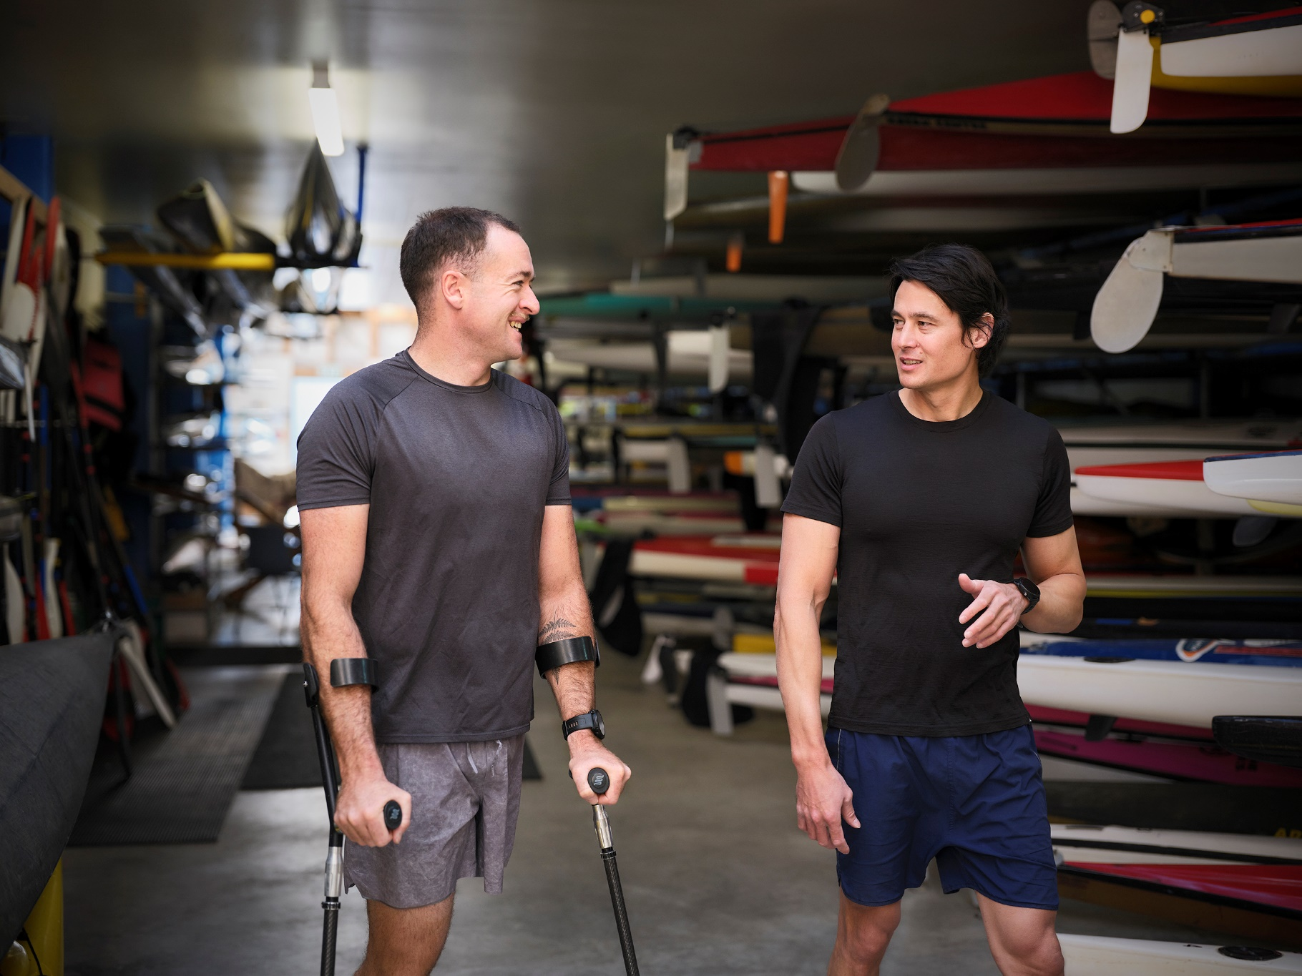
Author: Dr Andrea Knox, Counterbalance Analytics
Analysis conducted: July to December 2023

ACC Disclaimer:
The information in the Measuring Equity of Access to ACC Report available on or through the ACC website is intended to provide general information to the public on measuring equity of access to ACC and all reasonable measures have been taken to ensure the quality and accuracy of the information published. However ACC makes no warranty, express or implied, nor assumes any legal liability or responsibility for the accuracy, suitability, correctness, completeness or use of any information in the Measuring Equity of Access to ACC Report. Nothing contained in the Measuring Equity of Access to ACC Report is, or shall be relied on as a promise or representation by ACC on any of the matters considered in the Measuring equity of access to ACC Report.
The content of the Measuring Equity of Access to ACC Report should not be construed as medical or professional advice. It is not intended to replace clinical judgement or be used as a clinical protocol.
Information contained in the Measuring Equity of Access to ACC Report is current as at the date of the Report and may not reflect any event or circumstances which occur after the date of the Report.
The Measuring Equity of Access to ACC Report does not necessarily represent the official view of ACC or represent ACC policy.
Stats NZ Disclaimer:
Access to the data used in this study was provided by Stats NZ under conditions designed to give effect to the security and confidentiality provisions of the Data and Statistics Act 2022. The results presented in this study are the work of the author, not Stats NZ or individual data suppliers.
These results are not official statistics. They have been created for research purposes from the Integrated Data Infrastructure (IDI) which is carefully managed by Stats NZ. For more information about the IDI please visit https://www.stats.govt.nz/integrated-data/.
Copyright:
Copyright © 2023 Unless otherwise stated, the information in this Measuring Equity of Access to ACC Report is protected by copyright and is subject to the copyright laws of New Zealand. The Measuring Equity of Access to ACC Report was prepared by Dr Andrea Knox of Counterbalance Analytics. The Measuring Equity of Access to ACC Report may be reproduced without permission, subject to the material being reproduced accurately and not being used in a misleading context. In all cases, the Accident Compensation Corporation must be acknowledged as the source.
Acknowledgements:
Many thanks to Dr Mairead Shanahan, Elenita Castillo, and Dr Michele Morris for contributions to this work.
Contents
1 Summary 5
2 Background 7
2.1 Despite being a compulsory scheme, there are disparities in access to the AC Scheme 7
2.2 ACC has undertaken to better understand and address disparities in access 7
2.3 Equity of access to the AC Scheme relates to disparities in ACC claim rates for injured people and it is challenging to measure 8
2.4 ACC has commissioned research on ways to measure disparities in access 8
3 Results 9
3.1 Key findings from the search for New Zealand data on injuries 9
3.1.1 National surveys and ACC claims data can be used to estimate claim rates for injured people but none of the current national surveys support this 9
3.1.2 Other potential (non-survey-based) methods exist, but none hold great promise 10
3.2 Key findings from analysis of GSS 2008-12 data 15
3.2.1 It is possible to use a survey to select people who have been injured within a specified timeframe 15
3.2.2 Similar results are obtained from the GSS and the SoFIE, when comparing injured people’s claim rates across demographic groups 16
3.2.3 Caveat 1: Survey respondents may not recall all injuries and may not consider the full range of ACC-covered conditions when reporting injuries 20
3.2.4 Caveat 2: Survey responses are sensitive to how questions are asked and GSS-like questions may not be the best approach 21
3.2.5 Caveat 3: Sample size constraints limit the usefulness of a survey for intersectional and time series analysis 22
4 Recommendations 23
4.1 Recommendation 1. Use a survey and linked ACC claims data to estimate equity of access for ACC groups 23
4.2 Recommendation 2. Add injury questions to an existing national survey and/or to ACC’s
own survey 24
4.3 Recommendation 3. Use population data in the IDI to carry out a more detailed analysis of claim rates over time and intersectional analysis for ACC groups 24
5 References 26
6 Appendix 1. Data and methods 30
6.1 Search for New Zealand data on injuries 30
6.2 Analysis of linked GSS and ACC data 30
6.2.1 The Integrated Data Infrastructure (IDI) 30
6.2.2 Linking GSS and ACC data in the IDI 30
6.2.3 Analysis of linked GSS and ACC data 31
7 Appendix 2. Survey datasets that were investigated 33
7.1 The General Social Survey (GSS) 33
7.2 The New Zealand Crime and Victims Survey (NZCVS) 33
7.3 The New Zealand Health Survey (NZHS) 34
7.4 The New Zealand Household Disability Survey 34
7.5 The NZ Attitudes and Values Survey (NZAVS) 35
7.6 Growing up in New Zealand (GUINZ) 35
7.7 Pacific Islands Families (PIF) Study 36
7.8 The Home Injury Hazards Study 36
7.9 The Dunedin Multidisciplinary Health and Development Study and The Christchurch Health and Development Study 36
7.10 Other New Zealand survey datasets 37
8 Appendix 3. GSS and SoFIE injury questions 38
8.1 SoFIE 2004-05, 2006-07 and 2008-09 injury questions 38
8.2 GSS 2008, 2010, 2012 injury questions 38
9 Appendix 4. Alternative calculations of the estimate of injured people’s claim rates 43

1 Summary
The Accident Compensation (AC) Scheme provides comprehensive no-fault injury compensation support to people who are injured in an accident. However, even though it is a compulsory scheme, there are disparities in access to its support. Groups that experience barriers to healthcare in general are less likely to lodge an AC claim when injured, more likely to have their claim declined, and less likely to access the full range of diagnostic and treatment support (Tiatia et al. 2006, Wren 2015, Ministry of Health 2019, ACC 2020, Ingham et al. 2022, The Treasury 2022, Xiang et al. 2023).
The Accident Compensation Corporation (ACC) has undertaken to better understand and address disparities in access and is now required, under the AC Amendment Act 2023, to provide annual reports to the Minister on the level of access to the Scheme, disparities in access, and barriers to access among Māori and other identified population groups (The Parliament of New Zealand 2023).
Equity of access to the AC Scheme is defined as the absence of disparities in ACC claim rates for injured people. This is challenging to measure because it requires injury data that is independent of ACC claims (so that we can estimate the proportion of injured people who have made a claim).
A search for existing New Zealand data on injuries showed that no existing New Zealand datasets fully meet ACC’s needs for measuring equity of access among injured people.
- Claim rates for injured people can be estimated using ACC claims data linked to survey data, if the survey is large, nationally representative and asks about injuries. The 2004-09 Surveys of Family, Income and Employment (SoFIE) and 2008-12 General Social Surveys (GSS) asked such questions. Unfortunately, none of the large national surveys currently ask about injuries.
- Various non-survey-based approaches were investigated (for example, using linked hospitalisations and ACC claims data), but all were found to have caveats that make them less promising than a survey-based approach.
To explore the viability of using a survey and linked ACC claims data to estimate claim rates among injured people, GSS 2008-12 responses were linked with ACC data in the Integrated Data Infrastructure (IDI) and claim rates among injured respondents were estimated and compared to published findings from a similar analysis that used the SoFIE (Poland 2018). This analysis showed that it is possible to estimate disparities in access using linked survey and ACC data, but that some caveats need to be considered.
- Gender and ethnicity-based comparisons of equity of access gave similar results across the GSS and the SoFIE, suggesting no significant gender-based difference in injured people’s claim rates and lower claim rates among injured people of Māori and Asian ethnicity. This broadly aligns with what we would expect, given what we already know about barriers to access (Wren 2015, Xiang et al. 2023). The consistency across surveys gives us some reassurance as to the reliability of the approach.
- ACC claim rates can exceed the injury rates reported in surveys, suggesting that survey responses may be influenced by respondents’ recall of injuries and interpretation of injury questions.
- Results are sensitive to the design of the injury questions and the GSS question design may not be the best approach. Instead of asking if a respondent had an injury and then exploring the circumstances of the injury, the GSS asked about accidents due to work, crime, traffic, or other causes, and then asked if the respondent had been injured as a result. The GSS appears to have under-counted injuries that occurred at home, in the community, or due to sport or recreation (which are the largest proportion of ACC claims) probably because they were only covered in a catch-all “other” question. The SoFIE question design gave results that are more comparable to ACC claims data.
- Survey sample size constraints limit the usefulness of this method for time series or intersectional analysis (where the effects of demographic and socio-economic characteristics are explored within Māori and other population groups) because larger datasets are needed for this type of work.
Based on these findings, the following next steps are recommended.
- Use a survey and linked ACC claims data to estimate equity of access for ACC’s identified population groups, potentially basing question design on the SoFIE injury questions.
- To make this possible, add injury questions to an existing national survey, such as those run by the Ministry of Health or Statistics New Zealand, or ACC’s own population survey.
- Use population data in the Integrated Data Infrastructure (IDI) to carry out a more detailed analysis of claim rates over time and an intersectional analysis of claim rates for Māori and other identified population groups.

2 Background

2.1 Despite being a compulsory scheme, there are disparities in access to the AC Scheme
The Accident Compensation (AC) Scheme provides comprehensive no-fault injury compensation support to people who are injured in an accident. Support includes payments towards treatment, help at home and at work, and compensation for lost income. All people in New Zealand are covered by the Scheme including adults and children, citizens, residents, and temporary visitors who are injured in New Zealand (ACC 2023c).
However, despite it being compulsory there is evidence for longstanding disparities in access to AC Scheme support. Groups that experience barriers to healthcare, in general, are less likely to lodge an AC claim when injured, more likely to have their claim declined, and less likely to access the range of diagnostic and treatment services supported by the Accident Compensation Corporation (ACC) (Tiatia et al. 2006, Wren 2015, Ministry of Health 2019, ACC 2020, Ingham et al. 2022, The Treasury 2022, Xiang et al. 2023).

2.2 ACC has undertaken to better understand and address disparities in access
Aligning with its 2023-2032 strategy: Huakina Te Rā, and responding to requirements in the Accident Compensation (Access Reporting and Other Matters) Amendment Act 2023, ACC has undertaken to deepen its understanding of equity and to reduce disparities in access, experience and outcomes (ACC 2023b, The Parliament of New Zealand 2023).
The AC Amendment Act 2023 requires ACC to provide annual Scheme access reports to the Minister covering the level of access to the Scheme, disparities in access, and barriers to access among Māori and other identified population groups. The legislation states that ACC must:
13 (1) Consult with such organisations and people as the Corporation considers appropriate about the methods that it proposes to use in preparing that report, including the methods that the Corporation proposes to use to identify –
(a) The levels of access to the accident compensation scheme by Māori and identified population groups the Corporation proposes to report on in the first annual scheme access report; and
(b) Disparities in access to the accident compensation scheme that affect Māori or any identified population group
The first access report is due soon after June 2024 and the population groups that have been identified for investigating disparities are Māori, Pacific people, Asian people, and disabled people. These are referred to as the ‘ACC groups’ in this report.

2.3 Equity of access to the AC Scheme relates to disparities in ACC claim rates for injured people and it is challenging to measure
The ACC Board interprets equity as ‘The absence of unfair, avoidable, or remedial difference in injury risk, Scheme access, service experience and wellbeing outcomes for the people we serve in Aotearoa’. The ACC 2021-2025 Statement of Intent states that ‘Equity is helping people to get the support they need, when they need it, to recover from injuries’ (ACC 2021).
‘Access’ is about entry to the ACC Scheme at the point of claim lodgement and so equity of access relates to the absence of disparities in claim lodgement rates among injured people. Estimating these disparities is challenging because it requires a measure of injury rates that is independent of ACC claims (so that we can compute the proportion of injured people who have made a claim). There are few independent measures of injury rates and all have caveats.

2.4 ACC has commissioned research on ways to measure disparities in access
ACC has commissioned exploratory research to help it achieve Huakina Te Rā and meet its reporting obligations under the AC Amendment Act 2023. This report presents results from this research, including:
- the findings from a search for existing New Zealand data on injuries
- the findings from a preliminary analysis of 2008-12 General Social Survey (GSS) data on injury rates, with comparisons to previous work that used Survey of Family, Income and Employment (SoFIE) data.
- recommended next steps for ACC, given the findings of this research.

3 Results

3.1 Key findings from the search for New Zealand data on injuries
Discussions with experts and a metadata search were used to investigate potential methods for estimating equity of access (see Appendix 1. Data and methods).

3.1.1 National surveys and ACC claims data can be used to estimate claim rates for injured people but none of the current national surveys support this
Any survey that asks respondents if they have been injured has the potential to be used, in conjunction with ACC data, to estimate the percentage of injured people who lodge ACC claims. If that survey includes data on ethnicity, disability, and other demographic factors, then it can also be used to compare injured people’s claim rates across the ACC groups. A group with a lower claim rate among injured people may be experiencing greater barriers to accessing the AC Scheme.
This approach was used by Poland (2018), who used data from the 2004-09 SoFIE surveys, linked to ACC claims data in the Integrated Data Infrastructure (IDI). Poland first filtered the SoFIE dataset for people who answered yes to the question:
“In the last 12 months, have you had an injury that stopped you from doing your usual activities for more than a week?”
She then used linked ACC claims data to determine whether each person had made an ACC claim in the 12 months prior to the survey. She used multiple regression to estimate the differences in injured people’s claim rates associated with demographic characteristics and socio-economic circumstances and found that, among injured SoFIE respondents:
- increased age was associated with a lower likelihood of claiming
- ethnicity was strongly related to the likelihood of claiming, with Māori and Chinese ethnicities less likely to claim, compared to the NZ European ethnicity
- machine operators and drivers were more likely to claim than people in other occupations, possibly because injuries were more likely to impact their ability to work
- people with qualifications were more likely than people with no qualifications to claim
- people living in rural areas and people who lived with a partner were less likely to claim, although these associations were weaker when variables related to health and access to healthcare were controlled for.
This method holds promise as a way for ACC to estimate equity of access among ACC groups. Unfortunately, the SoFIE was discontinued after 2009.
I searched for other surveys that could be linked to ACC data and used in this way. Such a survey must have the following characteristics.
- It must ask respondents if they have been injured, within a specified timeframe.
- It must contain, or be able to be linked to, data on:
- whether an ACC claim was made within the specified time frame
- ethnicity and disability status (for identification with ACC groups)
- other influencers of injury prevalence and access to healthcare (at a minimum: age and gender, but ideally also location and household and work characteristics).
- It must be current and continuing into the future so that ACC can use it for ongoing reporting.
- It must gather a large enough sample of injured people to support statistical comparisons of claim rates across ACC groups.
- Ideally, it should be a nationally representative survey of adults and children, but some departure from this is acceptable.
Appendix 2 describes the surveys that were considered. I found no currently running surveys with the characteristics needed for this analysis. The GSS from 2008-12 contained questions about injuries, but they were removed after 2012. The New Zealand Crime and Victims Survey (NZCVS) asks about injuries sustained as a result of a crime, but the injured population it identifies is too small to support an analysis of claim rates across ACC groups. Other surveys with injury questions exist, but none have, or can easily be linked to, ACC claims data.

3.1.2 Other potential (non-survey-based) methods exist, but none hold great promise
Several other ways of estimating equity of access were explored, but all were found to have caveats that make them less promising than a survey-based approach. These approaches are discussed below.

3.1.2.1 Data on hospitalised injuries may be useful, but further work is needed to determine if it can be used to estimate equity of access
The IDI includes data on public and private hospitalisations. Diagnostic codes in these datasets can be used to select hospitalisations due to an injury and then linked ACC claims data can be used to find out what proportion of hospitalised people also had an ACC claim. In theory, we can estimate disparities in access to ACC among injured people by comparing this claim rate across groups.
However we have encountered some problems with this approach.
- We see different claim rates associated with different diagnostic codes, suggesting that the type of injury may be a key factor in determining whether a claim is lodged.
- A large proportion of accidental injury-related hospitalisations are associated with claims and this may make it difficult to see any differences in claim rates between groups.
- Hospitalisations tend to be associated with more serious injuries and, as yet, we do not know if the pattern of claim rates for these injuries is generalisable to the wider pool of injuries that ACC provides support for.
ACC is investigating these issues further. The approach may become viable in future, but at this stage we don’t know enough about the factors that drive claim rates among hospitalised people. We need to understand this better to determine whether this is a useful approach for estimating equity of access to the AC Scheme.

3.1.2.2 Primary healthcare data could be used, but it would underestimate disparities associated with barriers to accessing health services
It may be possible to use Primary Healthcare Organisation (PHO) clinical notes to identify people who visit their general practitioner or practice nurse with an injury. ACC claims data for those people could be linked and claim lodgement rates could be investigated using this linked data. There is currently no government source of aggregated PHO clinical data, but Reach Aotearoa has a system, HealthStat, which collates data from 100 geographically representative PHOs (Reach Aotearoa 2023). Reach Aotearoa could be commissioned to use HealthStat data to identify injured people (from clinical notes) and to estimate their ACC claim rates (Barry Gribben, personal communication). However, this would be resource intensive and it would not provide information on people who are injured but do not access primary healthcare. This may produce a misleading result, given that barriers to accessing healthcare are thought to be a key driver of disparities in access to the AC Scheme.

3.1.2.3 Traffic accident data can be used to estimate claim rates, but this data does not currently include the variables we need to estimate equity of access for ACC groups
Waka Kotahi maintains the Crash Analysis System (CAS), which captures information on where, when and how road crashes occur (Waka Kotahi NZ Transport Agency 2023). This dataset includes some demographic details for people involved in traffic accidents and a flag for whether they were injured. ACC has access to some of this data and has confidentially linked it with claims data to estimate claim rates among people who were injured in traffic accidents.
In theory, this linked dataset could be used to estimate disparities in claim rates across ACC groups. However, it currently only includes ethnicity data for ACC claimants and it has no data on disability status. This means that it cannot be used to estimate claim rates for the ACC groups. ACC may be able to negotiate access to ethnicity information for all injured accident victims, but this data may be of poor quality because demographic details are recorded by the police officer at the scene and may have errors due to the difficulty of capturing accurate information under those circumstances (Simon Gianotti, personal communication). Furthermore, no other socio-economic variables are available from the CAS, limiting the insights that it can provide. The analysis would be restricted to traffic accidents that were attended by police. Claim lodgement rates associated with these accidents may not be generalisable to the wider pool of injuries from other causes.

3.1.2.4 Data on victims of crimes resulting in an injury could be used, but results may not be generalisable to the wider population of injured people
Police data on victims of crime is available in the IDI from the Recorded Crime Victims (RCVS) datasets (NZ Police 2016). We could identify an injured population from this data by filtering it for victims of crimes coded to the ANZSOC code: 0211 Serious assault resulting in injury. Linked ACC claims data in the IDI could then be used to estimate claim lodgement rates in that population. Other IDI data could also be linked and multiple regression could be used to estimate associations between ACC claim rates, ACC groups, and other demographic and socioeconomic characteristics.
NZ.Stat data on recorded offences counts 8,000 to 11,000 serious assaults resulting in an injury per year, meaning that the sample size is likely to be sufficient for ACC’s needs (Stats NZ 2023b). However, findings from this analysis may not be generalisable to the wider population of injured people because the data is based only on injuries resulting from a serious assault and where that assault is reported to the police.

3.1.2.5 Injury-related mortality data could be used but the dataset may be too small and results may not be generalisable to non-fatal injuries
The IDI Ministry of Health Mortality dataset contains data on the underlying cause of death for all deaths registered in New Zealand. It includes diagnostic codes that identify injury-related causes of death (Manatū Hauora Ministry of Health 2023a). ACC does provide support in relation to fatal injuries (such as supporting funeral costs and compensation for family members) and, for less sudden fatalities, there may have been additional ACC support for the injured person prior to death. Therefore, it may be possible to use linked mortality and ACC data in the IDI to investigate disparities in access to ACC support relating to fatal injuries.
However, the drivers of disparities may differ for fatal and non-fatal injuries and this, in combination with the relative rarity of fatal accidents, means that the approach is likely to be less informative than other methods.

3.1.2.6 InterRAI injury data cannot be used because it has no information on the date of injury
The International Resident Assessment Instrument (InterRAI) dataset in the IDI contains information derived from assessments of older people’s eligibility for publicly funded home and community support and admission to residential care (InterRAI New Zealand 2023). While it contains an indicator of whether the person has sustained a traumatic injury affecting their care or condition (Gabrielle Stent, personal communication), it is not useful for estimating claim rates as it has no data on when the injury occurred, so ACC claims data cannot be linked with any accuracy.

3.1.2.7 WorkSafe injury data is restricted to serious workplace accidents, so is a limited and non-generalisable source of information on claim rates
WorkSafe collects data on notifications from employers about workplace accidents and near misses (WorkSafe 2023a). However, notifications are only required for serious events (WorkSafe 2023b), meaning that the dataset is small and injuries are almost certain to have been reported to ACC. It is not possible to generate reliable estimates of disparities in claim rates when almost all injuries have an associated claim. Any results that are obtained may not be generalisable to the wider population of injured people.

3.1.2.8 The lag between injury and claim lodgement may not be a good indicator of the likelihood of claiming when injured
In our early discussions with experts, it was suggested that the lag (the length of time elapsed) between injury and ACC claim lodgement may be a good proxy indicator of a person’s propensity to claim when injured. The rationale is that people who put off seeking healthcare for an injury may also be more likely to avoid health service use (and ACC support) altogether. If this were true, we would expect factors that are associated with a lower likelihood of claiming when injured to also be associated with lengthier lags between injury and claim lodgement.
However, preliminary analysis suggested that the opposite may be true. Several factors that were found by Poland (2018) to be associated with a lower likelihood of making a claim when injured were also associated with shorter average lags between injury and claim lodgement. For example, shorter average lags were found for Māori, who are a group that Poland (2018) found were less likely to claim when injured. In addition, the preliminary analysis showed that higher risk occupations and industries were associated with shorter lags. This may make sense if the injuries sustained by people in higher risk situations tend to be more severe or more likely to be of a type where medical care is urgently (and very obviously) needed. People in these situations may be less likely to claim, but when they do claim it may be more likely to be for an injury that requires urgent treatment.
It may be possible to use lags as an indicator of a person’s propensity to claim if we first subset the data for specific injury types or if we incorporate statistical controls for injury type into the method. Further investigation to develop this method is needed, if ACC wishes to pursue it. Without such controls, claim lodgement lags are unlikely to be a good indicator of the likelihood of claiming when injured.

3.2 Key findings from analysis of GSS 2008-12 data
The GSS is a large, nationally representative survey that gathers information on the wellbeing of people living in New Zealand. It was first fielded in 2008 and has been repeated every two years. Each time, it samples approximately 8,000 adults aged 15 years and older and asks a wide range of questions covering demographics, family relationships, income, and social outcomes. The three earliest iterations of the GSS: 2008, 2010 and 2012, included questions about physical health problems or injuries experienced as a result of crime, work, traffic accidents, or accidents at home or elsewhere Appendix 3.
To explore the viability of a survey-based approach to estimating claim rates among injured people, GSS 2008-12 responses were pooled and confidentially linked to respondents’ ACC claims data in the IDI (method described in Appendix 1). The linked data was used to estimate injury and claim rates among GSS respondents with breakdowns by age, gender and ethnicity. Findings are described below and are compared to those of Poland (2018) whose similar (but more detailed) analysis used data from the 2004-09 SoFIE surveys.
Overall, a survey-based approach to estimating claim rates among injured people appears to be viable, giving consistent results across surveys. However, it has caveats, including:
- injury rates are sensitive to questionnaire design
- injuries may be under-reported by survey respondents
- a very large sample size is needed for detailed intersectional and time series analysis.

3.2.1 It is possible to use a survey to select people who have been injured within a specified timeframe
The GSS and the SoFIE both asked about injuries in the last year, but the SoFIE restricted this to injuries that stopped the respondent from doing their normal activities for more than a week, while the GSS imposed no such restriction (the questions are reproduced in Appendix 3). As we would expect, given the more permissive nature of the GSS questions, almost twice as many GSS respondents reported an injury in the last 12 months (21.6%), compared to SoFIE respondents (12.6%) (Table 3.1).
Table 3.1: Proportion of respondents who reported an injury in the last 12 months in the GSS (2008, 2010 and 2012 pooled responses) and the SoFIE (2004/5, 2006/7 and 2008/9 pooled responses calculated by Poland (2018)). Weighted values are adjusted to be representative of the New Zealand population, while the unweighted values are not. The information available in Poland (2018) does not allow calculation of a confidence interval (CI) for the SoFIE weighted proportion with an injury.
Survey | Respondents, unweighted | % with injury, unweighted | % with injury, weighted
GSS | 24,741 | 21.6%  (95% CI: 21.1%, 22.2%) | 21.2%  (95% CI: 20.4%, 21.9%)
SoFIE | 51,147 | 12.6%  (95% CI: 12.3%, 12.9%) | 12.4%

Along with imposing no restriction on the impact of the injury, the GSS questions were less specific to injuries, asking if respondents had a “physical injury or health problem” as a result of a violent crime, a non-violent crime, work, a traffic accident, or another incident (Appendix 3). The injury rates in this report collate responses across these questions. Some of the GSS responses may relate to illnesses without an external cause, rather than injuries caused by accidents, and this may also contribute to the higher injury rates among GSS respondents.
The GSS included questions about the effect of each incident on the respondent’s quality of life. For example, after being asked whether a crime had caused a physical injury or illness, emotional distress, or costs, respondents were asked if the crime had made their quality of life significantly worse, slightly worse, better, or no different. I investigated whether effects on quality of life could be used as indicators of the impact of the injury, but I found that quality of life responses were more strongly correlated with costs and emotional distress than injuries (data not shown) and therefore do not provide a good filter for injuries with a greater impact.

3.2.2 Similar results are obtained from the GSS and the SoFIE, when comparing injured people’s claim rates across demographic groups
Despite the differences in the SoFIE and GSS injury questions, we see similar patterns of claim and injury rates across the two surveys. Patterns across the ACC group ethnicities are very similar. This provides some reassurance that a survey-based method is valid and likely to be consistent over time.
The results in this section estimate injury rates, claim rates, and the proportion of injured people who had a claim, using linked GSS and ACC claims data from the IDI. Figure 3.1 illustrates how these rates were calculated. The injury rate is the proportion of GSS respondents who reported that they had been injured (from any cause) in the last 12 months. The claim rate is the proportion of GSS respondents who had at least one accepted ACC claim with an injury date in the 12 months prior to their GSS interview. The proportion of injured people with a claim divides the number of respondents who had a claim and reported an injury by the total number who reported an injury.
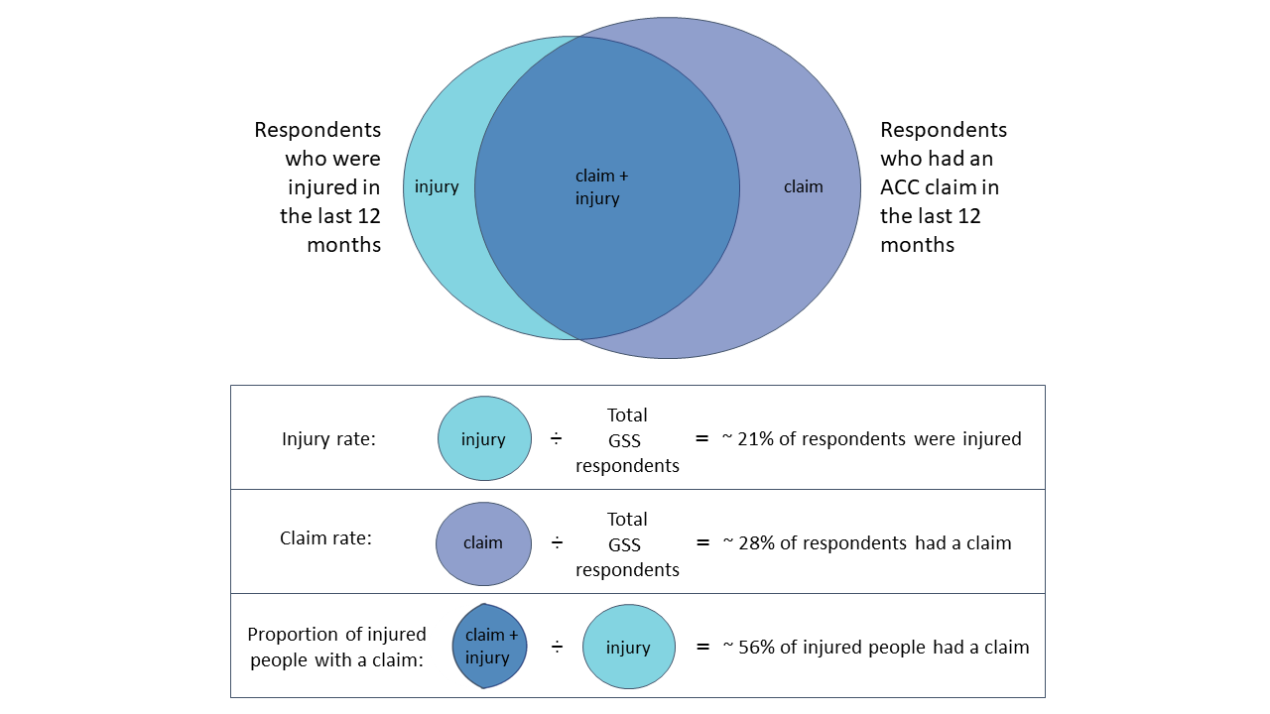
Figure 3.1: Illustration of the approach to estimating injury rates, claim rates, and the proportion of injured people with a claim, using linked GSS and ACC data.
Overall, 21.2% of GSS respondents reported an injury in the last year (95% confidence interval: 20.4%, 21.9%) and 27.7% had an ACC claim with an injury date in the year prior to their survey (95% confidence interval: 26.9%, 28.4%). The proportion of injured GSS respondents with a claim was 55.5% (95% confidence interval: 53.7%, 57.3%).
Pacific and Asian people were significantly less likely to report an injury than non-Pacific and non-Asian people, while Māori were more likely to report an injury than non-Māori (although this difference was only just significant at the 5% level) (Figure 3.2(a)).
Among injured respondents, Māori, Pacific, and Asian people were less likely to have claims than non-Māori, non-Pacific and non-Asian people, respectively (Figure 3.2(c)). There are wide error bars, especially for Pacific and Asian people, because the sample size for injured Pacific and Asian people is fairly low. The only statistically significant difference was the gap between Asian and non-Asian, which is the largest of the ethnicity-based gaps (Figure 3.2(c)). These results are very similar to what was seen in the SoFIE data, where injured Māori and Chinese people had significantly lower claim rates and the gap was especially wide for Chinese (Poland 2018). Note that the Asian group includes more ethnicities than Chinese, but Poland (2018) did not include a comparable Asian group in her analysis, so Chinese is the closest possible comparison.

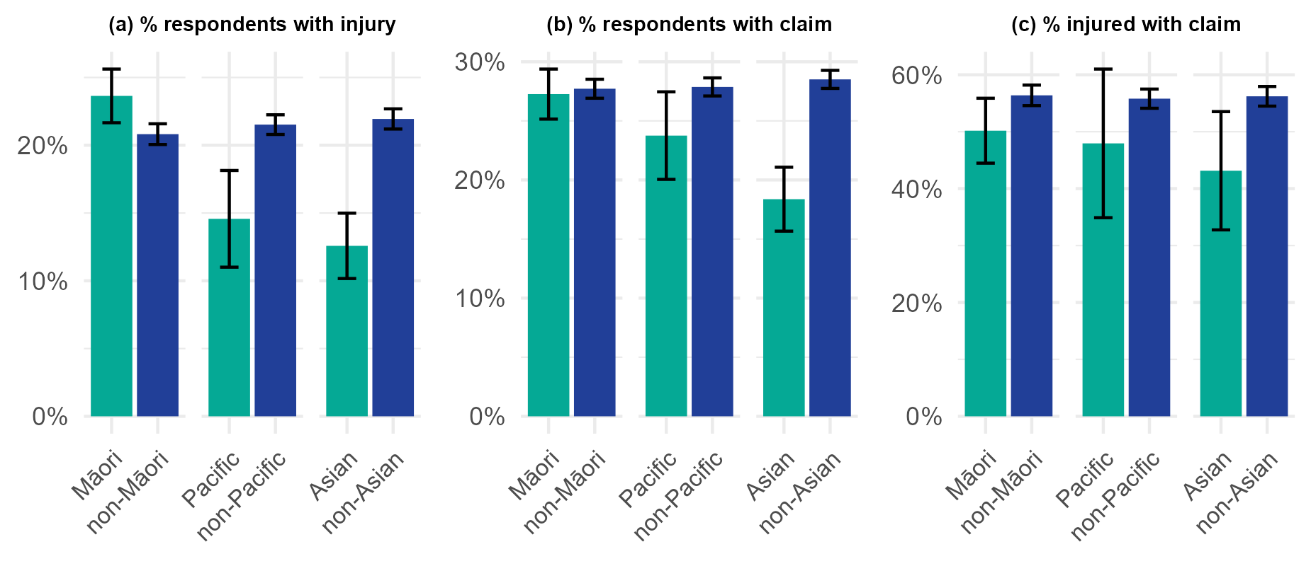
Figure 3.2: Injury and claim rates for Māori compared to non-Māori, Pacific compared to non-Pacific, and Asian compared to non-Asian. (a) The percentage of GSS respondents who reported an injury in the previous 12 months. (b) The percentage of GSS respondents who had an accepted claim with an accident date in the previous 12 months. (c) The percentage of respondents who reported an injury and who also had an accepted claim. Proportions are based on population-weighted data and error bars represent 95 confidence intervals. Note that the charts have different scales on the y-axis.
Figure 3.3(a) shows that, among GSS respondents, the 65+ age group were significantly less likely than younger people to report an injury (13%, as compared to 21-23% of younger people). However, older people were only slightly less likely to have a claim (26% as compared to 28-29%) (Figure 3.3(b)).
Older people who reported injuries in the GSS were slightly more likely than younger people to have a claim, but the difference was not statistically significant at the 5% level (Figure 3.3(c)). This differs somewhat from the SoFIE findings, where the claim rate among 65+ year-olds who reported an injury was slightly lower than that of younger groups (Poland 2018). It is not possible to determine the reasons for this difference, but some possibilities are as follows.
- Over 65-year-olds are less likely to be working and so their injury rates may be particularly affected by the GSS’s under-count of non-work injuries (see Caveat 2). I found that over 65-year-olds were less likely than younger people to report a work injury in the GSS (data not shown). If older people’s injury rates are biased downwards, it could bias their claim rates per injured person upwards.
- The difference may be due to random chance.
Older people might be more likely than younger people to access AC Scheme support for the more moderate injuries covered by the GSS.

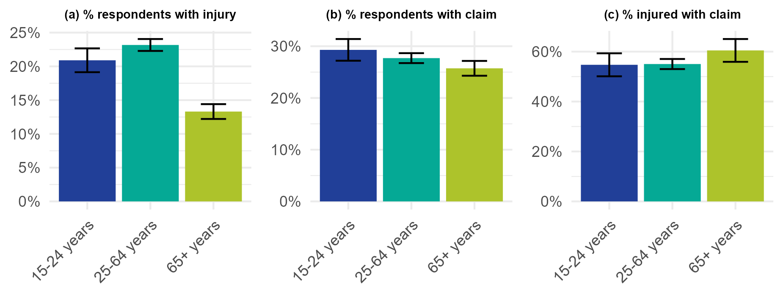
Figure 3.3: Injury and claim rates by age group. (a) The percentage of GSS respondents who reported an injury in the previous 12 months. (b) The percentage of GSS respondents who had an accepted claim with an accident date in the previous 12 months. (c) The percentage of respondents who reported an injury and who also had an accepted claim. Proportions are based on population-weighted data and error bars represent 95 confidence intervals. Note that the charts have different scales on the y-axis.
Men were more likely to report an injury and to have a claim than women (Figure 3.4 (a), (b)), but there were no significant differences in the claim rates of injured men and women (Figure 3.4(c)). This is consistent with results from the SoFIE, which showed no significant difference in injured people’s claim rates by gender (Poland 2018).

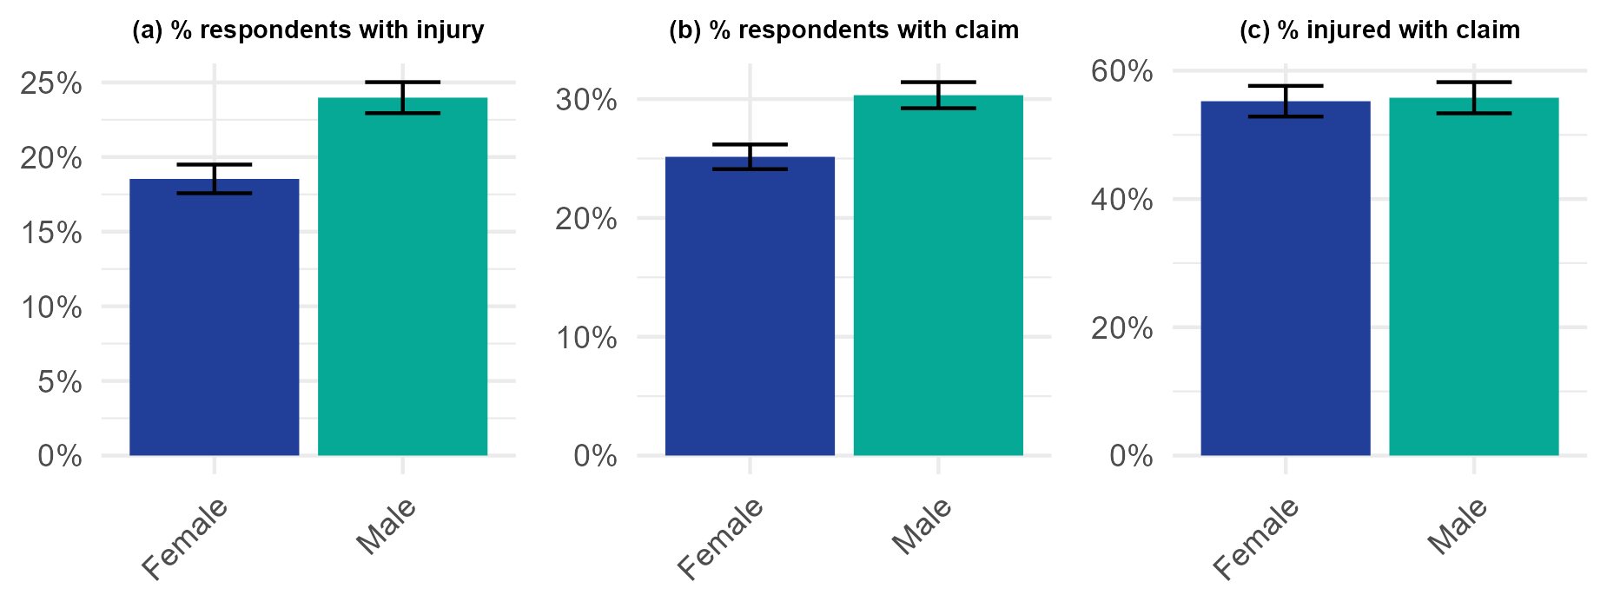
Figure 3.4: Injury and claim rates by gender. (a) The percentage of GSS respondents who reported an injury in the previous 12 months. (b) The percentage of GSS respondents who had an accepted claim with an accident date in the previous 12 months. (c) The percentage of respondents who reported an injury and who also had an accepted claim. Proportions are based on population-weighted data and error bars represent 95 confidence intervals. Note that the charts have different scales on the y-axis.

3.2.3 Caveat 1: Survey respondents may not recall all injuries and may not consider the full range of ACC-covered conditions when reporting injuries
The proportion of respondents who had an ACC claim in the 12 months prior to the survey was around 28% (for both the GSS and the SoFIE), exceeding the proportion who reported an injury (Figure 3.5). Poland (2018) suggested that this difference may result from the SoFIE’s restriction to more limiting injuries than the broader coverage of the AC Scheme. However, the fact that claim rates also exceeded GSS injury rates shows that this is only part of the explanation. Other possible explanations are as follows.
- Respondents may not have recalled some injuries, especially less recent ones.
- Respondents may have interpreted the survey questions as covering a narrower range of injuries than those covered by the AC Scheme.
- Respondents may have been reluctant to discuss injuries with the survey interviewer.
- Some of the ACC claims may have been for problems that were not caused by injuries.

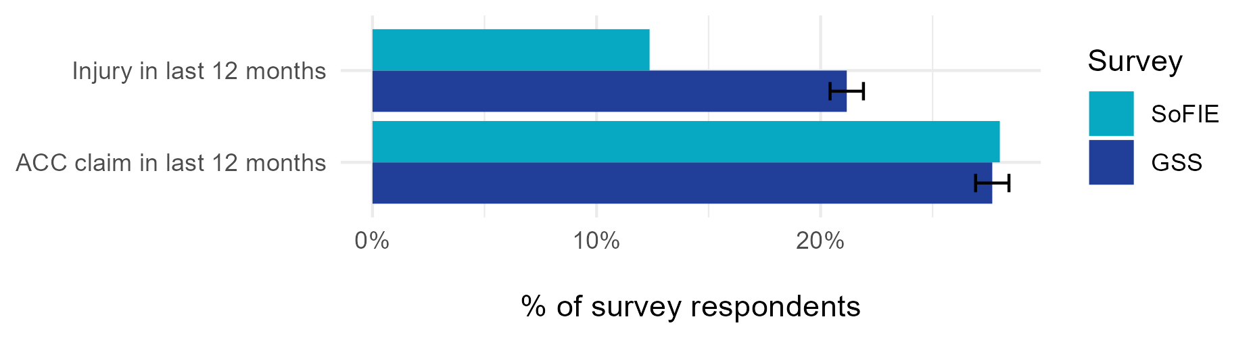
Figure 3.5: Proportion of SoFIE and GSS respondents who reported an injury in the last 12 months compared to the proportion who had an accepted ACC claim in the 12 months prior to the survey. SoFIE results are from Poland (2018) and are pooled across the years 2004/5, 2006/7 and 2008/9. GSS results are pooled across 2008, 2010 and 2012. Proportions are based on population-weighted data. Error bars represent 95 confidence intervals (but are unavailable for the SoFIE results).
This apparent under-reporting of injuries has implications for the technical details of how claim rates among injured people should be estimated. This is discussed in Appendix 4.

3.2.4 Caveat 2: Survey responses are sensitive to how questions are asked and GSS-like questions may not be the best approach
The GSS questionnaire asked about injuries in a less direct fashion than the SoFIE, first asking if people had experienced a safety issue (such as a crime, a traffic accident, or a safety issue at work) and then asking about the follow-on effects, including illness or injury, emotional distress, and costs. This is a less direct approach than the SoFIE, which asked if people had experienced an injury and then asked about the type of injury and where it occurred (Appendix 3).
The GSS yielded a different profile of injury types to ACC claims and SoFIE responses. The largest group of injuries/illnesses related to a safety issue at work (52% of injured respondents). The next largest group was 36% of injured respondents reporting injuries from other incidents (in response to the question: “have you had anything else happen to you that you have not already mentioned?”), followed by injuries from traffic accidents (6% of injured respondents) and crime (6% of injured respondents) (Figure 3.6). In contrast, only 10% of ACC claims are for work injuries, while 88% relate to sport, recreation, or injuries at home or in the community (ACC 2023a). SoFIE responses had a more similar profile to ACC claims: 17% of the injured SoFIE respondents were workers whose injuries happened at work (Poland 2018).

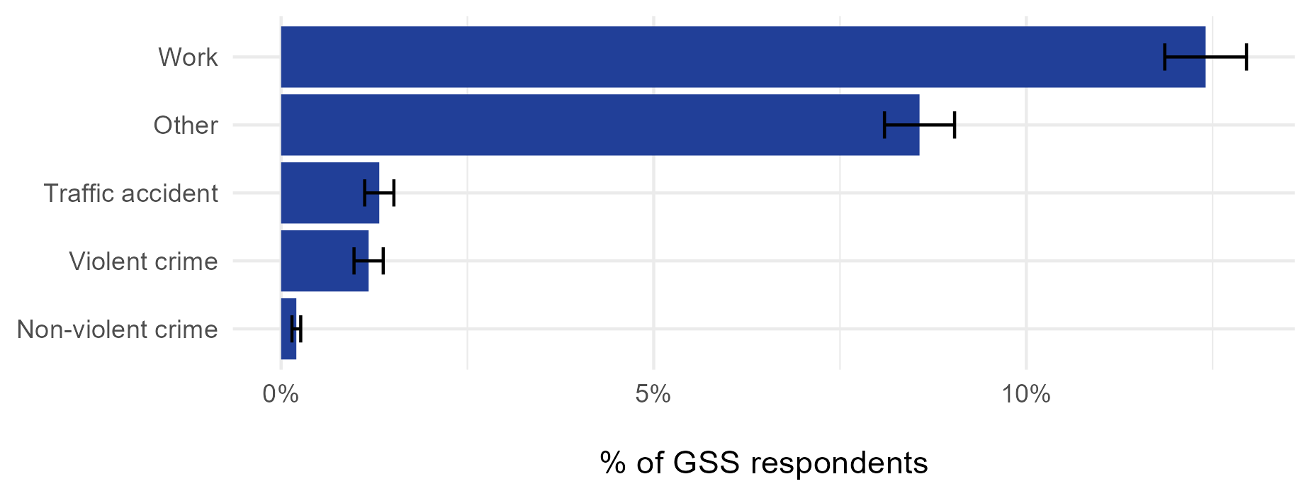
Figure 3.6: Proportion of GSS respondents who reported an injury in the last 12 months that occurred as a result of work, a traffic accident, crime, or another incident. Proportions are based on population-weighted data pooled across the 2008, 2010 and 2012 surveys. Error bars represent 95 confidence intervals. The proportions sum to slightly more than the 21.2% who had any type of injury because some people had multiple injuries.
The GSS responses may have been affected by how the questions were asked and by the ordering of the questions. Injuries that happened at home, in the community, or as a result of sport or recreation were only covered by the final catch-all question about other incidents. Respondents may have failed to recall injuries that happened at home or in the community without specific prompting, and they may also have been tired of talking about safety issues by this point in the survey. The SoFIE’s approach, which first asks about injuries and then asks how and where they occurred may produce an injury rate that is more comparable to ACC data and be a better fit with ACC’s needs.
The fact that injuries from traffic accidents were relatively uncommon in the GSS (as they are in ACC claims and SoFIE responses) gives us some confidence in its results. However the GSS may have substantially under-counted injuries that happened at home, in the community, or at sport and recreation because of its questionnaire design.

3.2.5 Caveat 3: Sample size constraints limit the usefulness of a survey for intersectional and time series analysis
ACC is exploring an intersectional approach in which associations between claim rates and factors such as gender, age, and location will be explored within each ACC group. This approach explicitly acknowledges that the effects of demographic and socio-economic characteristics can vary between the ACC groups and it will help ACC to better target its disparity reduction efforts. In practice, an intersectional approach requires large sample sizes that can be difficult to achieve, even with a survey such as the GSS.
As shown in Table 3.2, the total number of responses pooled across three years was 24,741, but once we filter for injured people who identify as Māori, Pacific or Asian, respondent numbers are much lower. Sample sizes are especially low for injured Pacific people and Asian people, partially due to the lower injury rates that they reported. These numbers are insufficient for all but the most limited intersectional analysis and analysis of changes over time.
Table 3.2: Unweighted GSS sample sizes for the ACC ethnic groups, before further filtering ('Respondents (unweighted count)' column) and after filtering for respondents who reported that they had an injury in the last year ('Injured respondents (unweighted count)' column). Counts are pooled across the three GSS survey years: 2008, 2010 and 2012.

Ethnic group | Respondents  (unweighted count) | Injured respondents  (unweighted count)
All | 24,741 | 5,355
Māori | 2,865 | 675
Pacific | 963 | 150
Asian | 1,329 | 177

There are other national surveys that have a larger sample size than the GSS. For example, the New Zealand Health Survey (NZHS) has an annual sample size of around 14,000 adults and 5000 children and employs a booster sample for Māori (Ministry of Health 2021). The NZHS would be an excellent vehicle for injury questions because of its large sample size and because it collects data on barriers to accessing healthcare, which may provide very useful insights about factors affecting equity of access to ACC. Nevertheless, the NZHS would still be limited in its ability to support an intersectional approach.

4 Recommendations
This work has found that no existing datasets fully meet ACC’s needs for measuring equity of access among injured people. However, a survey-based approach is viable and could be developed, alongside other methods. I recommend the following actions to support ACC’s reporting under the AC Amendment Act 2023.

4.1 Recommendation 1. Use a survey and linked ACC claims data to estimate equity of access for ACC groups
A survey-based approach, where survey questions are used to identify people who have been injured in the last year and linked ACC data is used to estimate the proportion of injured people who had claims, is viable and has been used before (Poland 2018). Injured people’s claim rates can be compared across the ACC groups to estimate equity of access.
This method can meet ACC’s needs for estimating injury rates across a broad representative cross-section of the population, including people who did and did not access healthcare for their injuries. The approach has caveats including sensitivity to how the injury questions are asked and problems with respondents’ recall of injuries. In using this method to compare claim rates between ACC groups, we assume that the problems affect the groups similarly, on average.
The SoFIE may have done a better job than the GSS of identifying people with injuries of a similar profile to those covered by the AC Scheme. I therefore suggest that any new survey question design be based on the SoFIE injury questions but potentially removing the SoFIE’s restriction to injuries that interfered with normal activities for more than a week (in order to include milder injuries that are eligible for ACC coverage).

4.2 Recommendation 2. Add injury questions to an existing national survey and/or to ACC’s own survey
The NZHS and the GSS are existing national surveys that could have injury questions added to them (subject to negotiation with Stats NZ for the GSS and Manatū Hauora Ministry of Health for the NZHS). Both surveys are repeated regularly, have large nationally representative samples, and have their data loaded into the IDI (enabling linkage with ACC claims data). Of these two surveys, the NZHS would be a better choice because its sample size is larger, it employs a booster sample for Māori, and it includes questions on barriers to accessing healthcare, which may be critical determinants of AC Scheme access.
Alternatively, ACC could add injury questions to its own national survey. Subject to respondent permission, injured people’s responses could then be linked to ACC claims data (outside the IDI), enabling an estimate of the proportion who had claims. Compared to the NZHS or GSS, ACC’s own survey will provide ACC with more timely reporting of results and greater control over the survey content. However, it has the disadvantage that the linkage between survey responses and ACC claims data will be less complete than the linkage in the IDI, and the availability of data on other important variables (such as employment status and disability) will be limited to what is available from the survey.
I therefore recommend that ACC pursue addition of injury questions to an existing national survey such as those run by the Ministry of Health or Statistics New Zealand, alongside adding injury questions to its own national survey.

4.3 Recommendation 3. Use population data in the IDI to carry out a more detailed analysis of claim rates over time and intersectional analysis for ACC groups
A major limitation of the survey-based approach is that, even for large surveys, sample sizes become small once responses are filtered for injured people within the ACC groups. The survey-based approach can be used to estimate broad comparisons of claim rates across ACC groups, but it will not support a detailed intersectional analysis of demographic and socio-economic influences within ACC groups. It will also be limited in its ability to produce robust comparisons over time.
For this reason, I recommend accompanying the survey with an IDI-based analysis of population data that investigates claim rates over time and associations between claim rates and other demographic and socio-economic characteristics within the ACC groups.
Population data in the IDI has the numbers to support this analysis, but it does not allow us to filter for injured people, so its claim rates will be influenced both by injury rates and by the proportion of injured people who claim. It therefore cannot measure equity of access among injured people directly, but it can provide context for the survey results and information on sub-groups within the ACC groups who may be experiencing greater barriers to access.

5 References

ACC (2020) Te Wero: Te Ara Kōmihana i ngā rātonga kaupapa Māori ki Te Ara Te Kaporeihana Āwhina Hunga Whara, The Challenge. ACC.
ACC (2021) Tauākī Whakamaunga atu Statement of Intent 2021–2025. ACC. Available from: https://www.acc.co.nz/assets/corporate-documents/ACC7849-Statement-of-Intent-2021-2025.pdf.
ACC (2023a) Injury claim statistics. Available from: https://www.acc.co.nz/newsroom/media-resources/injury-claim-statistics/.
ACC (2023b) Our strategy | Huakina Te Rā. Available from: https://www.acc.co.nz/about-us/corporate-documents/our-strategy-huakina-te-ra/ .
ACC (2023c) What we do. Available from: https://www.acc.co.nz/about-us/who-we-are/what-we-do (October 31, 2023).
AUT Pacific Health Research Centre (2023) Pacific Islands Families Study. Available from: https://phrc.aut.ac.nz/our-research/pacific-islands-families-study.
Christchurch Health and Development Study (2023) Christchurch Health and Development Study. Available from: https://www.otago.ac.nz/christchurch/research/healthdevelopment/.
Dunedin Multidisciplinary Health & Development Research Unit (2023) For researchers. Available from: https://dunedinstudy.otago.ac.nz/for-investigators.
Growing Up in New Zealand (2023) Available Data. Available from: https://www.growingup.co.nz/available-data-2.
Ingham TR, Jones B, Perry M, King PT, Baker G, Hickey H, Pouwhare R, Nikora LW (2022) The Multidimensional Impacts of Inequities for Tangata Whaikaha Māori (Indigenous Māori with Lived Experience of Disability) in Aotearoa, New Zealand. International Journal of Environmental Research and Public Health 19: 13558. https://doi.org/10.3390/ijerph192013558
InterRAI New Zealand (2023) Data and reporting. Available from: https://www.interrai.co.nz/data-research-and-reporting/.
Keall M (2009) Taranaki home injury hazards study. Available from: https://www.healthyhousing.org.nz/sites/default/files/2021-12/Press_Study-finds-multiple-hazards-Injury2.pdf.
Manatū Hauora Ministry of Health (2012) New Zealand Health Survey Content Guide and questionnaires 2012/13. Available from: https://www.health.govt.nz/publication/new-zealand-health-survey-content-guide-and-questionnaires-2012-13.
Manatū Hauora Ministry of Health (2023a) Mortality data and stats. Available from: https://www.health.govt.nz/nz-health-statistics/health-statistics-and-data-sets/mortality-data-and-stats.
Manatū Hauora Ministry of Health (2023b) New Zealand Health Survey. Available from: https://www.health.govt.nz/nz-health-statistics/surveys/new-zealand-health-survey.
Ministry of Health (2019) Achieving Equity in Health Outcomes: Summary of a discovery process. Ministry of Health. Available from: https://www.health.govt.nz/publication/achieving-equity-health-outcomes-summary-discovery-process (November 21, 2023).
Ministry of Health (2021) Methodology Report 2020/21: New Zealand Health Survey. Manatū Hauora Ministry of Health. Available from: https://www.health.govt.nz/publication/methodology-report-2020-21-new-zealand-health-survey.
Ministry of Justice (2022a) Data tables for NZCVS Key findings – Cycle 4. Ministry of Justice. Available from: https://www.justice.govt.nz/assets/20220518-NZCVS-Cycle-4-Section-9-Crime-scene-and-consequences-final-v0.5.xlsx.
Ministry of Justice (2022b) Survey findings – Cycle 4 report. Ministry of Justice. Available from: https://www.justice.govt.nz/assets/Cycle-4-Core-Report-v0.20-20220628.pdf.
NZ Police (2016) Data and statistics user guides. Available from: https://www.police.govt.nz/about-us/publication/data-and-statistics-user-guides.
Poland MA (2018) The determinants of injury compensation claims in a universal claims environment. PhD thesis. University of Otago Available from: http://hdl.handle.net/10523/8497.
Reach Aotearoa (2023) HealthStat: Primary Healthcare Intelligence. Available from: https://reach.co.nz/Services/Population+Health+Monitoring/HealthStat.html.
Ruiz B, Broadbent JM, Thomson WM, Ramrakha S, Boden J, Horwood J, Poulton R (2022) Is childhood oral health the “canary in the coal mine” for poor adult general health? Findings from two New Zealand birth cohort studies. Community Dent Oral Epidemiol. 00: 1–9. https://doi.org/10.1111/cdoe.12772
Schluter PJ, Paterson J, Percival T (2006) Non-fatal injuries among Pacific infants in Auckland: Data from the Pacific Islands Families First Two Years of Life study. Journal of Paediatrics and Child Health 42: 123–128. Available from: https://doi.org/10.1111/j.1440-1754.2006.00810.x.
School of Psychology, University of Auckland (2018) The NZAVS Time 10 (2018) Postal Questionnaire.pdf. School of Psychology, University of Auckland. Available from: https://osf.io/gptda.
School of Psychology, University of Auckland (2023) The New Zealand Attitudes and Values Study. Available from: https://www.psych.auckland.ac.nz/en/about/new-zealand-attitudes-and-values-study.html.
Stats NZ (2005) SoFIE survey objectives and questionnaire flowcharts. Health modules. Available from: https://cdm20045.contentdm.oclc.org/digital/collection/p20045coll2/id/1232/rec/1.
Stats NZ (2011) User Guide for the 2010 New Zealand General Social Survey Basic Confidentialised Unit Record File. Stats NZ. Available from: https://www.stats.govt.nz/assets/Uploads/Retirement-of-archive-website-project-files/Sitetree-pages/Confidentialised-unit-record-files/04-curf-user-guide-nzgss-2010.pdf (November 13, 2023).
Stats NZ (2013) New Zealand General Social Survey (2012). Available from: https://statsnz.contentdm.oclc.org/digital/collection/p20045coll2/id/528/rec/38%202010.
Stats NZ (2018) About the General Social Survey. Available from: https://www.stats.govt.nz/help-with-surveys/list-of-stats-nz-surveys/about-the-general-social-survey/.
Stats NZ (2020) Microdata output guide (fifth edition). Stats NZ. Available from: https://www.stats.govt.nz/assets/Methods/Microdata-Output-Guide-2020-v5-Sept22update.pdf (November 13, 2023).
Stats NZ (2022) Integrated Data Infrastructure. Available from: https://www.stats.govt.nz/integrated-data/integrated-data-infrastructure/ (November 13, 2023).
Stats NZ (2023a) Household Disability Survey 2023: Final content. Stats NZ. Available from: https://www.stats.govt.nz/reports/household-disability-survey-2023-final-content.
Stats NZ (2023b) NZ.Stat Annual Recorded Offences for the latest Calendar Years (ANZSOC). Available from: https://nzdotstat.stats.govt.nz/.
The Parliament of New Zealand (2023) Accident Compensation (Access Reporting and Other Matters) Amendment Act 2023.
The Treasury (2022) Pacific peoples’ wellbeing: Background Paper to Te Tai Waiora: Wellbeing in Aotearoa New Zealand. The Treasury. Available from: https://www.treasury.govt.nz/sites/default/files/2023-04/ap23-01.pdf (November 21, 2023).
Tiatia, J. and Kingi, P. and Clarke, F. P. (2006) “ACCess” Pacific Peoples’ Access and ACC. NIU Development Inc.
University of Auckland (2023) Growing Up in New Zealand. Available from: https://www.growingup.co.nz.
Waka Kotahi NZ Transport Agency (2023) Crash Analysis System (CAS). Available from: https://www.nzta.govt.nz/safety/partners/crash-analysis-system/.
WorkSafe (2023a) Data Centre. Available from: https://data.worksafe.govt.nz/.
WorkSafe (2023b) What events need to be notified? Available from: https://www.worksafe.govt.nz/notifications/what-events-need-to-be-notified/.
Wren P J.and Jansen (2015) Brief of Expert Evidence: History of Maaori underutilisaton ACC injury treatment and rehabilitation support services, the barriers to their utilisation, and what works to improve service delivery to Māori. ACC Research, Wellington, New Zealand.
Xiang V, Parackal S, Gurung G, Subramaniam RM (2023) Asian migrants navigating New Zealand primary care: A qualitative study. Journal of Primary Health Care 15: 30–37. https://doi.org/10.1071/HC22132

6 Appendix 1. Data and methods

6.1 Search for New Zealand data on injuries
Discussions with government and academic experts sought their advice on methods of estimating equity of access and their suggestions for existing data that could help.
This was accompanied by a review of the potentially useful datasets’ metadata, focused on the following questions.
- What population is included in the dataset (and who is not included)?
- Does the dataset identify people who were injured, and within a specified timeframe?
- Does the dataset contain, or can it be linked to, individual-level data on whether an ACC claim was made within the specified time frame?
- Does the dataset contain, or can it be linked to, individual-level data on identification with the ACC groups and influencers of injury prevalence and access to healthcare?
- What time period is the usable data available for and is it likely to be updated in future?

6.2 Analysis of linked GSS and ACC data

6.2.1 The Integrated Data Infrastructure (IDI)
GSS and ACC data were accessed through the Integrated Data Infrastructure (IDI), a large research database developed by Statistics New Zealand (Stats NZ 2022). The IDI links data across various administrative data sources, including health, welfare and economic data, as well as Census and survey data collected by Statistics New Zealand. The IDI operates under strict security protocols to maintain the security, privacy and confidentiality of individuals and their information.

6.2.2 Linking GSS and ACC data in the IDI
GSS 2008, 2010 and 2012 responses were linked to ACC claims data for each respondent using the snz_uid variable: a unique identifier assigned to each person in the IDI. For each GSS respondent, ACC claims data was extracted for claims that had an accident date within the 12 months prior to their GSS interview date. Respondents were further limited to those that could be linked to the IDI spine, so that responses where linkage failed would not be counted as people who had not made a claim.
At the time of the analysis, ACC data in the IDI only included accepted claims. People counted as having made a claim are therefore restricted to those for who had a claim that was accepted; claims that were lodged but then declined by ACC are not included.

6.2.3 Analysis of linked GSS and ACC data
The results presented in this report use both weighted and unweighted data from the GSS. Weighted data use the GSS survey weights that are provided by Stats NZ to transform the GSS sample estimates into representative population estimates. Confidence intervals were estimated using the GSS replicate weights, provided by Stats NZ for this purpose (Stats NZ 2011).
As required by the microdata output rules of the IDI, all results were rounded to maintain confidentiality and suppressed if based on small samples (Stats NZ 2020).
Age, gender and ethnicity variables were derived from the GSS 2008-12 datasets in the IDI and are based on respondents’ answers to the demographic questions in the GSS. Total ethnicity is used, meaning that people who identified as an ethnicity were categorised into that group, while people who did not identify as that ethnicity were categorised as non-members of the group. People who identified as more than one ethnicity were classified into each group that they identified with.
Injury variables were derived from questions SAFQ06 to SAFQ24 of the 2008-12 GSS surveys (Appendix 3), as follows.
- people who answered “I had a physical injury or health problem” in response to question SAFQ06 were classified as having an injury resulting from a violent crime.
- people who answered “I had a physical injury or health problem” in response to question SAFQ10 were classified as having an injury resulting from a non-violent crime.
- people who answered “Yes” to question SAFQ12 were classified as having an injury at work.
- people who answered “I had a physical injury or health problem” in response to question SAFQ19 were classified as having an injury resulting from a traffic accident.
- people who answered “I had a physical injury or health problem” in response to question SAFQ243 were classified as having an injury resulting from another incident.
- people who reported one or more of any of the types of injuries above were classified as having an injury in the last 12 months.
Linked ACC data was used to create a flag for whether the respondent had made at least one claim for an injury occurring in the 12 months prior to the survey.
Where an injured person had a claim, it is not possible to determine whether the claim was, in fact, for the injury that they reported in the GSS. The analysis simply looks at the probability of an injured person having a claim and compares probabilities across groups.

7 Appendix 2. Survey datasets that were investigated

7.1 The General Social Survey (GSS)
The GSS is a large, nationally representative survey that gathers information on the wellbeing of people living in New Zealand. It was first fielded in 2008 and is repeated every two years. Each time, it samples approximately 8,000 adults aged 15 years and older and asks a wide range of questions covering demographics, family relationships, income, and social outcomes (Stats NZ 2018).
The three earliest iterations of the GSS (2008, 2010 and 2012) included questions about physical health problems or injuries resulting from crime, work, traffic accidents, or accidents at home or elsewhere.
GSS data is in the IDI, so it can be easily linked to ACC claims data (which is also in the IDI). Unfortunately, there have been no injury-related questions in the GSS since 2012, making it of no use for ACC’s ongoing reporting. However, GSS 2008-12 injury data is useful as a consistency check on the results of Poland (2018), so that we can better understand the viability of a survey-based approach.

7.2 The New Zealand Crime and Victims Survey (NZCVS)
The NZCVS is an annual survey of people usually resident in NZ and aged 15 or over that gathers information on experiences of crime. It samples around 8,000 people per year and includes oversampling of Māori to help with obtaining statistically significant results by ethnicity. It has run annually since 2018, and has sampled a total of 29,737 people, including 9377 Māori, between March 2018 and November 2021 (Ministry of Justice 2022b). NZCVS data is present in the IDI.
NZCVS respondents are asked about experiences of crime in the last 12 months and if they were injured as a result. We could filter for respondents who reported an injury as a result of a crime and use linked to ACC claims data in the IDI to estimate claim rates among ACC groups.
However, there are two major problems:
- The NZCVS sample size is likely to be too low to support anything other than a very basic analysis by ACC group. Based on published data from the NZCVS, which reports around 57-61 offences per 100 adults, 8.86% of which resulted in an injury (Ministry of Justice 2022a). I estimate a sample size of around 1500 people with injuries, pooled across the four most recent survey years. This small sample size will limit the statistical power of the analysis and will not provide reliable findings on relationships between ACC groups and claim rates.
- This analysis would only include only injuries resulting from a crime. These injuries may not be representative and the disparities in claim lodgement rates associated with these situations may not be generalisable to disparities in general.

7.3 The New Zealand Health Survey (NZHS)
The NZHS is a nationally representative survey of people usually resident in New Zealand that is used to monitor population health and provide evidence for health policy and strategy development (Manatū Hauora Ministry of Health 2023b). It was first fielded in 1992/93 and it became an annual survey in 2011/12. It has an annual sample size of around 14,000 adults and 5000 children (Ministry of Health 2021).
A module on injuries and poisonings was included in 1997/97 but was subsequently dropped from the survey. Since then, the only injury-specific survey content has been three questions in 2012/13 about injuries due to drug or alcohol use (Manatū Hauora Ministry of Health 2012).
While none of the current NZHS data is helpful for estimating injury rates, the NZHS would be an excellent vehicle for future injury-related questions. The NZHS has a strong focus on barriers to healthcare and its data is available in the IDI. Analysing ACC claim lodgement rates in the context of these barriers would provide very useful insights on the associations between barriers and disparities in accessing the AC Scheme.

7.4 The New Zealand Household Disability Survey
The Disability Survey was fielded in 2013 and again in 2023. It collects information on the characteristics of disabled people in New Zealand, including the nature and cause of impairments and the types of support needed. It underwent a major overhaul for 2023 and, for the first time, it asked specific questions about accidents and receipt of ACC support (Stats NZ 2023a). In time, this data will become available, enabling analysis of factors associated with disparities in ACC support among people experiencing disability due to an accident.
The 2013 Disability Survey did not ask about receipt of ACC support and used a different method to define a disabled population. As a result, it is not comparable to 2023 and is of limited use for ACC’s work on equity of access. Once 2023 data is available, it should be explored for the insights it may provide on equity of access to the AC Scheme among disabled people.

7.5 The NZ Attitudes and Values Survey (NZAVS)
The NZAVS is a longitudinal national study of social attitudes, personality, ideology and health outcomes. It has run annually since 2009 and has collected responses from more than 70,000 New Zealand residents (School of Psychology, University of Auckland 2023).
From 2018 onwards, it has asked whether respondents experienced any significant life events in the past year and one of the response options for this question is “suffered an accident leading to serious injury” (School of Psychology, University of Auckland 2018). This question could be used to filter for injured respondents and be compared to ACC claims data from the relevant time periods.
The survey’s sample size is likely to be sufficient to support this analysis, but there are two potential problems.
- The injury question is open to interpretation and the effect of this on the consistency of responses needs investigation.
- NZAVS data is not in the IDI and the survey’s consent provisions may prohibit access to the data for people outside of the research team responsible for the survey. So it may not be possible to link ACC claims data for NZAVS respondents.
The potential usefulness of this survey could be explored further, but it was not pursued as part of this project.

7.6 Growing up in New Zealand (GUINZ)
Growing Up in New Zealand is a large longitudinal study of child health and wellbeing, with responses from more than 6000 rangatahi and their families (University of Auckland 2023). The rangatahi followed by the survey were born in born in 2009-10 and are now 13-14 years of age. The survey collects a large amount of information on demographic and socio-economic characteristics and barriers to accessing healthcare.
Some waves of the study have asked whether the child experienced an injury for which they accessed healthcare services (Growing Up in New Zealand 2023). GUINZ data is not in the IDI, but there is a process for applying to access it and it might be possible to get permission to link ACC data for respondents who reported an injury.
This approach could be explored further for future work focusing on childhood injuries. As yet, due to its longitudinal nature, the GUINZ does not include any injury data for adults.

7.7 Pacific Islands Families (PIF) Study
The PIF is a longitudinal study, based in South Auckland, that follows a cohort of 1398 Pacific children since their birth in 2000 (AUT Pacific Health Research Centre 2023). While the PIF questionnaires are not available online, several published papers indicate that questions about injuries have been asked (Schluter et al. 2006, Ruiz et al. 2022). These papers do not include any findings based on ACC claims data, suggesting that no linkage to ACC claims has been done.
PIF data is not in the IDI but options for accessing and linking the data could be explored further for future work focusing on childhood injuries.

7.8 The Home Injury Hazards Study
The Home Injury Hazards Study collected information from around 1000 homes (housing around 2000 people), on safety hazards in the home, injury history among the home’s inhabitants, and demographic and socioeconomic characteristics (Keall 2009). The self-reported injury data was linked to ACC claims and so this dataset could be used to investigate ACC claim rates among injured people. However, the study was carried out in the early 2000’s and so its data is now around 20 years old. In addition, the study did not oversample particular ethnic groups, so its sample size is unlikely to support much in the way of detailed analysis within ACC groups (Michael Keall, personal communication).
Later studies by the same group, including the Home Injury Prevention Intervention (HIPI), the Māori Home Injury Prevention Intervention (MHIPI), and Safety on Steps (SOS) used ACC data only and did not collect self-reported injury data (Michael Keall, personal communication).

7.9 The Dunedin Multidisciplinary Health and Development Study and The Christchurch Health and Development Study
There are two long-running longitudinal studies based in the South Island: the Dunedin Multidisciplinary Health and Development Study (Dunedin Multidisciplinary Health & Development Research Unit 2023) and The Christchurch Health and Development Study (Christchurch Health and Development Study 2023). Both have completed many waves of interviews and it is likely that injury-related data has been collected. However, these studies began at a time when oversampling for particular ethnicities was not common practice in New Zealand research. As a result, the sample sizes for the ACC group ethnicities are too small to be useful for this project.
- The Dunedin Multidisciplinary Health and Development Study includes 7.5% Māori and 1.5% Pacific people, equating to approximately 74 and 15 people, respectively (Ruiz et al. 2022).
- For the Christchurch Health and Development Study, approximately 13% of participants report Māori or Pacific ethnicity, equating to around 164 people (Ruiz et al. 2022).

7.10 Other New Zealand survey datasets
Metadata from the following large-scale surveys were investigated and found to have no injury-related content that would meet ACC’s needs.
- the Household Economic Survey (HES)
- the Household Labour Force Survey (HLFS)
- the New Zealand Income Survey (which is now integrated into the HLFS)
- the Living in Aotearoa Survey
- the New Zealand Census (although it contains no injury-related content, the Census is a useful source of data on other variables)
- The Youth2000 series of surveys
- Te Hoe Nuku Roa
- the Longitudinal Immigration Study of New Zealand
- the Health Work and Retirement Study (the 2022 questionnaire asked if respondents had ever had a head injury but there is no information on an injury date, so we cannot match responses to ACC claims data).

8 Appendix 3. GSS and SoFIE injury questions

8.1 SoFIE 2004-05, 2006-07 and 2008-09 injury questions
The following questions were in the Health module of the SoFIE questionnaire (Stats NZ 2005).
qInjury. In the last 12 months, have you had an injury that stopped you from doing your usual activities for more than a week?
An injury includes burns, near drownings, and poisoning.
yes ►go to qMoreThan1
no, DK, RF ►go to next section
qMoreThan1. In the last 12 months, did you have more than one injury?
yes, no, DK, RF ►go to qInjuryType
qInjuryType. Looking at Showcard 64, what type of injury was [it]/[the most recent that stopped you from doing your usual activities for more than a week]?
an injury from a traffic accident ►go to qWhere
a sports injury ►go to qWhere
another type of injury ►go to qWhere
DK ►go to qWhere
RF ►go to next section
qWhere. Looking at showcard 65, where did it happen?
at home ►go to illness questions
at work ►go to illness questions
at another place ►go to illness questions
DK, RF ►go to next section

8.2 GSS 2008, 2010, 2012 injury questions
The following questions were included in the safety module of the GSS questionnaire (Stats NZ 2013).
For people who reported that at least one violent crime was committed against them in the last 12 months:
SAFQ06. Looking at showcard 34, did any of these things happen to you as a result of that crime/those crimes involving violence? You can choose as many as you need.
I had a physical injury or health problem ►go to SAFQ07
I experienced emotional hurt, or severe distress ►go to SAFQ07
I had costs to cover, or had things to replace or repair ►go to SAFQ07
other – please specify ►go to SAFQ06
nothing happened ►go to SAFQ07
don’t know ►go to SAFQ07
refused ►go to SAFQ07
SAFQ07. Looking at showcard 35, overall, what effect has that crime/have those crimes involving violence had on your quality of life?
it is significantly worse
it is slightly worse
no effect
it worked out better in the end
don’t know
refused
For people who reported that at least one non-violent crime was committed against them in the last 12 months:
SAFQ10. Looking at showcard 34, did any of these things happen to you as a result of that non-violent crime/those non-violent crimes? You can choose as many as you need.
I had a physical injury or health problem ►go to SAFQ11
I experienced emotional hurt, or severe distress ►go to SAFQ11
I had costs to cover, or had things to replace or repair ►go to SAFQ11
other – please specify ►go to SAFQ10Oth
nothing happened ►go to SAFQ11
don’t know ►go to SAFQ11
refused ►go to SAFQ11
SAFQ11. Looking at showcard 35, overall, what effect has that non-violent crime/have those non-violent crimes had on your quality of life?
it is significantly worse ►go to SAFIntro3
it is slightly worse ►go to SAFIntro3
no effect ►go to SAFIntro3
it worked out better in the end ►go to SAFIntro3
don’t know ►go to SAFIntro3
refused ►go to SAFIntro3
Work injury/illness questions:
SAFIntro3 The next few questions are about your safety at work in the last 12 months. In these questions, please do not count traffic accidents. I will not be asking you for details of things that have happened to you
Please don’t mention situations you have already told me about.
SAFQ12. In the last 12 months, did you have any kind of physical health problem or injury while working? This could be anything from an accident to a long term back problem or Occupational Overuse Syndrome.
Yes ►go to SAFQ13
no ►go to SAFQ14
respondent hasn’t worked in the last 12 months ►go to SAFIntro5
don’t know ►go to SAFQ14
refused ►go to SAFQ14
SAFQ13. Did this cause you to have any additional costs, loss of money or income?
Yes ►go to SAFQ14
no ►go to SAFQ14
don’t know ►go to SAFQ14
refused ►go to SAFQ14
SAFQ14. In the last 12 months, did you experience any emotional hurt or severe distress because of work?
Yes ►go to SAFQ15
no ►go to decision box
respondent hasn’t worked in the last 12 months ►go to decision box
don’t know ►go to decision box
refused ►go to decision box
SAFQ15. Did this cause you to have any additional costs, loss of money or income?
Yes ►go to SAFQ16
No ►go to SAFQ16
don’t know ►go to SAFQ16
refused ►go to SAFQ16
SAFQ16. Looking at showcard 35, overall, what effect have all those incidents at work had on your quality of life?
it is significantly worse ►go to SAFIntro5
it is slightly worse ►go to SAFIntro5
no effect ►go to )SAFIntro5
it worked out better in the end ►go to SAFIntro5
don’t know ►go to SAFIntro5
refused ►go to SAFIntro5
For people who reported that they had at least one traffic accident in the last 12 months (as a driver, passenger, pedestrian or cyclist):
SAFQ19. Looking at showcard 34, did any of these things happen to you as a result of that accident/those accidents? You can choose as many as you need.
I had a physical injury or health problem ►go to SAFQ20
I experienced emotional hurt, or severe distress ►go to SAFQ20
I had costs to cover, or had things to replace or repair ►go to SAFQ20
other – please specify ►go to SAFQ19Oth
nothing happened ►go to SAFQ20
don’t know ►go to SAFQ20
refused ►go to SAFQ20
SAFQ20. Looking at showcard 35, overall, what effect has that/have those accidents had on your quality of life?
it is significantly worse ►go to SAFQ21
it is slightly worse ►go to SAFQ21
no effect ►go to SAFQ21
it worked out better in the end ►go to SAFQ21
don’t know ►go to SAFQ21
refused ►go to SAFQ21
Other injury/illness questions:
SAFQ21. In the last 12 months, have you had anything else happen to you that you have not already mentioned? For example, accidents at home, or while on holiday, or things that happened in your leisure time. Again I will not be asking you for any details.
yes ►go to SAFQ22
no ►go to SUPIntro1
don’t know ►go to SUPIntro1
refused ►go to SUPIntro1
SAFQ22. Did more than one thing happen to you?
yes ►go to SAFQ23
no ►go to SAFQ23
don’t know ►go to SAFQ23
refused ►go to SUPIntro1
SAFQ23. Looking at showcard 34, did any of these things happen to you because of that incident/those incidents? You can choose as many as you need.
I had a physical injury or health problem ►go to SAFQ24
I experienced emotional hurt, or severe distress ►go to SAFQ24
I had costs to cover, or had things to replace or repair ►go to SAFQ24
other – please specify ►go to SAFQ23Oth
nothing happened ►go to SAFQ24
don’t know ►go to SAFQ24
refused ►go to SAFQ24
SAFQ24. Looking at showcard 35, overall, what effect has that incident/have those incidents had on your quality of life?
it is significantly worse ►go to SAFIntro1
it is slightly worse ►go to SAFIntro1
no effect ►go to SAFIntro1
it worked out better in the end ►go to SAFIntro1
don’t know ►go to SAFIntro1
refused ►go to SAFIntro1
End of module

9 Appendix 4. Alternative calculations of the estimate of injured people’s claim rates
In this report, and in the work of Poland (2018), claim rates were estimated by first filtering survey data for injured survey respondents and then finding the proportion of injured respondents who had an ACC claim (using linked IDI data). An alternative approach was raised in discussions about this project, of simply comparing the proportion of claimants to the proportion of injured people and presenting the result as a ratio. The two approaches are illustrated in Figure 9.1.
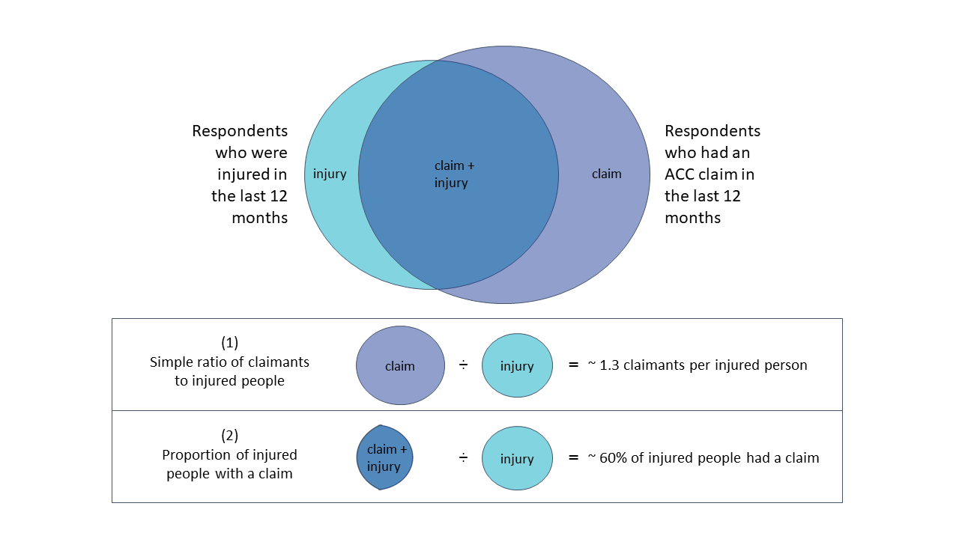
Figure 9.1: Illustration of alternative approaches to estimating claim rates for injured people. The simple ratio (1) includes claimants who did not report an injury and provides a ratio of claimants to injured people. This is a less direct measure of injured people’s claim rates than approach (2), which divides the number of injured people who had a claim by the total number of injured people.
While a simple ratio of claimants to injured people has the apparent advantage of eliminating the need to link ACC and survey data for respondents, I do not recommend it for the following reasons.
- It is subject to greater measurement error than the proportion of injured people with a claim because it includes the people who had a claim but who (presumably mistakenly) did not report an injury in the survey. As a result, it will be especially inaccurate for groups that under-report injuries in the survey.
- The claimants to injured people ratio is a less intuitive concept than a percentage claim rate among injured people and may be especially confusing when there are more claims than injuries.
Below I compare ratio-based estimates with estimates of the proportion of injured people with a claim, for the GSS results by age and ethnicity.
Figure 9.2(d) shows the ratio of claimants to injured people by age group. Compared to the percentage of injured people with a claim (Figure 9.2(c)), the ratio elevates the relative claim rates of older people. This is because the ratio is heavily influenced by the smaller size of the 65+ injured group (Figure 9.2(a)) and it may be more severely biased upwards by under-reporting of injuries among older people than the percentage of injured people who claim.

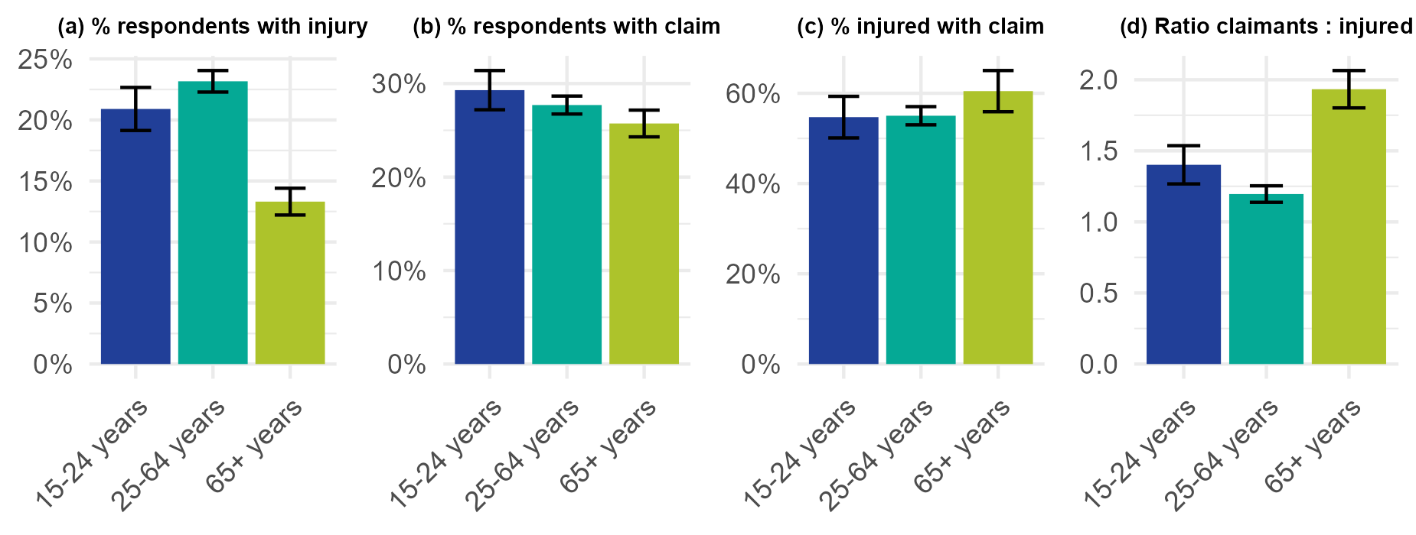
Figure 9.2: Injury and claim rates by age group. (a) The percentage of GSS respondents who reported an injury in the previous 12 months. (b) The percentage of GSS respondents who had an accepted claim with an accident date in the previous 12 months. (c) The percentage of respondents who reported an injury and who also had an accepted claim. (d) The ratio of respondents with claims to respondents who reported an injury. Proportions are based on population-weighted data and error bars represent 95 confidence intervals. Note that the charts have different scales on the y-axis.
Similar to what we see for age groups, the ratio of claimants to injured people appears to be sensitive to the smaller size of the injured Pacific and Asian groups, elevating the claimant to injured people ratio for these ethnicities (Figure 9.3(d)) as compared to the percentage of injured people who had a claim (Figure 9.3(c)).

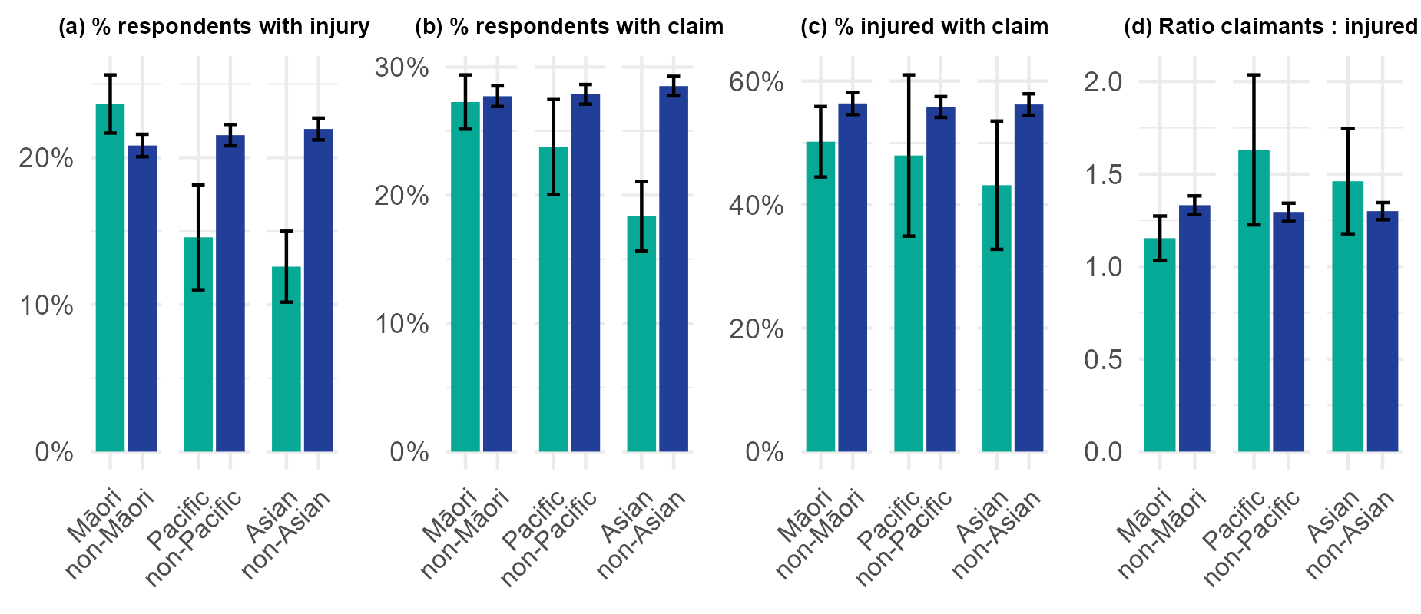
Figure 9.3: Injury and claim rates for Māori compared to non-Māori, (a) The percentage of GSS respondents who reported an injury in the previous 12 months. (b) The percentage of GSS respondents who had an accepted claim with an accident date in the previous 12 months. (c) The percentage of respondents who reported an injury and who also had an accepted claim. (d) The ratio of respondents with claims to respondents who reported an injury. Proportions are based on population-weighted data and error bars represent 95 confidence intervals. Note that the charts have different scales on the y-axis.

