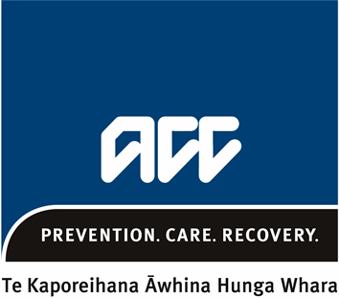
Impairment Assessment (Accredited Employer) Report
ACC
4152
Please complete this form with details of the injury/ies managed by the Full Self Cover Accredited Employer only. Then send it to ACC along with your completed Impairment Assessment Report. Note: Please type your answers.
1. ASSESSOR DETAILS
Vendor name: |  |  |  |  |  | Vendor number:
Date of assessment: |  |  |  |  |  | Purchase order number:
2. CLAIM DETAILS
Client’s name: |  |  |  |  | Claim number:
Date of birth: |  |  |  |  | Date of injury:
Injury assessed:

3. ASSESSMENT
1. Comment on the permanence and stability of the injury and adequacy of the medical records.
2. Describe the process used to asses the injury, ie the interview with the client and the clinical examination. How did you assess the injury and examine the particular body part? Were any tests used?
- Include analysis and discussion, ie what did you do, what comments and conclusions can you make from the examination?
- Reference any documents or information used in the assessment.
3. Comment on the clinical findings of the examination that relate to the injury, eg degree of flexion, swelling.
- Include an impairment rating, relevant references from the ‘AMA’ guides (tables, calculations and worksheets), and any analogy, range finding or multiple methods used.
4. What is the impact of other injuries or conditions on the impairment for the injury managed by the Accredited Employer, eg does apportionment apply?
No impact, or impact has been taken into account and is reflected in the Whole Person Impairment rating.
Provide comments:

5. What is the assessed Whole Person Impairment rating for the injury managed by the Accredited Employer?
4. SIGNATURE
Assessor’s signature: |  |  |  |  |  |  | Date:
The information collected by ACC on this form will be used to fulfil the requirements of the Accident Compensation Act 2001. In the collection, use and storage of information, ACC will at all times comply with the obligations of the Privacy Act 1993 and the Health Information Privacy Code 1994. View our privacy disclaimer at acc.co.nz/privacydisclaimer
All about
Impairment assessment reports for Full Self Cover Accredited Employers
- information for assessors
What is a Full Self Cover Accredited Employer and why do they need an impairment assessment report?

What is a Full Self Cover Accredited Employer?
These are employers who have joined ACC’s Partnership Programme and take full responsibility for managing their employees’ work injury claims. This includes providing rehabilitation and entitlements.

There are approximately 180 Full Self Cover Accredited Employers in the programme which accounts for over 25% of the full-time workforce.
Does ACC ever get involved in the claims process?
Yes, we manage applications for lump sum payments on behalf of the Accredited Employer.
How does the assessment process differ for Full Self Cover Accredited Employers?
The only difference is that as well as completing the usual Impairment Assessment Report, we need you to complete an additional Impairment Assessment (Accredited Employer) Report.

The additional report covers only work-related injuries relating to the Accredited Employer and is a shorter summary of the Impairment Report. We will send a copy of the report to the Accredited Employer.
Why do they need an Impairment Assessment (Accredited Employer) Report?
Feedback from Full Self Cover Accredited Employers has indicated they would like to understand better their employee’s injury/ies. This will help them manage the claim and make any payments their employee is entitled to receive.

As the full assessment report contains information not related to the work injury, we’re not able to give them a copy of this.

We send a copy of both reports to the employee for their information.
Where can I get a copy of the Impairment Assessment (Accredited Employer) report template?
We’ll send you a copy of the report template or you can find a copy at https://www.acc.co.nz/home/search?Search=ACC4152.
We’re happy to answer your questions.
If you’d like to know more, please call 0800 101 996 or visit us at www.acc.co.nz .

