Complete this form to describe a patient’s injury, any other conditions they have and the support they need from ACC for a safe discharge.
Return this form to us at least 48 hours before the planned discharge date. Please complete sections 1-5 for this patient. Send the completed form to claimsdocs@acc.co.nz.
1a. Patient details
If completing this form in hard copy, attach BRADMAR sticker over the relevant details.
Patient name: | Date of birth:
Address:

Contact number: | NHI Number:

1b. Authorised alternative contact details
Contact name: | Contact number:
Relationship to patient:

2a. Referral information
Planned discharge date: | Date supports are required:
Referrer name: | Role:
Hospital name:
Phone number: | Email address:

2b. Service request
Tick all that apply, fill in sections 3 to 5 and then complete the below listed specific sections.
Home & Community Support (HCS) – section 8 |  | Interim care (eg ARC) – section 9 |  |  | Equipment – section 7 |  | Rehabilitation – section 6
☐ Notify ACC a referral for HCS – Return to Independence has been sent to a provider  ☐ Request ACC arranges home and community support (where ineligible for HCS-RTI). |  | ☐ Request interim residential care |  |  | ☐ Notify ACC of equipment required to support discharge  ☐ Request for ACC to arrange |  | ☐ Notify ACC rehabilitation services have been put in place  ☐ Request rehabilitation services (not provided by NARP or HCS Provider)
3. Discharge planning (attach the discharge summary report if available)
Tick all that apply and provide the additional information requested next to those selections.
Patient is discharging from: | ☐ Acute inpatient |  |  | ☐ Non-acute rehab inpatient |  | ☐ Emergency department
If the patient is being discharged to a different address to the one in section 1a, please provide this address:

Contact number (if different to the number supplied in section 1a):
Does the patient live alone: |  |  | ☐ Yes ☐ No, provide information below
Patient’s living situation:
List any risks or hazards a provider needs to know when visiting the patient’s home, eg dogs, firearms, infectious diseases. Also indicate if risks or hazards are unknown:

Does the patient, or anyone else in the household, receive formal support |  |  |  | ☐ Yes, provide more information below  ☐ No, continue to the next question
Carer/agency: |  |  |  | Hours: per ☐ day ☐ week ☐ fortnight
Does the patient require an interpreter? |  |  |  | ☐ Yes, advise which language ☐ No
List any informal support available in the home or community to assist the patient, eg family/whānau, neighbours, church, friends, social clubs:

4a. Injury details
ACC45 number: | Date of injury:
Injury diagnosis at the time of discharge:

Has this changed since the ACC45 was lodged? ☐ Yes ☐ No
How did the accident happen?

List the patient’s relevant treatment history (including surgery):

4b. Pre-injury medical or disability details
Indicate any pre-existing conditions that might affect the patient’s ability to rehabilitate.
☐ Hypertension or ☐ Hypotension  ☐ Osteoporosis  ☐ Arthritis  ☐ Mental health diagnosis  ☐ Heart disease  ☐ Type 1 diabetes ☐ Type 2 diabetes |  | ☐ Cognitive impairment  ☐ Hearing impairment  ☐ Visual impairment  ☐ Total knee joint replacement ☐ Left ☐ Right  ☐ Total hip joint replacement ☐ Left ☐ Right  ☐ Chronic obstructive pulmonary disorder
☐ Mobility issues, eg if mobility aid used, specify details:

☐ Neurological condition, specify details:

☐ Other conditions, specify details:

4c. Post injury functional limitations
Select patient’s functional limitations due to personal injury.
Weight bearing status | Mobility aids |  | Transfers | Upper limb
☐ Full weight bearing  ☐ Weight bearing as tolerated  ☐ Partial weight bearing  ☐ Abide by hip precautions  ☐ Non-weight bearing | ☐ Nil aid  ☐ Walking stick  ☐ Crutches  ☐ Standing walking frame  ☐ 2W2C frame  ☐ Pram handle frame  ☐ Gutter frame  ☐ Wheelchair |  | ☐ Independent  ☐ Supervision  ☐ 1 person assist for transfers  ☐ 2 person assist for transfers  ☐ Hoist transfers | Upper limb limitations:  ☐ Left ☐ Right  Dominant hand:  ☐ Left ☐ Right
☐ Other, specify details:

5. Support requirements due to injury
Confirm the patient’s pre-injury status and then post discharge supports needs, as a result of their injury.
Support | Pre-injury status | Describe the patient’s post discharge needs
Household tasks (eg laundry) | ☐ Independent  ☐ Assistance needed  ☐ Funded ☐ Self-funded
Showering/ bathing | ☐ Independent  ☐ Assistance needed  ☐ Funded ☐ Self-funded
Toileting | ☐ Independent  ☐ Assistance needed  ☐ Funded ☐ Self-funded
Meal preparation | ☐ Independent  ☐ Assistance needed  ☐ Funded ☐ Self-funded
Transport | ☐ Independent  ☐ Assistance needed  ☐ Funded ☐ Self-funded
Medication management | ☐ Independent  ☐ Assistance needed  ☐ Funded ☐ Self-funded

6. Rehabilitation requirements due to injury
If the patient will receive Home and Community Support – Return to Independence (HCS-RTI), the supplier can provide up to 10 hours of Allied Health over a three-month period, per claim. This is a combined total for physiotherapy, occupational therapy and nursing.
If rehabilitation support is needed and HCS-RTI is not being requested, please confirm whether ACC or the hospital will arrange rehabilitation.
Does the patient require any further rehabilitation or treatment? | ☐ Yes, provide more information below  ☐ No, continue to section 7
Rehabilitation or treatment required:
Who will arrange this rehabilitation? | ☐ Discharging hospital ☐ ACC ☐ HCS-RTI provider

7. Equipment
Complete this section if the patient requires equipment on discharge.
Indicate if equipment is being provided by the hospital or you require ACC to arrange it:
☐ Equipment will be provided by the hospital
If the equipment will be needed for longer than 6 weeks post-acute discharge, complete a short term equipment request form (ACC4249).
☐ ACC to arrange, detail in the table below.
Early planning is essential for specialised requirements, include make and model if known.
Equipment to be arranged by ACC: | Length of time required:
1.
2.

8. Home and Community Supports (HCS), if required
Determine which HCS service is appropriate using the flow chart below.
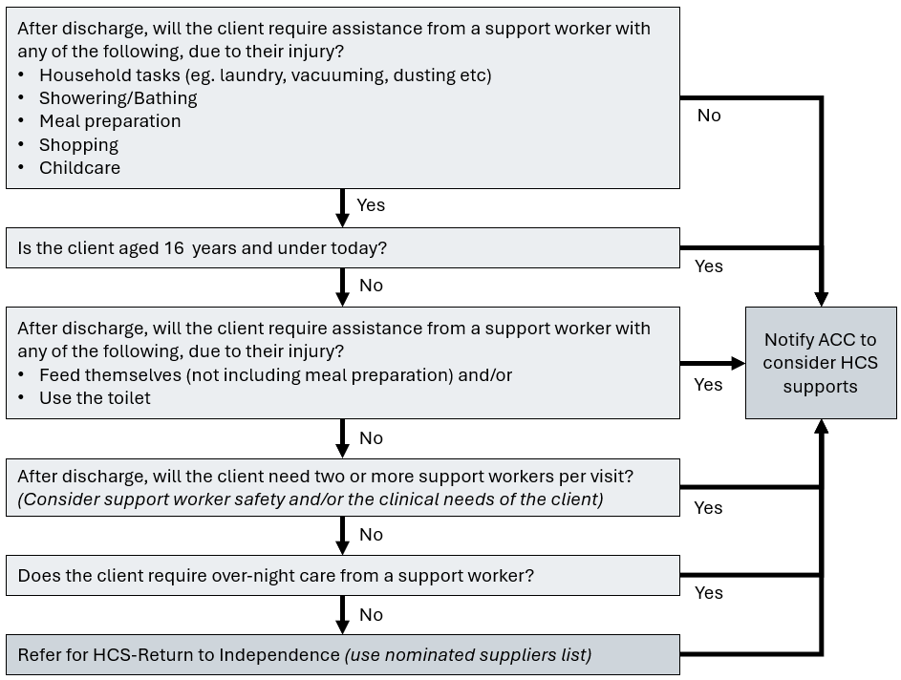
Select an outcome:
☐ Notify ACC to consider supports and make a referral
☐ Hospital has referred for HCS - RTI (select a supplier below)
HCS – Return to Independence suppliers (national coverage)
Select a supplier from the list below, checking if the patient has a preference.
If the patient is already receiving care from a supplier who is not on the list, call the supplier and confirm they are an ACC subcontractor.
Only the suppliers listed below, or ACC subcontractors, can provide this service.
Once an ACC supplier or subcontractor has been selected, email the supplier this form.
Supplier | Phone | Email
☐ Care on Call (NZ) | 0800 633 822 | referral@careoncall.co.nz
☐ Solora Healthcare & Rehabilitation | 0800 725 705 | homecare@solora.nz
☐ Oko Āio Limited | 0800 656 246 | referrals@okoaio.nz
☐ Te Amo Atawhai | 0800 183 266 | referrals@teamoatawhai.co.nz
☐ Access Community Health | 0508 123 010 | acc_referrals@access.org.nz
☐ Healthcare New Zealand | 0800 002 722 | referral@healthcarenz.co.nz
☐ Health Vision | 0508 733 377 | service@healthvision.co.nz
☐ Custom Care Nursing Limited | 0508 687 737 | referrals@customecarenursing.co.nzreferrals@customcarenursing.co.nz
☐ Geneva Health | 0800 436 382 | homecareemails@genevahealth.com
Has a phone referral been accepted by the HCS-RTI supplier? ☐ Yes ☐ No

9. Interim care requirements
Complete this section if the patient requires funded interim care due to their injury.
What was the patient’s living situation before their accident?
☐ Normally lives at home and needs to enter facility for short term care
☐ Normally lives in rest home/facility:
 | ☐ Independent unit/apartment  ☐ Rest home level care  ☐ Hospital level care | ☐ Dementia level care  ☐ Specialised psychogeriatric level care
☐ Due to their injury, they require:
 | ☐ Independent unit/apartment  ☐ Rest home level care  ☐ Hospital level care | ☐ Dementia level care  ☐ Specialised psychogeriatric level care
What is the clinical rationale for the patient needing interim care and why can’t the patient go home with a support plan in place?

Name of residential facility the patient is being discharged to:
The following details are required to create a purchase order for the entire period of the patient’s stay in interim care.
Date interim care is required from:
Anticipated length of stay:
Will ACC pay the discharging hospital or the aged residential care (ARC) facility for interim care? ☐ Hospital ☐ ARC facility

10. Referral checklist
Check that all actions required for the service request have been completed.
☐ Patient details and pre/post injury information sections (1-5) have been completed
☐ Service request section (2b) has ticks indicating the services being requested
☐ Relevant service sections (6-9) have been completed with required information
☐ The discharge plan or service request has been discussed with the patient and patient representatives
☐ If available, supporting evidence such as the discharge report is attached
In the collection, use, disclosure, and storage of information, ACC will at all times comply with the obligations of the Privacy Act 2020, the Health Information Privacy Code 2020 and the Official Information Act 1982.

